AerCap Holdings
Research by Alejandro Llamazares
Equity Research · Aviation Leasing · NYSE: AER


Index
Recent Results & Outlook
Company Overview
Strategy
Company History
Supply Chain
Competitive Analysis
Industry Overview
Market Analysis
Competitors
Company Analysis
Margins
Returns (ROE / ROA)
Balance Sheet
Debt
Liquidity & Solvency
Cash Flow
Valuation
DCF & Residual Income
Accounting Methodology

Report Date: 15 July 2026

Current Price: $150
Risk: Medium
12-mo target
BUY
Target Price: $164 (+ 9.03%)

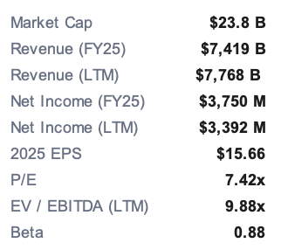
Share Price – Trailing 12 Months
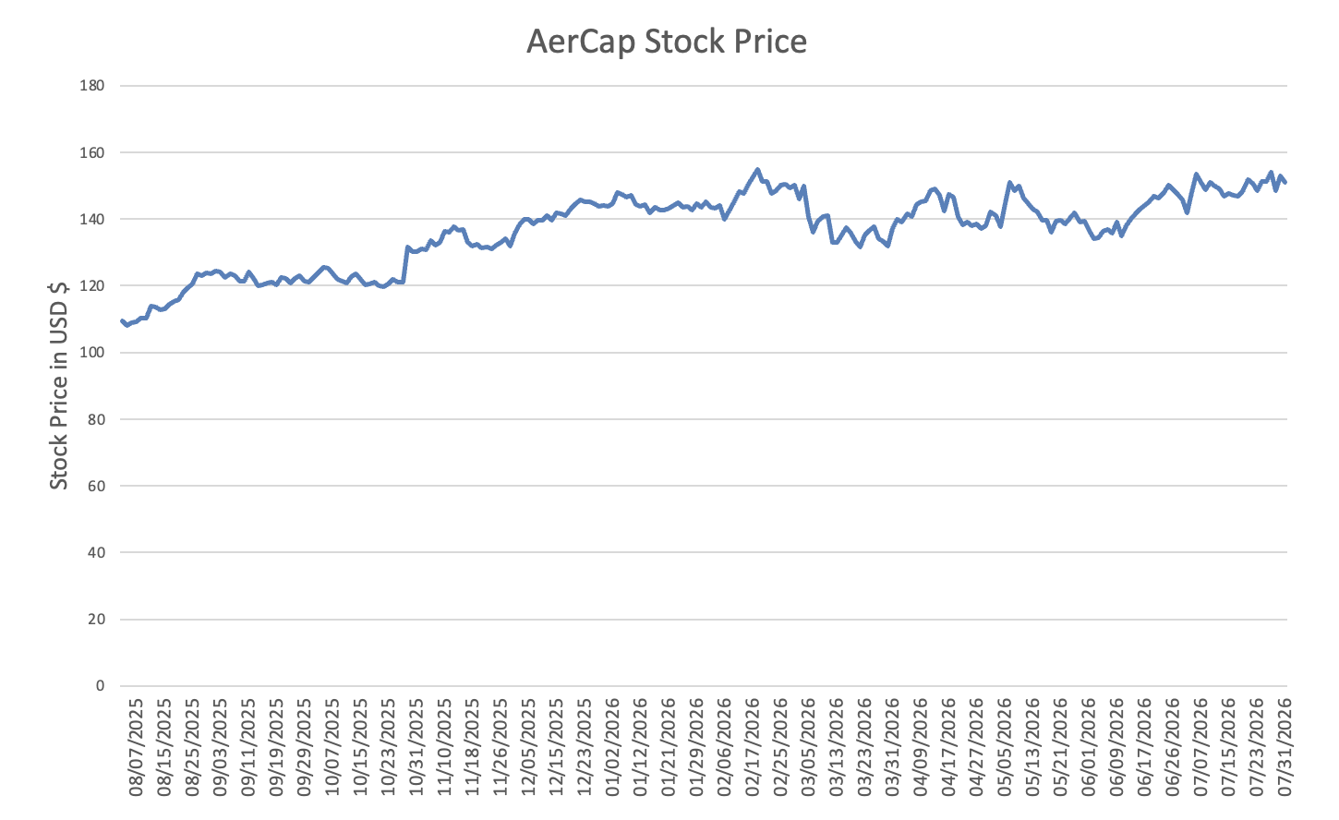

Figure 1 - Share Price – Trailing 12 Months

Investment Thesis
Airlines want to own less of their own fleets, and AerCap is set up to take the other side of that. Six years of shocks since COVID, geopolitical and environmental, have pushed carriers toward leasing, and AerCap is positioned to absorb that demand. Its OEM relationships and its sheer scale let it keep growing the fleet while holding onto pricing power on lease yields. Long term demand in global air passenger demand forecasted to continue increasing at 3% CAGR till 2050 supporting market environment to continued increase in AerCap’s products.
As the world's largest lessor, that scale is the foundation of the moat. It earns OEM discounts and delivery-slot priority, and, funded at roughly 4.1% on an investment-grade balance sheet, it lets AerCap grow a leveraged book at a cost smaller peers cannot match. Fleet quality reinforces the position: new-technology aircraft now make up around 76% of net book value against an 85% target for 2030, and these are the assets airlines most want, carrying lower residual risk and longer-duration cash flows. Underpinning all of it is a proven ability to consolidate the industry, having integrated its largest deals (Genesis, ILFC and GECAS) at a time when pure-play competitors are shrinking and Air Lease has been taken private in 2026.

Recent Results & Outlook
First-Quarter 2026 Results
The first quarter of 2026 was a record. AerCap reported net income of $818 million, or $4.96 per share, and record adjusted net income of $889 million, or $5.39 per share. Return on equity came in at 18%, adjusted ROE at 19%, on $1.4 billion of operating cash flow. Portfolio activity was strong: $1.5 billion of asset sales at $291 million of gains, a 24% unlevered gain-on-sale margin, or 1.9x book value on an equity basis. On capital return, AerCap bought back 5.4 million shares for $745 million and announced a new $1.0 billion repurchase program. Book value per share reached $116.67 at March 31, 2026, up about 20% year over year, with the adjusted debt-to-equity ratio at 2.1x. It also kept adding new-technology equipment, putting 110 Airbus A320neo Family aircraft into the order book during the quarter, including 45 exercised options with deliveries from 2028, and signing for 48 CFM LEAP-1A engines through its Shannon Engine Support joint venture. Over the quarter it closed 286 transactions and extended 87% of expiring leases.
Full-Year Guidance
Management raised full-year 2026 adjusted EPS guidance to about $14.50, before any further gains on sale this year. Even with the recent geopolitical noise, it said demand for aviation assets is holding up, helped by steady travel demand and tight aircraft supply, and expects that combination to keep creating value for shareholders.

Company Overview
AerCap's strategy is to earn good risk-adjusted returns across the whole life of an aircraft. It comes down to four things: buying in-demand aircraft, engines and helicopters at the right price; funding them cheaply; hedging interest-rate risk; and placing them across a global platform to keep utilization high. Once an asset is on lease, management works the return by managing lease rates, time off-lease, and financing and maintenance costs, and by timing sales well. To cut downtime and transition costs, it tries to extend leases with the current operator well before expiry, and re-leases to someone else or sells only when that pays better. It also staggers lease terms, currently out to about 16 years, so the fleet is not all coming up for re-lease into the same market. Underneath all of it is the shift to newer, more fuel-efficient “new-technology” equipment, now about 76% of fleet net book value against an 85% target for 2030. Run at scale, with 705 asset transactions in 2025, this is what lets AerCap earn solid returns and stay flexible as the market moves.
Company History

AerCap's roots go back to the leasing business built in the 1970s by Guinness Peat Aviation (GPA) and International Lease Finance Corporation (ILFC), the firms that turned the operating lease into a mainstream way for airlines to get aircraft. AerCap Holdings N.V. was incorporated in the Netherlands on July 10, 2006. It has grown mainly by acquisition, which management sees as a core edge. It bought Genesis Lease in 2010, ILFC in 2014, then one of the largest lessors in the world, and GE Capital Aviation Services (GECAS) from General Electric in November 2021. ILFC and GECAS are the two biggest deals in the history of aviation leasing. GECAS, which also brought the engine, helicopter and materials businesses up to their current size, roughly doubled the asset base and made AerCap the leader in every category of aviation leasing. That history shows in the structure today: the main operating subsidiaries include AerCap Ireland, AerCap Ireland Capital DAC, AerCap Global Aviation Trust and the legacy ILFC entities, while the parts arm, AerCap Materials, traces back to the Memphis Group founded in 1971.

Supply Chain
Upstream: a multi-channel origination engine

AerCap sources equipment through several distinct channels rather than relying on manufacturer orders alone

Bulk OEM orders
Purchases of bundled aircraft of varying types and ages, on- or off-lease, adding scale and diversifying vintage in a single transaction
Large-volume purchases placed directly with Airbus and Boeing to capture volume discounts. AerCap is among the largest customers of both manufacturers, and its 283-aircraft order book, composed exclusively of new-technology, fuel-efficient types, is sourced this way.
Buying aircraft directly from airlines and immediately leasing them back, sourcing equipment from carriers rather than OEMs.
Individual acquisitions where the portfolio-management team, in constant contact with airlines worldwide, identifies mispriced assets.

Portfolio acquisition

Purchase-and-leaseback

Opportunistic single-aircraft trades

In 2025 AerCap agreed to purchase 52 A320neo Family aircraft (with options on up to 45 more) that had previously belonged to the Spirit Airlines order book, effectively acquiring another carrier's delivery positions. Given the multi-year scarcity of narrowbody delivery slots, this is a strategically valuable route to advance in the production queue.
Acquired order books and delivery slots

Corporate and platform M&A
The most transformative channel. AerCap built its leadership through the acquisitions of Genesis Lease (2010), ILFC (2014) and GECAS (2021), the latter two the two largest transactions in the history of aviation leasing. A substantial share of the current fleet, engine and order-book base was sourced by acquiring entire leasing platforms wholesale, and the 20-F identifies this integration capability as a key competitive advantage.

Downstream: aftermarket, conversion and disposition

AerCap also controls the exit side of its own supply chain. Through AerCap Materials (established 1971), it runs an aviation-parts business spanning component distribution, consignment, asset and repair management, and a dedicated dismantlement facility in Greenwood, Mississippi, where end-of-life aircraft and engines are disassembled into parts and sold to airlines, MRO providers and distributors. This "part-out" capability provides a value-maximizing exit for aging assets as an alternative to whole-aircraft sale. On the engine side, the 50/50 SES joint venture with Safran adds spare-engine pooling, guaranteed pool access, and engine trading and exchange services. AerCap Cargo extends asset life further through freighter-conversion programs, including the "Big Twin" 777-300ER program with Israel Aerospace Industries and participation in the 767-300BDSF, 737-800BCF and A321P2F conversion programs.
On disposition, AerCap sells whole aircraft, to airlines, financial investors and competing lessors, when it judges a type's value has peaked or to rebalance the portfolio, giving it several monetization paths for any given asset (re-lease, sale, conversion or part-out).

Competitive Analysis Porters Five Forces
Bargaining power of suppliers (OEMs): HIGH
Threat of new entrants: LOW to MODERATE
The economics keep most newcomers out, because leasing is a game of scale and cost of capital. AerCap's ~$8.5B revenue base, its investment-grade rating (now BBB+ at all three agencies after the 2025 Fitch upgrade), $11.0B of undrawn credit lines, and the fact that it arranged $13.2B of financing in a single year give it a funding cost a new entrant simply can't match. Scale also buys OEM delivery slots and pricing. Even so, the moat is capital rather than technology or regulation, so well-funded new lessors, often backed by sovereign wealth, Asian capital or private equity, do keep entering, which is why this isn't a “very low” threat. The real barriers are cost of capital, OEM relationships and order backlog, and the platform needed to remarket and repossess aircraft across jurisdictions.

This is probably the force working hardest against AerCap. New aircraft come from the Airbus/Boeing duopoly and engines from a handful of makers, with long lead times and high switching costs. The 20-F keeps flagging how much AerCap depends on the manufacturers to deliver on time and to spec, and it points to real damage from OEM problems such as the 737 MAX and 787 delays and the FAA production caps. AerCap offsets some of this with its buying scale, as one of the largest customers of both OEMs it gets some leverage and delivery priority, and by sourcing on the secondary market and through sale-leasebacks rather than only OEM orders. But the underlying supplier concentration keeps this force high.

Threat of substitutes: LOW to MODERATE
Bargaining power of buyers (airlines/lessees): MODERATE
Individually, buyer power is diluted by AerCap's ~300-customer base with no lessee over 10% and top-five at 18.5% -that diversification limits any one airline's leverage. Working the other way, leasing is competitive and lessees can shop across lessors, airlines are cyclically fragile (bankruptcies/restructurings force renegotiation), and the product is somewhat commoditized (a given aircraft type is fungible across lessors). Net, buyers have real but bounded power - offset by AerCap's ability to remarket to another operator, staggered lease expirations, and the 99% utilization it sustains.
The substitute here isn't another way to travel, there's no substitute for a jet, but the other ways an airline can finance one: buying outright, bank or export-credit financing, or EETCs instead of an operating lease. The long-run trend runs against substitution. Airlines have leaned more on operating leases since the 1970s to save capital and keep fleet flexibility, and the leased share of the global fleet has been climbing for decades. So airlines can self-finance, but the structural pull toward leasing keeps this force weak. Within leasing itself, freighter conversions and part-outs give AerCap other uses for aging aircraft.

Competitive rivalry: HIGH

The 20-F itself calls the business “highly competitive.” AerCap is up against the other large lessors (Avolon, SMBC Aviation Capital, Air Lease, BOC Aviation and others), plus airlines, manufacturers, brokers and banks, all competing on delivery dates, lease rates, terms, aircraft condition and availability. Rivalry is intense because the asset is fungible and most of the competition comes down to price and terms. AerCap leans on scale, portfolio breadth, global reach and its remarketing record, and argues that makes it a strong competitor on every front, but rivalry is still a high force that squeezes lease-rate spreads.

Market Analysis

2) Supply Constrained
1) Wars and their impact
3) Over Travel Demand

- Wars and their impact
1a. Russia / Ukraine (2022)

This was the biggest single event in AerCap's recent history. When Russia seized foreign-owned jets after the 2022 invasion, AerCap took a $2.7 billion pre-tax net charge for the write-offs and impairments of aircraft stranded in Russia and Ukraine (AerCap press release, June 2025). It lost more than 100 aircraft, and its insurance claim covered 116 aircraft and 15 standalone engines (AeroTime, June 2025). The recovery has been large. On June 11, 2025, London's Commercial Court awarded AerCap about $1.0 billion ($1.035bn) under the “War and Allied Perils” cover, though less than the roughly $2bn it sought net of prior settlements (AerCap PR; CNN; Brick Court Chambers, June 2025). With earlier settlements added in, total pre-tax recoveries tied to Ukraine reached about $2.9 billion by Q3 2025, offsetting most of the original $2.7bn write-off (AerCap Q3 2025 release, Oct 2025). Those recoveries, about $1.5bn of them in 2025, were the main reason AerCap posted a record $3.8bn of net income for the year (AerCap FY2025 release, Feb 2026). Two things to keep in mind for the model: insurers applied to appeal the judgment in October 2025, and AerCap is still chasing about $1.8bn of additional “operator policy” claims, with another trial scheduled, so some of the recovery value is still contingent (Herbert Smith Freehills Kramer, Nov 2025).

1b. Middle East conflict- An energy and airspace shock (2026)
The escalation in late February and March 2026, including the US–Israeli strikes, shut major airspace corridors and badly disrupted the Dubai, Doha and Abu Dhabi hubs; more than 21,300 flights were cancelled worldwide in the first week of March alone (FinancialContent/MarketMinute, March 2026). The effective closure of the Strait of Hormuz, which carries roughly a quarter of the world's oil and jet-fuel supply, drove crude up more than 60% in March 2026 and doubled jet-fuel prices within weeks, with US Gulf Coast jet fuel hitting $4.12/gallon, a near four-year high (Grant Thornton, May 2026). Because many carriers had wound down their fuel hedges, that fed straight into costs (FinancialContent, March 2026). A later peace framework, reopening Hormuz, lifting the naval blockade and opening a 60-day negotiation window, calmed things down, and carriers began rebuilding schedules, though fares and surcharges stayed above pre-conflict levels (Radiant, 2026).

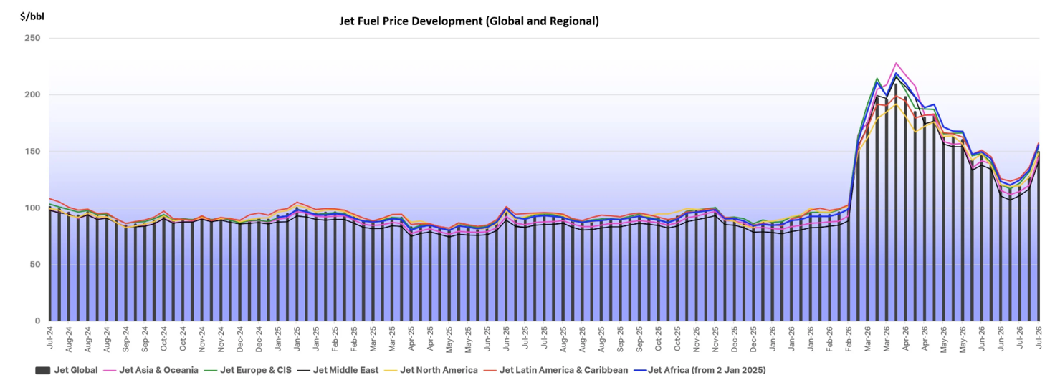
Figure 2 - Jet Fuel Price Development

This conflict, layered on top of the inflation of recent years, has weighed heavily on the prospect of an interest-rate cut.

The rate outlook shifted materially in 2026, and a change at the top of the Fed sits behind it. Jerome Powell's term ended and Kevin Warsh was sworn in as Fed Chair on May 22, 2026, nominated by President Trump, who had pushed for lower rates. Despite that backdrop, Warsh has taken a hawkish, price-stability-first line rather than cutting. At his first FOMC meeting in June 2026 the Fed held the funds rate at 3.50%–3.75%, shortened the statement, and stripped out the easing-leaning forward guidance, consistent with his preference to stay data-dependent rather than pre-commit. Warsh declined to submit his own “dot,” but the committee's median projection moved up to about 3.8% for end-2026, with nine of eighteen members flagging a possible hike this year, a sharp reversal from the single cut penciled in back in March. The trigger was the Iran-war energy spike, which pushed CPI to roughly 4.2% in May, its highest since 2023. He has since repeated that prices are too high and signaled no tolerance for above-target inflation, and markets now price cuts out to 2027–2028.
For AerCap, the takeaway is simple: instead of the modest easing expected at the start of the year, US rates look set to stay higher for longer, which keeps lessor funding costs up. What offsets that is pricing power. Lessors have been passing higher funding costs through to airlines in the form of record lease rates, and AerCap's investment-grade balance sheet (BBB+) keeps its access to the unsecured bond and ABS markets cheap and deep. Those markets stayed strong through 2025–2026, with tight spreads on new-technology-aircraft paper. Europe helps too: the ECB deposit rate sits at 2% and is expected to hold through mid-2026. The sector has to refinance roughly $19.3 billion of debt in 2026, but with the market this open that risk looks manageable.
A weaker dollar is a quieter tailwind, and this one runs to AerCap's customers rather than to AerCap itself. The dollar fell about 10% against most trading-partner currencies over the past year and is expected to weaken a further ~5% across 2026, having lost roughly 2.5% by end-April. Because fuel invoices and most aircraft debt are priced in dollars, a softer dollar makes those costs cheaper for carriers that earn in currencies which have appreciated, which supports the broader cycle and non-US airlines in particular. Since much of AerCap's lessee base sits outside the dollar bloc, this modestly improves customer credit quality and rent-paying capacity, a small but real positive for lessor receivables.

COVID-19 and the historical resilience case

COVID-19 and the historical resilience case
The most important lesson for a long-horizon aviation investor is that the industry has come back from every major shock it has faced, oil crises, wars, terrorism, financial crises and pandemics. Passenger demand has returned each time, and new aircraft have stayed essential to keeping the world connected. That track record is why today's Middle East conflict reads as a cyclical disruption rather than a structural break.
COVID-19 was the sharpest downturn aviation has ever seen, and the best stress test we have. At the low point in 2020, roughly 90% of the global fleet was grounded and a number of airlines went bankrupt; international flights fell nearly 80% and domestic about 70% by early April 2020, and global RPKs were still down around 80% year-on-year as late as July 2020. The recovery took years, with capacity and passenger numbers held down well into 2022–2023, but traffic eventually got back past pre-pandemic levels, and AerCap is now posting records. The pattern holds further back too: after SARS in 2003, monthly international traffic was back to its pre-crisis level in about nine months, and after MERS in roughly six.
Two things are worth pulling out for AerCap. First, IATA notes that COVID left a permanent mark: the RPK collapse opened a gap that even the high-growth scenario doesn't fully close against the old pre-pandemic trend by 2050. So the industry got its growth path back, but off a permanently lower base. Second, and this one is directly about lessors, the lasting legacy of the pandemic, on top of post-2008 bank regulation and ESG pressure, has been that banks and investors are more cautious about financing new aircraft even as demand grows. That financing gap actually favors well-capitalized, investment-grade lessors like AerCap: when banks pull back, airlines lean harder on lessors for aircraft and capital, which reinforces the sale-leaseback and leasing-penetration trends above.
- Supply Chain Constrained
Tight Supply

Aircraft supply is as tight as it has been in decades, and that works in favor of whoever owns the assets.
- The order backlog reached 18,100 aircraft in May 2026, up from 17,000 in 2024 - over 50% of the entire active fleet. At roughly 12 years of production, Boeing's backlog alone is around $695 billion. Demand for new aircraft remains strong, with orders continuing to exceed deliveries.
- Deliveries keep missing targets. Airbus delivered 114 aircraft in Q1 2026 (down from 136 a year earlier) and pushed its A320-family "rate 75" target from 2026 to late 2027, blaming Pratt & Whitney GTF engine shortages; it filed a formal damages claim against P&W in March 2026. Boeing delivered 143 in Q1 2026 and was cleared to raise 737 MAX output from 42 to 47/month.
- The shortfall is systemic. More than 5,300 deliveries are “missing” against the pre-pandemic trend, about 5,000 aircraft sit in storage, the average airline fleet age has climbed to a record ~15.2 years, and a normal supply-demand balance isn't expected before 2031–2034; the delays are estimated to cost airlines over $11bn a year. The shortage even stalled industry-wide fuel-efficiency gains for the first time ever across 2024–2025, as carriers keep flying older jets. United's CEO has said engine constraints could stay the industry's biggest problem for up to five years.
- Demand-supply divergence is stark: Q1 2026 saw 569 new orders (461 single-aisle), the strongest Q1 since 2013, against only 261 deliveries.
Aircraft values and lease rates

This scarcity feeds straight into asset economics, and that is really how the industry backdrop reaches AerCap's numbers. Lease rates have hit record levels because there simply aren't enough aircraft available and airlines still want to expand or renew their fleets, and that flows directly into AerCap's basic lease rents whenever it re-leases or places an aircraft. With so few new deliveries coming through, values are holding up and rates keep climbing, especially for the young fuel-efficient narrowbodies (A320neo, 737 MAX, A321neo) and the widebodies everyone wants (A350, 787). Even older narrowbodies like the 737-800 and A320ceo are keeping their value, because airlines would rather extend a lease than go hunting for a replacement that isn't there. Appraisers have started raising their long-term value forecasts too, pointing to maintenance costs and inflation, and put new-aircraft value inflation at around 1.5% for 2026. So lessors are holding onto aircraft longer and getting better rates for them.
There's a two-sided cost effect here: the same shortage that lifts lease rates also raises costs, because the older fleets airlines are stuck operating need more maintenance. For a lessor that mostly cuts the right way, since under an operating lease it's the airline, not AerCap, that pays for in-service maintenance, but it does add to redelivery and reconfiguration costs on aging aircraft at lease end.

- Overall Demand

Passenger Travel Demand

Long term, the structural growth case is strong. IATA's Long-Term Demand Projections have global passenger demand more than doubling by 2050. The mid case reaches 20.8 trillion revenue passenger kilometers (RPK) by 2050, a 3.1% CAGR from 9 trillion in 2024; the high case is 3.3% (21.9tn) and the low case 2.9% (19.5tn). Growth is slowing from history, from roughly 4.5% a year over 1998–2024 to about 3.1%, but IATA frames that as the market maturing rather than demand weakening, with absolute passenger numbers still rising a lot.
Near term, 2026 got revised down after the conflict. Before it, consensus was for roughly 4.9% global RPK growth, and early-year traffic backed that up: RPK rose 3.8% in January, on a record January load factor of 82.0%, and 6.1% in February. Then the conflict hit: March RPK slowed to +2.1%, international traffic fell 0.6%, and Middle East carriers' international traffic collapsed 60.8% year-on-year. In June 2026 IATA cut its full-year forecast to just 2.1% RPK growth on the conflict and the energy shock, with the Middle East set to contract 11.4% for the year, North America up only 0.8%, and Africa the fastest region at +10% as routings shift.
Fleet growth and new-aircraft demand
The two OEM forecasts agree the global fleet roughly doubles over 20 years:
- Boeing projects demand for about 43,600 new airplanes over 2025–2044, with the fleet nearly doubling to 49,600 by 2044 and passenger traffic growing 4.2% annually; single-aisle jets are 72% of the future fleet and ~80% of in-service aircraft get replaced. Its 2026 update raised this to nearly 44,000 new airplanes and a fleet above 50,000 by 2045.
- Airbus puts 20-year demand at 42,060 new aircraft (trimmed from 43,420 a year earlier), with the fleet growing to 45,550 by 2045 from 23,310 in 2025.
- Cirium independently projects ~46,500 deliveries worth ~$3.4 trillion over 2025–2044.
Emerging markets are the growth engine. Boeing expects them to hold more than 50% of the global fleet by 2044, up from about 40% in 2024, and reckons roughly half of all deliveries are replacements of older, less-efficient aircraft.
Leasing vs. buying - the structural shift towards leasing
The long-run trend favors lessors. About 55% of the global commercial fleet is now leased, and operating leases make up roughly 60% of leasing agreements. Lessors fund around half of new deliveries, and the leased share is expected to keep rising toward 60%. Airlines increasingly want asset-light balance sheets and use sale-and-leaseback to free up capital and keep liquidity and fleet flexibility, a trend the current fuel and cost pressure only reinforces.
Market-sizing estimates vary a lot by source but all point up: from roughly $180–227 billion in 2025 to somewhere between ~$278 billion and ~$510 billion by the early-to-mid 2030s, which works out to CAGRs of about 7%–12%. Narrowbodies dominate the leased units (~61% in 2025), and Europe, mostly Ireland, where AerCap is domiciled, holds the largest regional share (~52%) thanks to its tax and operating advantages.

Competitors

The #2 lessor. Japanese-owned but based in Ireland, with a fleet of around 760 aircraft, heavily narrowbody, more than 500 of them A320- or 737-family jets. It's owned by a Sumitomo consortium (SMBC bank, SMFL, Sumitomo Corp), so it competes on cheap, bank-backed funding. Versus AerCap: pure narrowbody, no engines or helicopters, younger and less diversified.
SMBC Aviation Capital

The #3 lessor, Dublin-based, owned by China's Bohai Leasing (the HNA legacy) alongside Japan's Orix. Around 600 aircraft, built around young, fuel-efficient jets and a large A320neo order book. It leans on new-technology narrowbodies and markets itself hard on sustainability. Versus AerCap: order-driven, younger fleet, narrower asset mix, Asian ownership.
Avolon



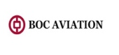
Singapore-headquartered, listed in Hong Kong, majority-owned by Bank of China. Its edge is cheap parent-bank funding and a sale-and-leaseback-heavy sourcing model concentrated in Asia-Pacific. Versus AerCap: a bank-funding advantage, an Asia tilt, and a young narrowbody book.
BOC Aviation

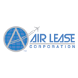
Los Angeles-based and, like AerCap, US-listed. Founded by Steven Udvar-Házy, the man who built ILFC, which AerCap later absorbed. Its model is disciplined forward-ordering straight from Airbus and Boeing, placing aircraft years ahead to keep one of the youngest fleets in the industry. Versus AerCap: much smaller, pure-play, no older legacy metal and no engines or helicopters, a young-fleet, order-book specialist. It was recently acquired by Sumitomo Corporation, the owner of SMBC Aviation.
Air Lease Corporation (ALC)


Dubai-based, owned by the government's Investment Corporation of Dubai. A full-service Middle East player that grew by buying AWAS and the regional-aircraft lessor Falko, and also offers engineering services. Versus AerCap: sovereign-backed, Gulf-centered, smaller and more regional.
Dubai Aerospace Enterprise (DAE)

Company Anslysis
Revenue

Maintenance Revenue & Basic Lease
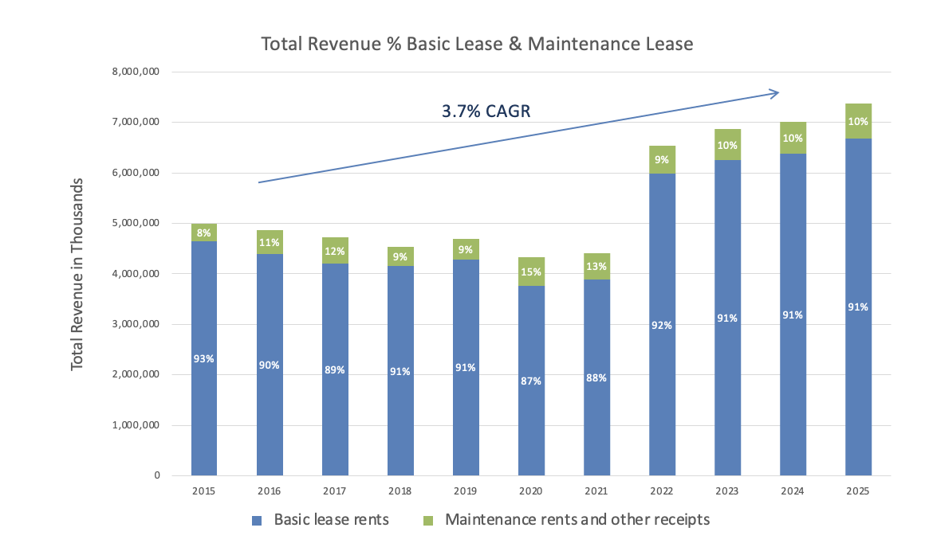
Figure 3 - Total Revenue by Basic Lease and Maintenance Revenue

On operating revenue, meaning lease revenue before net gains on asset sales and other income, basic lease rents have historically been about 90% of the total, with maintenance revenue the other 10%. That fits the business: maintenance revenue comes off the operating-lease portfolio and is a much smaller part of how AerCap earns.
Total revenue grew at a 3.7% CAGR from 2015 to 2025, mostly on the back of the 2021 GECAS acquisition, which greatly expanded the asset base and, with it, the number of leases.

Biggest Customers
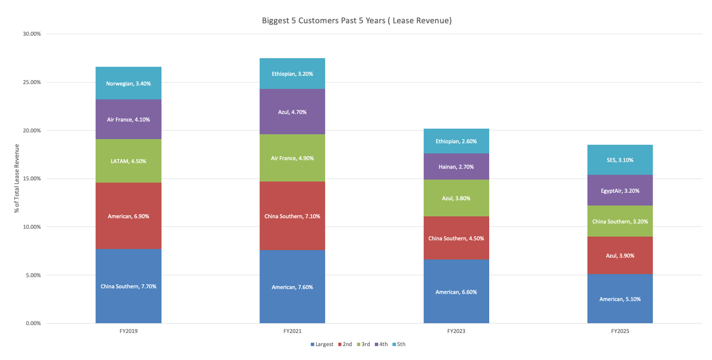
Figure 4 - Biggest 5 Customers Past Five Years

Across the years, two names sit in the top five every single year, China Southern and American, while the other three rotate. Those rotating positions have included European carriers such as Norwegian and Air France, alongside demand from airlines in less developed markets such as Egypt and Brazil.

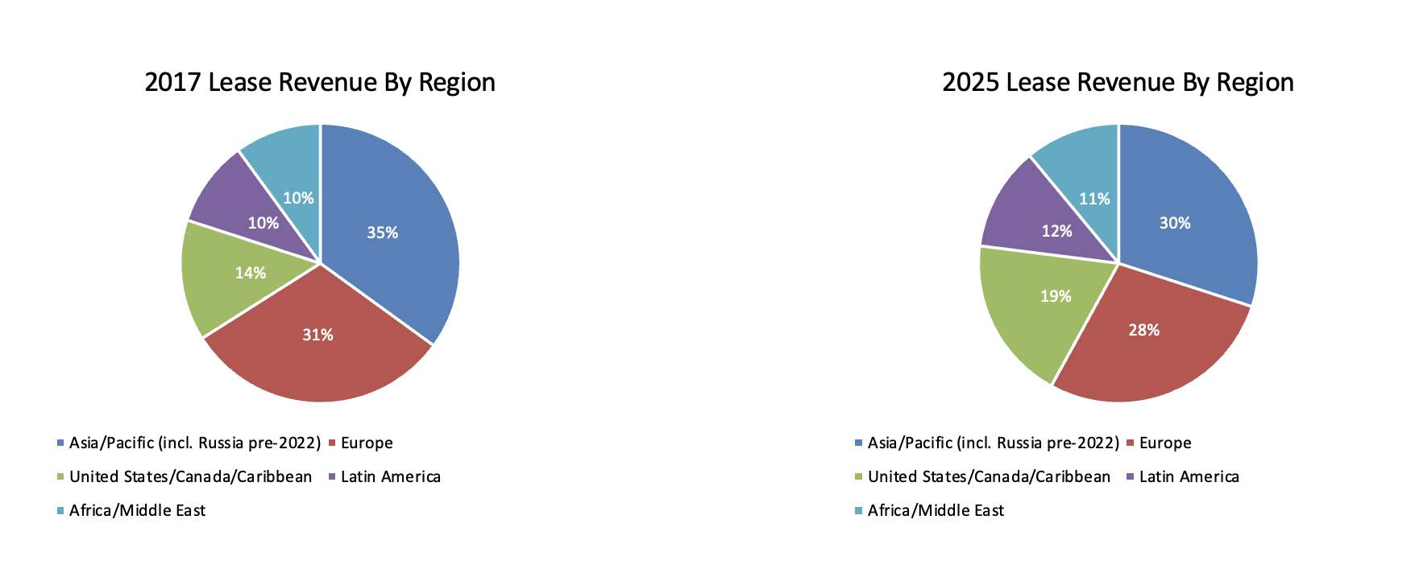
Geography
Figure 5 - 2017 & 2025 Lease Revenue By Region Comparison
AerCap's geographic spread looks like what you'd expect from the market leader. Comparing its customer mix in 2017 and 2025, exposure to Asia fell by 5%, which also shows up in the top-five list, where China Southern went from the largest customer in 2017 to third in 2025. Regions with more developing economies gained: Latin America and Africa each rose, from 10% and 10% to 12% and 11%, in line with forecasts that emerging markets grow fastest in the coming years. The US, Canada and Caribbean region also jumped, from 14% to 19%.

Lease Yield
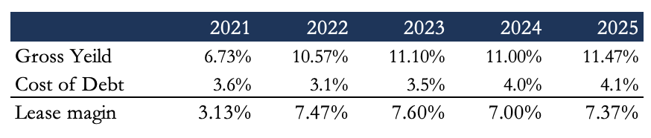

Figure 6 - Lease Margin

Dividing basic lease revenue by the flight equipment held for operating leases gives the gross yield AerCap earns on its leases. Set against the cost of debt, that yield gives the lease margin, the spread between the two. Substituting the full cost of capital instead, the 6.13% WACC calculated earlier, narrows the margin to 4.1%, still a healthy spread on the asset base and a core part of how AerCap creates value for shareholders.

Only about 1% of the leases carry floating rates.

Margins

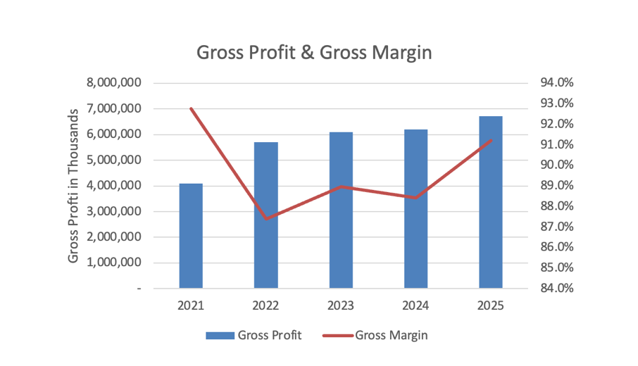
Why did they experience higher leasing expenses in 2021?

Gross profit, leasing revenue less leasing expenses, has climbed steadily since 2021. The jump from 2021 to 2022 is GECAS, which lifted gross profit but pushed gross margin down that year to around 87% from roughly 92%; it has since recovered toward 89%. Gross profit grew at a 13.2% CAGR from 2021 to 2025, but a lot of that was the acquisition, so on a 2022-to-2025 basis the CAGR drops to 5.6%.

Figure 7 - Gross Profit & Gross Margin

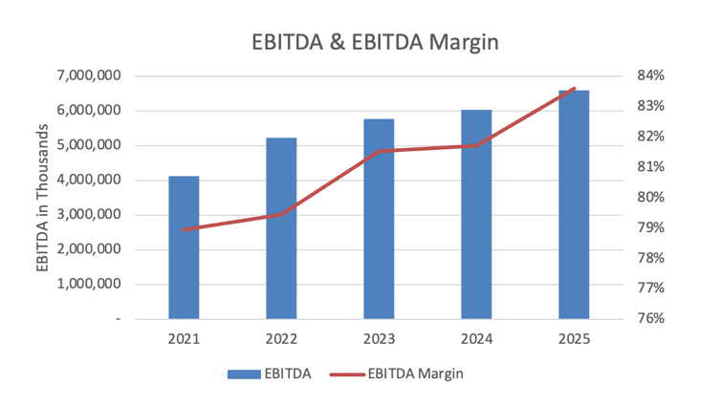
Figure 8 - EBITDA & EBITDA Margin
EBITDA has also grown sharply, at a 12.5% CAGR over 2021–2025, though excluding 2021 the 2022–2025 CAGR of 8% shows a narrower gap than for gross profit - largely because SG&A has not risen as quickly as leasing expenses.

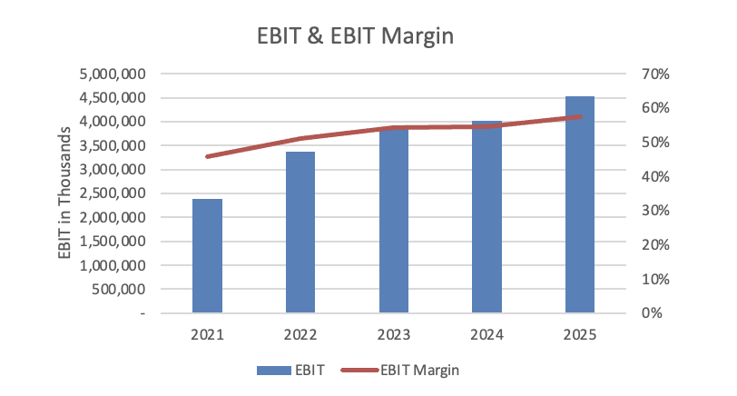
Figure 9 - EBIT & EBIT Margin

There's a big step down from EBITDA to EBIT, and it comes from the nature of the business: when depreciable assets are most of your book value, depreciation is large, and for AerCap it is the single biggest expense every year. EBIT grew at a 17.4% CAGR including 2021 and 10.4% over 2022–2025, again mostly on acquired assets.

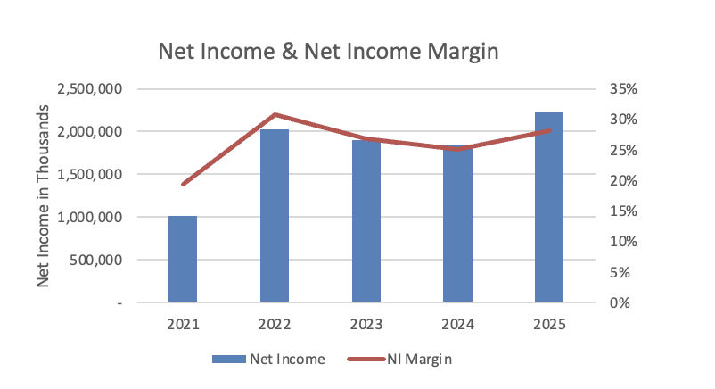
Figure 10 - Net Income & Net Margin

Net income shows the highest CAGR of any line from 2021 to 2025, at 21.8%, but the lowest from 2022 to 2025, at just 3.1%. The gap comes largely from a sizeable tax benefit in 2022; taxes have been higher since, though they swing considerably from year to year. Interest expense has stayed relatively stable over the period, as a falling debt balance has roughly offset the higher rates AerCap now pays on new and floating-rate debt.

ROE analysis

Basic Dupont Analysis
ROE

Total Leverage
Total Asset Turnover
Net Profit Margin

AerCap is able to achieve high net profit margins which make sense for a business model which has low operating costs and where the main costs are the depreciation and amortization and the interest expense
The total asset turnover shows the capital intensity nature of the company due to having very high cost assets and the how it takes time to generate back the whole capital deployed. On the other hand, even though it is capital intense it is able to achieve higher asset turnover than you would expect, this foreshadows the good lease margin that they are able to generate
Lastly, leverage is what carries most of the ROE. It started with more power in 2022 but throughout the las past years the leverage level has been decreasing and compensated mostly by the increase in net profit margin. Net profit margin is something difficult to keep increasing for a company in this industry which for future years means that ROE can be highly impacted by the leverage.

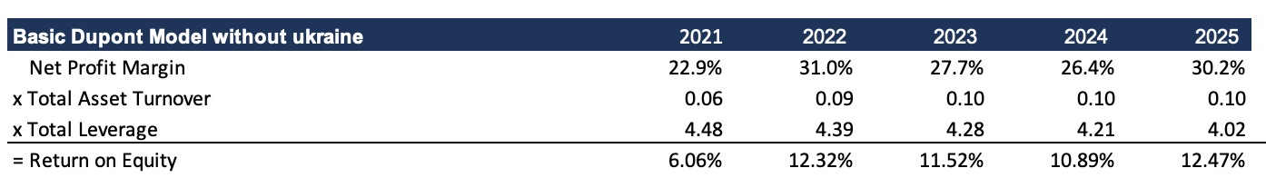

Figure 11 - Basic DuPont Analysis

Advance Dupont Analysis
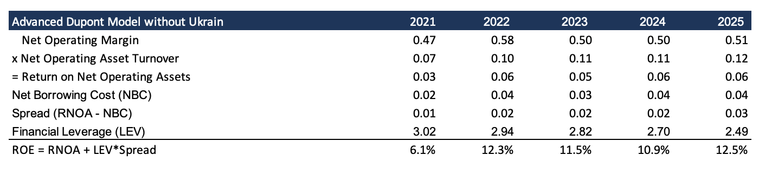
Figure 12 - Advanced DuPont Analysis
The advanced DuPont analysis tells the same story. Inside RNOA, the gap between net operating asset turnover and total asset turnover comes from stripping out investments in finance leases and assets held for sale, which aren't operating assets. The positive spread is the value the assets throw off relative to the cost of the debt used to buy them. And once again, the big leverage contribution shows how much a change in leverage can move ROE. Having a cost of equity of around 9% and an ROE of 12% means that the company is able to create value for their equity holders, most of this value created through leverage.

Comparing vs non adjusted Ukraine impacts.
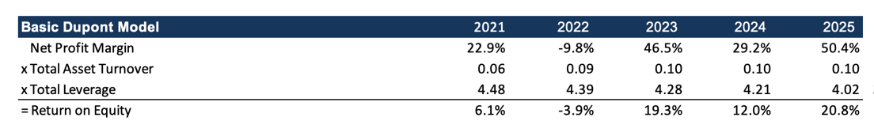

Figures 13 & 14 - ROE – Reported vs Ukraine-Adjusted

Removing the Ukraine adjustments produces a markedly different ROE, driven mainly by the swing in net profit margin. The war forced large write-downs in 2022, totaling $2.7 billion, which pushed net income to roughly $600 million and turned the net profit margin negative. In the years since, AerCap has taken the case to court in the UK and recovered $2.9 billion from insurers. Those recoveries landed unevenly across 2023–2025, $1.3 billion, $190 million and $1.5 billion respectively, producing the large year-to-year swings in net profit margin.


ROA analysis

Figure 15 - ROA

AerCap's ROA has run between 2.6% and 3.1% over the past four years, at the low end of the 2.5%–3.5% range typical for an aviation lessor. That reflects the capital intensity of the business, where a large, high-cost asset base takes time to earn back its return.

Balance Sheet
Assets
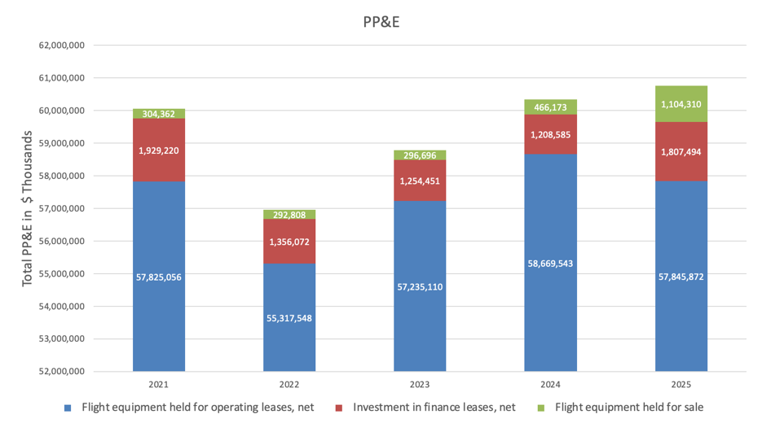
Figure 16 - PP&E Composition
Total PP&E has changed little over the past five years, following the large GECAS acquisition. Flight equipment held for operating leases has stayed broadly flat at around $57.5 billion, and investment in finance leases has likewise held close to $1.7 billion. The one item that has grown is flight equipment held for sale, and that increase has come mostly in the last few years: with supply constrained and market prices high, AerCap has been taking advantage of conditions to sell its older aircraft.

Flight Equipment held for operating leases
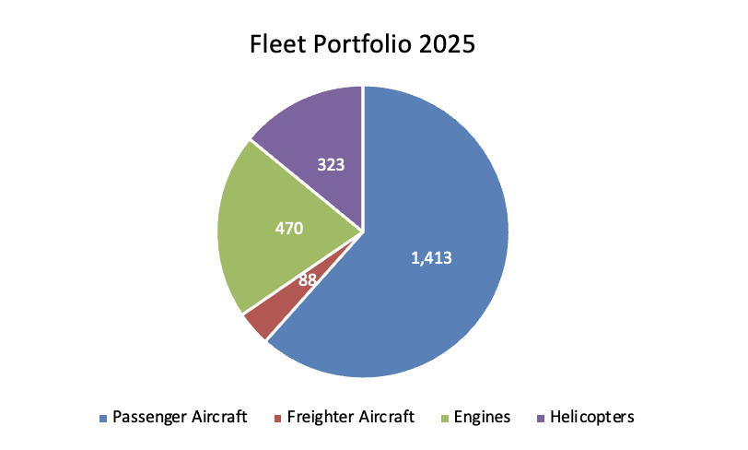
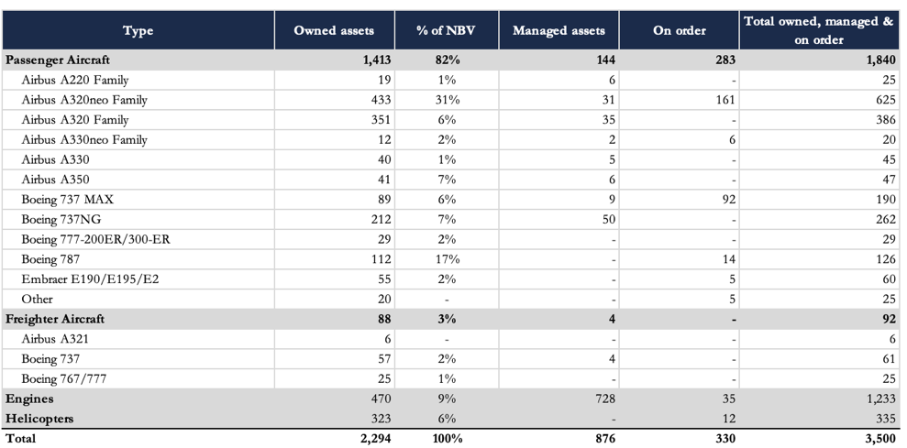
Figures 17 & 18 - Fleet Composition By Asset Type

Aircraft account for 66% of AerCap's net book value, predominantly passenger aircraft. Engines are the second-largest category at roughly 20% of the book, followed by helicopters at 14%.

Within the passenger fleet, the A320neo and A320 families are the largest by unit count, at 31% and 25% of total aircraft, mid-size types that fly short- and medium-haul routes. The 737 MAX, a similar size, is another 6% of the passenger fleet. On top of that concentration in mid-size aircraft, AerCap holds a solid position in larger types, the 787, 777 and A330, together about 30% of the fleet by number. Measured by net book value instead of unit count, the large-aircraft share rises to roughly 50% and the small-aircraft share falls.

Beyond the assets it owns, AerCap also manages equipment on behalf of others, concentrated in engines: it manages 728 engines against the 470 it owns. The company additionally holds an order book of 330 assets for future years. Counting owned and managed assets together, the portfolio totals 3,170; including assets on order, it rises to 3,500.
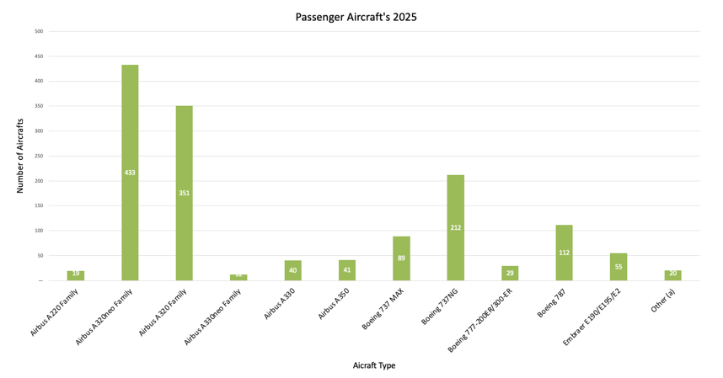
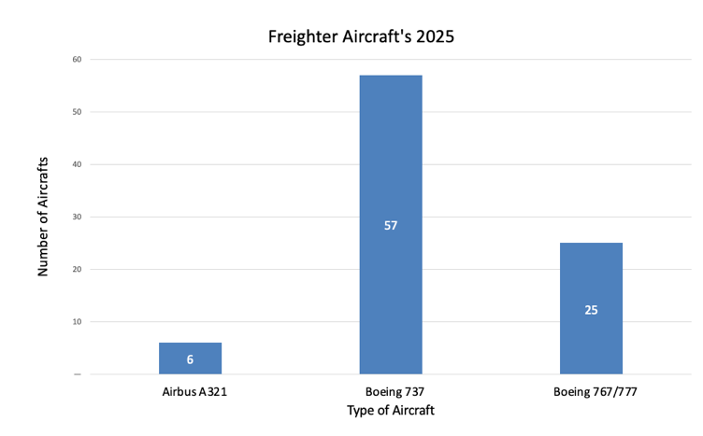
Figure 19 - Passenger Fleet by Aircraft Type
Figure 20 - Freighter Aircraft's 2025

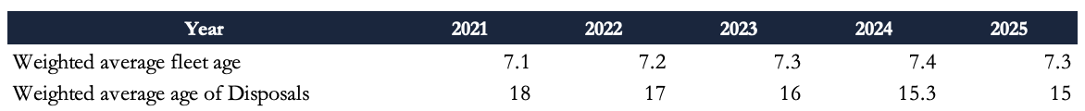

Figure 21 - Fleet Age

At year-end 2025 the fleet had a weighted-average age of 7.3 years. Since GECAS, AerCap has managed its buying and selling each year to hold the average around that level, in line with a model of running aircraft until they're roughly 15 to 17 years old and then selling. That timing also follows how aircraft depreciate: values hold up over the first half of the life and fall much faster in the second, so selling near the 15-year mark gets the most value back out of each aircraft.

Figure 22 - Fleet Utilization

Utilization is a good read on how well AerCap runs its assets. It has historically sat between 94% and 99%. It was lower in 2021 and 2022 because the new GECAS aircraft took time to place, and over the last three years it has held around 99%. That level says both that the assets are being used well and that AerCap can keep earning off its fleet, helped by tight supply and strong demand.

Current Technology vs New Technology
The split is really an engine story. “Current technology” means the prior-generation narrowbodies and widebodies: mainly the A320ceo family (“current engine option”), the 737NG, older 767s and 777s, and first-generation Embraer E-Jets. “New technology” means their re-engined and clean-sheet successors: the A320neo family (“new engine option”), A220, A330neo, A350, 737 MAX and 787, and the Embraer E2. These often share airframe lineage with the older types, but the real difference is a new generation of high-bypass turbofans, the CFM LEAP and the Pratt & Whitney geared turbofan (GTF), plus aerodynamic tweaks like Sharklet wingtips.
New-technology aircraft also burn roughly 15–20% less fuel per seat than the models they replace, with about 50% less noise and much lower CO2 and NOx. The cost edge compounds: new-generation narrowbodies run roughly 12–25% cheaper per available seat mile than current-technology equivalents. And since fuel is 30–40% of narrowbody operating cost, that gap is a real saving for airlines and AerCap's other customers.
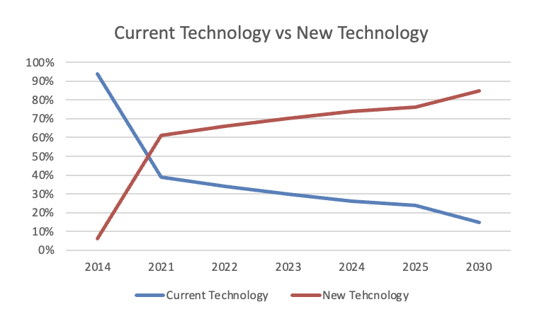
Figure 23 - New vs Current Technology
AerCap has been acquiring new-technology aircraft steadily since 2014. By 2025 these represented 76% of the total fleet, up from 6% in 2014, and the company targets 85% by 2030.

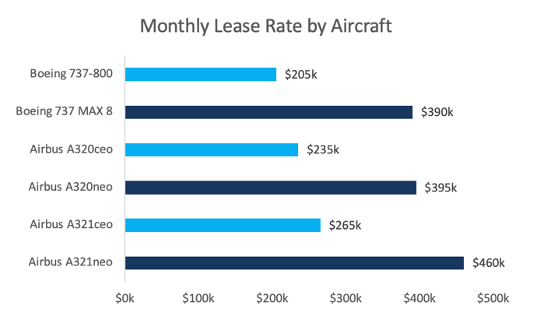
Figure 24 - Monthly Lease Rate by Aircraft

New-technology aircraft command higher monthly lease rates because of the running-cost benefits they bring to the lessee. Given the fuel savings these aircraft deliver, lessees are willing to pay more for them.

When both were in production, the two didn't cost very differently. Airbus has since stopped building the A320ceo, but while both were offered the gap was small, list prices of about $100 million for the ceo and $110 million for the neo. Those are list prices, the numbers OEMs publish; in practice nobody pays them, since buyers negotiate big discounts.

Debt
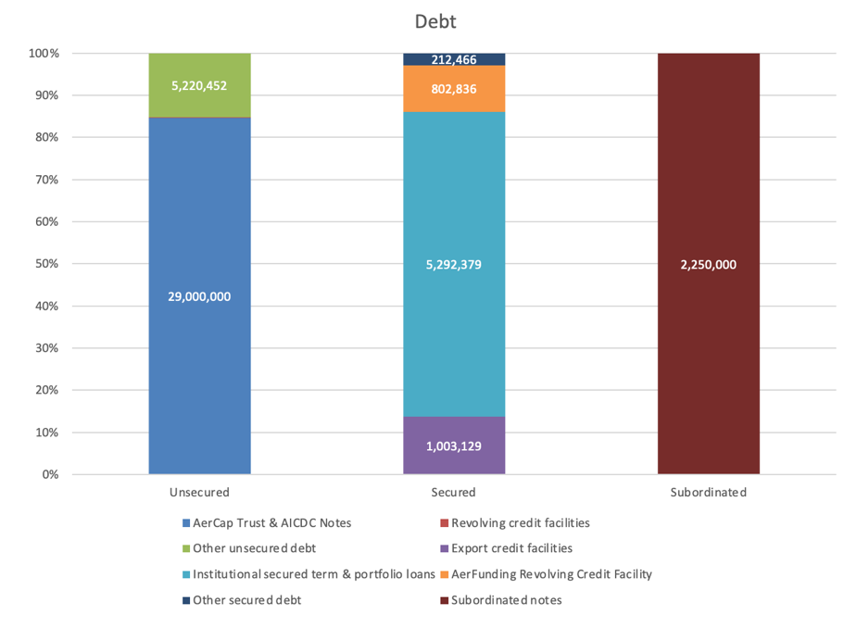
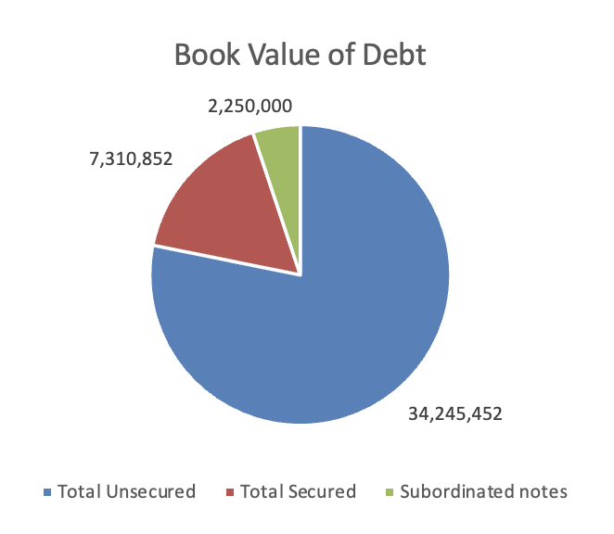
Figures 25, 26 & 27 - Debt

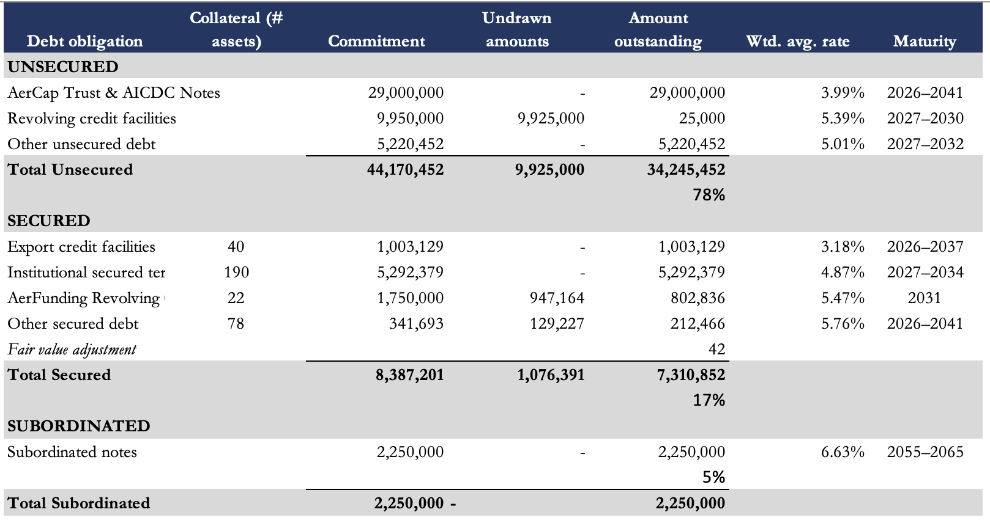

AerCap's debt is distributed across unsecured, secured and subordinated facilities. Most of it is unsecured, principally the AerCap Trust and AICDC Notes, with an outstanding value of $29 billion, roughly two-thirds of total debt outstanding. Of the total, 25%, or about $10.9 billion, carries a floating rate calculated off SOFR.
The maturity profile of the debt in the coming years is shown in the graph below.
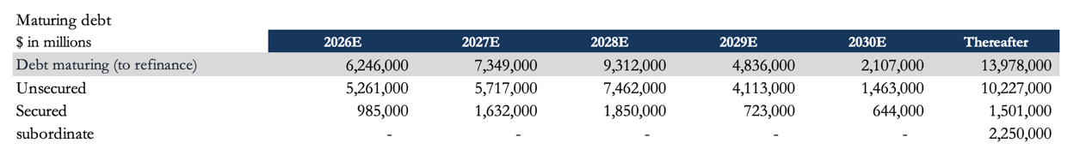
Figure 28 — Debt Maturity Schedule

Debt-to-equity
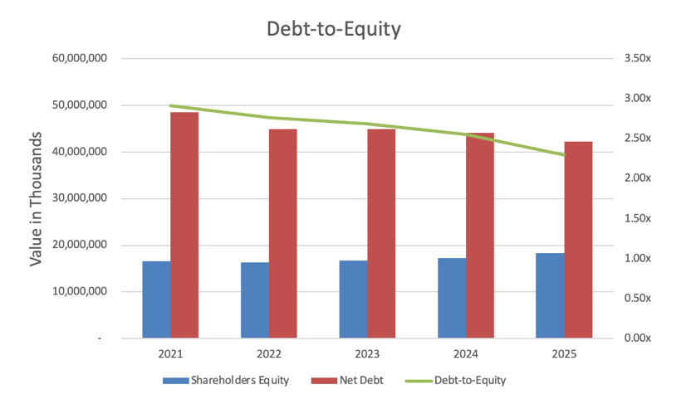
Figure 29 - Debt-to-Equity Past 5 Years
The net debt-to-equity ratio has declined steadily over the past four years, from about 2.91x at the end of 2021 to 2.30x in 2025 - close to the company's target. AerCap took on additional debt in 2021 to fund the GECAS acquisition, but has required little incremental debt since, particularly as its PP&E has remained broadly stable rather than growing.

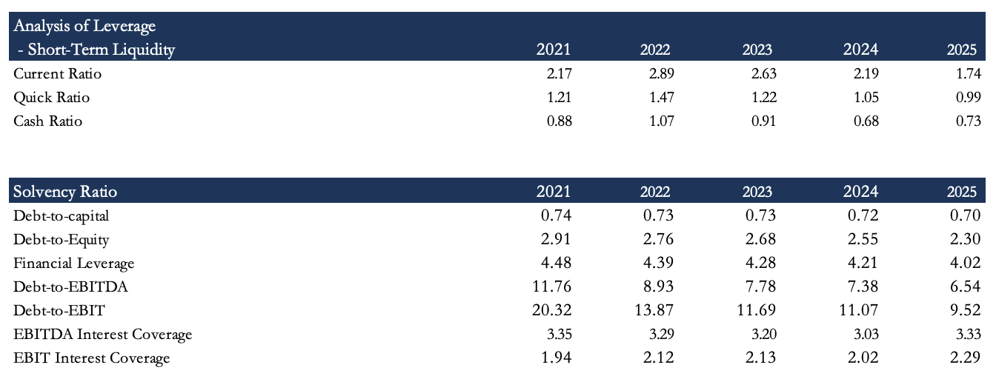
Liquidity & Solvency Ratios

Figure 30 — Liquidity & Solvency Ratios

Although AerCap carries a substantial debt load, its liquidity ratios show it can cover short-term liabilities with current assets, provided it is not relying on the cash balance alone. That supports its ability to keep funding day-to-day operations.

AerCap keeps solid EBITDA and EBIT interest-coverage ratios, which matters for a company carrying this much debt. The big gap between the two ratios is just the large depreciation and amortization charge.

The scale of debt AerCap uses to fund its expansion also shows up in its leverage ratios, which sit at the high end for the sector.

Cash Flow – Sources and Uses of Cash
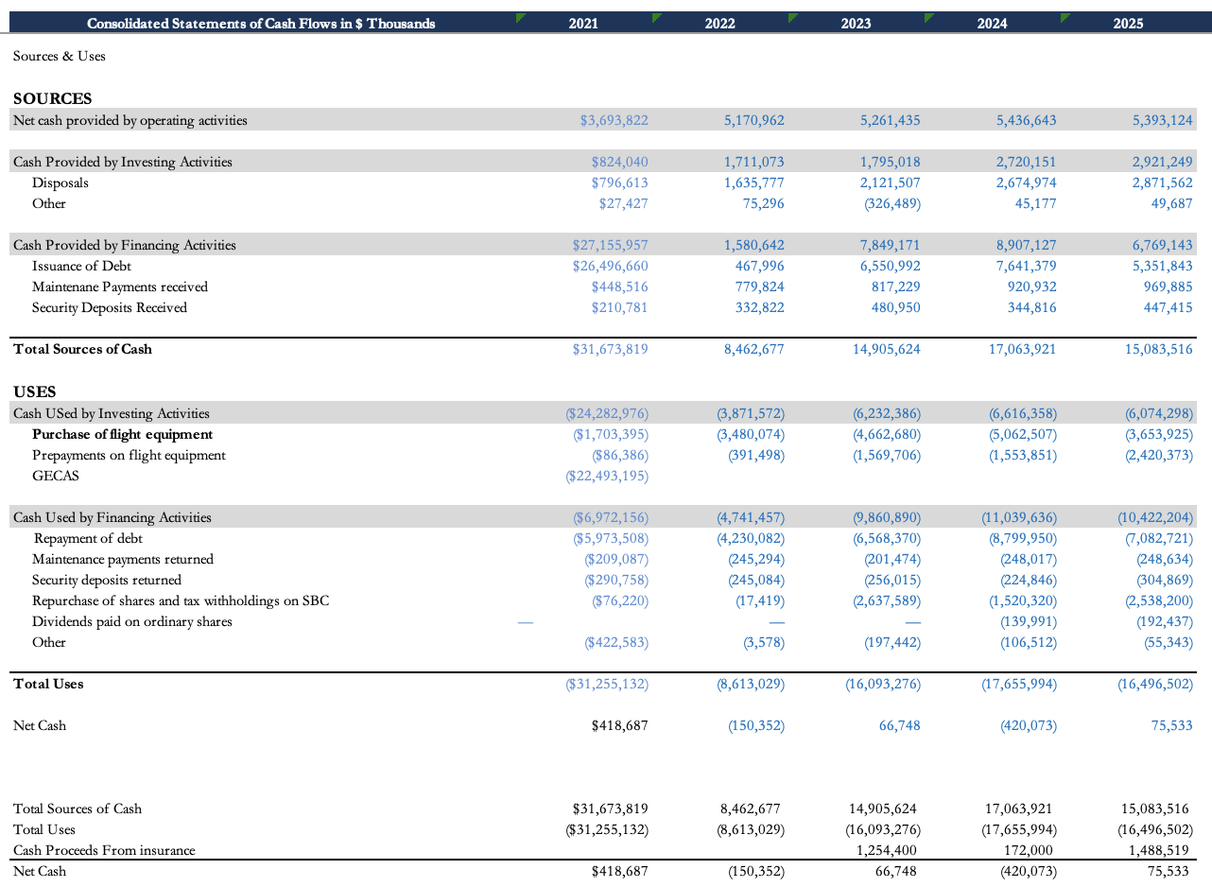
Figure 31 — Sources and Uses of Cash

AerCap's cash flows are best read as sources and uses: where the cash comes from and where it goes. The biggest and steadiest source is operating cash flow, up from $3.7 billion in 2021 to $5.4 billion in 2025 as the lease book has grown. Disposals are the other recurring source, up from $0.8 billion to $2.9 billion as AerCap has sold older aircraft into a tight, high-priced market. Debt issuance is much lumpier: the $26.5 billion raised in 2021 paid for GECAS, and since then issuance has settled into a $5–8 billion range, mostly to refinance debt as it matures. On top of that sit smaller, steady inflows from maintenance payments and security deposits.
Most of that cash goes straight back out. The largest use is buying flight equipment, running at $3.5–5.1 billion a year once you strip out the one-off $22.5 billion GECAS purchase in 2021, plus prepayments on aircraft still to come. The next is repaying debt, which roughly matches issuance at $6.6–8.8 billion in recent years. Beyond that, AerCap returns a growing amount to shareholders, $2.5 billion of buybacks in 2025 plus dividends since 2024.
Taken together, the two sides leave the company close to breakeven, with net cash hovering around zero each year. That figure includes the insurance proceeds received for the damage incurred in the Ukraine war.
This is the business model doing exactly what it should: the cash from operations and asset sales gets recycled straight into new aircraft and debt service, with little sitting idle and any surplus handed back to shareholders.
Valuation

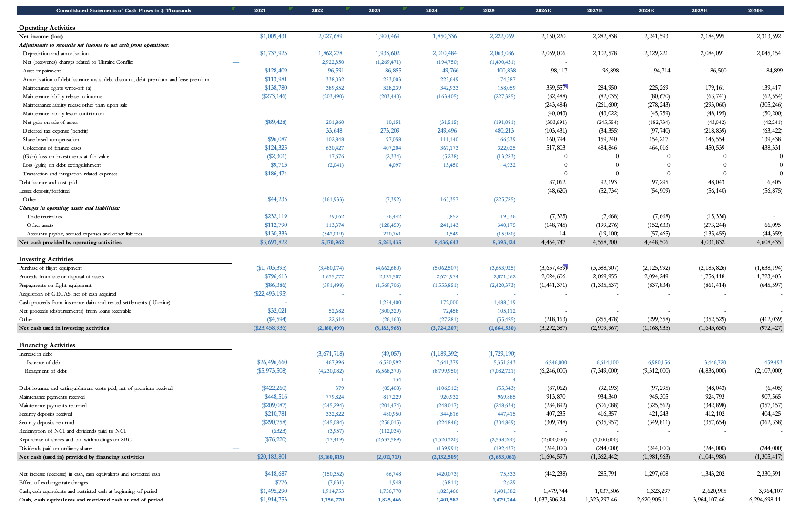
1st Scenario

Figure 32 - Bear Case – FCFF Forecast

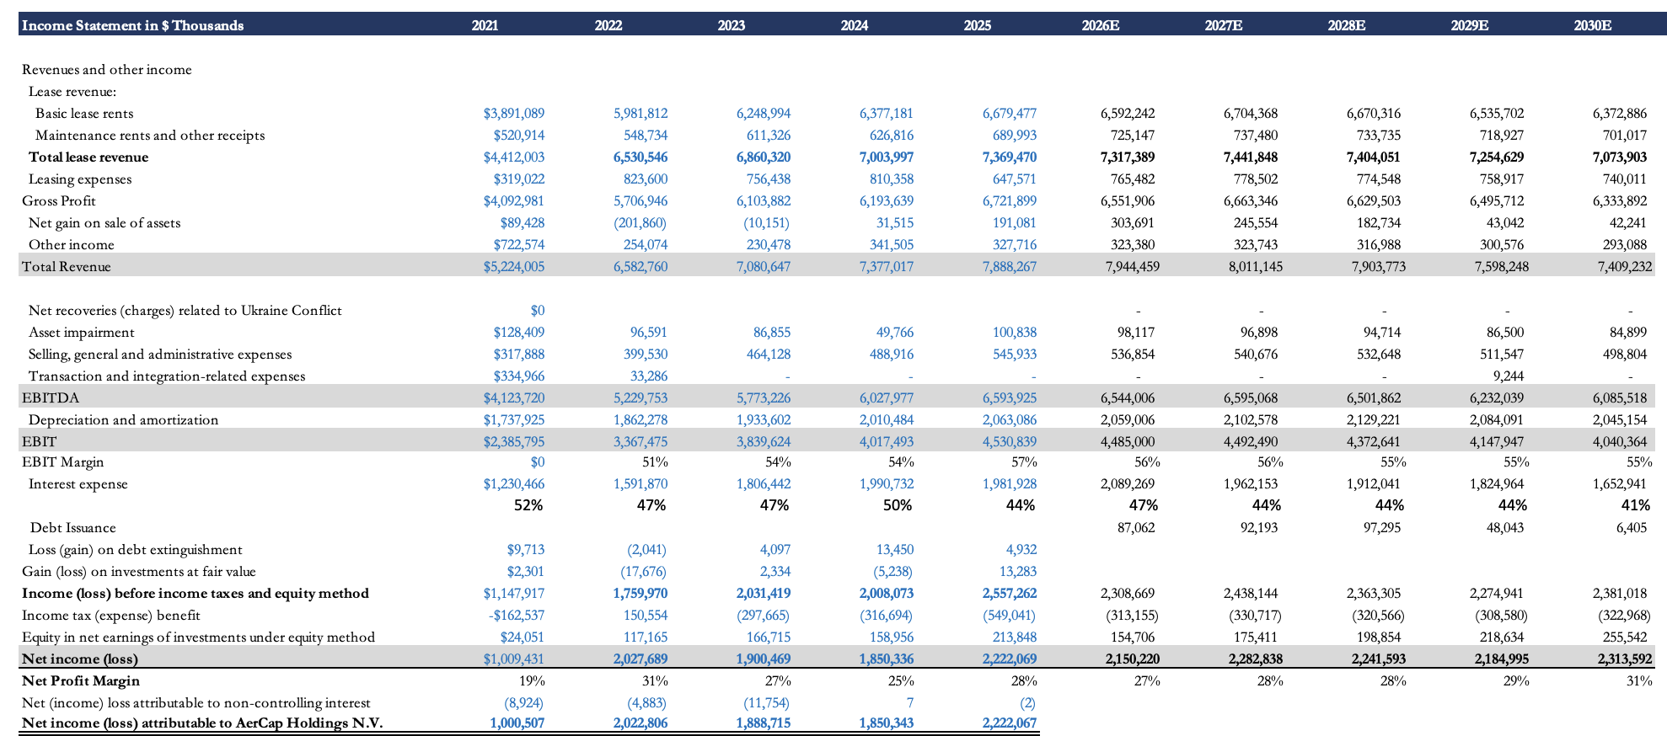

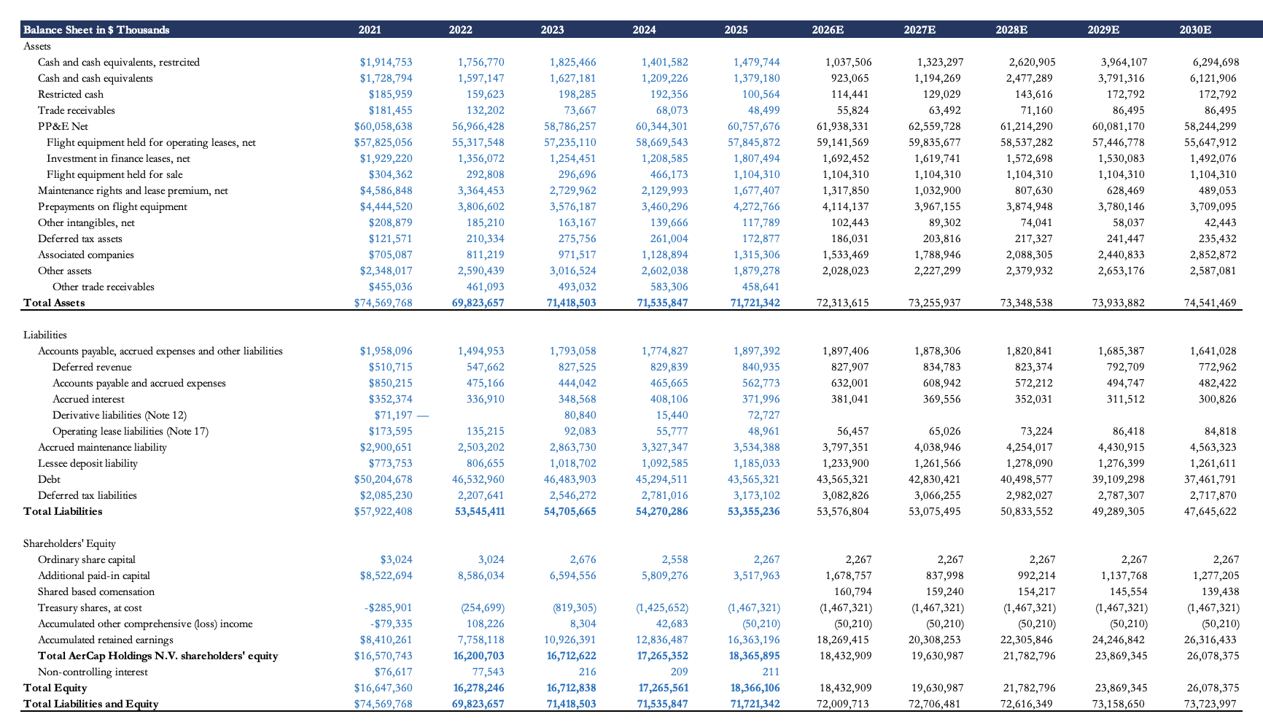
Figure 33 - Bear Case – Implied Share Price
Residual Income Model

A residual income model, rather than a DCF, is used to get the implied price per share. As noted earlier, a DCF doesn't fit a company with cash outflows this large: it ends up understating the value the company is actually creating.

Residual Model Base
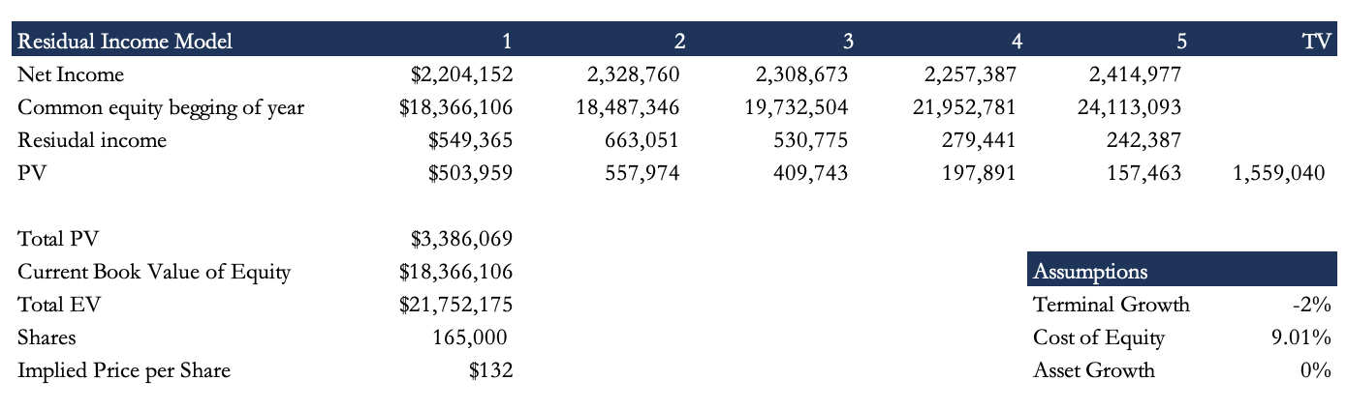
Figure 34 - Residual Income

This model is the base due to the only use of assuptions absed on the what Aer tells us on the financila statements. This include a fleet that only chnages using the contractual acquisitions they currently have for the future years + a slight premium derived from historical differences between forecasted contractual acquisitions and the actual spending. Using this the fleet keeps decreasing as the acqusitions are lower each year into the future. For this model debt oligations is also used only using what they need to repay each year and the issuance of new debt calcuilated to get an amount close to the hsitorical percentage of cash to rest of assets, meaning that maintaining an adjusted debt-to-euity ratio of 2.1 has not been used. These assumptions lead the model to having a negative terminal value which might seem rather unusual. The reasoonign behind this si that with a fleet decreasing every year the only possuible way for the company to have a positive terminal growth would be for the lease yields to continue decreasing by the terminal growth percentage eery eyar, an assumptions not believed to be possible due to the dynamics of the industry. This model calculates an implied share price of $132. Mor einformation on the forecasting and accoutning assumptions are on the Acounting Methodology section.

ROE falls steadily, from 12.47% in 2025 to 9.4%, and would keep falling. That's the drop in leverage coming through, since this version of the model doesn't hold the 2.1x debt-to-equity level.

The catch with this model is that raising the debt-to-equity ratio barely changes anything: since the cash wouldn't fund asset purchases and buybacks aren't assumed to rise, it would just pile up in cash and equivalents, leaving net debt about the same.
Figure 35 - ROE Forecast

Second Scenario
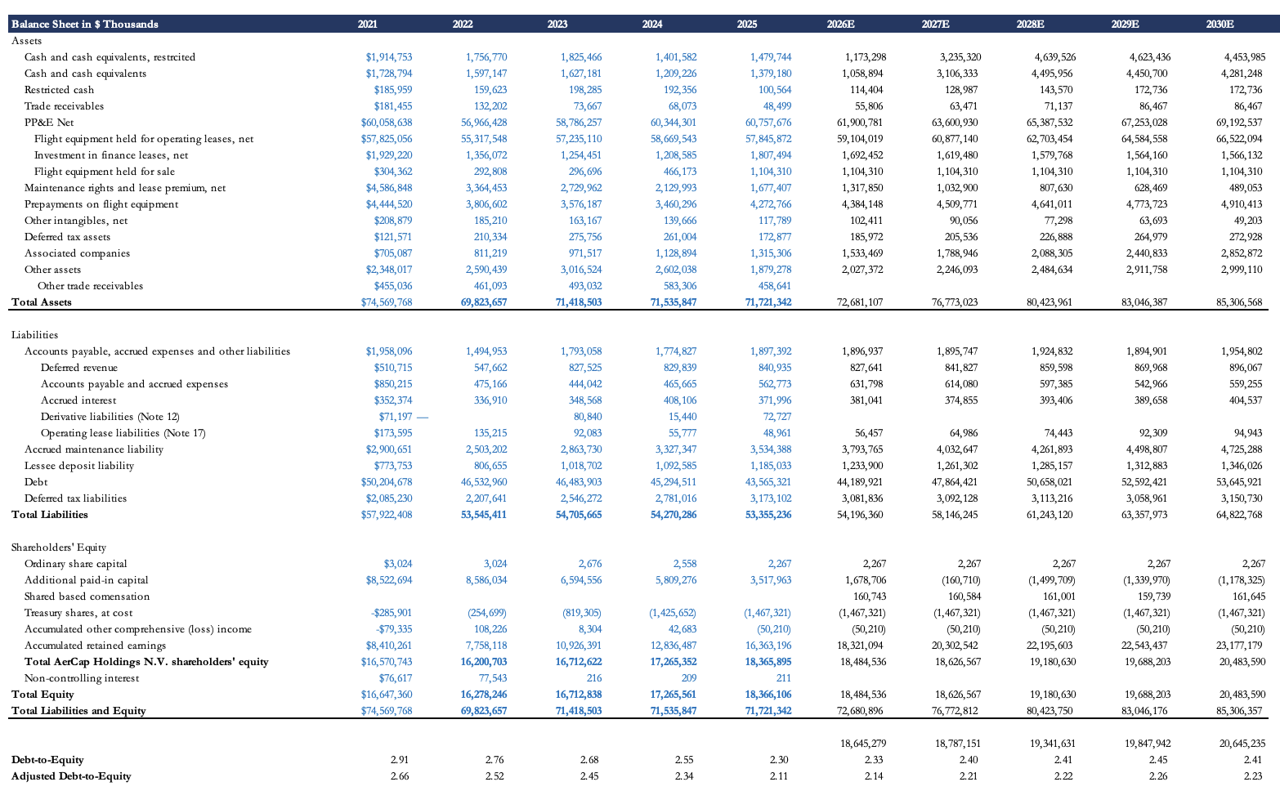
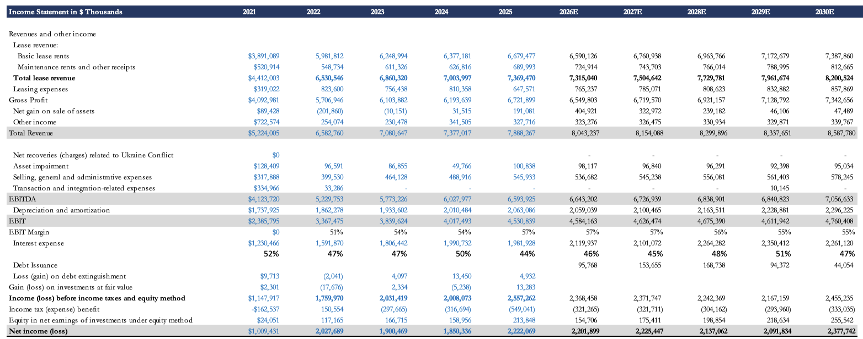

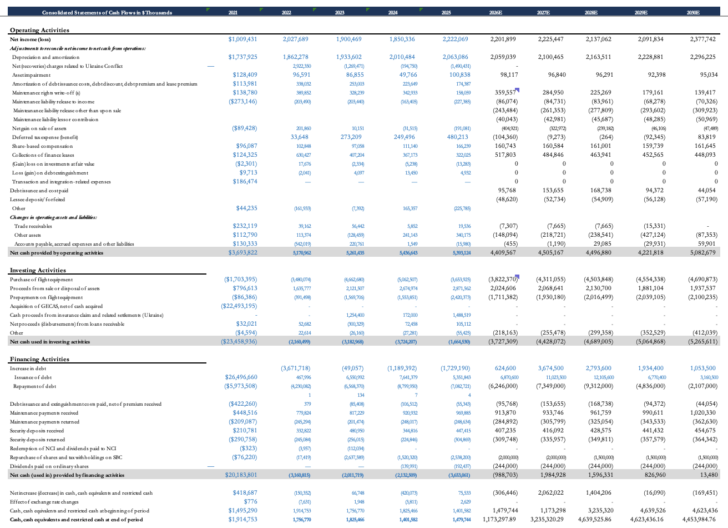

Residual Income

The second scenario is the bull case, and the more realistic one, since it assumes AerCap does not intend to slowly wind itself down in the coming years.
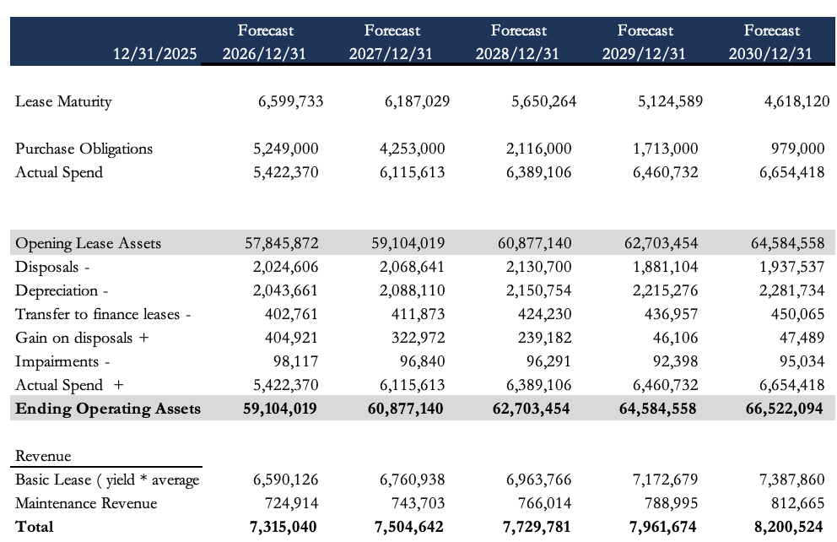
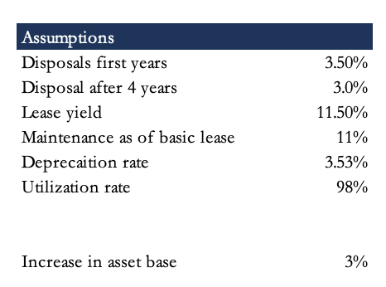

Figure 36 - Residual Income – Asset Growth

This second scenario shows the implied price if the asset base kept growing at 3% from 2027 on. That takes a lot of capex, but it lets the fleet support a terminal growth rate close to 3%.

Figure 37 - Second Scenario – Debt-to-Equity

It also assumes AerCap holds its adjusted debt-to-equity ratio near 2.1x. That's done by paying out more to shareholders each year rather than taking on more debt, since the business throws off enough cash that it doesn't need to borrow much more.

Figure 38 - Second Scenario – Debt Issuance and Repayment

Figure 39 - Capital Return Schedule
The payout is modeled as buybacks, though whether it's buybacks or dividends makes no real difference here.
Figure 40 - ROE

Debt is modeled using a ratio of issuance to repayment calibrated to achieve a debt-to-equity ratio close to the 2.1x target.
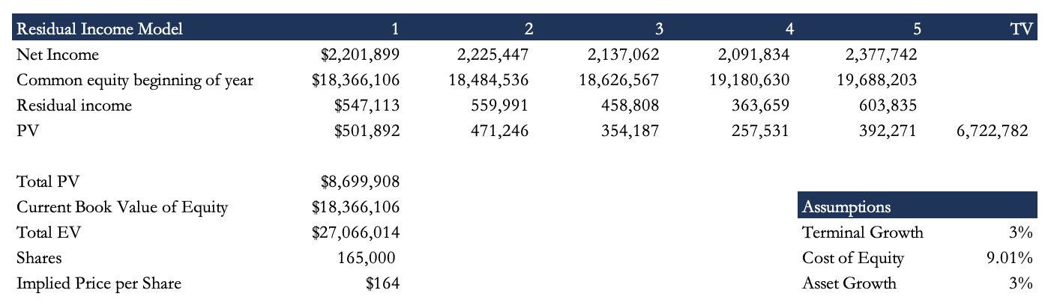
By holding debt-to-equity close to the adjusted 2.1x target, ROE stays within the historical range of the past four years.
Figure 41 - Residual Income Model, Second Scenario

The result is an implied price per share of $164.

DCF

Alongside the residual income model, a FCFE DCF has also been built for this bull case.
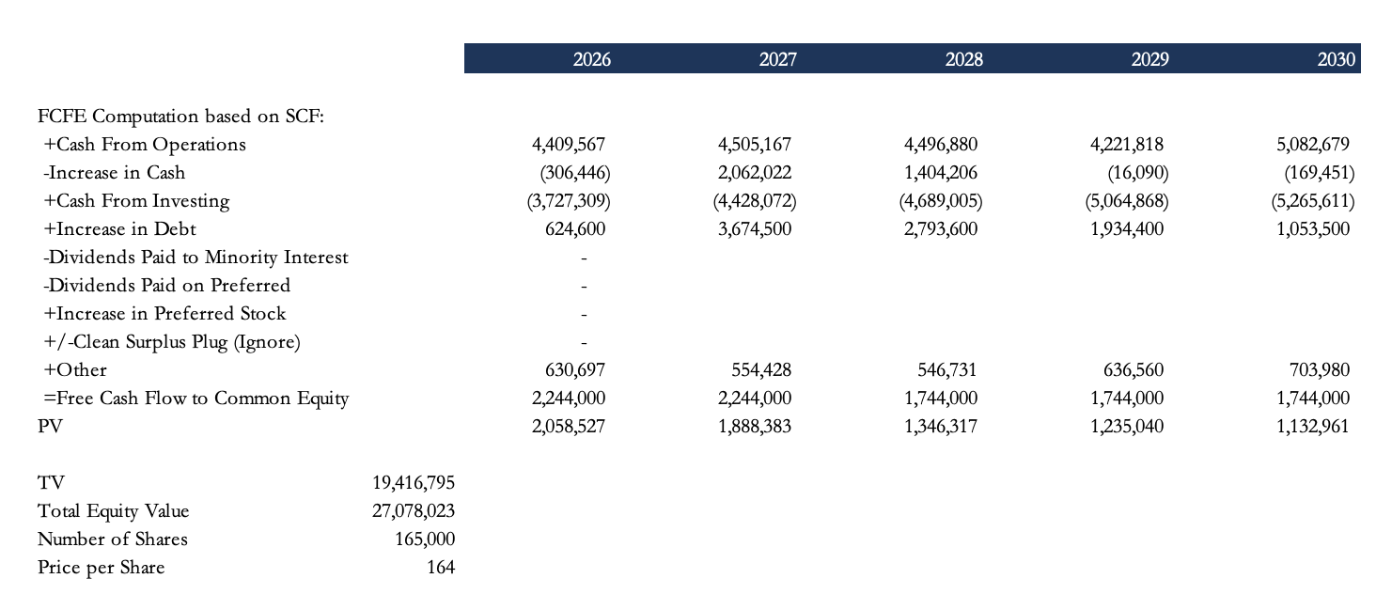
Figure 42 -FCFE From Statement of Cash Flows
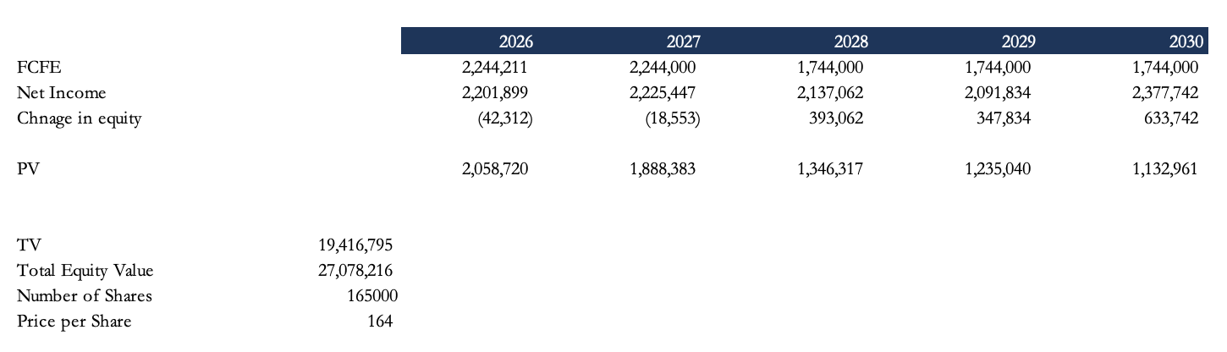
Figure 43 - FCFE From Net Income
The DCF is built two ways, from the statement of cash flows and from net income, to confirm that the statements were modeled consistently and that both approaches arrive at the same price. Running it separately from the residual income model also provides a cross-check against computational errors.

The DCF uses the same assumptions as the bull residual income model, including the same discount rate, the 9.01% cost of equity.

Additional Calculations For The Models
Market Value of Debt

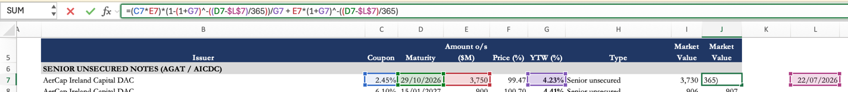
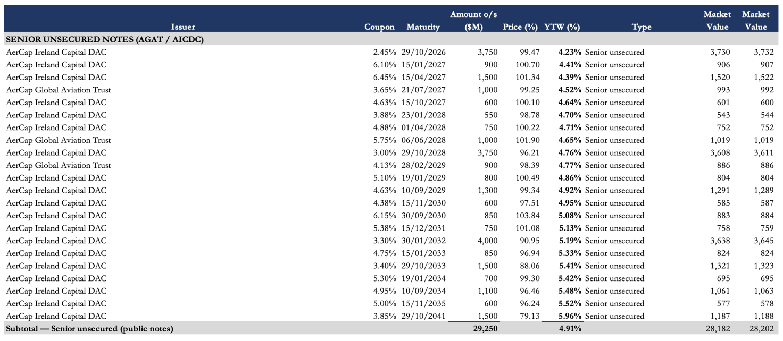
Traded Bonds
Figure 44 - Debt & Cash Schedule (Base)

Of AerCap's total debt, $29 billion is in tradable bonds. To estimate the market value of these bonds, the model uses the formula shown in the second exhibit, which calculates the present value of the coupon in perpetuity to maturity plus the present value of principal.
Because calculating a market value for the remaining types of debt is less feasible, book value has been used for those.
The difference between the book value and market value of debt therefore comes entirely from the tradable bonds, whose market value is $28.2 billion rather than $29 billion. This brings the total value of debt to $43 billion.
WACC calculation
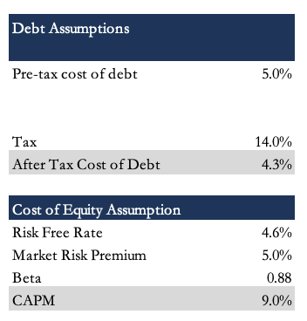
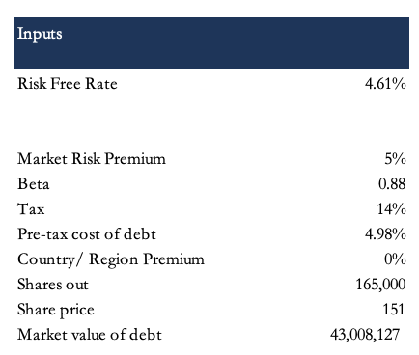
Figure 45 - Base Case - Equity Roll-Forward

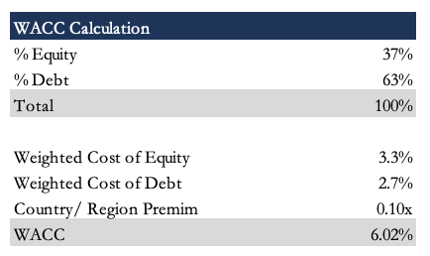
The WACC needs a weighted cost of debt and a weighted cost of equity. For the cost of debt, I use the weighted-average cost across all of AerCap's facilities and apply a 14% tax rate, close to the 2025 figure.

For the cost of equity I use CAPM, with a risk-free rate of 4.61% (the 10-year US Treasury), a beta of 0.94 and a 5% market premium. That gives a WACC of 6.13%. I apply a 0% country risk premium: even though a lot of AerCap's customers are in emerging or higher-risk markets, AerCap itself faces no real jurisdictional limits and can move equipment elsewhere if a particular customer or country turns risky.
Figure 46 - Base Case – Implied Share Price

Sensitivity Analysis For Bull Residual Income Model

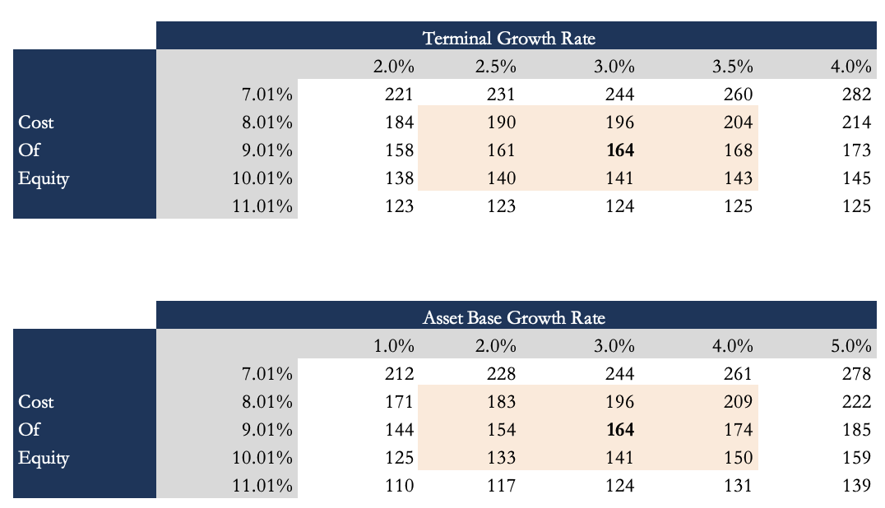

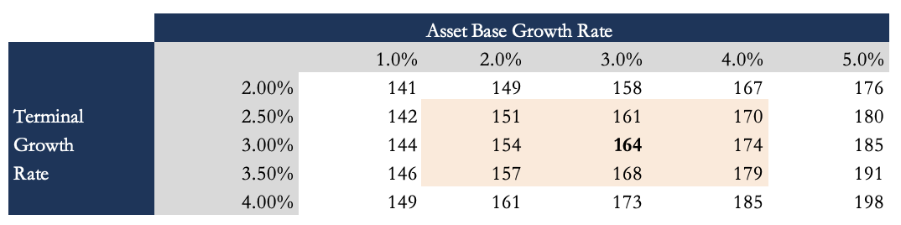
Figures 47 & 48 - Sensitivity – Re vs Terminal Growth- Re vs Asset Base Growth Rate

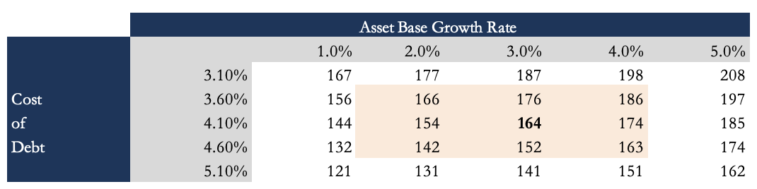
Figure 49 - Sensitivity – Terminal Growth Rate vs Asset Base Growth Rate

Figure 50 - Sensitivity – Rd vs Asset Base Growth Rate

Ratios
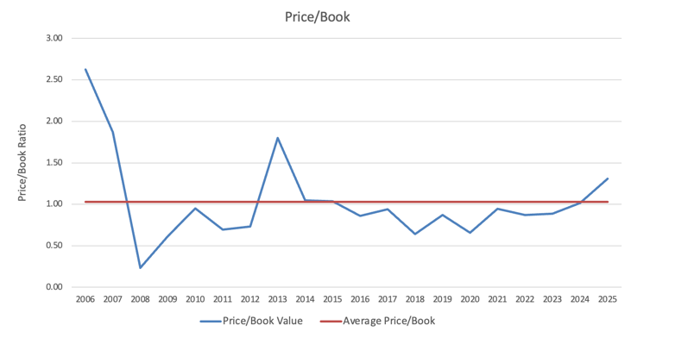
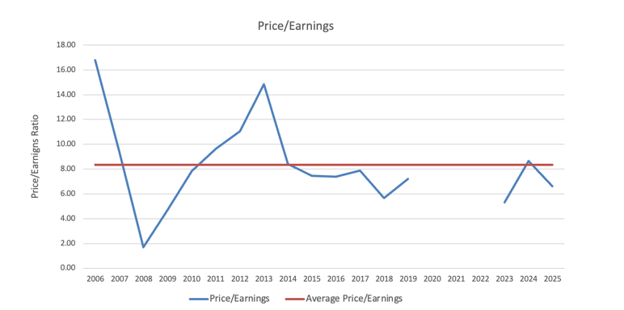
Figures 51 & 52 - P/E and P/B

At the end of 2025, AerCap traded at a valuation close to its historical average (2006–2025) across the following ratios: P/E, P/B, EV/EBITDA and EV/EBIT. The historical averages for these ratios are 8.34, 1.03, 17.24 and 9.95 respectively.

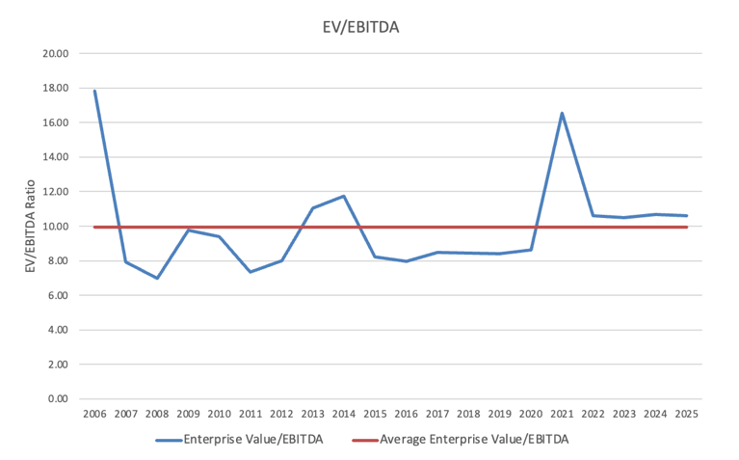
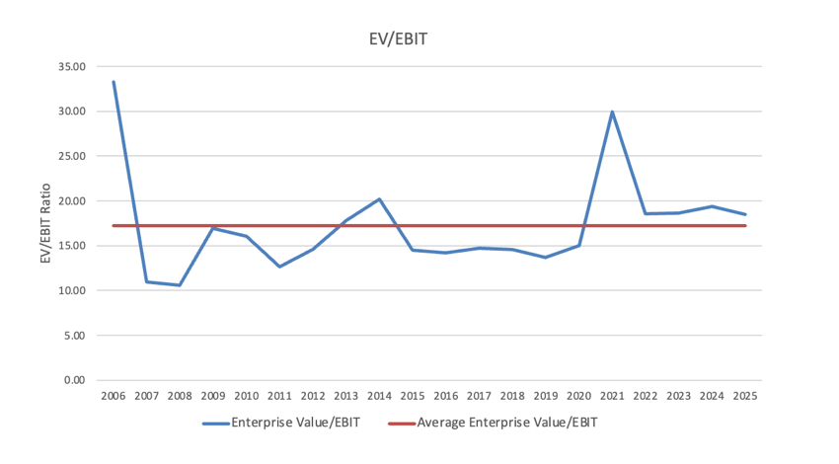
Figure 53 — Public Company Comparables

Public Company Comparables
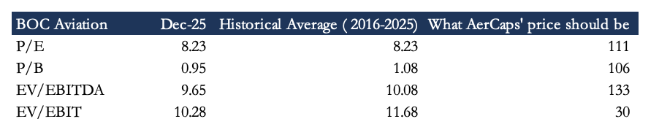

Figure 54 - BOC Aviation Multiples

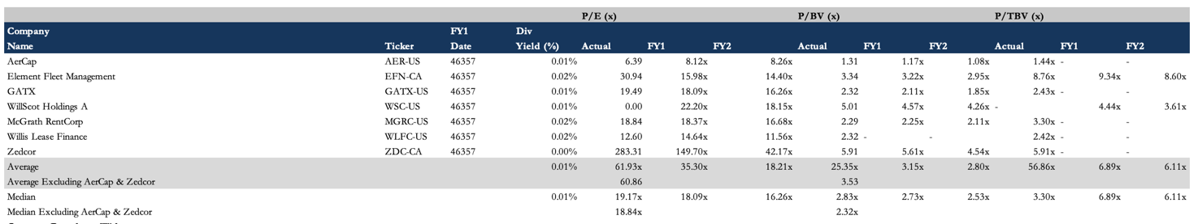
When valuing a leasing company on multiples, P/E is preferable to P/B, because different lessors acquire aircraft at different prices depending on their relative purchasing power.
Figure 55 - Other Company Comparables

The problem is that clean comparables keep disappearing, with Air Lease the latest to go private in 2026. The companies in the second table come from FactSet, and all of them are weak comparables. The best of them is BOC Aviation. Even BOC has issues: a large stake sits with Bank of China, a state-owned bank, so its debt costs aren't comparable, its free float is small, which means fewer public shares and less liquidity, and it carries extra political considerations. With all that, it's still the closest public comparable there is.
Applying BOC Aviation as the comparable produces a valuation range of $30 to $111 for AerCap; weighting earnings more heavily points to the $111 figure.

Precedent Transaction

The cleanest recent precedent is the take-private of Air Lease Corporation. Air Lease signed a definitive merger agreement on September 2, 2025, to be bought by a new Dublin-based holding company owned by Sumitomo Corporation, SMBC Aviation Capital, Apollo-managed funds and Brookfield. The deal closed on April 8, 2026, and Air Lease was renamed Sumisho Air Lease Corporation. Its order book moved to SMBC Aviation Capital, which now services most of the portfolio. In effect, it puts Air Lease, the third-largest lessor, under SMBC Aviation Capital, the second-largest. J.P. Morgan and Skadden advised Air Lease; Citi and Goldman advised SMBC/Sumitomo.
On price, the offer was $65.00 in cash per Class A share, a total equity value of about $7.4 billion, or roughly $28.2 billion including debt to be assumed or refinanced net of cash. It was all cash, with no financing contingency. That worked out to a 7% premium over Air Lease's all-time-high closing price (Aug 28, 2025), 14% over the 30-trading-day VWAP, and 31% over the trailing-12-month VWAP.
The multiples are the interesting part. On price-to-tangible-book, the deal came in around 0.85–0.9x: pre-deal, Air Lease traded around 0.77x tangible book at ~$57, which implies tangible book of roughly $74 a share, so the $65 offer is below tangible book, about 0.88x. In other words, it was taken out at a discount to tangible book. On EV to fleet net book value, the ~$28.2 billion enterprise value against a fleet net book value of ~$29.1 billion (June 30, 2025) is essentially fleet book value, so nothing was paid for the platform. And on earnings, Air Lease traded around 10x pre-deal at ~$57, so $65 implies roughly 11x.
The same picture shows up in book value: Air Lease's equity book value was about $8.5 billion at year-end 2025 against an acquisition price of about $7.4 billion, so even the third-largest lessor changed hands at a discount to book.

Investment Thesis

Risk Factors

Airline credit and concentration risk. AerCap's revenue rides on the financial health of its lessees, and airlines are a cyclical business. A default, restructuring or bankruptcy can mean missed payments, repossession costs, and aircraft sitting idle off-lease. The risk is bigger where AerCap is exposed to emerging-market carriers, or to any single customer or aircraft type that's a large share of the portfolio.
Interest-rate and financing risk. As a capital-intensive business run on a large, leveraged balance sheet, AerCap is exposed to interest rates and to the state of the debt markets. Lease rates are mostly fixed while some of the debt reprices, so when rates rise or stay high, funding costs climb faster than they can be passed through, and margins compress. AerCap also needs continued access to capital at good rates: a downgrade below investment grade, or a freeze in the capital markets, would push up funding costs and hold back growth.
Residual-value and technology risk. The value of AerCap's aircraft can fall with age, oversupply, newer technology, or weaker demand for a given type. If aircraft turn out to be worth less than assumed, AerCap faces impairments, smaller gains on sale, and worse re-lease economics, a risk that sits mostly in older, current-technology aircraft as newer types come in.
Supply-chain and OEM risk. AerCap depends on Airbus and Boeing to deliver ordered aircraft on schedule and on engine manufacturers for maintenance. Manufacturing delays, production-rate constraints, and reliability issues , such as those affecting geared-turbofan engines, can disrupt deliveries and fleet availability. This matters especially for the bull case, which depends on continued expansion of the asset base.
Geopolitical, legal and operational risk. AerCap operates in roughly 80 countries and is exposed to war, terrorism, sanctions, expropriation and other geopolitical events, as the write-off of aircraft stranded in Russia after the 2022 invasion, and the insurance litigation still running from it, make clear. It also faces risks around repossessing aircraft across different jurisdictions, changes in tax law affecting its Irish and Dutch structure, and the fallout from a major aviation incident or a cyber breach.

Accounting Analysis & Forecasting

Introduction
This section lays out the forecasting framework and accounting choices behind the AerCap three-statement model (income statement, balance sheet and cash flow statement). The model uses fiscal 2021–2025 as actuals and projects five years out through 2030, with a terminal year for the DCF. It isn't meant to restate the thesis or the valuation, those are in the main report, but to walk line by line through how each projection was built, what drives it, and where I used judgment versus where it's just mechanics.
Aviation leasing works differently from the retail and consumer names where three-statement models are the norm. Revenue isn't same-store sales or units shipped; it's a function of fleet net book value, lease yields and utilization. The costs are mostly depreciation on long-lived aircraft and interest on a leveraged balance sheet, not COGS in any usual sense. So the model had to be built around those mechanics from scratch rather than dropped into a generic template.
For the graphs and explanations below, everyhting is for the bull case unless specified otherwise.

Normalization

The Residual-Value Problem
Before forecasting anything, there's a distortion in the reported numbers to deal with: how depreciation policy and gain on sale interact. AerCap depreciates its aircraft straight-line over a 25-year life down to a 15% residual. The trouble is that aircraft actually depreciate more slowly early on and faster after about year 15. That inflates the gains on sale: because AerCap usually sells around the 15-year mark, it has booked more depreciation over those first 15 years than real market depreciation would, so book value sits below market when it sells.
This matters because the gain-on-sale line has grown fast, from $89M in 2021 to $819M in 2025, and now runs at nearly 10% of total revenue.

Calibration Approach
I looked at a few ways to normalize this. The first was to build a curved depreciation schedule for each asset type, but AerCap doesn't disclose the useful life of its individual assets, so that would rest on a lot of assumptions. I went a different way.
I raised the assumed residual from 15% to 34%, set so that under a 25-year life the adjusted gain on sale over 2022–2025 sits around zero rather than trending up. The logic is simple: if the residual assumption is right, aircraft should on average sell near book value, and gains on sale should be small and mean-reverting. A 34% residual gets you there.
Here's how it works. At the higher residual, annual depreciation falls by a factor of (1 − 0.34) / (1 − 0.15) = 0.776, which cuts reported depreciation by roughly $530–580M a year across 2022–2025. At the same time, the higher assumed book value at sale means that, for the same proceeds, the implied gain drops by about the same amount. Which of the two wins in a given year depends on how much was sold: in low-disposal years (2022–2023) the depreciation saving dominates and normalized income is a bit higher; in high-disposal years (2024–2025) the smaller gain dominates and normalized income comes down slightly.
The cumulative balance-sheet effect by end-2025 is only about $50M, so it's immaterial. That tells you this is an earnings-quality and presentation adjustment, not a hidden-book-value story. The 2021 GECAS deal already fair-valued the fleet close to market, so there's no big embedded surplus to find. What the adjustment does is reshape the income statement: a lower but steadier depreciation charge and a gain-on-sale line that moves around zero, which gives a cleaner read on the recurring leasing economics.

Ukraine Conflict
AerCap's 2022–2025 income statements carry a volatile line, net recoveries and charges from the Ukraine conflict, from writing off the aircraft stranded in Russia and then recovering on insurance. The amounts are big, a $2.7B charge in 2022, a $1.3B recovery in 2023 and a $1.5B recovery in 2025, and they're entirely one-off. In the normalized model this line is set to zero for every forecast year. Same treatment for asset impairment, which I model as a small ongoing charge tied to average fleet NBV rather than the lumpy reported numbers, and for the GECAS transaction and integration costs, which are zeroed from 2024 on.

Revenue Forecast

Basic Lease Rents / A Yield-on-Assets Approach

First Case
Basic lease rents are AerCap's core revenue line, $6.7B in 2025, about 78% of total revenue. I don't forecast it with a top-down growth rate. It's built bottom-up from the fleet: basic lease revenue equals the average net book value of flight equipment held for operating leases, times a gross lease yield, times a utilization rate.
The gross lease yield is computed historically as basic rents over the average of opening and closing flight-equipment NBV. Post-GECAS, from 2023 on, it rose from 10.9% to 11.5%, roughly +60 basis points of pure pricing power off the OEM supply shortage.
For the forecast I hold the yield at 11.5%, just under the 2025 level. That's deliberately conservative: it assumes re-lease drag, some extensions re-signing at lower rates, as the 20-F notes, roughly offsets the continued supply-shortage pricing. Every +50 basis points of sustained yield on a ~$58B fleet is about $290M of basic lease rents, so this is the single most important lever in the model. Utilization is held at 98%, in line with the post-COVID average.
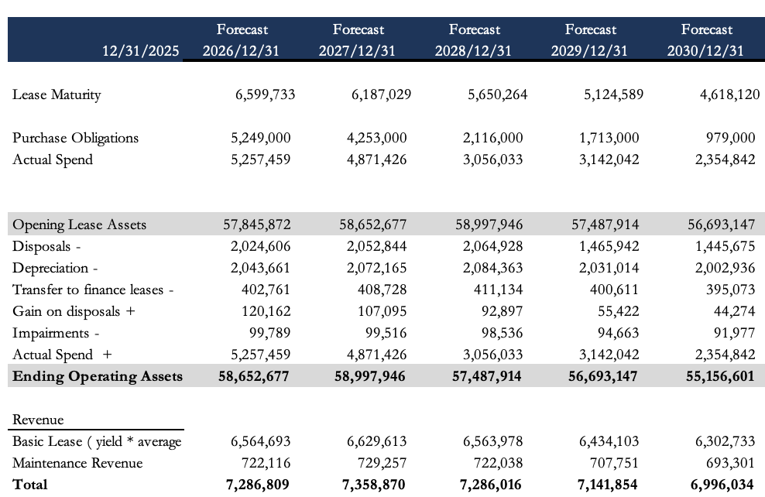
Figure 56 - Basic Lease Rent Forecast
For disposals, I assume AerCap sells more in the first few years, given how high prices are while supply is tight, then works back toward the historical rate of around 2.6%.
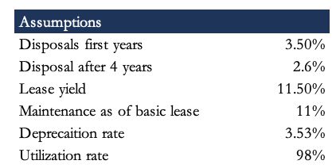
Figure 57 — Disposals Forecast

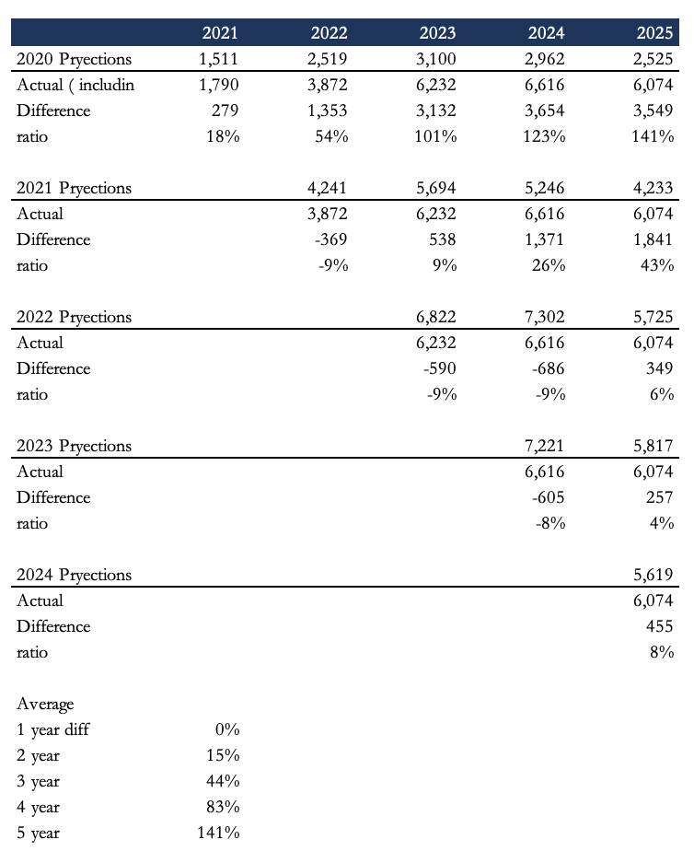

Figure 58 - NBV Roll-Forward

A big driver of revenue is how much AerCap buys in future years. For the base case I use the purchase obligations AerCap discloses in the 20-F, shown in the exhibit where revenue is calculated. Rather than the raw obligations, I apply a figure I call “actual spend”: I measure the difference between what was forecast for a given year in prior 20-Fs and what was actually spent, and add that as a premium to the disclosed obligations. There's some room for error here, since the four-year-ahead forecast versus actual spend only goes back to 2021 data.

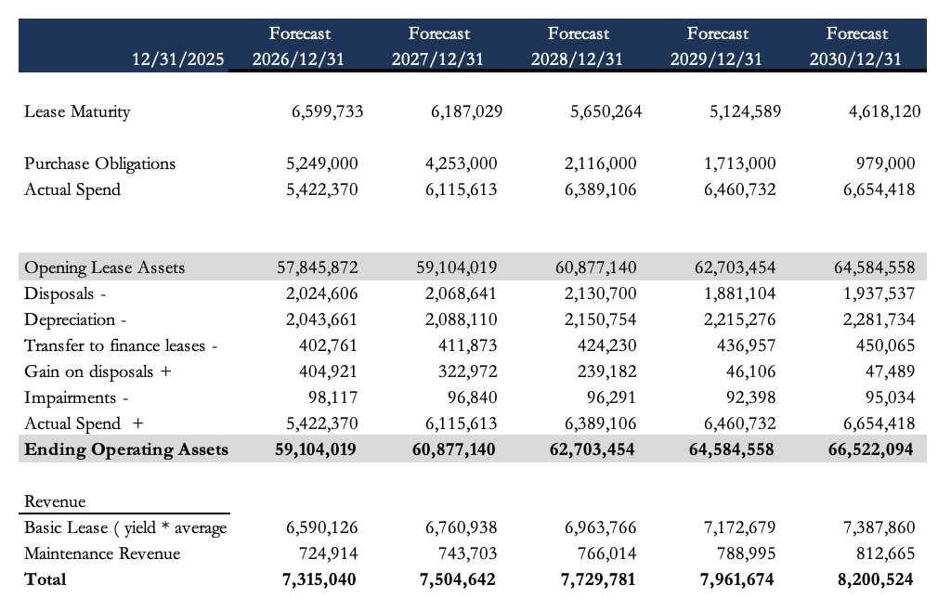
Bull Case

As explained in the valuation section, the bull case builds revenue a bit differently. Instead of the known contractual obligations, it assumes the fleet grows 3% every year, which takes a lot more spending than the current contracted obligations. Basic lease revenue still uses the 11.5% yield, and maintenance revenue uses the same method as before.

Maintenance Rents
Maintenance rents and other receipts are modeled as a percentage of average flight-equipment NBV, the same idea as basic lease rents but with its own yield. Historically that ratio has averaged about 1.1% and stayed fairly steady. The forecast holds it at the 2025 level (~1.2%), so maintenance revenue drifts down gently with the fleet as older aircraft leave.

Total Lease Revenue and Other Income
Total lease revenue is basic plus maintenance rents. Other income, which covers management fees, insurance proceeds and odds and ends, is modeled as a percentage of total lease revenue, held at about 4.4%, near the recent average. In the normalized model, gain on sale is a residual that sits around zero by construction, since the normalization pulls the structural gain into depreciation. For the forecast I have gain on sale higher in 2026 and then declining to a terminal level, to reflect AerCap taking advantage of the high asset prices while they last.
For the reported model, the gain on sale is forecast as a percentage of disposal proceeds, declining from ~20% in 2025 toward the normalized average of around 2%.

Fleet and Asset Forecasting

The NBV Roll-Forward
For the Base case the flight-equipment balance ($57.8B at end-2025) is the anchor of the whole model. Rather than forecast it as a percentage of revenue or assets, I build it as a physical roll-forward: opening NBV, plus additions (capex on new aircraft), less depreciation, disposals and transfers to held-for-sale. Each piece has its own driver.
Additions come off the purchase-obligation schedule in each year-end 20-F. As of December 2025, AerCap had $15.5B of remaining commitments for 283 aircraft across 2026–2031 and beyond. I use actual spend as the capex figure: $5.3B in 2026E, $4.9B in 2027E, falling to $2.4B by 2030E as the current order book runs off. Actual spend comes from comparing each prior year's forecast commitments against what was actually spent. It's an estimate, and there's room for error, since that comparison only runs from 2021 and the sector is cyclical in when it buys.
Importantly, actual spend routinely exceeds the prior year's disclosed commitment for the given delivery year, by an average ratio of roughly 1.3x over 2022–2025, because AerCap supplements its order book with opportunistic purchases throughout the year.
As noted for the second residual model, the bull case has additions grow the total flight equipment held for operating leases by 3% a year.
Depreciation uses the normalized rate: I take the normalization multiplier and apply it to the 2025 rate of 4.55% (depreciation over average PP&E held for operating leases).
Disposals are modeled as a percentage of average fleet NBV. Historically AerCap has sold 2.4–3.5% of the fleet a year on a proceeds basis, a bit less on NBV removed. I hold disposals near 3.5% of average NBV in the near term, then step down to 2.5–3.0% in later years as prices normalize once supply loosens and AerCap no longer has the same reason to sell extra now. So the fleet shrinks and AerCap keeps more aircraft. Proceeds follow from applying the historical sale-to-book ratio (~1.3x on average over 2022–2025) to the NBV removed.
The result is a fleet that peaks around $58.6B in 2027E and then eases down through 2030E as the current order book delivers its last aircraft and disposals continue. That decline is a direct result of the conservative capex assumption: if AerCap signs new orders or exercises purchase rights, the fleet flattens out or turns back up.

Prepayments on Flight Equipment
Prepayments are advances on aircraft not yet delivered. I model them as a roll-forward: opening balance, plus net additions, less the amount that converts into flight equipment on delivery. Since prepayments track the level of contractual obligations, the roll-forward is driven by the ratio of the t+1

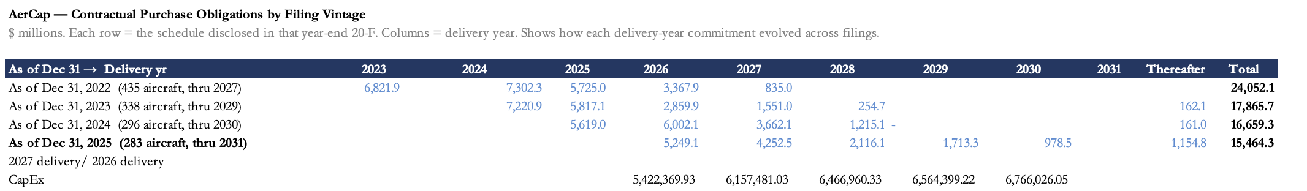

contractual obligation to the year-t contractual obligation, which drives both the additions and the transfer into flight equipment each year. On this method, the bull model has the account rise from $4.2 billion at end-2025 to $4.9 billion by end-2030; the base case falls instead, following the decline in operating assets.
Figure 59 – Contractual Purchase Obligatins
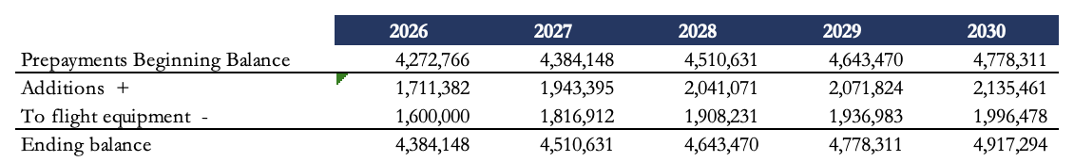

Figure 60 - Prepayments Roll-Forward

Additions are calculated by multiplying that ratio by the beginning balance. The transfer to flight equipment is derived by multiplying the prior-year transfer by the same ratio.

Maintenance Rights and Lease Premium
This intangible, $1.7B at end-2025, came out of the GECAS acquisition and amortizes over the remaining lease terms of the acquired portfolio. I model it as a simple decay of the prior-year balance, set to the historical rate (~78% of the prior year kept, so about a 22% annual write-down). By 2030E the balance is down to roughly $500M. It's non-cash and runs through the maintenance-rights write-off line on the cash flow statement.

Expense Structure

Leasing Expenses
Leasing expenses, the aircraft-level costs like repositioning, insurance, and end-of-lease and transition costs, are modeled as a percentage of total lease revenue. That ratio has run from 8.8% (2025) to 12.6% (2022), with a normalized average around 11.0%. I hold it at roughly 11.0% across the forecast, which keeps gross margin in the high-80s as a percentage of lease revenue. The 8.8% in 2025 looks unusually low and not something to count on.

Selling, General & Administrative
SG&A is modeled as a percentage of total lease revenue, easing from 7.4% in 2025 to 7.1% by 2030E on continued operating leverage. The 7.1% is the average of 2023, 2024 and 2025 SG&A to sales. That fits the post-GECAS path: the integration synergies are done and the cost base is mostly fixed.

Debt & Interest Expense

The most judgment-heavy part of forecasting debt was deciding how much to issue each year. I set issuance as a percentage of repayments, because it's the least circular approach and it lets me tune the issuance percentage to different goals. For the base case, I used Solver to pick the percentage that keeps cash and equivalents at a steady share of total assets, historically around 2%. For the bull model, aimed at holding a 2.1x debt-to-equity ratio, I apply the same debt-ratio approach. Once issuance is set, debt is just opening balance, less repayments, plus issuance.
With the debt level set, I can build the full schedule. Debt splits into old and new. The old debt splits further into AerCap's three categories, unsecured, secured and subordinated. Using the maturities by category that AerCap discloses on its website, I can forecast exactly how much of each rolls off in a given year, and so how the blended rate on the old debt moves over time. New debt is just the newly issued amount: ending balance, less opening balance, plus what matured that year.
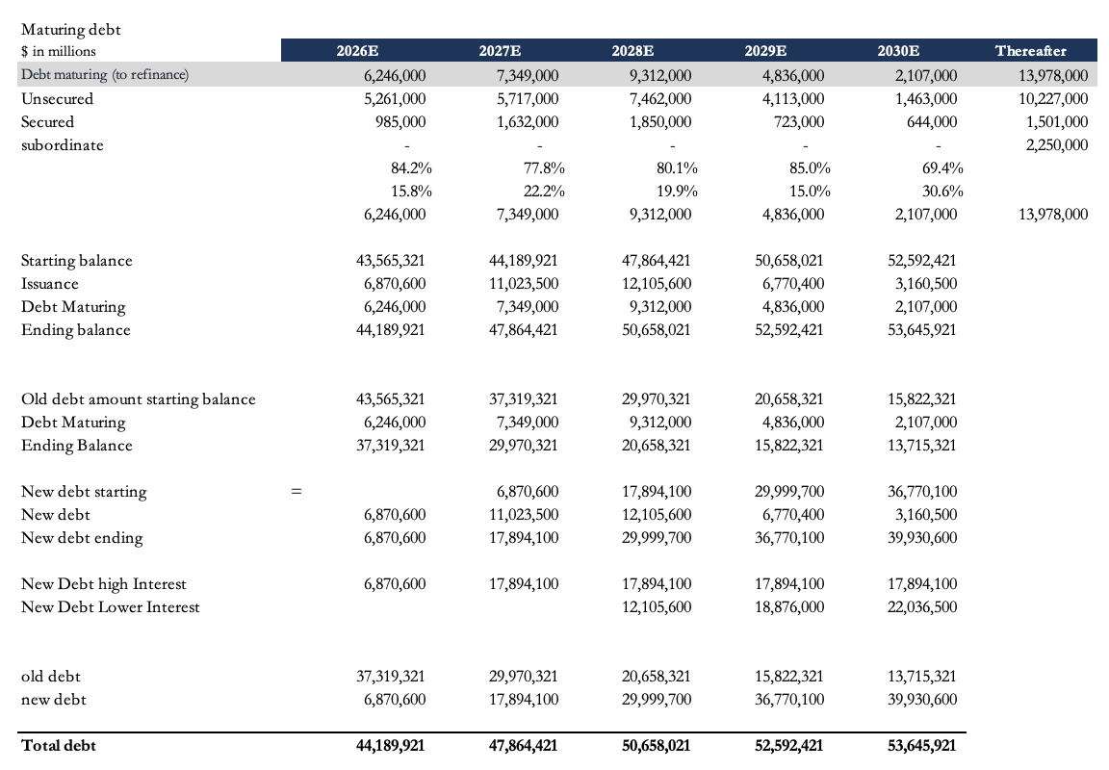
The picture below is the debt schedule of the bull case.

Figure 61 - Debt Schedule (Bull Case)

Interest Expense
For interest, I again split old from new. On the old debt I know the amount of each type and its rate, so interest on the old book is just each type times its rate.
For the cost of new debt, I use the market prices of AerCap's outstanding notes, sourced online, and take the average of their yields to maturity. Using market value makes the estimate sharper, since it reflects the return investors actually want to hold the debt right now.
Both the base and bull cases use the same cost of new debt. It's forecast to go from 4.9% in 2026 to 4.1% at terminal. The 4.9% comes from the current market yield on AerCap's notes; the 4.1% is the cost AerCap has managed to hold thanks to its hedging. I also assume rates and the inflation backdrop settle down over the next few years.
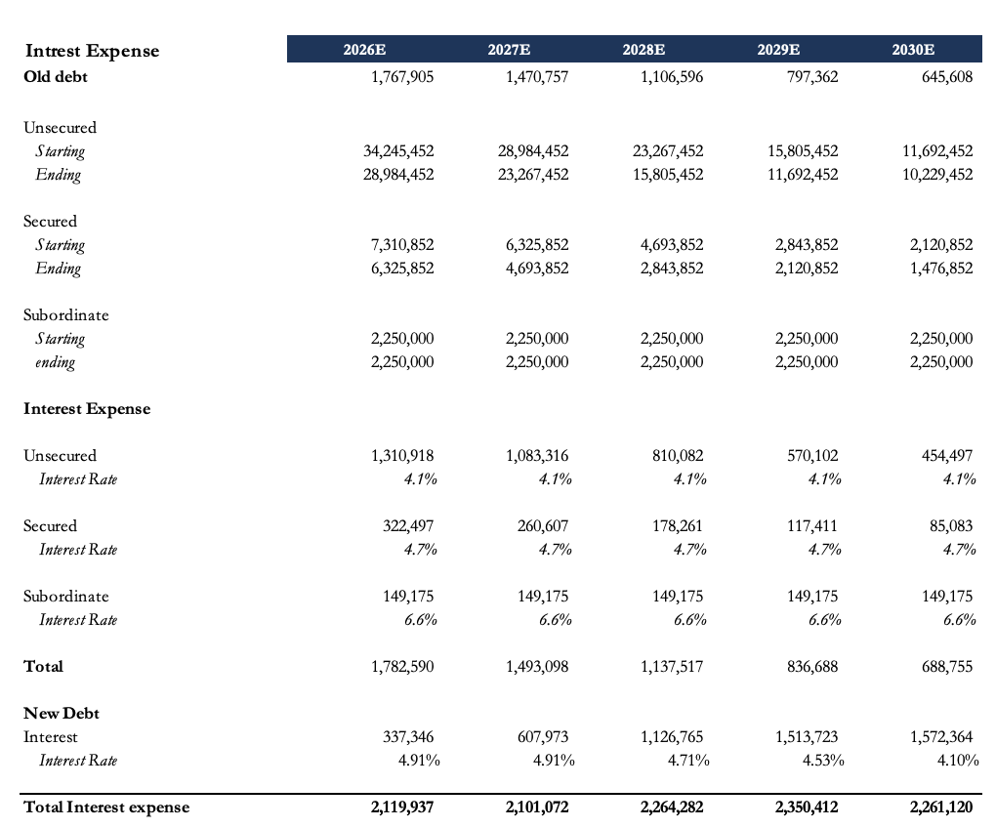

Figure 62 - Interest Rate Assumptions

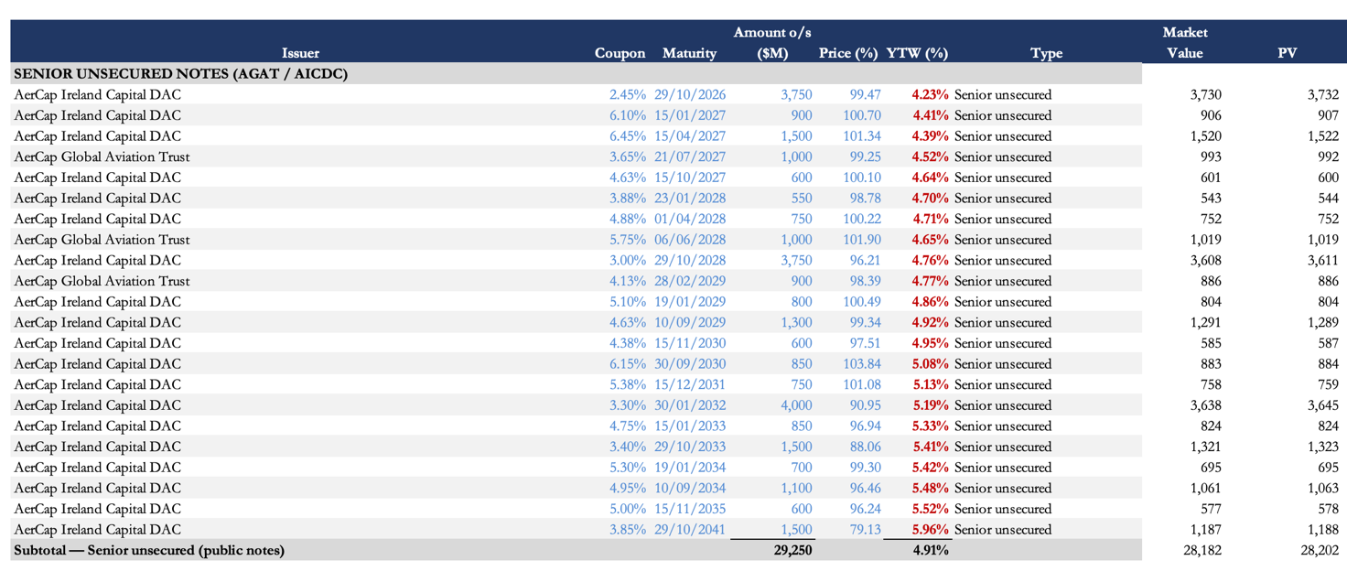
Figure 63 - Interest Expense Forecast

Balance Sheet Construction

Working Capital and Operating Items
Most balance-sheet items outside flight equipment and debt are modeled as percentages of the relevant revenue or asset base, set to recent averages and nudged gently toward long-term means.
Cash and equivalents is modeled to keep the historical percentage of assets ( for the base case) , excluding cash and equivalents itself. For the bull case cash is the output of maitaining adjusted debt-to-equity between 2.1 and 2.2
Trade receivables are small (~$48M at end-2025), modeled as a percentage of lease revenue and trending toward the historical average as the post-GECAS cleanup of stale receivables settles. Deferred revenue is modeled as a percentage of lease revenue (~11%); it's advance rent that gets recognized straight-line over the lease term.
Accrued maintenance liability ($3.5B at end-2025) is modeled as a percentage of average PP&E, held at ~5.5%. It's the cash maintenance reserves collected from lessees, either returned at lease end or released to income when an event happens. The matching cash flows, maintenance payments received and returned, are modeled separately in the cash flow statement as a percentage of average PP&E.
Deferred tax liabilities and assets. The deferred tax liability is a big item (~$3.2B at end-2025, or ~43% of lease revenue), from accelerated depreciation for tax. I model it as a percentage of lease revenue, easing toward 38% as the GECAS timing differences wind down. Deferred tax assets are also modeled as a percentage of lease revenue.

Lessee Deposit Liability
The lessee deposit liability is a balance-sheet liability and, next to debt, one of the larger accounts. It also hits the cash flow statement through two financing lines: security deposits received and security deposits returned.
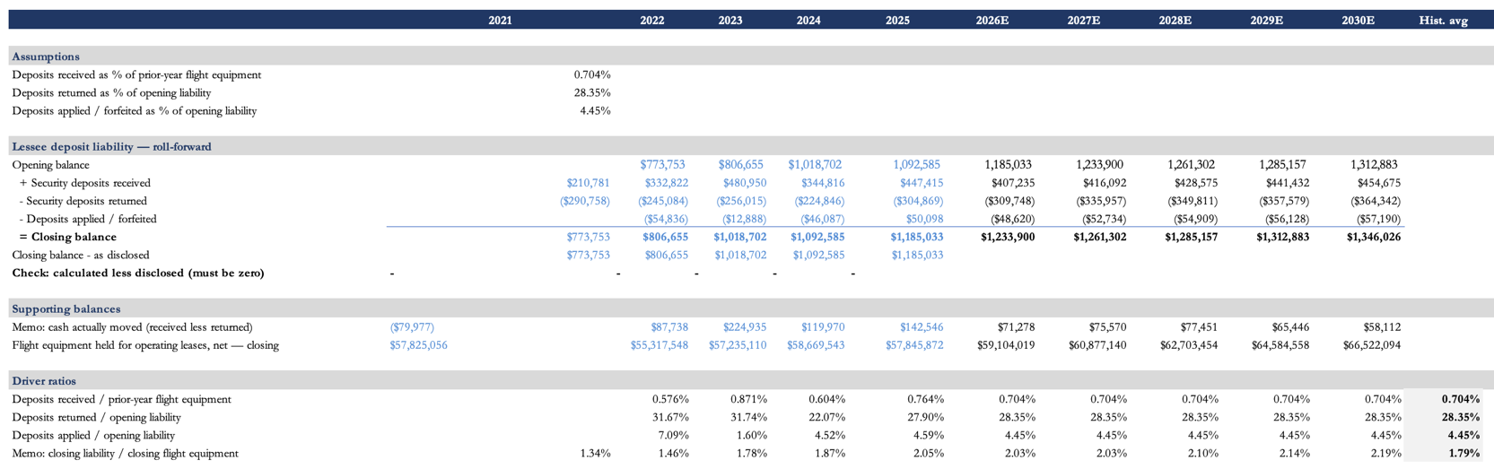
Figure 64 – Lessee Deposit Liability

I forecast this account off historical ratios for the three things that move it: deposits received, deposits returned and deposits forfeited. Each is forecast on its own, and together they give the closing balance. Received uses the historical average of deposits received to prior-year flight equipment; returned uses the average of returned to opening lessee deposit liability; and forfeited uses the average of forfeited to opening liability.
The picture above is the lessee deposit liability forecast for the bull scenario, the mechanics are the same for the base case.

Investment in Finance Leases
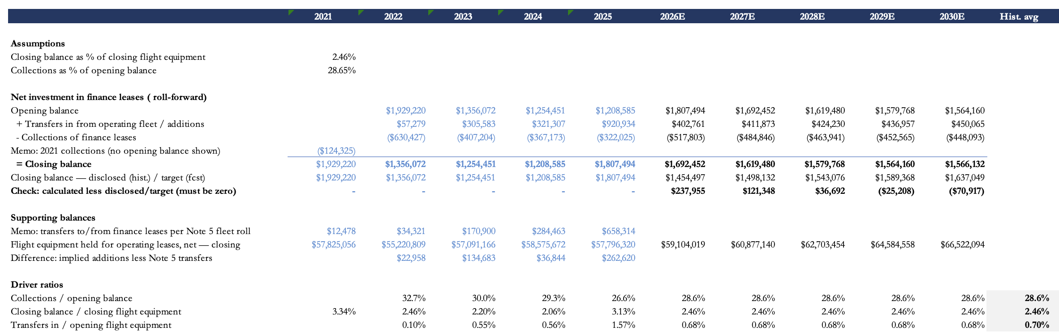
Finance leases move each year on two things: the amount transferred in from operating leases, and the amount collected. I forecast them off two historical ratios, collections to opening balance and transfers-in to opening flight equipment held for operating leases, which have averaged 28.6% and 0.70% over the historical period.
Figure 65 - Finance Lease Roll-Forward

So each year runs off those ratios and the relevant opening balances. The exhibit above is the bull case, but the base case works the same way.

Accrued Maintenance laibitlity
The account moves each year on five things: maintenance payments received, maintenance payments returned, release income on sale, release income other than on sale, and lessor contributions. Payments received are the periodic reserves collected from lessees; payments returned are reserves paid back when a lessee does qualifying maintenance; release income on sale is the piece of the liability released to income when an aircraft is sold with its reserves; release income other than on sale is reserve income taken at lease end or early termination when the maintenance isn't done; and lessor contributions are what AerCap itself puts toward maintenance events. All five are cash, so they also run through the cash flow statement.
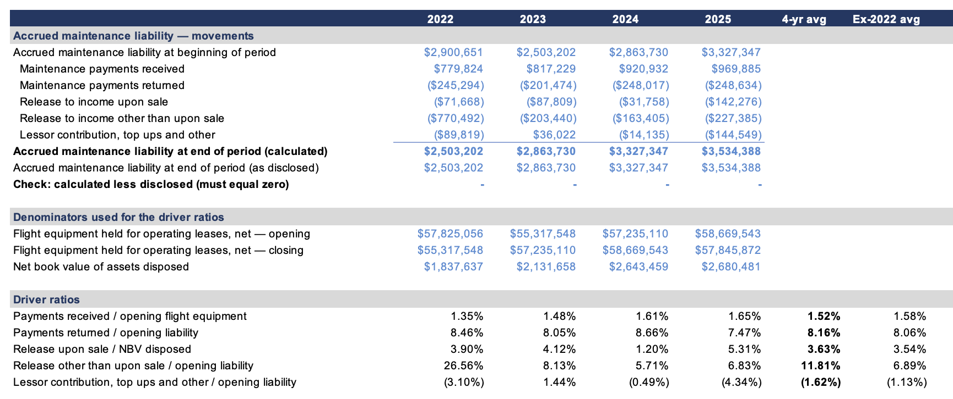
To forecast them, I apply historical average ratios to each: payments received to opening operating flight equipment; payments returned to opening accrued maintenance liability; release on sale to NBV disposed; release other than on sale to opening accrued maintenance liability; and lessor contributions to opening accrued maintenance liability.
Figure 66 - Accrued Maintenance Liability Roll-Forward

Associated Companies

Associated companies are AerCap's unconsolidated investments, where it doesn't have control but does have significant influence, accounted for under the equity method. It currently covers the joint venture with Shannon Engine Support Ltd, which at end-2025 was $1.12 billion of the $1.3 billion total, plus AerDragon Aviation Partners Limited and Other.

Shannon is a joint venture 50% owned by AerCap and 50% owned by Safran. They offer spare engine solutions to CFMI operators.

These investments are forecasted to continue growing at 17%, the historical growth rate for the past 4 years

Cash Flow Statement
The cash flow statement falls out of the income statement and balance sheet rather than being modeled on its own. Operating cash flow starts from net income and adds back the non-cash items: depreciation, asset impairment, maintenance-rights write-off, share-based comp, deferred tax, collections of finance leases, and the non-cash part of gain on sale. Working-capital changes, trade receivables, other assets, accounts payable, accrued maintenance liability and lessee deposit liability, are just the year-over-year moves in those balance-sheet lines.
Investing cash flow runs off three things: purchases of flight equipment (from the NBV roll-forward), proceeds from sales or disposals (from the disposal analysis), and prepayments on flight equipment (from the prepayment roll-forward). Ukraine insurance proceeds and GECAS acquisition costs are zeroed in every forecast year.
Financing cash flow covers debt issuance and repayment (from the debt schedule), maintenance deposits received and returned, security deposits received and returned, buybacks, and dividends. Debt issuance costs are a small percentage of gross issuance, in line with history (~1.4%).
As noted, how much debt gets issued matters a lot to overall cash flow, so the debt assumptions in each case weigh heavily here. The base case keeps shareholder payback modest, holding dividends flat and assuming buybacks only in 2026 and 2027. The bull case pays out more, mainly to keep adjusted debt-to-equity near 2.1x, with buybacks of $2 billion in 2026 and 2027 and $1.5 billion after that. That payback is recorded as buybacks, but on the balance sheet it's modeled to hit only accumulated retained earnings, pushing additional paid-in capital further negative. Where it's booked is mostly an accounting question and doesn't change what actually goes out to shareholders.
Figure 67 - Debt Issuance Costs

Summary of Key Assumptions
The model really comes down to a handful of assumptions. Lease yield is held at 11.5%, on a fleet that in the base case peaks near $58.6B and falls toward $53.4B by 2030, and in the bull case keeps growing 3% a year. Depreciation follows the normalized rate of about 3.2% of average gross flight equipment. Leasing expenses are held at 11.0% of lease revenue. The cost of debt reflects the higher short-term cost of newly issued debt.
Debt-to-equity isn't targeted in the base case but stays near the adjusted 2.2/2.1. Buybacks run at $1.0B a year with a $264M annual dividend. The effective tax rate is held at 14%, in line with AerCap's Irish-domiciled structure.

End of Methodology Section

IATA, Jet Fuel Price Monitor. https://www.iata.org/en/publications/economics/fuel-monitor/
CBS News, May 2026; PBS, June 2026.
CNBC, June 2026; Chase, June 2026.
Fox Business, June 2026; PBS, June 2026.
CBS News, June 2026.
Chase, July 2026; Motley Fool, July 2026.
Ogier, Feb 2026; Maples Group, May 2026.
Maples Group, May 2026.
Ogier, Feb 2026.
KPMG via Ogier, Feb 2026.
IATA, June 7 2026.
IATA, June 7 2026.
Satair, Oct 2025.
Satair, Oct 2025.
Deloitte.
IATA, 2020.
IATA, “What can we learn from past pandemic episodes”.
IATA LTDP, June 2025.
Satair, Oct 2025.
IATA, Financial Outlook, June 7 2026.
AerospaceGlobalNews, June 2026; ePlaneAI, 2026.
IATA, June 2026.
CNBC, Feb 2026; ePlaneAI, 2026.
AerospaceGlobalNews, June 2026.
AeroTime, May 2026; IATA, June 2026.
IATA, June 2026.
Airways/Reuters, June 2026.
SimpleFlying, May 2026.
IATA, June 7 2026.
Aircraft Value News, Jan 2026; IQ-EQ, March 2026.
IBA, May 2026.
IATA, June 7 2026.
IATA, Long-Term Demand Projections, June 2025.
IATA, June 2025.
KPMG Aviation Leaders Report 2026, via Ogier, Feb 2026; IATA Global Outlook, Dec 2025.
IATA, March 2026.
IATA, April 2026.
IATA via CAPA, June 2026.
Boeing Commercial Market Outlook 2025–2044, June 2025.
Boeing CMO, 2026.
Airbus Global Market Forecast 2026–2045, July 2026.
Cirium Fleet Forecast, October 2025.
Boeing CMO, June 2025.
ReAnIn, 2026.
Fortune Business Insights, 2025.
Precedence Research, March 2026; recent examples include Southwest/BBAM in 2025 and IndiGo/BOC.
Ogier/KPMG: $209bn in 2025 → $226.7bn in 2026 at 8.4%; Mordor Intelligence: $181.75bn 2025 → $278bn 2031 at 7.35%; higher-end figures from GM Insights and SNS Insider.
Mordor Intelligence, June 2026; Fortune Business Insights, 2025.
Lease-rate sources: • Reuters — Airbus A321neo lease rate ($455k/month): https://www.reuters.com/business/aerospace-defense/aircraft-shortages-turn-into-cash-bonanza-some-airlines-2024-05-31/; • SMBC Aviation Capital — Plane Insights Q4 2025 (A320neo and A320ceo): https://www.smbc.aero/sites/smbc.aero/files/2025-10/SMBC%20AC%20Plane%20Insights%20Q4%202025.pdf; • Cirium Ascend — A320neo and Boeing 737 MAX at approximately $400k/month: https://www.cirium.com/thoughtcloud/ascend-consultancy-weekly-team-perspective-impact-of-rising-interest-rates-lease-fees/; • SMBC Aviation Capital — Plane Insights Q2 2025 (737-800 and other single-aisle aircraft): https://www.smbc.aero/sites/smbc.aero/files/2025-04/SMBC%20AC%20Plane%20Insights%20Q2%2025.pdf; •Reuters — additional confirmation that new A320neo and 737 MAX 8 rates reached $400k/month: https://www.reuters.com/business/aerospace-defense/airlines-struggle-with-lack-planes-summer-travel-set-hit-record-levels-2024-04-09/.
simpleflying.com, Airbus A320 vs A320neo. https://simpleflying.com/airbus-a320-vs-a320neo/
FactSet.
FlightGlobal. https://www.flightglobal.com/air-transport/2026/04/smbc-aviation-capital-and-partners-complete-air-lease-acquisition/
Aviation A2Z. https://aviationa2z.com/index.php/2025/01/10/largest-aircraft-leasing-companies-by-fleet-2025/
stockanalysis.com. https://stockanalysis.com/stocks/al/financials/balance-sheet/

