Voice Coach — Análisis de voz
Idioma: English · Duración: 1m 2s · Palabras: 128 · Ritmo: 123 ppm · Positividad: 68% · Muletillas: 0 · Generado: 7/10/2026, 11:15:42 PM

Métricas
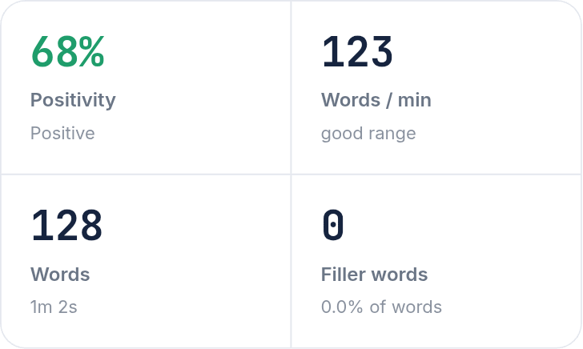

Arco de sentimiento


Transcripción
I prefer to work in a big company because you can move to different positions and build a career path. For example, you can ask Astridini and move on a CEO. Additionally, it is a reference to work on other companies. I disagree with the communication technology because in a face-to-face meeting you can identify the people reactions and see when an answer is true or not. For example, in a business negotiation it is important to close the projects. 3. I decide to study an MBA in PUCP because it's the best university in Peru and it has a partnership with USA, for example, at the end of the course I will go to USA to take some classes and apply for a degree in New Orleans.
Color del texto — Verde: positivo · Amarillo: neutral · Rojo: negativo

