**Reto 1: Conexión MySQL**

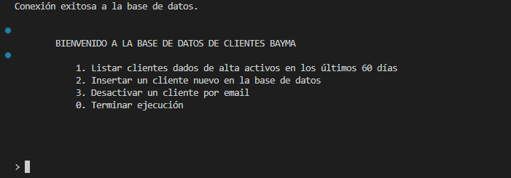

Insertar un cliente en la base de datos:

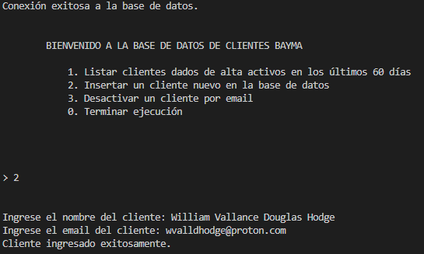

Almacenamiento desde Workbench

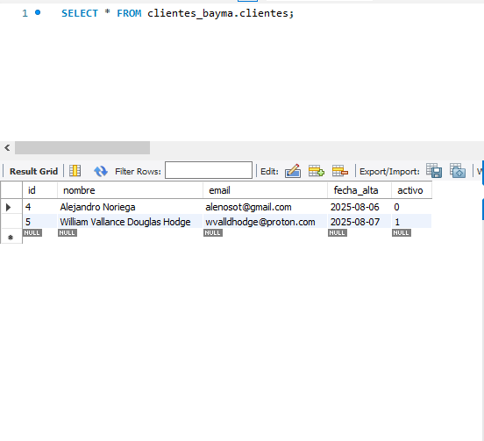

Listado de clientes activos:

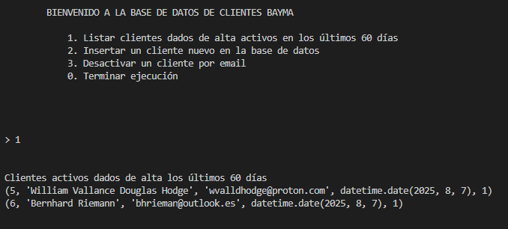

Desactivar cliente por email:

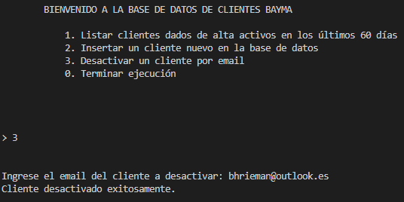

Vista desde Workbench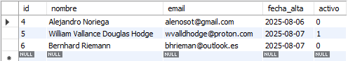

**Reto 2: Consumo de API**

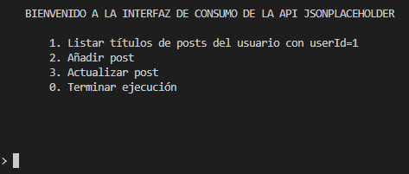

Listar todos los títulos de posts

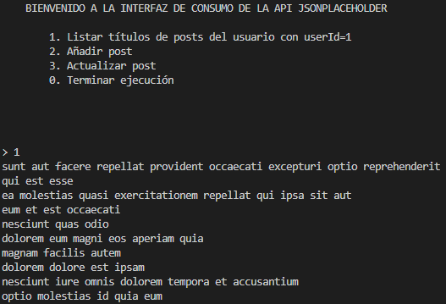

Agregar post

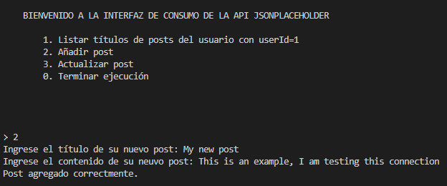

Actualizar un título de un post:

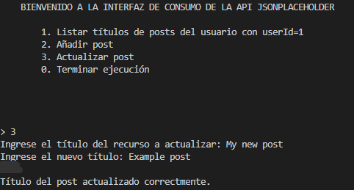

**Reto 2: Consumo de API**

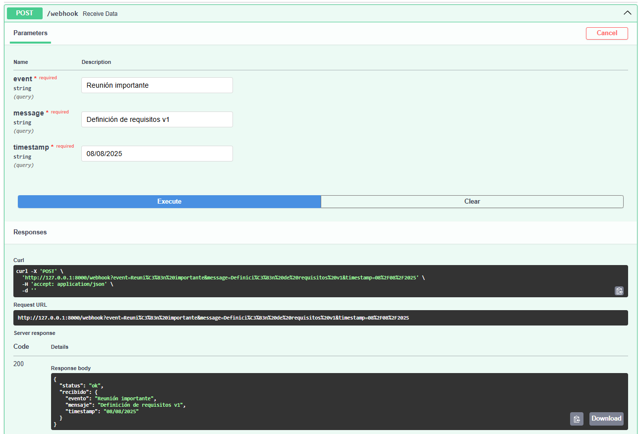

**Reto 2: Consumo de API**

A continuación se brindan algunos ejemplos para copiar y pegar en consola durante la ejecución del programa:

Reto 1 – Insertar nuevos usuarios:

Carl Gauss

[cfgauss@gmail.com](mailto:cfgauss@gmail.com)

Alexander Grothendieck

[axgroth@protonmail.com](mailto:axgroth@protonmail.com)

Agustín Rayo

[agusray@hotmail.com](mailto:agusray@hotmail.com)

Reto 2 – Añadir posts:

Make math without dying in the attempt

It is a tough task but several mathematicians along the history had invested many time researching new connections between theories that are apparently no related.

Are Statistics the future?

With the trend of machine learning algorithms new tools have come to the IT market, and a new horizon has spawned for many inventions that can help humans to accomplish difficult tasks.