Universidad de San Buenaventura

Alejandro Padilla Guevara – 30000045273

Análisis y diseño de algoritmos

Bogotá DC

**Ejercicios**

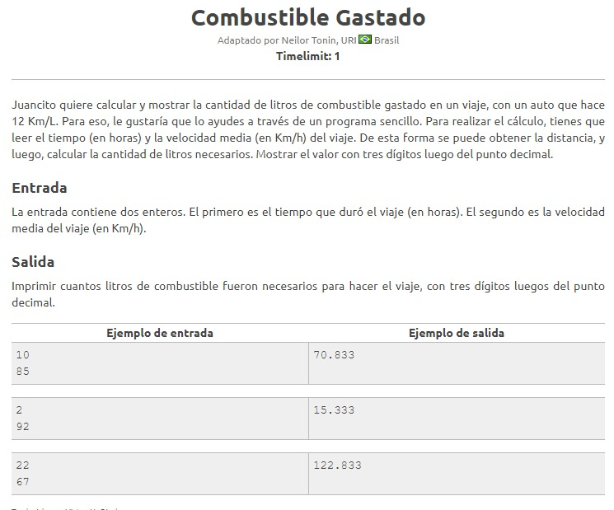

**JAVA**

package ejercicio1;

import java.util.Scanner;

public class Ejercicio1 {

public static void main(String[] args) {

System.out.println("Ingrese el numero de horas que duro el viaje");

Scanner sc = new Scanner(System.in);

float h = sc.nextInt();

System.out.println("Ingrese la velocidad media del viaje en km/h");

float v = sc.nextInt();

System.out.println("teniendo en cuenta que el combustible gasttado equivale a 12km/L");

float d = h * v;

System.out.println("La distancia recorrida es de: " + d);

float l = d / 12;

System.out.println("El combustible consumido en litros es de: " + String.format(("%.3f"), l));

}

}

PYTHON

print("Ingrese el numero de horas que gasto en el recorrido: ")

horas=input()

horas=int(horas)

print("ingrese la velocidad media con la que iba el vehiculo: ")

velocidad=input()

velocidad=int(velocidad)

print("teniendo en cuenta que el combustible gastado equivale a 12k/L")

distancia=horas*velocidad

print("la distancia recorrida es de: ",distancia)

combustible=distancia/12

print("Por lo tanto el combustible gastado es de: ","combustible:%.3f"%combustible)

#print("Por lo tanto el combustible gastado es de: ",float('{0:.3f}'.format(combustible)))

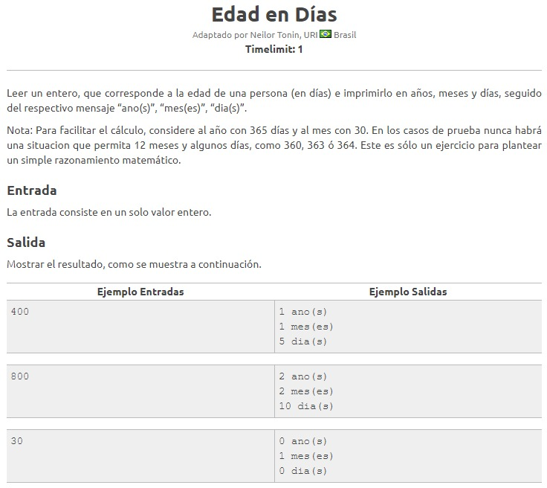

JAVA

* Métodos

package ejercicio2;

public class Metodos {

private int dias;

public Metodos(int dias) {

this.dias = dias;

}

public int CalcularAnios(){

return dias/365;

}

public int CalcularMeses(){

return (dias%365)/30;

}

public int CalcularDias(){

return(dias%365)%30;

}

public int getDias() {

return dias;

}

public void setDias(int dias) {

this.dias = dias;

}

}

* Main

package ejercicio2;

import java.util.Scanner;

public class Ejercicio2 {

public static void main(String[] args) {

int año = 365;

int mes = 30;

Scanner sc = new Scanner(System.in);

System.out.println("Ingrese un valor de tipo entero");

int dias = sc.nextInt();

Metodos m = new Metodos(dias);

System.out.println(m.CalcularAnios() + " anio(s)"

+ "\n" + m.CalcularMeses() + " mes(es)"

+ "\n" + m.CalcularDias() + " dia(s)");

}

}

PYHTON

print("Ingrese el numero de dias: ")

dias=input()

dias=int(dias)

def anio():

anios=dias//365

print("anios ",anios)

return anios

def mes():

meses=(dias%365)//30

print("meses ",meses)

return mes

def dia():

diias=(dias%365)%30

print("dias ",diias)

return diias

anio()

mes()

1. PROMEDIOSPONDERADOS

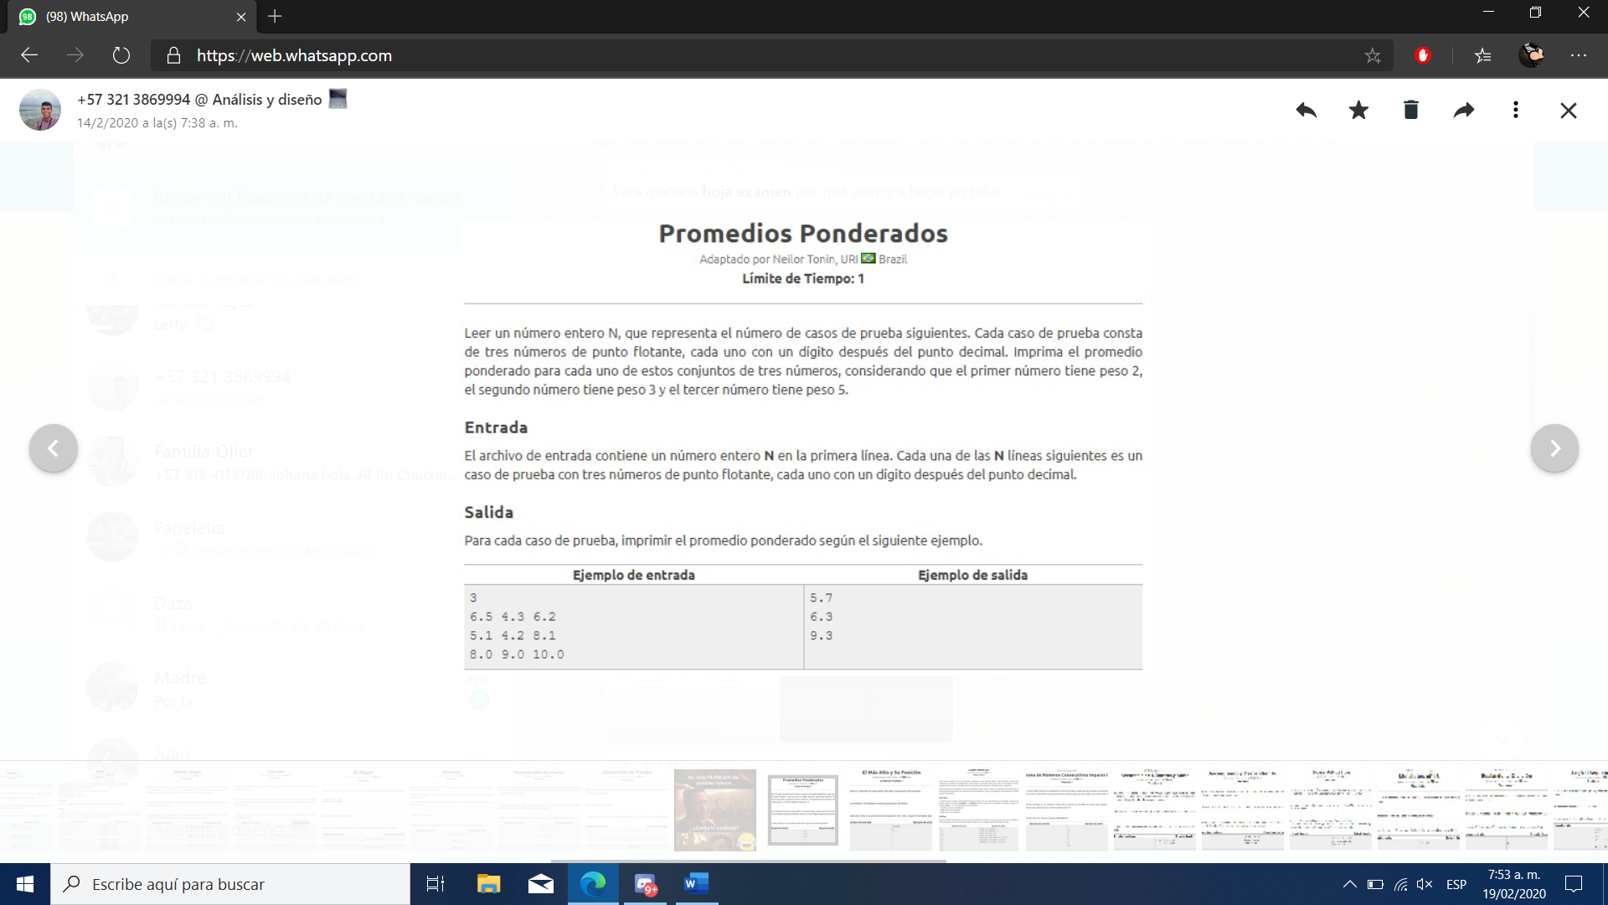

**SOLUCION PYTHON:**

print("ingrese el numeo de casos: ")  
casos=input()  
casos=int(casos)  
  
  
for i in range(0,casos):  
 print("ingrese los 3 numeros")  
 n1=input()  
 n1=float(n1)  
  
 n2=input()  
 n2=float(n2)  
  
 n3=input()  
 n3=float(n3)  
  
 respuesta=(n1+n2+n3)/3  
 print("Respuesta: ",respuesta)

1. EL MÁS ALTO Y SU POSICIÓN

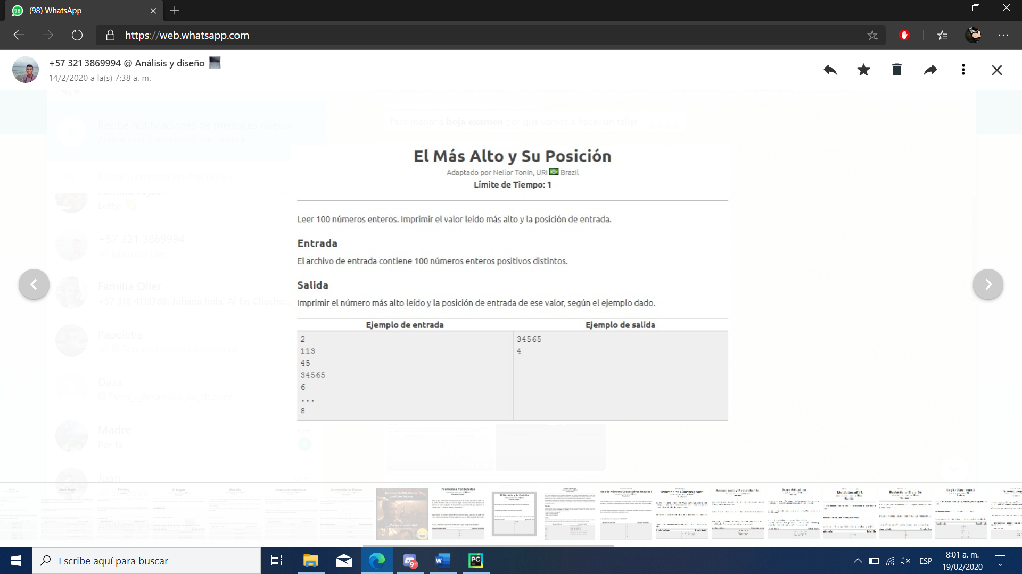

mayor = 0  
maximo = 100  
posicion=0  
   
print("digite los 100 numeros: ")  
  
for i in range(maximo):  
 num = int(input('Ingresa un numero:'))  
 if num > mayor:  
 mayor = num  
 posicion=posicion+1  
   
print("El numero mayor es: ", mayor, "La posicion es: ", posicion)

1. MJOLNIR

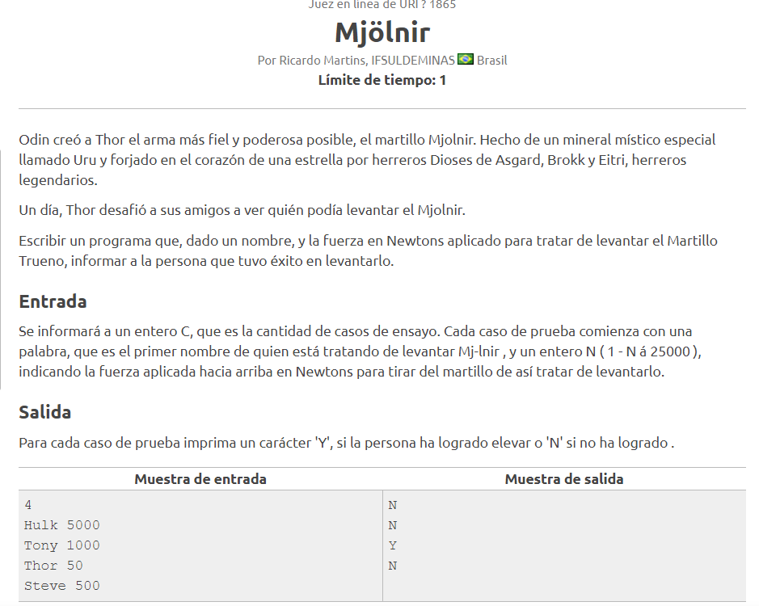

PYTHON

casos=int(input("Ingrese el numero de casos de ensayo: "))  
  
for i in range(casos):  
 nombre = input("Ingrese el nombre del que realizara el intento: ")  
 fuerza=int(input("Ingrese la fuerza aplicada en newtons"))  
 if nombre == "Thor":  
 print("Y")  
 else:  
 print("N")  
  
  
casos();

1. Triangulo

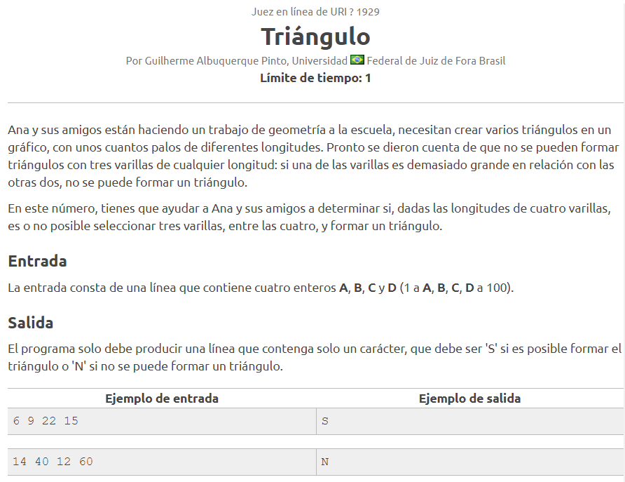

PYTHON

a=int(input("Ingrese el valor de la varrilla de A"))  
b=int(input("Ingrese el valor de la varrilla de B"))  
c=int(input("Ingrese el valor de la varrilla de C"))  
d=int(input("Ingrese el valor de la varrilla de D"))  
  
  
if a < (b+c) and b < (a+c) and c < (a+b):  
 print("S\n")  
elif a < (b+d) and b < (a+d) and d < (a+b):  
 print("S\n")  
elif a < (c+d) and c < (a+d) and d < (c+a):  
 print("S\n")  
elif b < (c+d) and c < (b+d) and d < (c+b):  
 print("S\n")  
else:  
 print("N\n")

1. Theon’s

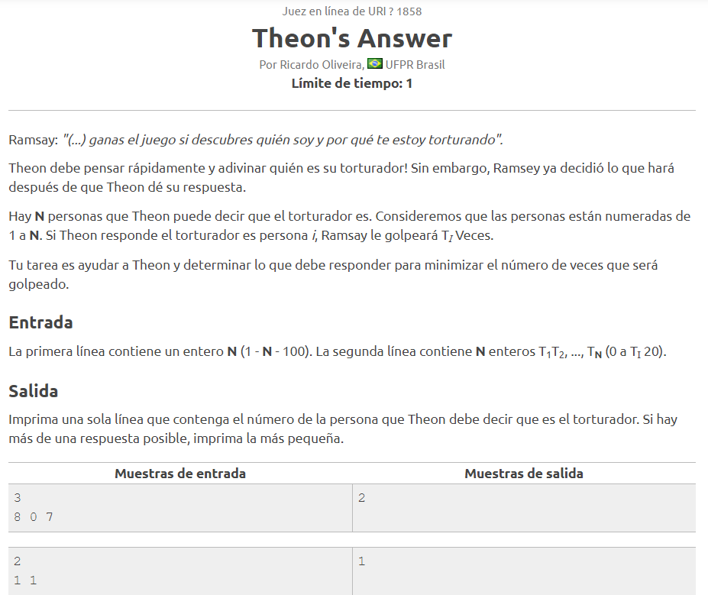

x=int(input("Ingrese el valor de x"))  
y=int(input("Ingrese el valor de y"))  
min=y  
for i in range (x-1):  
 y=int(input("Ingrese el valor"))  
 if min > y:  
 min=y  
 count=i+1  
  
  
print(count)

1. Our days are never coming back

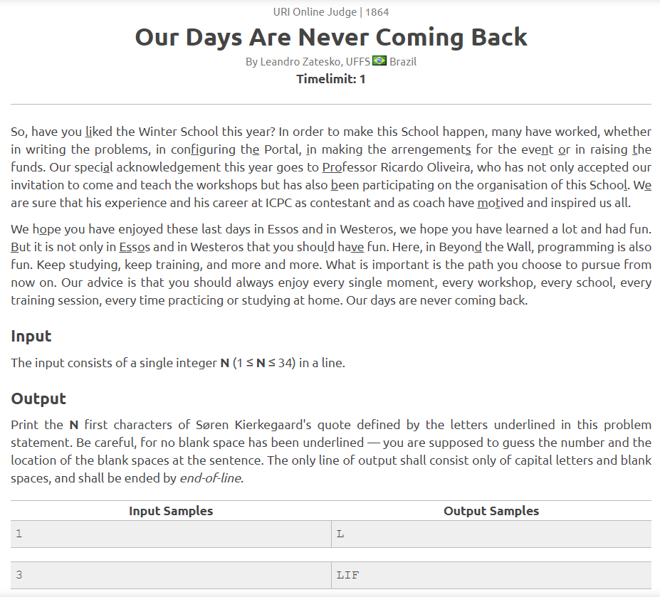

frase="La vida es bella"  
n=int(input("Ingrese un umero entre 1 y 16: "))  
print(frase[0:n])

1. Internship

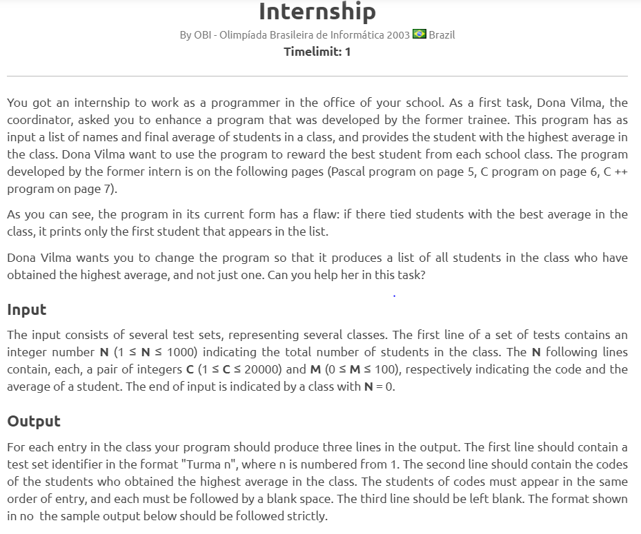

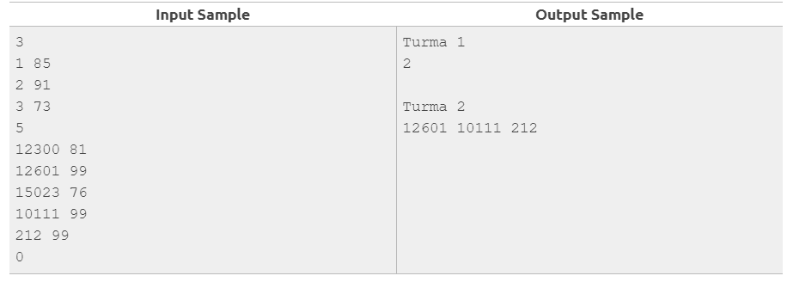

package internship;

import java.util.Scanner;

public class Internship {

public static void main(String[] args) {

Scanner sc = new Scanner(System.in);

while (sc.hasNext()) {

int M = sc.nextInt();

int totalC = 0;

int totalNC = 0;

for (int i = 0; i < M; i++) {

double N = sc.nextInt();

double C = sc.nextInt();

totalNC += N * C;

totalC += C;

}

double resultado = totalNC / (totalC * 100.0);

System.out.println(String.format("%.4f", resultado));

}

}

}

1. Web Browser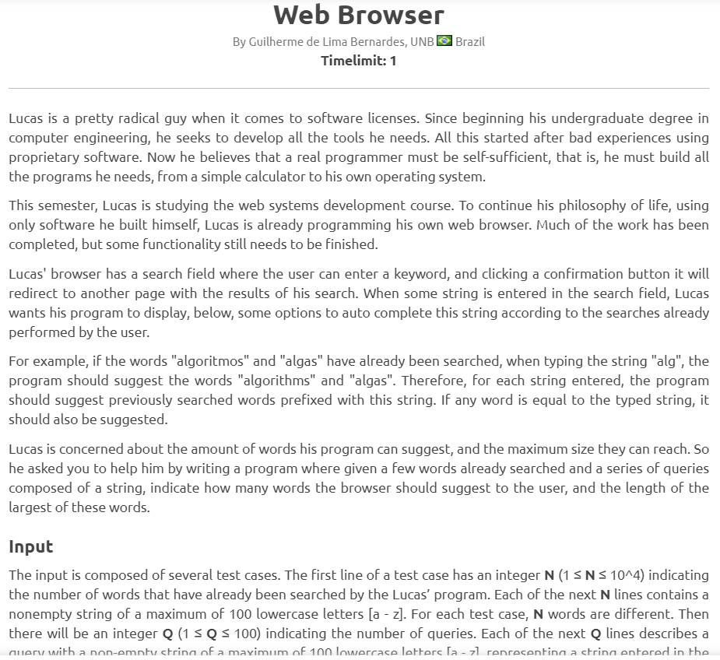

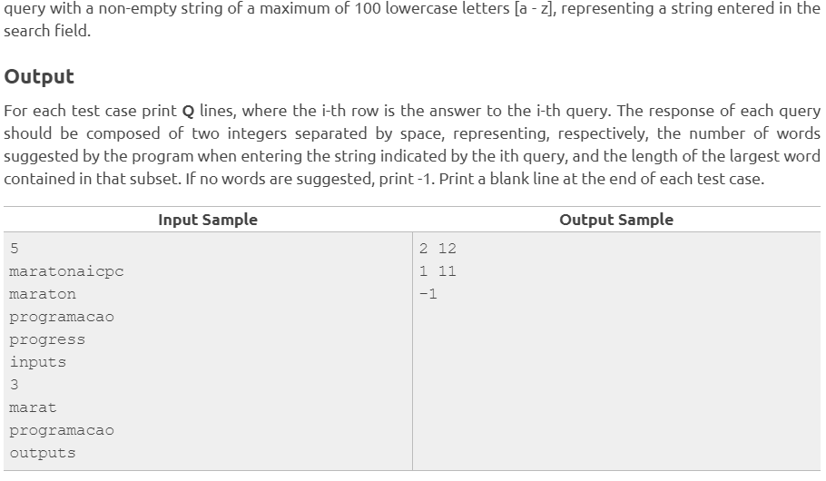

**package** web_browser;

**import** java.util.Scanner;

**import** java.util.InputMismatchException;

**public** **class** Web_Browser {

**public** **static** **void** main(String[] args) {

Scanner sc = **new** Scanner(System.***in***);

**int** numero = sc.nextInt();

String[] database = **new** String[numero];

**for** (**int** i = 0; i < database.length; i++) {

database[i] = sc.next();

}

sc.nextLine();

**int** cantb = sc.nextInt();

**for** (**int** j = 0; j < cantb; j++) {

String txt = sc.next();

**int** cant = 0;

**int** tamanio = 0;

**for** (**int** i = 0; i < database.length; i++) {

**if** (database[i].contains(txt)) {

cant++;

**int** aux = database[i].length();

**if** (aux > tamanio) {

tamanio = aux;

}

}

}

**if** (cant > 0) {

System.***out***.println(cant + " " + tamanio);

} **else** {

System.***out***.println("-1");

}

}

}

}

1. Dijstra

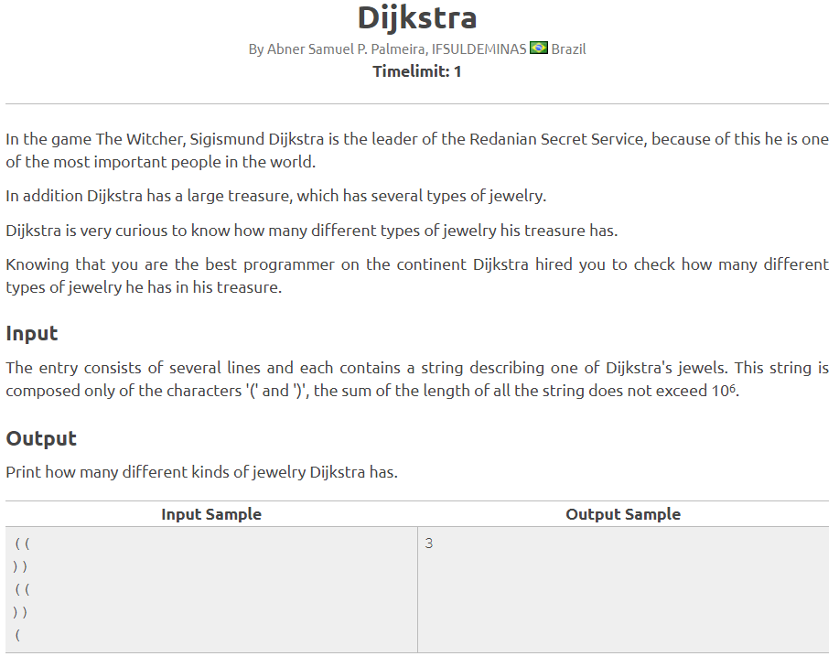

package dijkstra;

import java.io.IOException;

import java.util.ArrayList;

import java.util.Scanner;

public class Dijkstra {

public static void main(String[] args) throws IOException {

Scanner sc = new Scanner(System.in);

ArrayList<Object> lista = new ArrayList<Object>();

String dis = "";

int cont = 0;

Boolean kk = false;

do {

dis = sc.next();

lista.add(dis);

if (dis.equalsIgnoreCase("")) {

kk = true;

}

} while (kk == false);

if (lista.contains("((")) {

cont++;

}

if (lista.contains("))")) {

cont++;

}

if (lista.contains("(")) {

cont++;

}

if (lista.contains(")")) {

cont++;

}

System.out.println(cont + "");

}

}

1. LU-DI-HO!

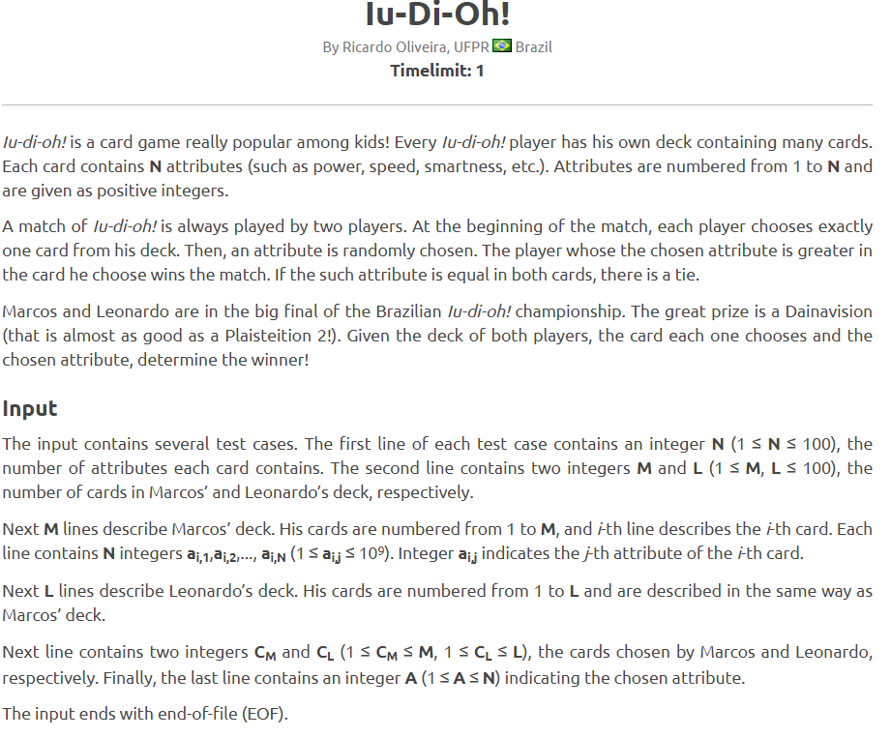

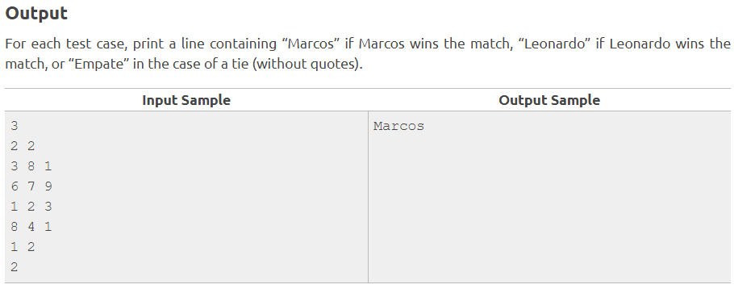

package lu.di.oh;

import java.io.BufferedReader;

import java.io.IOException;

import java.io.InputStreamReader;

public class LuDiOh {

private static final int converterInt(String a) {

return Integer.parseInt(a);

}

private static final String vencedor(int podermarcos, int poderleonardo) {

if (podermarcos > poderleonardo) {

return "Marcos";

}

if (podermarcos < poderleonardo) {

return "Leonardo";

}

return "Empate";

}

public static void main(String[] args) throws IOException {

InputStreamReader inp = new InputStreamReader(System.in);

BufferedReader br = new BufferedReader(inp);

String numeror;

String[] cartasq;

String[] cartasEscogidas;

int[][] matrizmarcos;

int[][] matrizleonardo;

String[] carta2;

String[] carta;

while ((numeror = br.readLine()) != null) {

cartasq = br.readLine().split(" ");

matrizmarcos = new int[Integer.parseInt(numeror)][Integer.parseInt(cartasq[0])];

matrizleonardo = new int[Integer.parseInt(numeror)][Integer.parseInt(cartasq[1])];

for (int i = 0; i < matrizmarcos[0].length; i++) {

carta = br.readLine().split(" ");

for (int j = 0; j < matrizmarcos.length; j++) {

matrizmarcos[j][i] = converterInt(carta[j]);

}

}

for (int i = 0; i < matrizleonardo[0].length; i++) {

carta2 = br.readLine().split(" ");

for (int j = 0; j < matrizleonardo.length; j++) {

matrizleonardo[j][i] = converterInt(carta2[j]);

}

}

cartasEscogidas = br.readLine().split(" ");

int a = converterInt(cartasEscogidas[0]) - 1;

int b = converterInt(cartasEscogidas[1]) - 1;

String atributos = br.readLine();

int podermarcos = matrizmarcos[converterInt(atributos) - 1][a];

int poderleonardo = matrizleonardo[converterInt(atributos) - 1][b];

System.out.println(vencedor(podermarcos, poderleonardo));

}

}

}

1. Magic and Sword

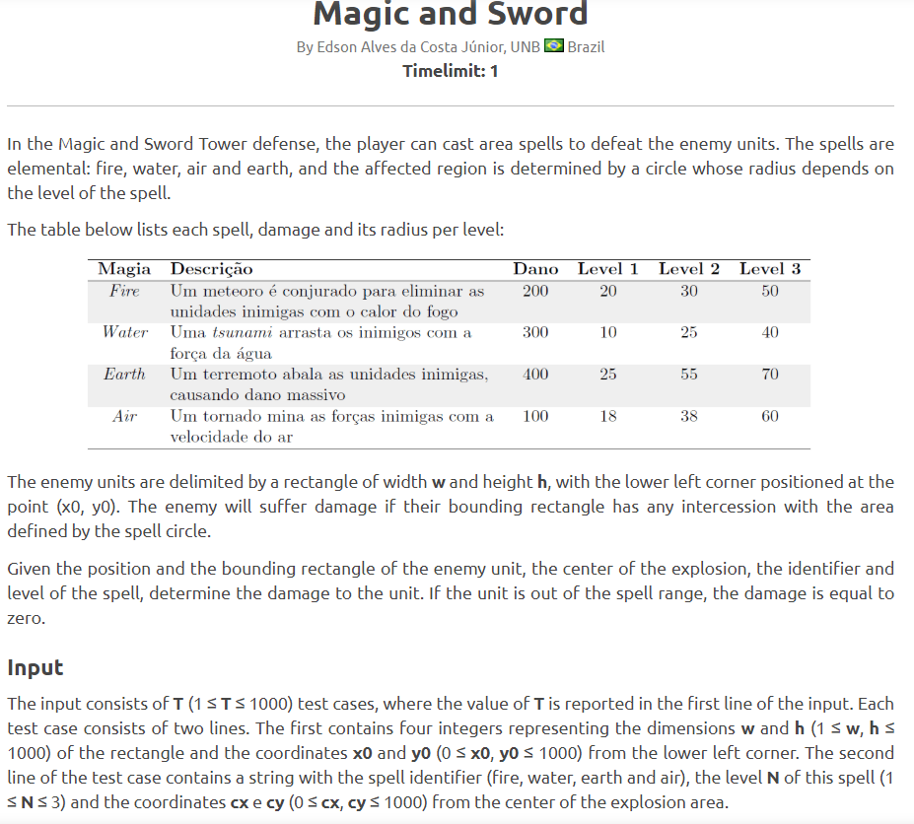

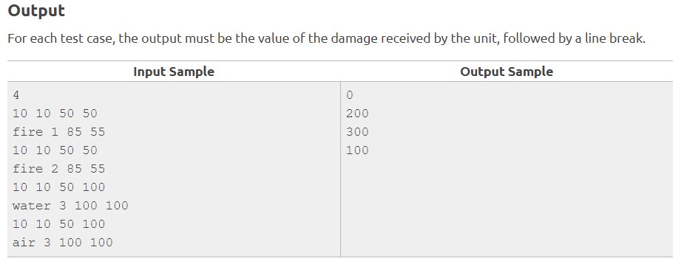

import java.util.Scanner;

public class MagicSword {

public void fire(int w, int h, int x0, int y0, int cx, int cy, int level, String spell) {

while (w <= 1000 & h <= 1000) {

while (x0 <= 1000 & y0 <= 1000) {

Integer damageF = 200;

Integer damageW = 300;

Integer damageE = 400;

Integer damageA = 100;

if (spell.toUpperCase().equalsIgnoreCase("FIRE")) {

while (level <= 3) {

switch (level) {

case 1:

if (cx >= x0 & cy >= y0) {

System.out.println(damageF = 0);

level = 0;

break;

} else {

System.out.println(damageF = damageF + 20);

break;

}

case 2:

if (cx >= x0 & cy >= y0) {

System.out.println(damageF = damageF + 0);

level = 0;

} else {

System.out.println(damageF = damageF + 30);

level = 0;

}

break;

case 3:

if (cx >= x0 & cy >= y0) {

System.out.println(damageF = damageF + 0);

level = 0;

} else {

System.out.println(damageF = damageF + 50);

level = 0;

}

break;

default:

break;

}

}

}

}

}

}

public void water(int w, int h, int x0, int y0, int cx, int cy, int level, String spell) {

while (w <= 1000 & h <= 1000) {

while (x0 <= 1000 & y0 <= 1000) {

Integer damageW = 300;

if (spell.toUpperCase().equalsIgnoreCase("WATER")) {

while (level <= 3) {

switch (level) {

case 1:

if (cx > x0 & cy > y0) {

System.out.println(damageW = 0);

level = 0;

} else {

System.out.println(damageW = damageW + 10);

level = 0;

}

break;

case 2:

if (cx > x0 & cy > y0) {

System.out.println(damageW = damageW + 0);

level = 0;

} else {

System.out.println(damageW = damageW + 25);

level = 0;

}

break;

case 3:

if (cx >= x0 & cy >= y0) {

System.out.println(damageW = damageW + 0);

level = 0;

} else {

System.out.println(damageW = damageW + 40);

level = 0;

}

break;

default:

break;

}

}

}

}

}

}

public void earth(int w, int h, int x0, int y0, int cx, int cy, int level, String spell) {

while (w <= 1000 & h <= 1000) {

while (x0 <= 1000 & y0 <= 1000) {

Integer damageE = 400;

if (spell.toUpperCase().equalsIgnoreCase("EARTH")) {

while (level <= 3) {

switch (level) {

case 1:

if (cx > x0 & cy > y0) {

System.out.println(damageE = 0);

level = 0;

} else {

System.out.println(damageE = damageE + 25);

level = 0;

}

break;

case 2:

if (cx > x0 & cy > y0) {

System.out.println(damageE = damageE + 0);

level = 0;

} else {

System.out.println(damageE = damageE + 55);

level = 0;

}

break;

case 3:

if (cx > x0 & cy > y0) {

System.out.println(damageE = damageE + 0);

level = 0;

} else {

System.out.println(damageE = damageE + 70);

level = 0;

}

break;

default:

break;

}

}

}

}

}

}

public void air(int w, int h, int x0, int y0, int cx, int cy, int level, String spell) {

while (w <= 1000 & h <= 1000) {

while (x0 <= 1000 & y0 <= 1000) {

Integer damageA = 100;

if (spell.toUpperCase().equalsIgnoreCase("AIR")) {

while (level <= 3) {

switch (level) {

case 1:

if (cx >= x0 & cy >= y0) {

System.out.println(damageA = 0);

level = 0;

} else {

System.out.println(damageA = damageA + 18);

level = 0;

}

break;

case 2:

if (cx > x0 & cy > y0) {

System.out.println(damageA = damageA + 0);

level = 0;

} else {

System.out.println(damageA = damageA + 38);

level = 0;

}

break;

case 3:

if (cx >= x0 & cy >= y0) {

System.out.println(damageA = damageA + 0);

level = 0;

} else {

System.out.println(damageA = damageA + 60);

level = 0;

}

break;

default:

break;

}

}

}

}

}

}

public static void main(String[] args) {

int width, height, px, py, pcx, pcy, lv, rpt;

String spl;

Scanner w = new Scanner(System.in);

Scanner h = new Scanner(System.in);

Scanner x0 = new Scanner(System.in);

Scanner y0 = new Scanner(System.in);

Scanner cx = new Scanner(System.in);

Scanner cy = new Scanner(System.in);

Scanner level = new Scanner(System.in);

Scanner spell = new Scanner(System.in);

Scanner repetition = new Scanner(System.in);

do {

System.out.println("How many repetitions do you want to do ?");

rpt = repetition.nextInt();

for (int i = 0; i < rpt; i++) {

System.out.println("Tip a spell");

spl = spell.nextLine();

if (spl.equalsIgnoreCase("FIRE")) {

segundo s = new segundo();

System.out.println("Tip a width ");

width = w.nextInt();

System.out.println("Tip a width ");

height = h.nextInt();

System.out.println("Tip a width ");

px = x0.nextInt();

System.out.println("Tip a width ");

py = y0.nextInt();

System.out.println("Tip a width ");

pcx = cx.nextInt();

System.out.println("Tip a width ");

pcy = cy.nextInt();

System.out.println("Tip a width ");

lv = level.nextInt();

s.(width, height, px, py, pcx, pcy, lv, spl);

} else if (spl.equalsIgnoreCase("WATER")) {

segundo s = new segundo();

System.out.println("Tip a width ");

width = w.nextInt();

System.out.println("Tip a width ");

height = h.nextInt();

System.out.println("Tip a width ");

px = x0.nextInt();

System.out.println("Tip a width ");

py = y0.nextInt();

System.out.println("Tip a width ");

pcx = cx.nextInt();

System.out.println("Tip a width ");

pcy = cy.nextInt();

System.out.println("Tip a width ");

lv = level.nextInt();

s.water(width, height, px, py, pcx, pcy, lv, spl);

} else if (spl.equalsIgnoreCase("EARTH")) {

segundo s = new segundo();

System.out.println("Tip a width ");

width = w.nextInt();

System.out.println("Tip a width ");

height = h.nextInt();

System.out.println("Tip a width ");

px = x0.nextInt();

System.out.println("Tip a width ");

py = y0.nextInt();

System.out.println("Tip a width ");

pcx = cx.nextInt();

System.out.println("Tip a width ");

pcy = cy.nextInt();

System.out.println("Tip a width ");

lv = level.nextInt();

s.earth(width, height, px, py, pcx, pcy, lv, spl);

} else if ((spl.equalsIgnoreCase("AIR"))) {

segundo s = new segundo();

System.out.println("Tip a width ");

width = w.nextInt();

System.out.println("Tip a width ");

height = h.nextInt();

System.out.println("Tip a width ");

px = x0.nextInt();

System.out.println("Tip a width ");

py = y0.nextInt();

System.out.println("Tip a width ");

pcx = cx.nextInt();

System.out.println("Tip a width ");

pcy = cy.nextInt();

System.out.println("Tip a width ");

lv = level.nextInt();

s.AirD(width, height, px, py, pcx, pcy, lv, spl);

}

}

} while (rpt != 0);

}

}

public class Principal {

public static void main(String[] args) {

int a = 9;

System.out.println("entro");

while (a <= 1000) {

System.out.println("entro otra vez");

int w = 10;

int h = 10;

while (w <= 1000 & h <= 1000) {

int x0 = 50;

int y0 = 100;

while (x0 <= 1000 & y0 <= 1000) {

String spell = "Air";

Integer damageF = 200;

Integer damageW = 300;

Integer damageE = 400;

Integer damageA = 100;

if (spell.equalsIgnoreCase("fire")) {

int level = 1;

int cx = 85;

int cy = 55;

while (level <= 3) {

switch (level) {

case 1:

if (cx >= x0 & cy >= y0) {

System.out.println(damageF = 0);

} else {

System.out.println(damageF = damageF + 20);

}

break;

case 2:

if (cx >= x0 & cy >= y0) {

System.out.println(damageF = damageF + 0);

} else {

System.out.println(damageF = damageF + 30);

}

break;

case 3:

if (cx >= x0 & cy >= y0) {

System.out.println(damageF = damageF + 0);

} else {

System.out.println(damageF = damageF + 50);

}

break;

default:

break;

}

}

} else if (spell.equalsIgnoreCase("water")) {

int level = 3;

int cx = 100;

int cy = 100;

while (level <= 3) {

switch (level) {

case 1:

if (cx > x0 & cy > y0) {

System.out.println(damageW = 0);

} else {

System.out.println(damageW = damageW + 10);

}

break;

case 2:

if (cx > x0 & cy > y0) {

System.out.println(damageW = damageW + 0);

} else {

System.out.println(damageW = damageW + 25);

}

break;

case 3:

if (cx >= x0 & cy >= y0) {

System.out.println(damageW = damageW + 0);

} else {

System.out.println(damageW = damageW + 40);

}

break;

default:

break;

}

}

} else if (spell.equalsIgnoreCase("Earth")) {

int level = 0;

int cx = 85;

int cy = 55;

while (level <= 3) {

switch (level) {

case 1:

if (cx > x0 & cy > y0) {

System.out.println(damageE = 0);

} else {

System.out.println(damageE = damageE + 25);

}

break;

case 2:

if (cx > x0 & cy > y0) {

System.out.println(damageE = damageE + 0);

} else {

System.out.println(damageE = damageE + 55);

}

break;

case 3:

if (cx > x0 & cy > y0) {

System.out.println(damageE = damageE + 0);

} else {

System.out.println(damageE = damageE + 70);

}

break;

default:

break;

}

}

} else if (spell.equalsIgnoreCase("Air")) {

int level = 3;

int cx = 100;

int cy = 100;

while (level <= 3) {

switch (level) {

case 1:

if (cx >= x0 & cy >= y0) {

System.out.println(damageA = 0);

} else {

System.out.println(damageA = damageA + 18);

}

break;

case 2:

if (cx > x0 & cy > y0) {

System.out.println(damageA = damageA + 0);

} else {

System.out.println(damageA = damageA + 38);

}

break;

case 3:

if (cx >= x0 & cy >= y0) {

System.out.println(damageA = damageA + 0);

} else {

System.out.println(damageA = damageA + 60);

}

break;

default:

break;

}

}

}

}

}

}

}

}