Collabtive Guide
Contents
2
2
Login 2
2
The Desktop 2
My Projects 2
My Tasks 3
Milestones 3
My Messages 3
Online List 4
Search 4
Browser search box 4
Personal Views 4
My Projects 4
My Tasks 4
My Messages 4
The project view 5
Overview 5
News 5
Tasks 5
Milestones 5
Files 5
People 5
Time and Attendance 5
5

Login
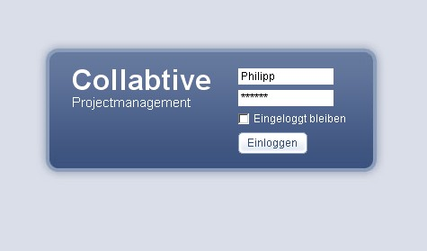
On the login page to enter your username and password.
The option to stay Logged In effect the next time you open Collabtive an automatic login. To use this option must have cookies enabled in your browser.

The Desktop
After logging opens up the desktop.
It is the central repository for tasks, messages, etc.

My Projects
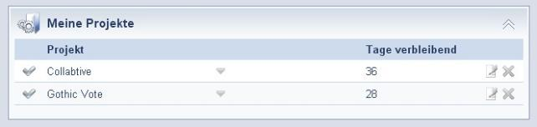
Here are the projects will be displayed is assigned to a user.
Administrators can complete projects, edit or delete them.
Clicking on a project leads to the project view.

My Tasks
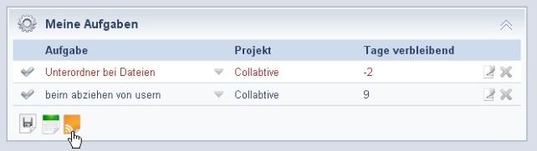
This block displays the current tasks of a user. Clicking on a task opens the detail view.
A click on the project name to open the task view of this project.
In addition, the tasks in iCal, RSS, or can be exported.
Tasks whose due date is in the future, appear in blue.
Tasks today are due to appear in green.
Late tasks appear in red.

Milestones
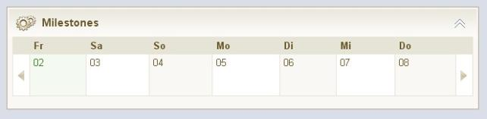
Here is a summary is available to active milestones.
This view provides a timeline of the next 7 days.
The view can use the arrows to scroll left and right.

My Messages
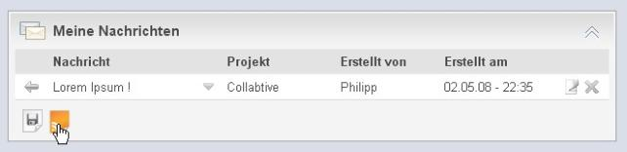
The My Messages view displays all messages a user from all its projects.
A click on the blue arrow opens a message to read.
Moreover, the messages will be exported as RSS can feed.

Online List
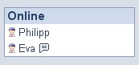
In the online list of currently active users are displayed.
A click on the name of a user opens his / her profile.
In addition, a discussion with others can be started by clicking on the bubble next to the name.

Search
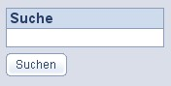
The search box located on the desktop lower right.
Here is for projects, tasks, messages, files, etc. will be searched.

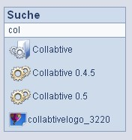
The search begins as soon as something is typed into the search box to search in the background and displays matching proposals.

Browser search box
The search can Collabtive than the integrated search engine search boxes of Firefox 2 and added to Internet Explorer 7.

Personal Views
In addition to the Quick Reference on the desktop and the reports in the projects Collabtive also offers an extensive range of personal views.
This can be achieved by clicking on the titles of the respective blocks on the desktop.

My Projects

My Tasks

My Messages

The project view

Overview

News

Tasks

Milestones

Files

People

Time and Attendance

Last Updated: 03.05.08
Page 6 / 6

