Groundwater modelling in SWAT+: Considerations for a realistic baseflow simulation

Alejandro Sánchez-Gómez\*a, Christoph Schürzb, Eugenio Molina-Navarroa, Katrin Biegerc.

*a Department of Geology, Geography and Environment. University of Alcalá. Carretera*

*Madrid-Barcelona Km. 33,6. 28805. Alcalá de Henares, Spain. (*[alejandro.sanchezgomez97@gmail.com](mailto:alejandro.sanchezgomez97@gmail.com), [alejandro.sanchezg@uah.es](mailto:alejandro.sanchezg@uah.es))

*b Department of Computational Landscape Ecology. Helmholtz Centre for Environmental Research. Permoserstrasse 15, 04318 Leipzig, Germany.*

*c Department of Ecoscience. Aarhus University. C.F. Møllers Allé 3, building 1130, 424,*

*8000, Aarhus C. Denmark.*

Appendix A: Parameters constrain example.

Figure A1: Parameters constrain example.

This figure is an example of parameters constrain based on one variable, in this case PBIAS. Red rectangles indicate the range values of the parameter that will be used for the following iteration. Green lines indicated the best possible value for PBIAS. As can be observed, only those parameters that show effect on the variable are constrained. It should be noted that for different variables, the constrained ranges for a certain parameter might be different.

Appendix B: Parameters values

The following figure shows the range of values used for each parameter for the iterations run in the different calibration approaches.

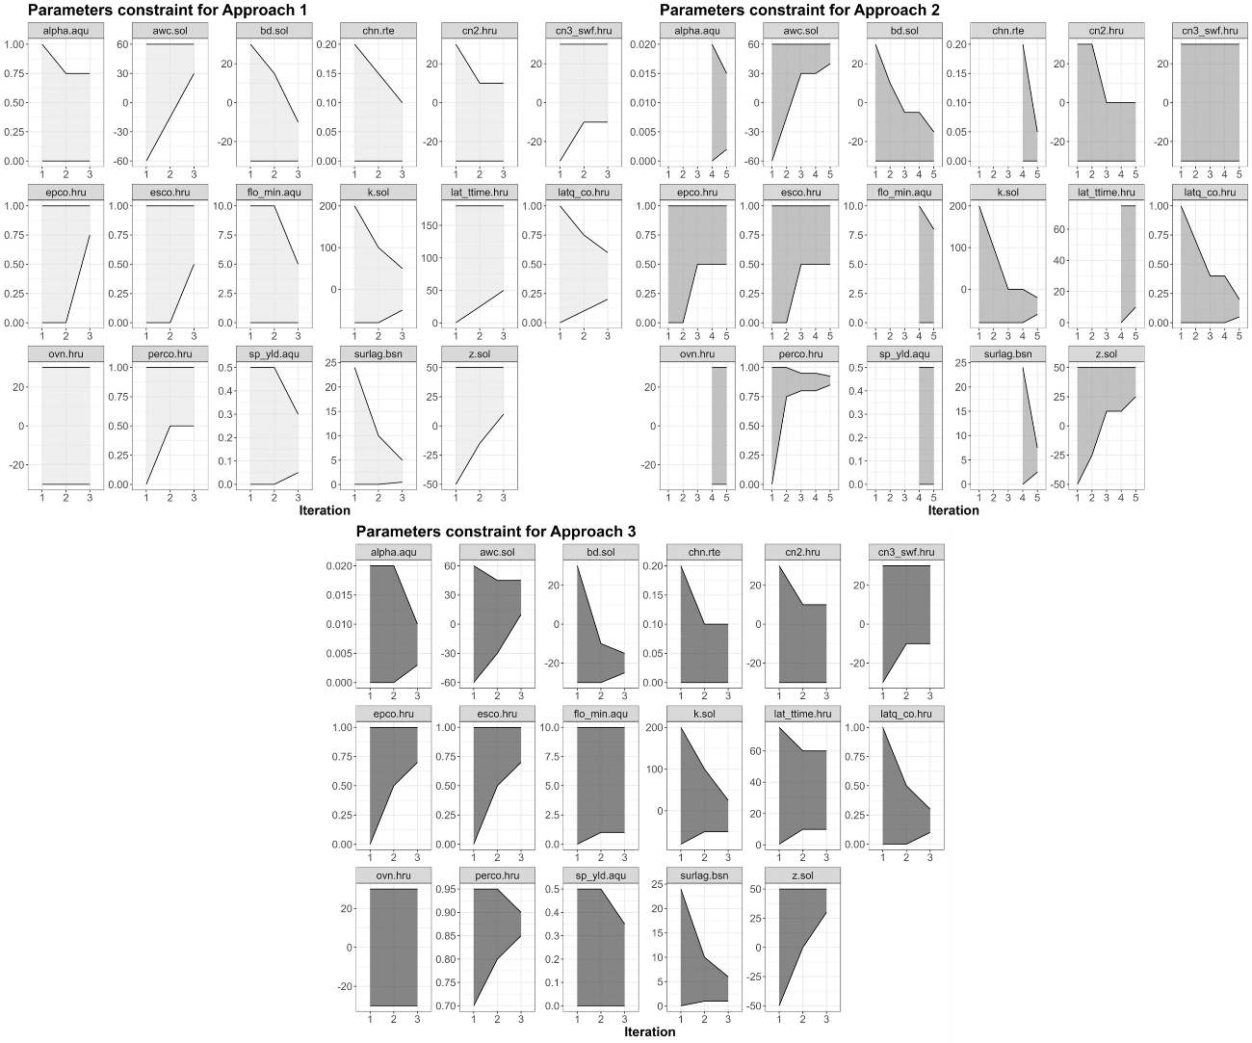

Figure B1: Parameter ranges used during calibration approaches for each iteration.

Table B1: Parameters’ values for the best simulations of each calibration approach and for the fine-tuning simulation.

