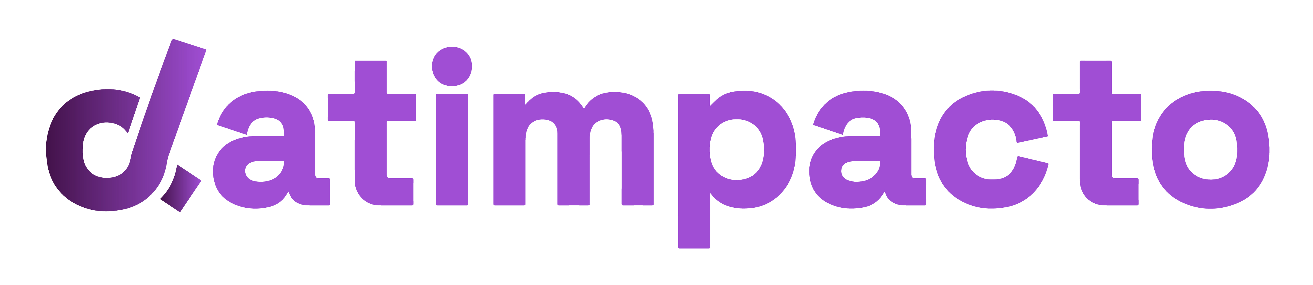
Datimpacto

Final Deliverable Sign-off Checklist
Datimpacto · MEL Community of Practice Toolkit · Tool 5
Purpose: decide whether a final deliverable is ready to approve, with reasons you can share with the consultant/provider. When to use: when the draft final deliverable arrives, and again for the revised version. Time needed: 1.5 to 3 hours, depending on length.

Seven Questions Before You Sign Off
# | Question | What to look for | Red flag
1 | Does it answer what was asked? | Every priority question or ToR requirement is addressed. | Requirements dropped or merged without explanation.
2 | Is the product trustworthy? | Sample achieved vs planned, response rates, missing data and limitations stated for a report; data lineage, coverage and known gaps stated for a dataset or system handover. | No mention of what went wrong, or what the deliverable does not cover.
3 | Is the underlying work sound? | Methods match the questions or requirements; comparisons, disaggregation or technical choices are explained. | Percentages with no base, claims the design cannot support, or technical choices left unexplained.
4 | Are the findings or outputs credible? | Each finding or output is backed by more than one source, or clearly labeled as based on one. | Findings or outputs resting on a single quote, a single site or an unverified source.
5 | Do conclusions follow from the evidence? | You can trace each conclusion or design choice back to specific evidence. | New ideas or choices that never appear in the evidence presented.
6 | Is the deliverable usable? | Each recommendation, indicator or component says who should do what, and by when, and links to a conclusion or requirement. | “Strengthen coordination” with no owner or action, or a component no one can operate without the consultant.
7 | Is it readable by the team that has to run with it? | An executive summary or handover note a busy reader can use on its own; plain language; annexes or technical documentation for detail. | A 100-page report with a 10-page summary, or documentation only the original consultant can navigate.
For each question, mark Meets / Partly meets / Does not meet, with a page or section reference.
Framed here for a final evaluation report, the toolkit’s running example. The same seven questions apply to a MEL system handover, a dataset, or a design document.

Decision
- Approve.
- Approve with minor revisions (list them; no new review round needed).
- Return for revision (list what must change before the next review).
Share comments in a response matrix (comment, section, provider response, status) so every point gets closed.

A Note on AI
An AI assistant can run a first pass on the deliverable’s text and stated methodology (see Tool 9). It does not see raw beneficiary-level data, and it does not approve the deliverable. A person reads it and signs off.

References
- UNEG (2010). Quality Checklist for Evaluation Reports.
- OECD DAC (2010). Quality Standards for Development Evaluation.
- ALNAP (2016). Evaluation of Humanitarian Action Guide.
- BetterEvaluation. Manager’s Guide to Evaluation. betterevaluation.org

