MySQL Question 1

Considering the query below, if you needed to add the tbl3 slug field into the result set how would you do it?
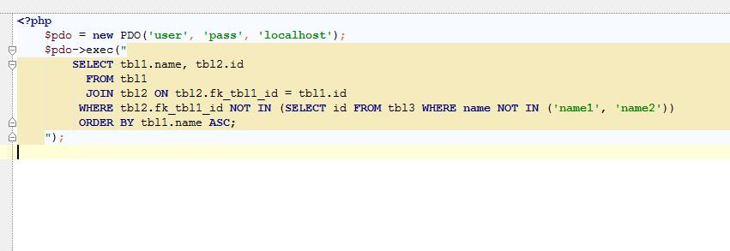

MySQL Answer 1

(Provide your answer below. Use as much space as necessary.)

I think we have to add an additional JOIN like:

SELECT tbl1.name, tbl2.id, tbl3.slug

FROM tbl1

JOIN tbl2 ON tbl2.fk_tbl1_id = tbl2.id

JOIN tbl3 ON tbl2.fk_tbl1_id = tbl3.id

WHERE tbl3.name IN ('name1', 'name2')

ORDER BY tbl1.name ASC;

