MySQL Question 2

The following query throws a duplicate primary key error and blocks a cron job to move forward. How can this query be changed so the error is not thrown, and the record is updated?
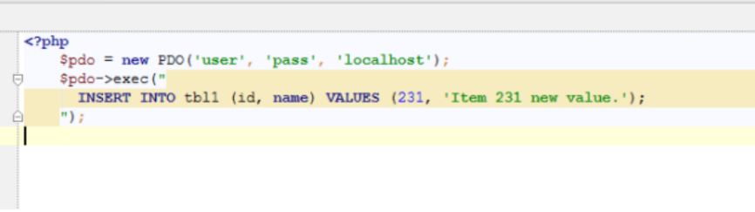
MySQL Answer 2

(Provide your answer below. Use as much space as necessary.)

We have to check if the record exists first, if it does – UPDATE, if it does not exist then INSERT.

