PHP Question 1.2

Consider that the Exam class will be successfully loaded by the autoloader.

Given the described class definition, what is the output of index.php?

Exam.php
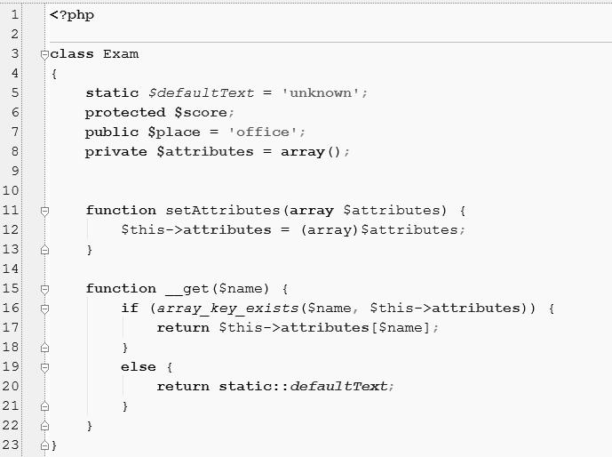
index.php

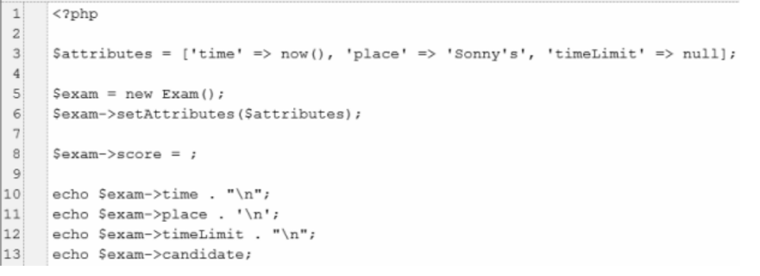
PHP Answer 1.2

(Provide your answer below. Use as much space as necessary.)

First of all the syntax error: $exam->score = ;

The second thing is the $score property cannot be accessed in index.php because it's protected. The way we could access it is using a get method like setAttributes()

So I would do the following changes:

require_once 'Exam.php';

$attributes = ['time' => date(time()), 'place' => 'Sonny\'s', 'timeLimit' => null];

$exam = new Exam();

$exam->setAttributes($attributes);

$exam->score = 5; // should be accessed via a getter method declared in Examp.php

echo $exam->time . "\n";

echo $exam->place . "\n";

echo $exam->timeLimit . "\n";

echo $exam->candidate . "\n";

