PHP Question 1.3

Assume that the Greeter and InformalGreeter classes will be successfully loaded by the autoloader. Given the described class definitions, what is the output of index.php?

Greeter.php

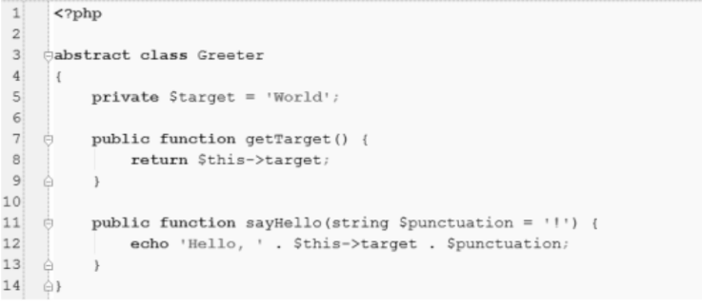
InformalGreeter.php
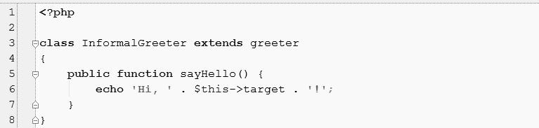

index.php
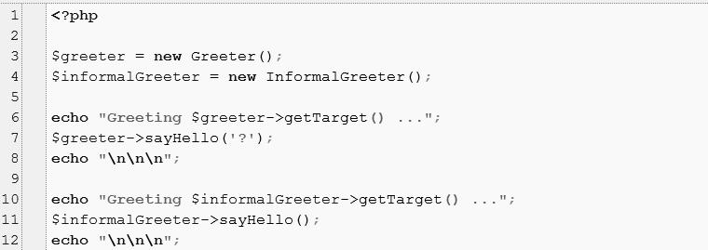

PHP Answer 1.3

(Provide your answer below. Use as much space as necessary.)

We can't create an instance of abstract class like new Greeter(). Also we should follow the abstract class parameters in order to override the InformalGreeter class methods. The next we have to do is change the $target property to protected so that it will be accessible in InformalGreeter class.

The way the given code would work after some changes is:

<?php
abstract class Greeter

{
protected $target = 'World';
public function getTarget() {
return $this->target;
}

public function sayHello(string $punctuation = '!') { echo 'Hello, ' . $this->target . $punctuation;

}

}

class InformalGreeter extends Greeter

{
public function sayHello(string $punctuation = '!') {
echo 'Hi, ' . $this->target . '!';

}

}

require_once 'Greeter.php';

require_once 'InformalGreeter.php';

// $greeter = new Greeter();

$informalGreeter = new InformalGreeter();

- echo "Greeting $greeter->getTarget() ...";

- $greeter->sayHello('?');

- echo "\n\n\n";

echo "Greeting " . $informalGreeter->getTarget() . " ..."; $informalGreeter->sayHello();
echo "\n\n\n";

The output will be like: Greeting World ...Hi, World!

