PHP Question 2.3

Without altering the given code:

- Represent a universal remote that can turn on a television and a cable box.

- Represent a remote-control user who can push the `power on’ button of a remote control.

- Have a remote-control user push the `power on’ button of a tv remote.

- Have the same remote-control user push the `power on’ button of a universal remote.


<?php

interface RemoteControl {

public function powerOn();
}

class Television {
public function setPower($state) {

// Truncated Code
}

}

class CableBox {

public function setPower($state) {
// Truncated Code

}
}

class TVRemote implements RemoteControl
{

private $tv;

public function __construct(Television $tv) {
$this->tv = $tv;

}

public function powerOn() {
$this->tv->setPower(true);

}
}

PHP Answer 2.3

(Provide your answer below. Use as much space as necessary.)

1.

class UniversalRemote extends TVRemote

{
private $cableBox;

public function __construct(CableBox $cableBox) { parent::__construct(new Television()); parent::powerOn();
$this->cableBox = $cableBox;
}

public function powerOn() {
$this->cableBox->setPower(true);
}

}

2.

class User extends TVRemote

{

public function __construct() {

$this->tv =new Television();


parent::__construct($this->tv);
}

public function powerOnButton() {
$this->powerOn();

}

}

3.
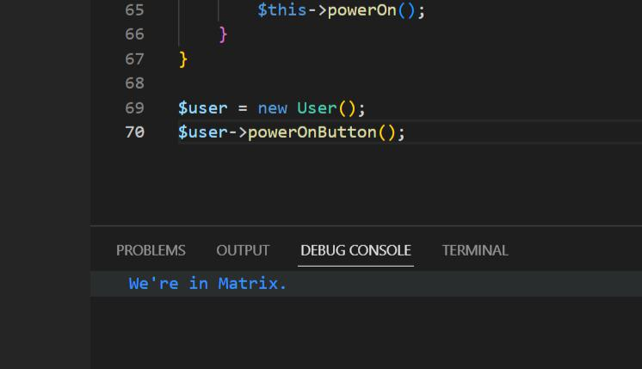

4.

class User extends TVRemote

{

public function __construct() {

$this->tv =new Television();

parent::__construct($this->tv);
}

public function powerOnButton() {
$this->powerOn();
}

public function powerOnUniversalButton(UniversalRemote $universalRemote) { $universalRemote->powerOn();

}

}

