Technical Assessment
Name: Alexander Jose Lopez Ochoa

Section A – Architecture & Roadmap
1. Target Architecture for Multi-Country Digital Direct Channel
To support a multi-country Digital Direct Channel, the architecture must follow a Geo-Distributed, Cloud-Native, API-First approach. The design relies on an Active-Active multi-region footprint to ensure low latency for local users and seamless failover.
Core Architectural Pillars:
- High Availability (HA): Deployments are distributed across at least two geographical regions (e.g., North America and Europe) in an Active-Active configuration. Global DNS and Content Delivery Networks (CDN) geo-route user traffic to the closest healthy region. If a region degrades, traffic is automatically routed to the surviving region.
- Scalability: Workloads run on managed Kubernetes clusters (e.g., AKS, EKS) utilizing Horizontal Pod Autoscaling (HPA) and Event-Driven Autoscaling (KEDA) based on CPU, memory, and queue depths. Databases are geo-replicated and scaled horizontally.
- Resilience: The application tier is decoupled from underlying legacy systems using Event-Driven Architecture (EDA). If backend fulfillment or ERP systems go down, the Direct Channel continues to take requests (e.g., orders/bookings) and queues them for eventual processing.
- Observability: A centralized observability plane aggregates Metrics, Logs, and Traces utilizing the OpenTelemetry standard. Distributed tracing correlates multi-country interactions, ensuring end-to-end visibility across microservices and external dependencies.
2. Integration & Resilience Patterns
To guarantee system stability under heavy load and unreliable network conditions, the following patterns are enforced across the integration layer:
- Retries (with Exponential Backoff & Jitter): Transient network errors are handled via automated retries configured at the Service Mesh level (e.g., Istio or Linkerd). Jitter prevents "thundering herd" scenarios where multiple instances retry simultaneously.
- Circuit Breaker: Implemented at the API Gateway and Service Mesh levels. If a downstream service (like a legacy CRM) experiences sustained failures or latency, the circuit trips to prevent cascading resource exhaustion, returning a cached response or a graceful error message.
- Idempotency: Critical for multi-country transactions (e.g., payments, orders). Every state-mutating API call requires an Idempotency-Key in the header. The gateway/service verifies this key against a distributed cache (Redis) to guarantee that a network retry never results in duplicate transactions.
- Bulkheads: Resource isolation is applied per service integration. Thread pools and memory limits are partitioned so that if a specific external API slows down, it only exhausts its dedicated connection pool, keeping the rest of the application responsive.
- Asynchronous Messaging: Direct point-to-point synchronous calls are minimized. A distributed message broker (e.g., Kafka or Cloud Service Bus) is used for Publish-Subscribe flows. For example, once an order is placed, an OrderCreated event is published, decoupling the frontend response from the heavy backend processing.
- Caching Strategies:
  - Edge Caching: Static assets and localized configurations are cached at the global CDN level.
  - Cache-Aside Pattern: Distributed Redis caches read-heavy, slow-moving data (product catalogs, multi-country localization files) at the microservice level to reduce database queries.

3. 12-Week Technical Roadmap
This roadmap outlines the phased execution across three critical workstreams to modernize and harden the platform.

Architecture diagram (source – architecture_diagram.mmd)

Phase | Reliability Workstream | Integration Modernization Workstream | Observability & Operations Workstream
Phase 1: Foundation (Weeks 1–4) | Multi-Region Base: Provision Active-Active K8s clusters across target regions. Setup Global DNS failover. | API Gateway Setup: Deploy and configure federated API Gateways. Define API contracts and Idempotency standards. | Telemetry Baseline: Implement OpenTelemetry agents across all environments. Define core SLIs and SLOs.
Phase 2: Core Build (Weeks 5–8) | Resilience Engineering: Configure Service Mesh Circuit Breakers, Retries, and Bulkheads. Implement Redis caching layers. | Async Backbone Deployment: Provision Kafka/Event Broker. Refactor 2 core synchronous legacy APIs into event-driven flows. | Distributed Tracing: Ensure trace IDs propagate through the API Gateway, Microservices, and Event Broker. Create centralized logging sinks.
Phase 3: Hardening (Weeks 9–12) | Chaos & Scale: Execute Chaos Engineering (pod disruption, region failover drills). Tune auto-scaling (HPA/KEDA) thresholds. | Legacy Decoupling: Finalize data sync between modern persistence layers and legacy ERPs. Rollout Edge CDN caching. | AIOps & Alerting: Build role-based dashboards (Business vs. Tech). Configure predictive alerting and automated runbooks for on-call teams.
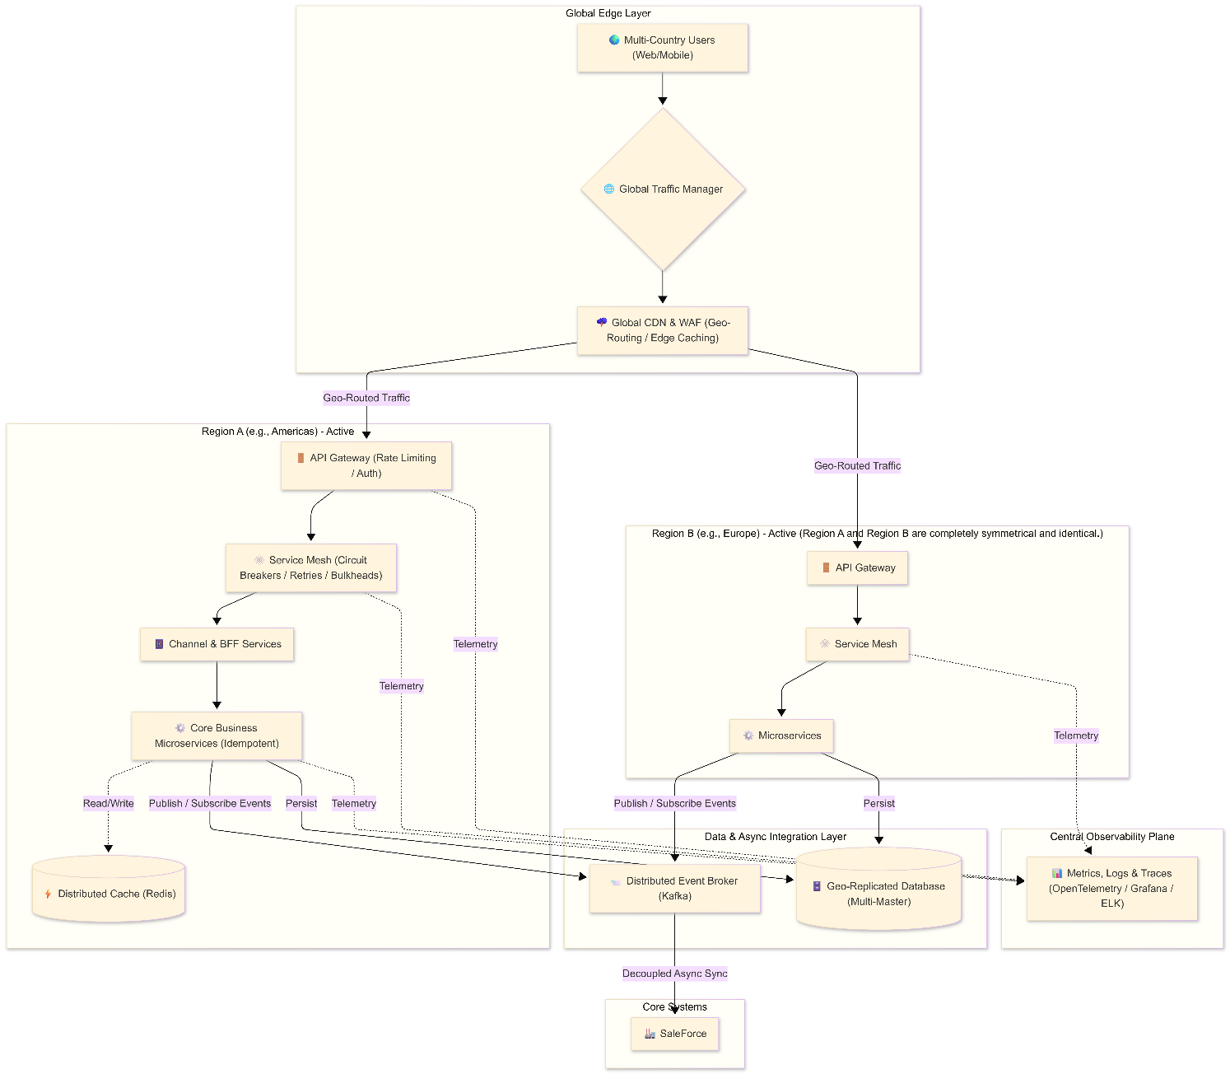

Section B – Reusable Integration Framework

- Design Decisions
The Framework is created in SpringBoot 3.5.14 +JAVA 21 +MAVEN
Clean Architecture (Ports & Adapters)
- Decision: Isolate business logic from infrastructure frameworks. The core domain should not know about HTTP clients, OpenTelemetry, or Resilience4j.
- Implementation: We define an interface (IntegrationPort) in the Application layer. The actual integration component (ResilientIntegrationAdapter) sits in the infrastructure layer and implements this interface.
Resilience (Timeouts, Retries, Circuit Breaker)
- Decision: Use Resilience4j, which is the standard fault-tolerance library for Spring Boot 3.x.
- Implementation: We configure a CircuitBreaker (to fail fast if the external system goes down), a Retry (with exponential backoff and randomized jitter to prevent thundering herd scenarios), and a TimeLimiter (to prevent hanging threads).
Observability (Logging & OpenTelemetry)
- Decision: Use Micrometer Tracing with an OpenTelemetry (OTel) bridge.
- Implementation: Spring Boot 3 natively supports Micrometer. By adding the OTel bridge, Spring automatically intercepts incoming and outgoing HTTP requests (via RestClient), injecting traceId and spanId into the SLF4J MDC (Mapped Diagnostic Context) for unified logging, and propagating the traceparent header to downstream services.
Idempotency
- Decision: Idempotency must be managed safely across retries to prevent duplicate processing on the external system.
- Implementation: We enforce passing an Idempotency-Key (e.g., a UUID or a hash of the payload) via HTTP headers. Because we use Resilience4j retries, keeping the exact same idempotency key for all retry attempts ensures the downstream system recognizes it as the same transaction.

Section C – Demo Service & Reliability Test

This demo service demonstrates a clean architecture integration framework with built-in resilience patterns , It includes a simulated flaky upstream service that can be configured at runtime to produce failures and latency, allowing you to observe how the resilience mechanisms mitigate issues.
The scenarios to test are:
- Healthy Upstream (0% failure)
- Flaky Upstream (60% failure) — Retry with Exponential Backoff + Jitter
- Total Upstream Failure (100%) — Circuit Breaker Activation
- Idempotency Key Support
- Observability — Trace Propagation
For detail instructions refer to DEMO.md

Section D – Technical Decision Record

Architecture Decision Record (ADR)
Title: Integration Strategy and Communication Patterns for Critical Flows
Date: May 9, 2026
Status: Accepted
1. Context
As we scale our multi-country Digital Direct Channel, we face systemic bottlenecks in how we deliver and execute integrations. Currently, a single centralized middleware team handles all partner integrations, creating long lead times. Simultaneously, our critical flows (e.g., order processing, payment capture) rely heavily on synchronous service-to-service communication, making the platform vulnerable to cascading failures during high-traffic events or partial outages. We must establish a scalable target operating model for integration ownership and a resilient architectural pattern for critical transaction flows.

2. Decision 1: Integration Platform Ownership
Options
- Option A: Centralized Integration Platform. A dedicated integration team owns a centralized Enterprise Service Bus (ESB) or centralized API Gateway. They build, deploy, and maintain all routing, transformation, and integration logic.
- Option B: Decentralized Team-Owned Integrations. "Smart endpoints, dumb pipes." Cross-functional product domains own their integrations from end-to-end, utilizing self-service infrastructure (e.g., an API Gateway configured via declarative CI/CD pipelines) and standard libraries.
Decision
We select Option B (Decentralized Team-Owned Integrations) with Centralized Governance. Product teams will build and maintain their own integration microservices. To prevent chaos, a central Platform Engineering team will provide standardized templates (scaffolding), self-service CI/CD tools, and enforce strict API governance (contracts, security policies, and observability standards) at the gateway level.

3. Decision 2: Architecture for Critical Flows
Options
- Option A: Synchronous Request-Response (REST/gRPC). Services call each other directly waiting for a response. Simple to reason about, trace, and implement.
- Option B: Event-Driven / Asynchronous. Services communicate by producing and consuming events via an event broker (e.g., Kafka). Services react to state changes without knowing about each other.
Decision
We select Option B (Event-Driven Architecture) for all critical state-changing flows, while retaining Synchronous API calls strictly for edge/client queries (Reads) and UI orchestration. Critical writes (e.g., Checkout, Inventory Reservation) will emit domain events.

4. Consequences
Positive Impacts
- Autonomy and Velocity: Domain teams are no longer blocked by a centralized integration team's backlog, drastically reducing time-to-market for new regional rollouts.
- Resilience and Fault Tolerance: In an event-driven model, if the Notification or Receipt service goes down, the Order service remains unaffected. Messages queue in the broker and process once the downstream service recovers.
- Scalability: We can scale specific consumers of an event independently based on load, rather than scaling an entire centralized monolith.
Negative Impacts / Risks to Mitigate
- Operational Complexity: Decentralization and event-driven architectures introduce heavy distributed complexity. We must heavily invest in OpenTelemetry (Distributed Tracing) and centralized logging to debug flows that span multiple asynchronous boundaries.
- Eventual Consistency: UI/UX paradigms must shift. Frontends can no longer expect an immediate "success" response for complex flows; they must handle pending states (e.g., WebSockets, polling, or optimistic UI updates).
- Skill Gap: Domain teams must be upskilled in handling asynchronous patterns, idempotency, dead-letter queues, and schema evolution (e.g., Avro/Protobuf registries).

