**UNRC**

**INGLÉS (Cód. 1976) MATEMÁTICAS Y CS. DE LA COMPUTACIÓN**

**GUÍA 5 - TAREA ASINCRÓNICA (PARTE I)**

<https://www.geeksforgeeks.org/what-is-data-structure-types-classifications-and-applications/?ref=lbp>

**Data Structure Types, Classifications and Applications**

Last Updated: 21 Dec, 2023

**What is Data Structure:**

*A data structure is a storage that is used to store and organize data. It is a way of arranging*

*data on a computer so that it can be accessed and updated efficiently.*

A data structure is not only used for organizing the data. It is also used for processing, retrieving,

and storing data. Different basic and advanced types of data structures are used in almost every

program or software system that has been developed. So we must have good knowledge of data

structures**.**

**Classification of Data Structure:**

Data structure has many different uses in our daily life. There are many different data structures

that are used to solve different mathematical and logical problems. By using data structure, one

can organize and process a very large amount of data in a relatively short period. Let’s look at

different data structures that are used in different situations.

*Classification of Data Structure*

•

**Linear data structure:** Data structure in which data elements are arranged sequentially or

linearly, where each element is attached to its previous and next adjacent elements, is called

a linear data structure.

*Examples of linear data structures are array, stack, queue, linked list, etc.*

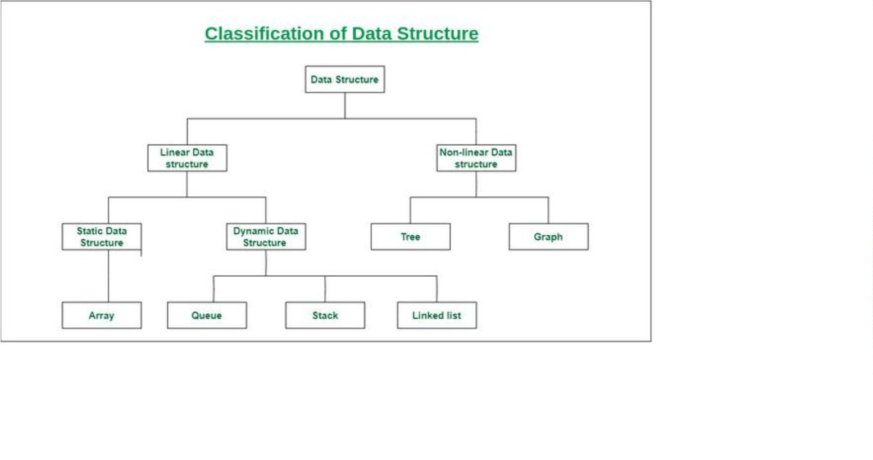

**UNRC**

**INGLÉS (Cód. 1976) MATEMÁTICAS Y CS. DE LA COMPUTACIÓN**

•

•

**Static data structure:** Static data structure has a fixed memory size. It is easier to

access the elements in a static data structure.

*An example of this data structure is an array.*

**Dynamic data structure:** In the dynamic data structure, the size is not fixed. It can

be randomly updated during the runtime which may be considered efficient

concerning the memory (space) complexity of the code.

*Examples of this data structure are queue, stack, etc.*

•

**Non-linear data structure:** Data structures where data elements are not placed sequentially

or linearly are called non-linear data structures. In a non-linear data structure, we can’t

traverse all the elements in a single run only.

*Examples of non-linear data structures are trees and graphs.*

**ACTIVIDADES DE PRELECTURA**

1

2

3

. Identifica y menciona la fuente del texto.

. Identifica el título y los subtítulos del texto y escribe un equivalente en español de cada uno.

. Observa la imagen que acompaña al texto y describe, brevemente y con tus palabras, qué muestra

la misma y de qué manera se relaciona con el texto.

4

. Busca en el diccionario el significa EXACTO de las palabras resaltadas, teniendo en cuenta el

contexto dado.

5

6

. Identifica en el texto una definición. ¿Qué concepto se define? ¿Cómo se define?

. Identifica en el texto una ejemplificación. A) Menciona el/ los ejemplo/s. B) Menciona qué palabra

o frase introduce el/los ejemplo/s. C) Explica con tus palabras qué se ejemplifica.

. En el párrafo a continuación, se menciona una descripción. ¿Qué se describe? ¿Cómo se describe?

7

**Static data structure:** Static data structure has a fixed memory size. It is easier to access the

elements in a static data structure. *An example of this data structure is an array.*

