Mickey’s Big Timer

Software Update Procedure.

This document is designed to help you keep the software up to date on your MBT. There are two different pieces of software in your system: 1) The Control Panel (CP) controller board ( with the LCD touch screen, and 2) the Display Controller (DC) board mounted on the LED display.

Generally after things settle down you won’t need to update the DC very often and hopefully the CP less often. Updating the CP is done when I add a new discipline (f5J, etc). Updating the CP is only necessary when the actual display changes (like new icons).

There are two procedures. One when you are only updating the CP, and one when you updating both the CP and DC.

Procedure 1: Updating both the Control Panel and the Display Controller.

1. Download the files needed from dropbox. The link is : <https://www.dropbox.com/sh/06uyux5wwh9ow2o/AAAOng3l3zObMMdgMNW4-Rz2a?dl=0>  
   The up to date firmware will always be stored here.
2. Unzip the programming software : en.stsw-link004.zip.  
   Note : You will have to do this on a PC, not a MAC.
3. Install the stlink software. I usually drag the program, once installed, to my desktop. 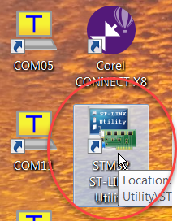
4. Pull the USB cable from the Display Contoller board and connect a similar cable to your PC. 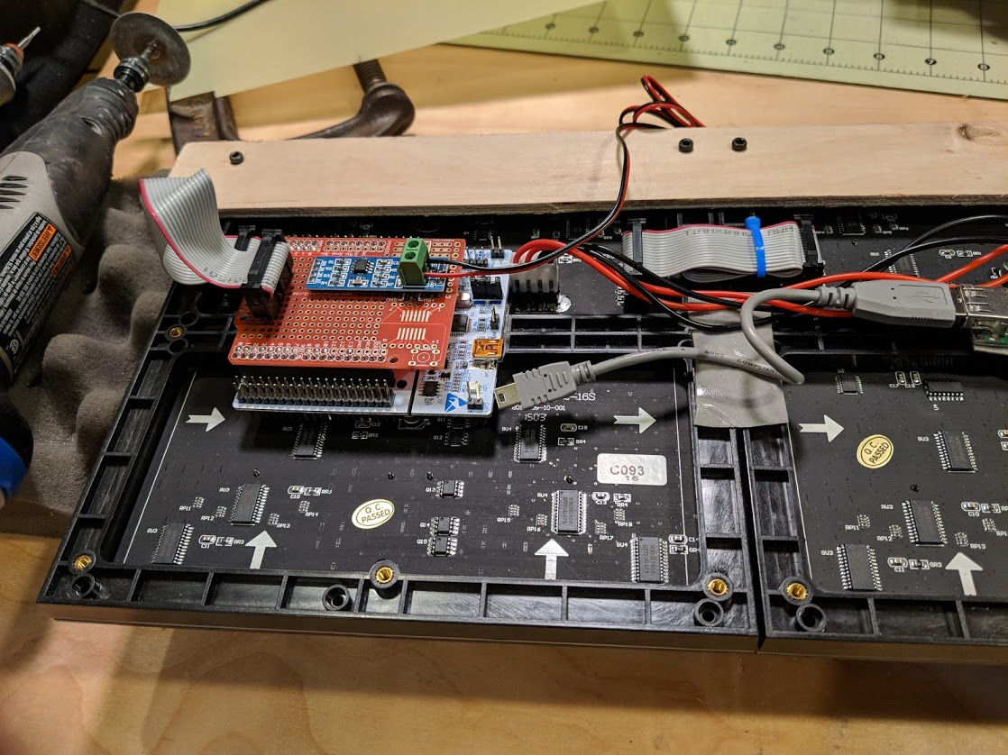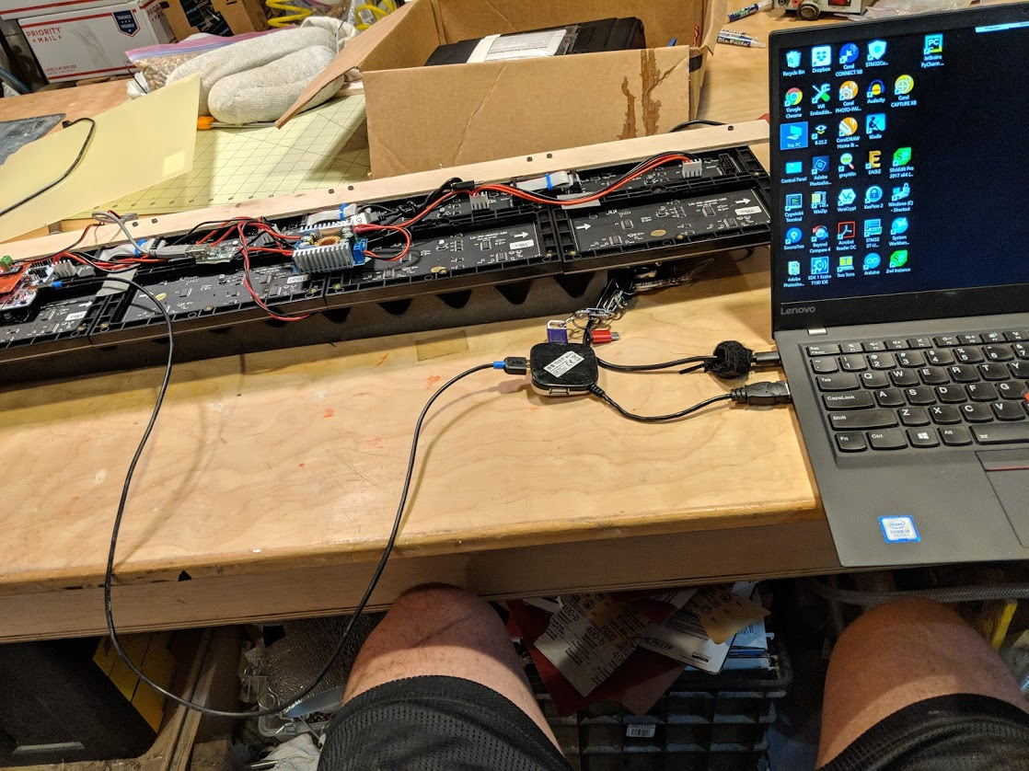
5. Run the STLINK program, then connect to your board by selecting Target->Connect. You might have to disconnect the board and reconnect it if it doesn’t work right away.  
   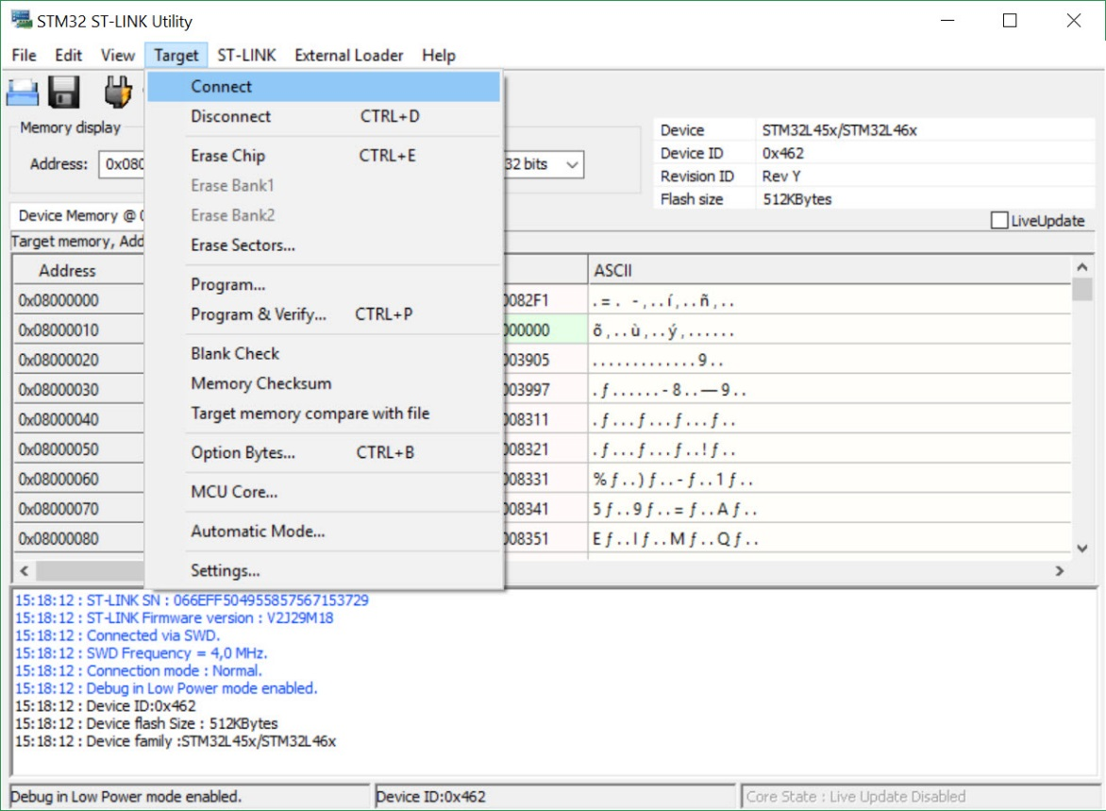
6. Chose File->open and find where you downloaded the firmware. Chose “Panel452.hex”.  
   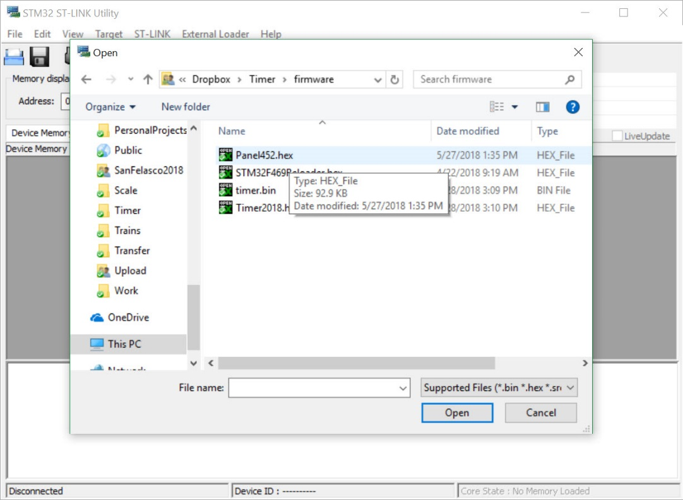
7. Chose Target->Program&Verify, then click ok to program:  
   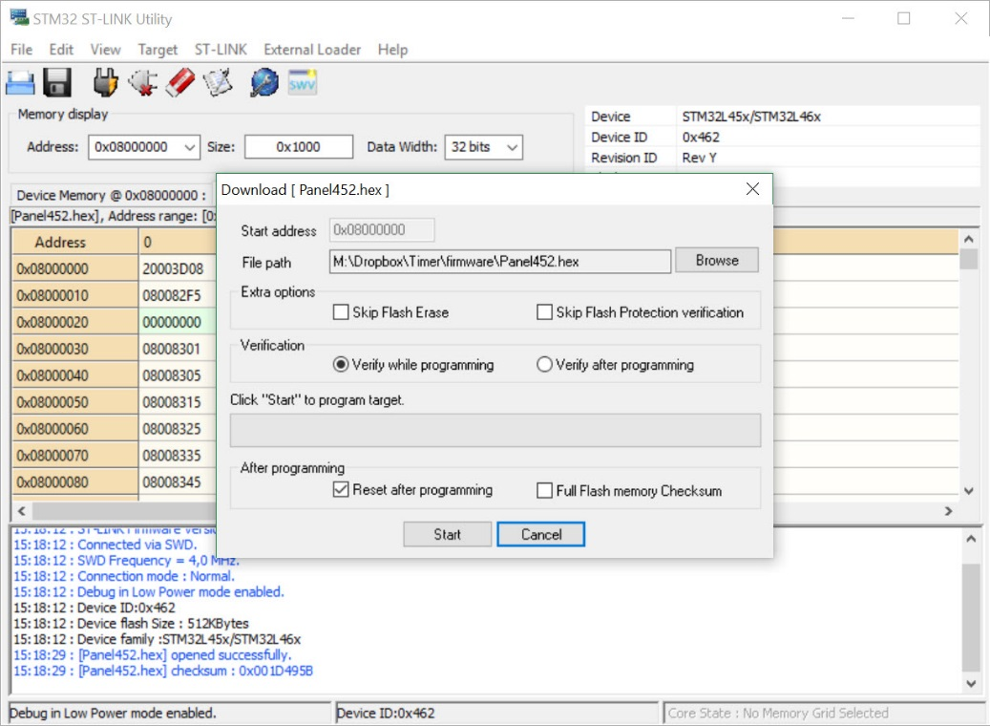
8. Check to see if it programmed ok. If things don’t complete, unplug the board, plug it back in and go back and start at step 5. You cannot damage the board or do any permanent damage, so it’s okay to repeat this to get it to work. Note that if you get a message saying that your firmware is out of date and needs to be upgraded, chose the STLINK->firmware update option, click the connect button, then let it upgrade the board. Then disconnect and re-connect the board and go back to step 5.   
   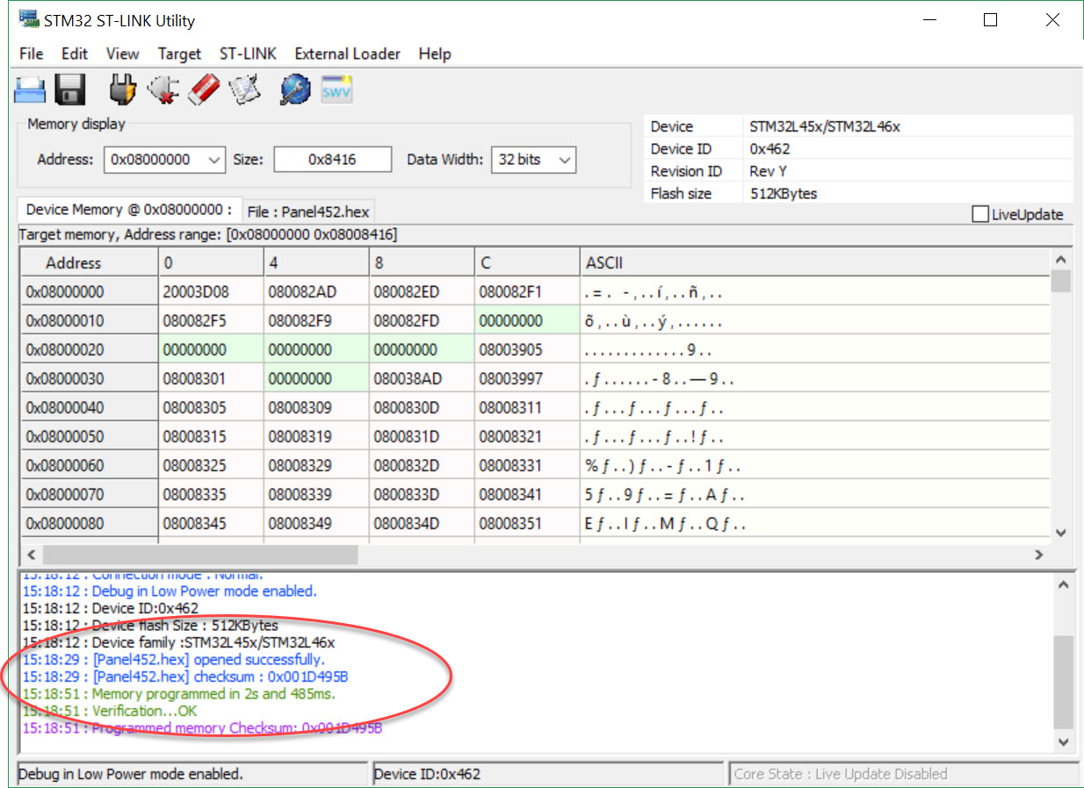
9. You are now done with the DC, disconnect the cable and reconnect the USB power cable to the DC.
10. For the Control Panel the steps are nearly identical, except you choose the file “Timer2018.hex”, and the cable is attached to the same type of connector on the Control Panel as was on the Display Contoller.

Procedure 2: Updating Only the Control Panel.

1. Power down the control panel.
2. Remove the SD card from the control panel.
3. Using an adapter mount the SD card on your computer.
4. Using explorer find the SD card and either make sure it exists or make a folder called “firmware”.
5. Copy the file “timer.bin” (not .hex) to the folder firmware.
6. Eject the SD card.
7. Put the SD card back into the Control Panel.
8. Power up the control panel.
9. Watch the lights blink and wait till the display comes back on as usual.
10. You are done.