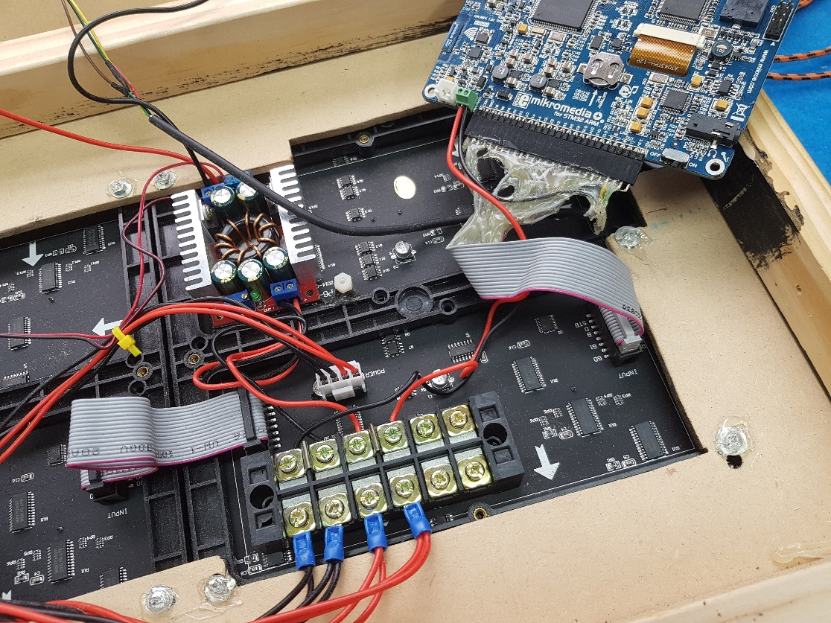

This power junction box is not like your board

do I just take the power wires out of junction for old board?

*I ’ll need to check when I get home this weekend. But I think so. The new board needs 12volts on the wires shown with the big arrow and into the power supplies with the heat sinks.. Is the junction 12volts or 5 volts? A little wider picture would help.*

Does the only power in feed come from the remote now?

Maybe this will help:



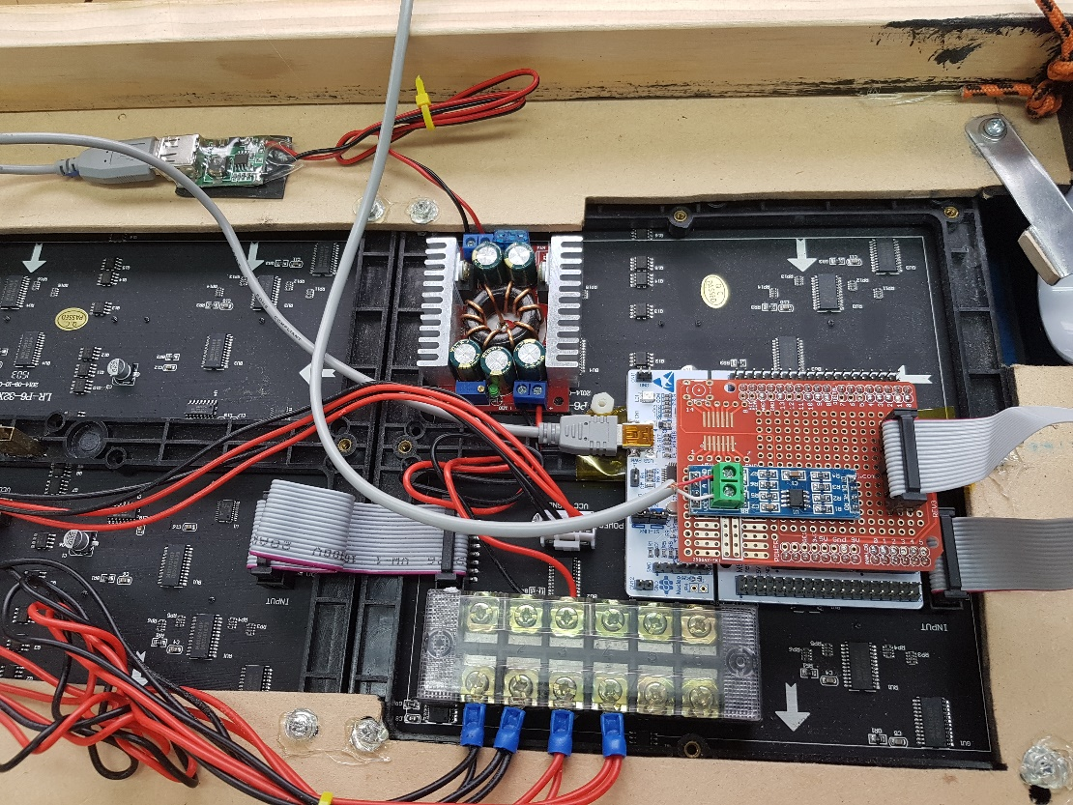

This is a pic of the wiring I have done so far for you check please

Can you send me a wider picture that shows where your 12V comes into the board?

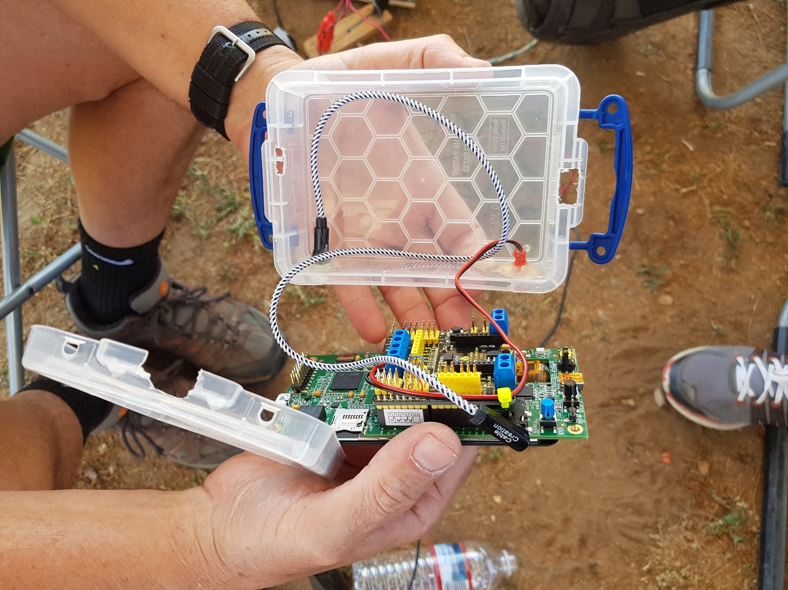

This photo was taken at poway

The red JST plug is for? *This is the connection to the display. It goes to the green screw terminal on the little blue board on the read board on the new computer board in the display panel.*

The other cable is for? And what type of jack is that called? *It’s just a 3.5mm head phone extension cable, this is the audio output*.

Sound? *Comes out here.*

Power? *5 Volt USB, like from a cell phone charger. Comes out on the mini-B usb (not the micro B usb). It’s helpful for this power to come from a different supply than the display as this will cut way down on the noise on the audio.*

Shielded cable connection to main light board? *Helpful, but not critical.*