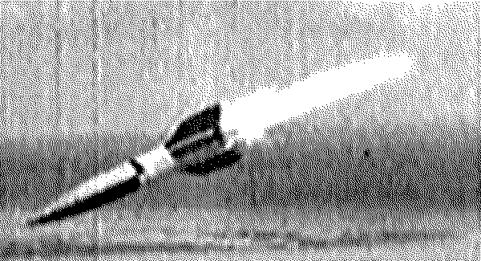

On October 3, 1942 the A-4 was first launched from Peenemunde.
Breaking the sound barrier, it reached an altitude of sixty miles.
It was the world's first launch of a ballistic missile and the first
rocket ever to go into the fringes of space
DroneTone: https://github.com/alejoduque/dronetones/wiki/Drone-Sound
Disconnect Sound Barrier:
The frightening sound of the V2 rocket or the buzzing one of UAV hexacopters. For a split second a soundless blast breaks in and all around is just destructions. The war machines strive to break the sound barrier while becoming odorless, remote & distant. Like the food: sans caffeine, sans alcohol, sans sugar, sans GMO. Meanwhile our actual environmental landscapes are even more polluted on radiolelectric "noise" when scanned under a spectrum analyzer.
Drone Sound:
On notions of loops, streams, encapsulation, doppler, feedback, ultra to infra sonic and similar 'sound' barriers. Our presentation proposes to reconsider the linkage between war technologies at the fringe of the networks. From analog to digital realms and back. To relocate sound at the core, at material level, and see/hear it gain dimension/momentum in relation to it's socio-political implications.
Drone Tone:
During WW2, the v2 rocket broke both the sound barrier and earth's gravity constraints in order to strike enemies abroad. The sound it produced while crossing the sky became part of its terrorizing power. nowadays, the absence of sound is even more alarming: A drone strike won't be noticed and who triggers it will be displaced by the computer screen thousands of kilometers away.
We propose a performance around the frightening omnipresent power of 'drones'. Based on remote controlled flying devices we will explore different ways of generating sound. Our flying devices will generate sound by themselves while gliding.
The planes will broadcast sound and video from an embedded microphone and camera. Thanks to this, the public/assistants/participants will be able to hear and see through the 'drone' eyes. It would allow them to be seen in real-time looking up at the drone.
"But it is a curve each of them feels, unmistakably. It is the parabola. They must have guessed, once or twice -- guessed and refused to believe -- that everything, always, collectively, had been moving toward that purified shape latent in the sky, that shape of no surprise, no second chance, no return. Yet they do move forever under it, reserved for its own black-and-white bad news certainly as if it were the rainbow, and they its children...."
Thomas Pynchon, Gravity's Rainbow
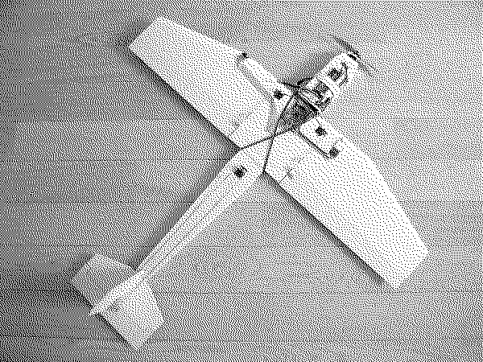
Failing the possibility of performing DroneTones at DEAF we could submit a video from our rehearsals with this remote controlled acoustic instrument for which automation of flight/partiture patterns will be accomplished via on-board micro-controllers (Ardupilot compatible http://www.diydrones.com/notes/ArduPilot).

Previous project: BDDWS - Bringing Down Drones With Stones http://www.coop.re/?BDDWS
Presented at Desert Numérique July 2013 / Drones Tracking People. People Tracking Drones BDDWS
CHECK THE VIDEO FROM BDDWS HERE: http://youtu.be/4HavZE4WuaM
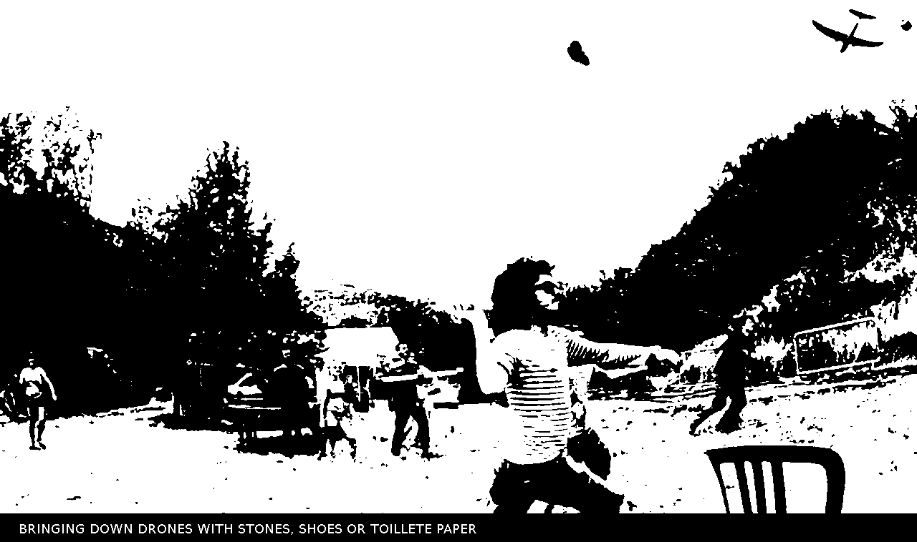

Cyrille Henry - ch@chnry.net
Alejo Duque – alejoduque@gmail.com
2014

