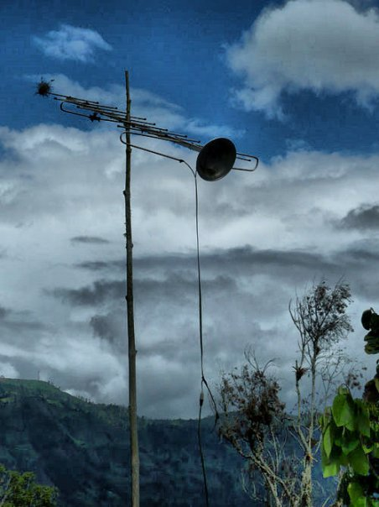
|dispositivos en exilio| |exiled dispositivs|

A Collaborative Art Deportment by: !Mediengruppe Bitnik (CH), no2somos+ (CO), DeSentro (BR), andres burbano (CO), Locus Sonus (FR-CO), Rafael Dorig (CH), MiMoSa (BR).

Keywords: social media, community networks, DIY cult, radioelectric spectrum, collaborative practices, networked sound and video art.

Individuals: Jose Balbino, Alexander Freire, Ricardo Ruiz, Doma, Carmen, Rafael, Alejandro Araque, Andres Burbano, Alejandro Duque,

(THIS GOES ON TOP OF THE EMAIL- NOT HERE-> no intro yet, since i will like to have a bit of feedback from each of the above participants so to know what you will like to work on and not force. say i.e, ricardo ruiz to roll the mimosa when he has or leads a current project that could be more relevant for the case in colombia)

A know.How exchange, in the style of the workshop, between (not so) young artists and programmers from Colombia, Brasil, France and Switzerland. Leaving a model to replicate by others if they will or like.

Developed in 2 workshops that will take place in Colombia. First, in the Tenza valley (el valle de tenza), where we will be hosted by no2somos a collective formed by the artist (from Universidad Nacional de Colombia) Alejandro Araque. This place has been chosen cuase it has a very strong tradition related to the uses of technology for communication, the big antenna trasmitter from Radio Sutatenza was once one of the strongest ones in the planet. It pairs with Radio Beromunster in the Luzern Canton (Switzerland). (add image)

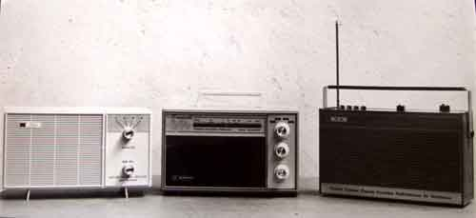
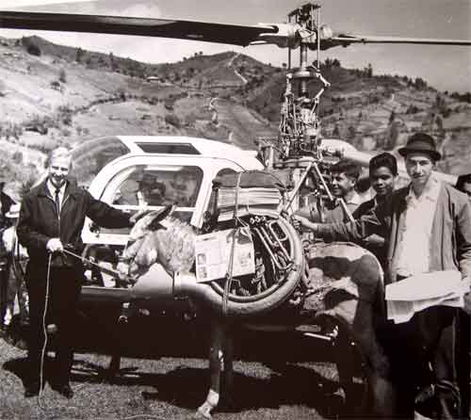
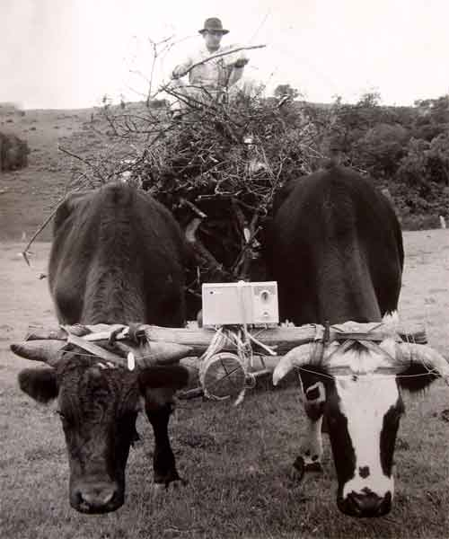

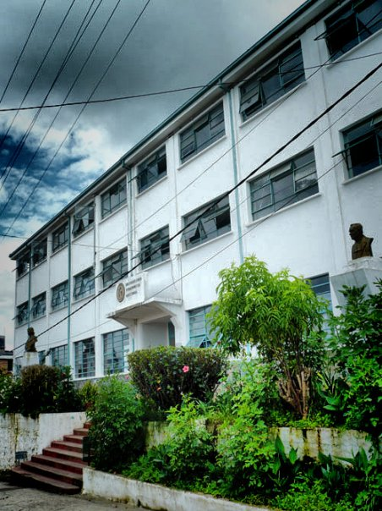
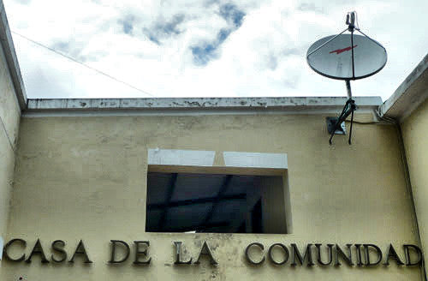

In Sutatenza (wikipedia link) we will set up a media production studio where to gather, distribute and most importantly learn together how to do the media.

We are taken today into the digital networks, all the analog systems are to expensive to be maintained and the so called covergence of the internet has claim the ariwaves. But TV and Radio as we knew them still define the pace in terms building community networks. Is not about taking a romantic position regarding media but, to allow expose the influence of one media into the other (vilem flusser quote). Our operative strategies on the analog signals will be anyhow shared with remote peers over the support of free information infrastructures (give names and exmples) in the shape of network streams of sound and video as in web.tv

Conscious that we live in an interconnected world, doing a revision of satellite technology is a must. (we will pay close attention to trace ideas related with electronic borders, media literacy and art power structures)

The result of this feedback research will serve to address the following question:

First draft proposal by:
Alejandro Duque (colombian)
PhD candidate E.G.S Switzerland (http://www.egs.edu)

[references:]
-Vibrant Media-
-Media Shed-
-GYOML (Grow Your Own Media Lab)-

