BL-16 - API: Supported language API

Service–name | Endpoint | Port
translation-service | v1/language | 8082
service-integration | v1/language | 8090

Request with authentication

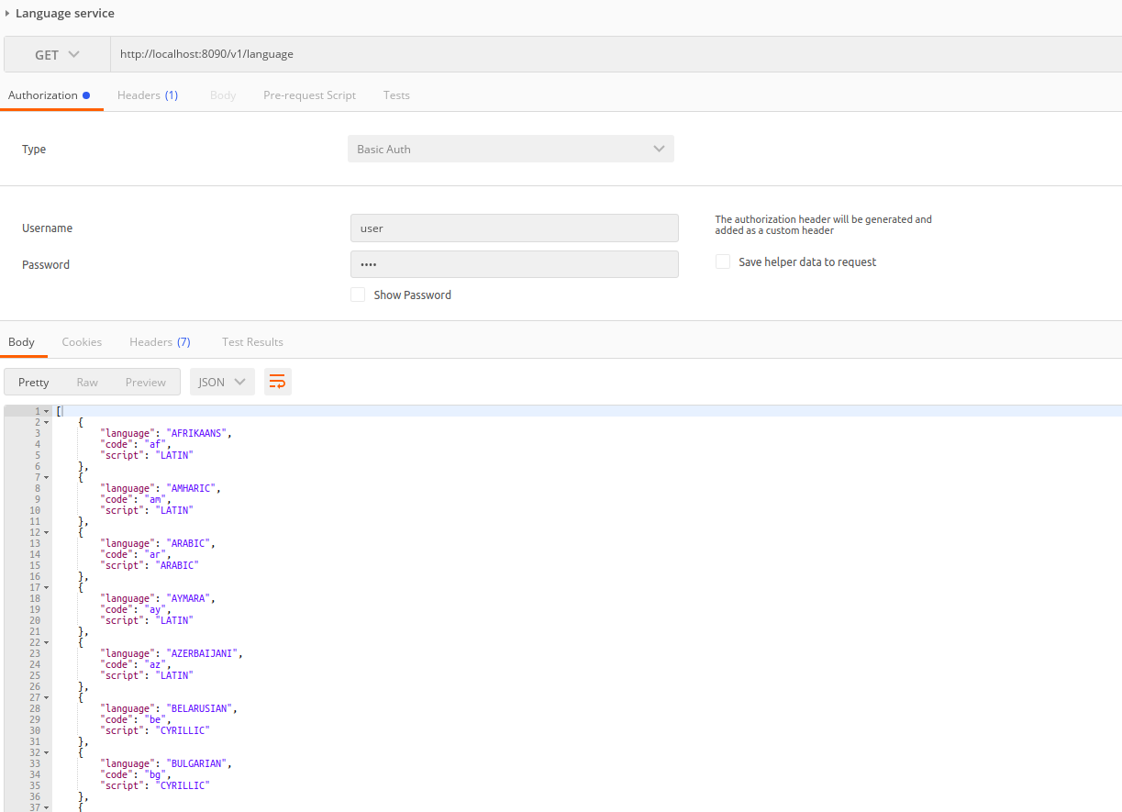

Request without authentication

