sudo apt-get install mysql

mysql -u vadmin -p

Enter password:

ERROR 1045 (28000): Access denied for user 'vadmin'@'localhost' (using password: YES)

Sudo mysql

ALTER USER 'root'@'localhost' IDENTIFIED WITH mysql_native_password BY '123';

Exit

mysql -u root –p

ALTER USER 'root'@'localhost' IDENTIFIED WITH auth_socket;

mysql> show databases;

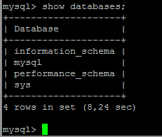

create database db_doc;

show databases;

use db_doc;

Создание таблиц

show tables;

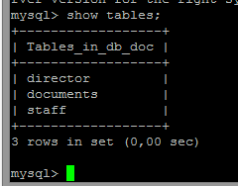

sudo apt-get install apache2 phpmyadmin (для визуального просмотра )))

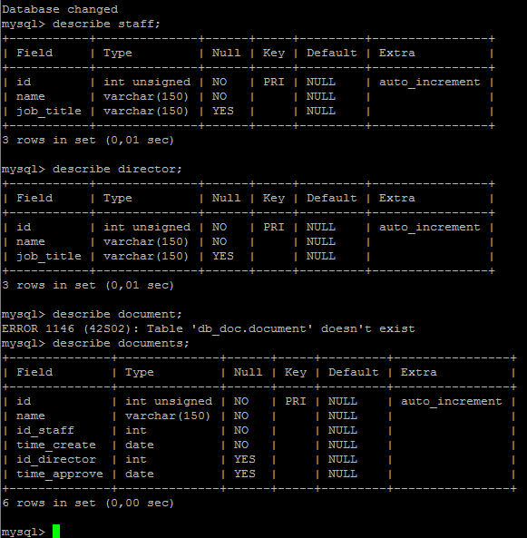

ALTER TABLE documents ADD CONSTRAINT fk_id_staff FOREIGN KEY (id_staff) REFERENCES staff(id);

ALTER TABLE documents ADD CONSTRAINT fk_id_dir FOREIGN KEY (id_director) REFERENCES director(id);

UPDATE documents SET id_director ='1', time_approve = '2022-10-23 22:03:00' WHERE id = 2;

UPDATE documents SET id_director ='2', time_approve = '2022-10-23 22:30:00' WHERE id = 3;

select * from documents;

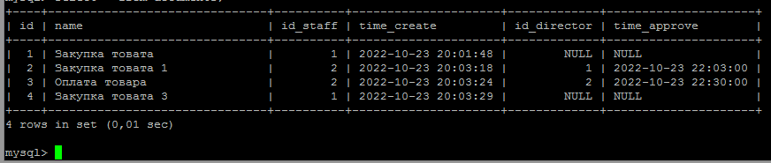

select d.id, d.name, s.name, d.time_create, d.time_approve from documents as d, staff as s where d.id_staff = s.id order by s.name;

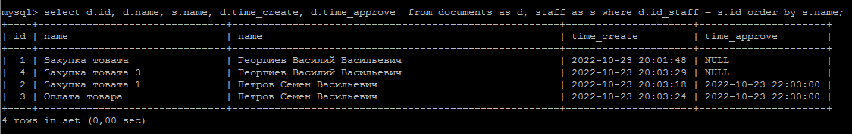

select count(documents.id) as d_col, staff.name as s_name from documents inner join staff on documents.id_staff = staff.id group by s_name;

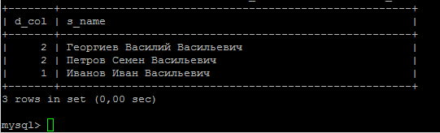

create database doc_other_company;

CREATE USER 'vadmin'@'localhost' IDENTIFIED BY '123';

select user from mysql.user;

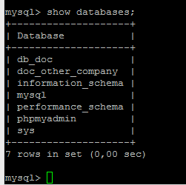

GRANT ALL PRIVILEGES ON doc_other_company.* TO vadmin@localhost WITH GRANT OPTION;

