sudo apt-get install mongodb

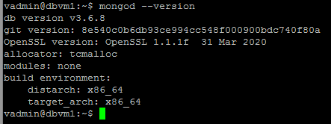

sudo systemctl status mongodb.service

mongo --eval 'db.runCommand({ connectionStatus: 1 })'

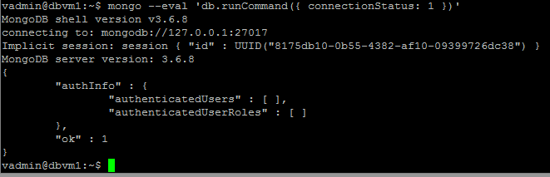

Mongo – connect to mongodb shell

>show dbs;

admin 0.000GB

config 0.000GB

local 0.000GB

>

> use documents_db – Создание базы

db.createUser( {user: "user1", pwd:"user1",roles: [ { role: "readWrite", db: "documents_db" }]})

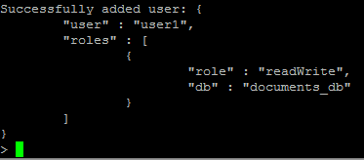

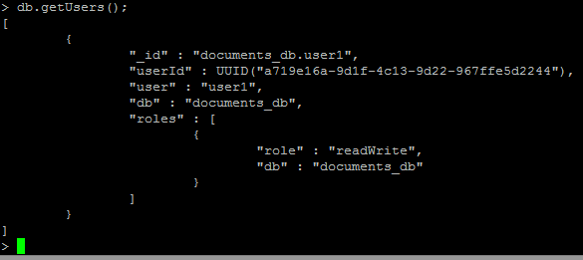

> show collections

documnets_db

>

db.documnets_db.insertOne({doc_name: "Закупка товата", date: "2022-10-23 23:07:00", staff_name: "Георгиев Василий Васильевич", stage:["created","edited","approved"]})

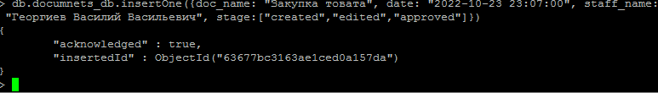

db.documnets_db.insertOne({doc_name: "Закупка товата 1", date: "2022-10-23 23:07:00", staff_name: "Георгиев Василий Васильевич", stage:["created","edited"]})

db.documnets_db.insertOne({doc_name: "Оплата товара", date: "2022-10-23 23:07:00", staff_name: " Петров Семен Васильевич", stage:["created"]})

db.documnets_db.insertOne({doc_name: "Закупка товата на месяц", date: "2022-10-23 23:07:00", staff_name: "Георгиев Василий Васильевич", stage:["created"]})

db.documnets_db.find()



> db.documnets_db.find({stage:"approved"})



> db.documnets_db.update({doc_name: "Закупка товата 1"}, {$set: {stage:["created","edited","approved"]}})

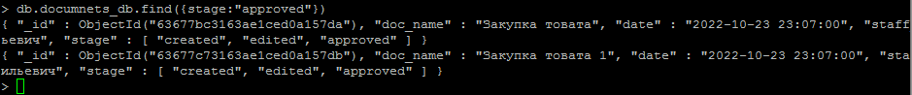

db.documnets_db.deleteMany({stage:"approved"})

