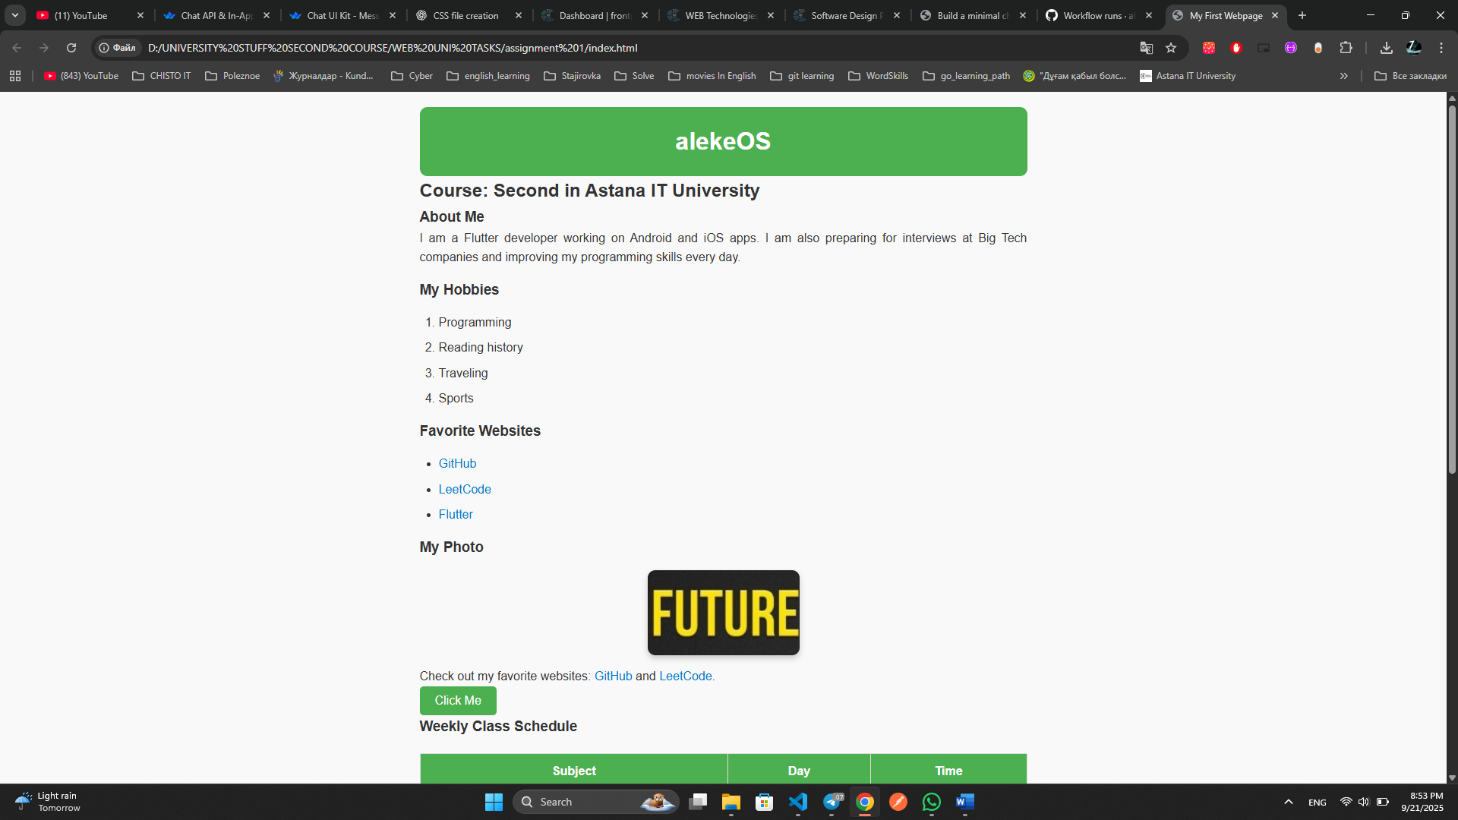

**Linked External CSS** – Created and linked style.css to the HTML file.

1. **Class & ID Naming** – Added meaningful classes and IDs (#main-header, .section-heading, .paragraph-text, .button-style, .table-schedule, .image-profile, #contact-form, .form-input, .submit-btn).
2. **Typography** – Applied font family, size, alignment, and text decoration for headings, paragraphs, and links.
3. **Color Scheme** – Used consistent green and blue tones with hover effects for links and buttons.
4. **Layout & Box Model** – Applied margins, padding, borders, rounded corners, and shadows to structure content.
5. **Table & Image Styling** – Styled schedule table and added borders/shadows for the profile image.
6. **Form Styling** – Designed input fields and submit button with proper spacing and hover effect.
7. **Centering Content** – Used Flexbox (display: flex; justify-content: center; align-items: center;) to align all content in the center of the screen.

**Summary:**  
The webpage was successfully styled with external CSS. A clean layout, color scheme, and responsive design principles were applied. Content is centered on the screen, and interactive elements (links, buttons, forms) have hover effects for better user experience.