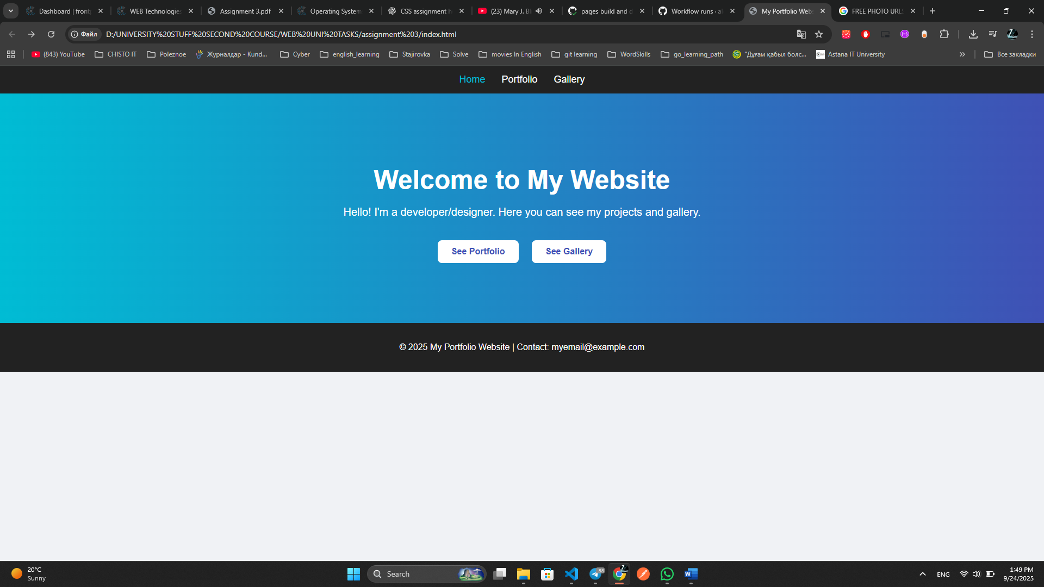

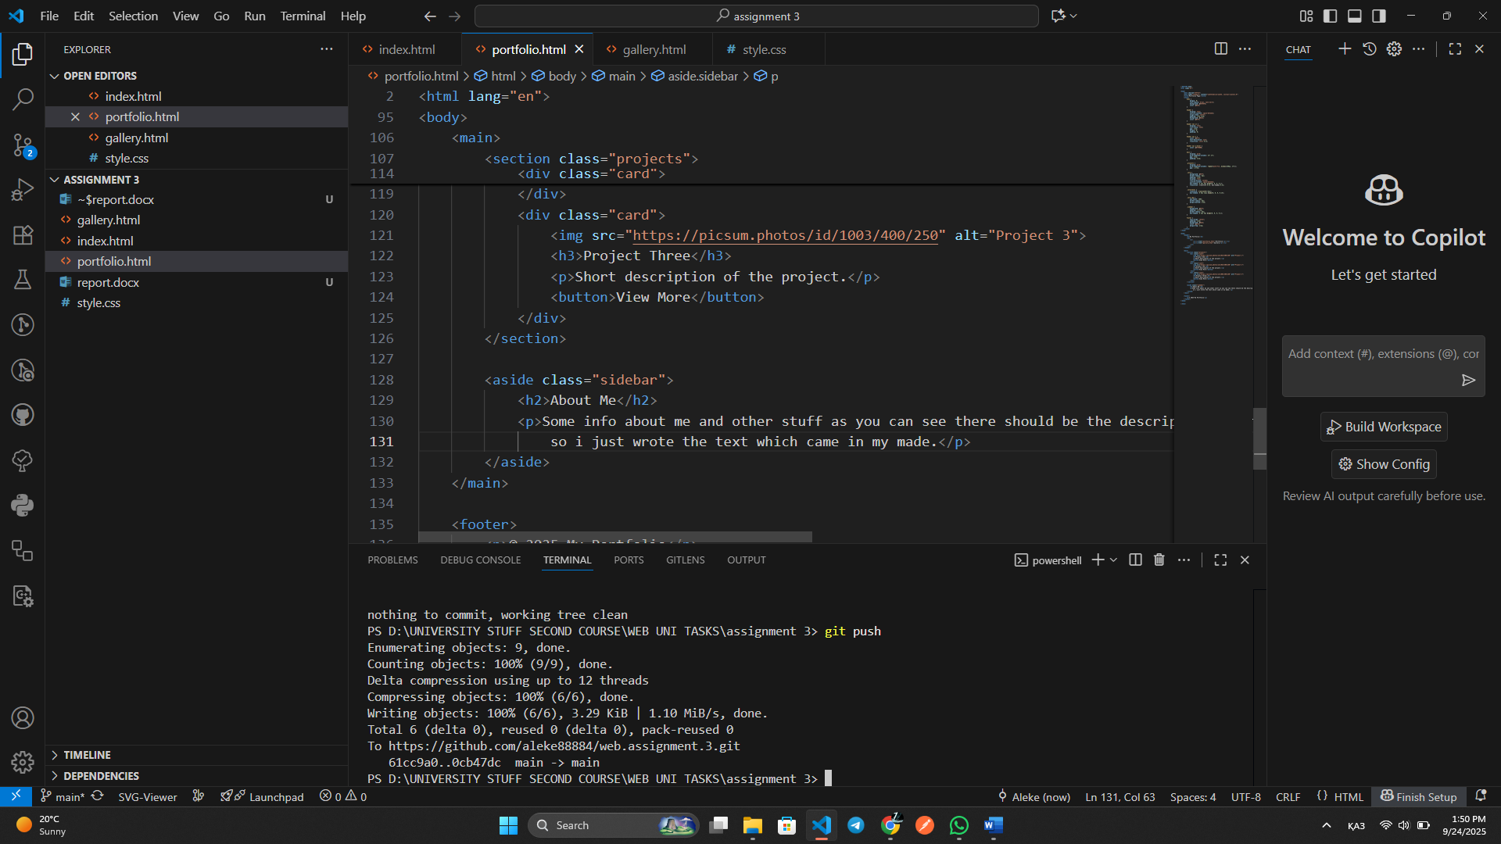

**Report**

In this assignment, I created a simple multi-page website using **HTML and CSS**. The project was separated into three main parts:

1. **Index Page** – serves as the home page with navigation and links to other sections.
2. **Portfolio Page** – contains a portfolio layout with projects and an “About Me” section.
3. **Gallery Page** – displays an image gallery with captions using a grid layout.

I also wrote separate **CSS styling for the index page** to make the homepage look modern and user-friendly, with a navigation bar, header section, buttons for navigation, and a footer.

**What I learned / achieved:**

* How to structure a website with multiple pages and connect them through navigation links.
* How to apply **Flexbox** and **Grid** for layout design.
* How to separate CSS for different pages and style them individually.
* Gained experience in creating a small portfolio project that looks clean and professional.