Computational discovery of PARG inhibitors
Materials and Methods
Muhammad Ali Khan · draft of 16 October 2026
All eight figures are embedded in position. Numbers throughout are the corrected values — see §2.10 for which metric applies where.

2. Materials and Methods

2.1 Target selection
Human poly(ADP-ribose) glycohydrolase (PARG; UniProt Q86W56, EC 3.2.1.143, ChEMBL target CHEMBL1795143) was selected by four sequential criteria: biological rationale; novelty with respect to existing computational screening literature; bioactivity-data sufficiency for scaffold-split evaluation; and structural feasibility, meaning high-resolution co-crystals, complete catalytic machinery, and multiple independent complexes permitting protocol validation. Candidate targets were compared against all four criteria before selection.

2.2 Dataset curation
Bioactivity records were retrieved from ChEMBL (target CHEMBL1795143, accessed 14 October 2026) and restricted to entries carrying a pChEMBL value. Records were aggregated by canonical SMILES with duplicate measurements averaged, yielding 870 unique compounds across 323 Bemis–Murcko scaffolds, pChEMBL range 4.06–8.32 (mean 6.155, SD 0.764).
At a 6.0 pChEMBL threshold the set partitions into 510 active and 35 inactive compounds. Because classification metrics on that imbalance report high accuracy for an uninformative model, the task was formulated as regression on continuous pChEMBL before any model was trained.

2.3 Data splitting
Three splits were generated. A scaffold split holding out whole Bemis–Murcko families (610 train / 260 test) served as the primary evaluation. A random split (609 / 261) was retained for contrast, quantifying the cost of extrapolating to unseen chemotypes. A temporal split (862 / 8) was abandoned because the test set was too small to support inference.

2.4 Model benchmarking
Four models were evaluated on the identical 260-compound scaffold-split test set: a mean predictor; Tanimoto 5-nearest-neighbour search on ECFP4 (Morgan radius 2, 2048 bit); Chemprop v2 D-MPNN (learned molecular graph, 318,000 parameters); and LightGBM on ECFP4 concatenated with 217 RDKit descriptors, 2,265 features total.
Model | Representation | RMSE | R² | Seeds
Mean predictor | none | 0.801 | 0.000 | —
Tanimoto 5-NN | ECFP4, 2048 bit | 0.509 | 0.561 | —
Chemprop D-MPNN | learned graph, 318K params | 0.504 ± 0.004 | 0.569 | 3
LightGBM | ECFP4 + 217 RDKit descriptors | 0.445 | 0.664 | 5

LightGBM hyperparameters: n_estimators = 500, learning_rate = 0.05, num_leaves = 31. On the random split for contrast, the baseline scored 0.411 (R² 0.689) and LightGBM 0.338 (R² 0.789).
Matched test sets were enforced explicitly. Chemprop initially scored RMSE 0.467 on its own internally generated scaffold split (n = 174), appearing to outperform both the baseline and LightGBM. Forced onto the project split (n = 260) via an explicit splits file, its error rose to 0.510, the baseline value. The apparent advantage was an easier test set rather than a better model.
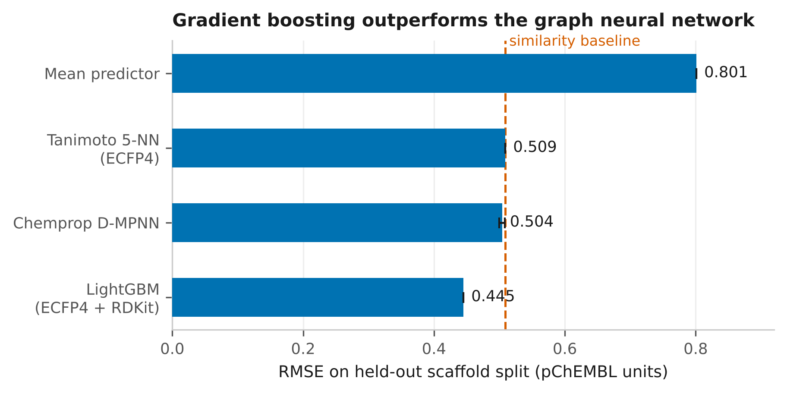
Figure 1. Model benchmark on the matched 260-compound scaffold-split test set. The graph neural network is statistically indistinguishable from nearest-neighbour similarity search despite 318,000 learned parameters.

2.5 Final model and library screening
The final model was LightGBM retrained on all 870 compounds with hyperparameters identical to the benchmark. The screening library was assembled from ZINC20 2D tranches (molecular-weight bins C–J, logP bins A–E, reactivity class A, purchasability A and B — in stock and orderable, not make-on-demand). Eighty tranche files yielded 3,204,633 unique molecules after deduplication. Scoring took 200.6 minutes on eight cores, approximately 270 molecules per second; one SMILES was unparseable, leaving 3,204,632 scored.
 | Training set | Screened library
Maximum | 8.32 | 6.73
Mean | 6.155 | 4.94
Minimum | 4.06 | 4.11

For reproduction: files.docking.org rejects the default Python-urllib user-agent; a browser user-agent header is required or every request returns an HTTP error.

2.6 Novelty assessment
Maximum Tanimoto similarity (ECFP4, 2048 bit) was computed from each of the top 5,000 hits to the nearest of the 870 training compounds.
Similarity band | n | %
0.0–0.3 (very novel) | 4,428 | 88.6
0.3–0.4 (novel) | 425 | 8.5
0.4–0.6 (related) | 121 | 2.4
0.6–1.0 (close analogue) | 26 | 0.5

The top 20 hits all fall between Tanimoto 0.16 and 0.30, and span predicted pChEMBL 6.73 to 6.55 — a range of 0.18 units, less than half the model’s own RMSE. Ordering within the top hits is not resolvable by the model and is not interpreted.

2.7 Random control
One hundred top-ranked compounds were docked against 100 drawn at random from the same library (seed 42, with the top 100 excluded from the sampling pool). The two groups were docked interleaved, so that any throughput degradation over the run affected both equally. Conditions were identical throughout: receptor rec_wet.pdbqt, 16 Å box centred on (27.20, 2.84, 0.17), exhaustiveness 16, seed 42. Selection was by model score alone; no pose or outcome information entered the choice.
Group | n | Mean | Median | Best | Below −9
Top-ranked | 92 | −8.41 | −8.42 | −10.21 | 20 (21.7%)
Random | 100 | −8.18 | −8.17 | −10.60 | 15 (15.0%)

Because compounds that fail to dock are silently excluded from summary statistics, the comparison was repeated with all eight failures imputed at both extremes of the observed affinity range.
Scenario | Difference | p one-sided | p two-sided | Outcome
As run (92 v 100) | +0.227 | 0.0154 | 0.031 | holds
Failures at −6.42 (worst observed) | +0.067 | 0.144 | 0.284 | fails
Failures at −10.21 (best observed) | +0.370 | 0.0014 | 0.003 | holds

The eight failures proved to be a single molecule in eight stereoisomeric forms (MW 459.6, 33 heavy atoms, 10 rotatable bonds), occupying 8% of the model’s top 100. Against compounds that docked successfully (mean MW 367.6, 25.6 heavy atoms, 5.0 rotatable bonds) they are substantially larger and twice as flexible, which is the profile expected to fail in 3D generation or search — making the conservative imputation also the more plausible one.
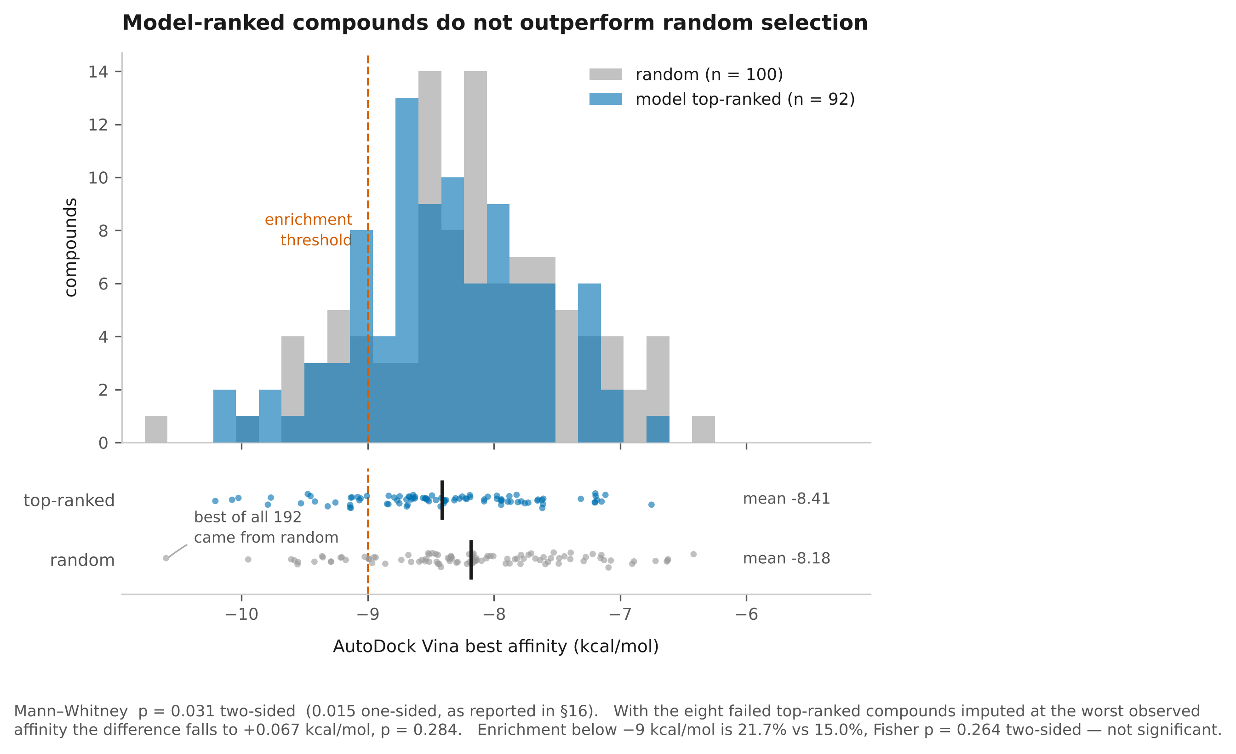
Figure 2. Random control. Best Vina affinity for 92 model-ranked compounds against 100 drawn at random from the same library, docked interleaved under identical conditions. The distributions overlap substantially and the best-scoring compound of all 192 came from the random group. The nominal separation does not survive conservative imputation of the eight top-ranked compounds that failed to dock.

2.8 Structure preparation and bridging-water selection
The primary receptor was 6OAK (1.70 Å, chain A, 497 ordered residues spanning 451–961, three chain breaks, none within 12 Å of the site). All catalytic residues — Asp737, Asn740, Glu755, Glu756, Tyr795 and Phe902 — are complete. The co-crystal ligand M0M comprises 43 atoms, 22 of them heavy, with centroid at (27.20, 2.84, 0.17). The structure contains 360 crystallographic waters.
Water-selection rule, fixed before any docking was run: retain waters lying within 3.5 Å of both a ligand heavy atom and a protein nitrogen or oxygen. Five waters qualify in 6OAK — HOH 1211, 1232, 1307, 1317 and 1402 — two of which hydrogen-bond to Gln754, with one contact at 2.22 Å. Two receptors were built: dry, containing no waters, and wet, containing these five.
The rule was applied unmodified to a second structure, 7KG1, where it returned a different count of four waters. No water was selected in order to produce a result.

2.9 Docking protocol
AutoDock Vina 1.2.5 was used throughout, with exhaustiveness 16, num_modes 9 and seed 42. Ligands and receptors were converted to PDBQT with Open Babel 3.2.1, retaining polar hydrogens only.
Cross-docking used a 24 Å box centred on the M0M centroid. This box was subsequently found to span the full poly(ADP-ribose) substrate groove and to permit escape to a secondary site approximately 6 Å below the pocket at (29.44, −0.38, −5.78). That site is not an artefact: it is lined by Gln754, Tyr795, Phe738, Cys872, Gly871, Gly873, Ala874 and Phe875, and forms part of the genuine substrate groove, which extends well beyond where a 22-atom inhibitor sits. All library screening and the random control therefore used a 16 Å box.

2.10 Pose-accuracy metric
Open Babel reorders ligand atoms when constructing the PDBQT torsion tree, so sequential-order RMSD compares non-corresponding atoms. The magnitude of this artefact was measured directly: a dry-receptor redock reported 5.73 Å by sequential comparison versus 3.75 Å by optimal assignment.
Two metrics appear in this work and must be distinguished.
Optimal assignment (scipy.optimize.linear_sum_assignment over squared interatomic distances, with cross-element pairs forbidden) ignores connectivity and is a strict lower bound on true symmetry-corrected RMSD.
True symmetry-corrected RMSD, used for all cross-docking results reported here, matches the PDB Chemical Component Dictionary ideal structure onto both reference and pose as a generic graph with bond orders disregarded, takes the minimum over all substructure matches, and applies no superposition — poses are compared in the crystal frame. Hydrogens are removed explicitly.
The two metrics were compared directly across all 34 cross-docking pairs. For poses correct under the 2 Å criterion the bound is tight (mean shift +0.010 Å, maximum 0.06 Å); for incorrect poses it is loose (mean +0.930 Å, maximum 3.42 Å; Mann–Whitney p = 0.0002). Every shift is non-negative, confirming the bound.
The lower-bound metric therefore flattered failures specifically. Any quantity still reported under it is conservative in a known direction: correct poses are unaffected, incorrect poses are understated.

2.11 Redocking validation
Native M0M was redocked into 6OAK in both receptors. The values below remain on the optimal-assignment metric and are pending recomputation; the direction of any correction is known and strengthens the finding, since the wet value is a correct pose whose bound is tight while the dry value can only increase.
Receptor | Best affinity | Top-1 RMSD | Rank of near-native pose
Dry | −7.79 kcal/mol | 3.75 Å | 8 of 9 (1.15 Å)
Wet (5 waters) | −7.15 kcal/mol | 0.99 Å | 1

The receptor giving the better score gave the worse pose. Binding score is not a proxy for geometric correctness, and virtual screening output cannot be ranked on raw score without independent pose validation.

2.12 Cross-docking set construction
All 25 human PARG structures were enumerated from UniProt Q86W56 (chain A, residues 448–976); 24 were downloaded, 6OAK serving as the reference. Modified residues (MSE, CSO, CSS, CME, 6WK) and buffer components were excluded; heteroatom groups were retained only at 15–50 heavy atoms; phosphorus-containing ligands were classified as substrate-like ADP-ribose analogues and excluded from the inhibitor analysis.
Superposition used Kabsch alignment on matched Cα atoms, with 490–497 atoms matched and Cα RMSD 0.13–0.37 Å, confirming that all structures occupy essentially one backbone conformation.
Series | Ligands
5LHB / 6HMx | 6WJ, 7JC, 73L, 7JB, 70J
6O9x / 6OAx | M0S, M0V, M1D, M0P (×2), M0M
7KGx | WD7, WDA, WDD, WDG, WDJ, WDM

The resulting set is 17 drug-like inhibitors spanning three independent medicinal-chemistry campaigns, each with 3–7 rotatable bonds and atom counts preserved through PDBQT conversion. Four substrate-like ligands (AR6, A8P, A1R, A3R) and one surface-bound AR6 in 5A7R, 13.71 Å from the site, were excluded.

2.13 Cross-docking analysis
Each of the 17 ligands was docked into both receptors, giving 34 pairs and nine modes each, for 306 poses in total. True symmetry-corrected RMSD was computed for every pose rather than only the top-ranked one, which permits sampling and ranking to be separated: whether a near-native pose was generated at all, and whether Vina ranked it first.
Receptor | Top-1 < 2 Å | Near-native sampled | Ranked first
Dry | 0 / 17 | 6 / 17 | 0 / 6
Wet | 6 / 17 | 7 / 17 | 6 / 7

Top-1 success: McNemar exact p = 0.031; Wilcoxon signed-rank on paired RMSD p = 0.035. For sampling, the dry set is a strict subset of the wet set — only 7KG7_WDJ is sampled in the wet receptor and missed in the dry one — giving McNemar p = 1.0, that is, no detectable difference in sampling.
For ranking, restricted to the six ligands sampled in both receptors so that denominators match, the mean rank of the near-native pose improves from 4.83 in the dry receptor to 1.17 in the wet, better in six cases out of six, Wilcoxon signed-rank p = 0.031. Binarised to ranked-first, the matched comparison is 0 of 6 against 5 of 6, McNemar p = 0.0625, which is why the rank comparison rather than the proportion is reported.
By inhibitor class, water-bridging compounds (n = 12) improve from 0/12 to 6/12 with a mean change of −1.76 Å, while water-displacing compounds (n = 5) remain at 0/5 with a mean change of +0.36 Å. The class difference gives Mann–Whitney p = 0.014.
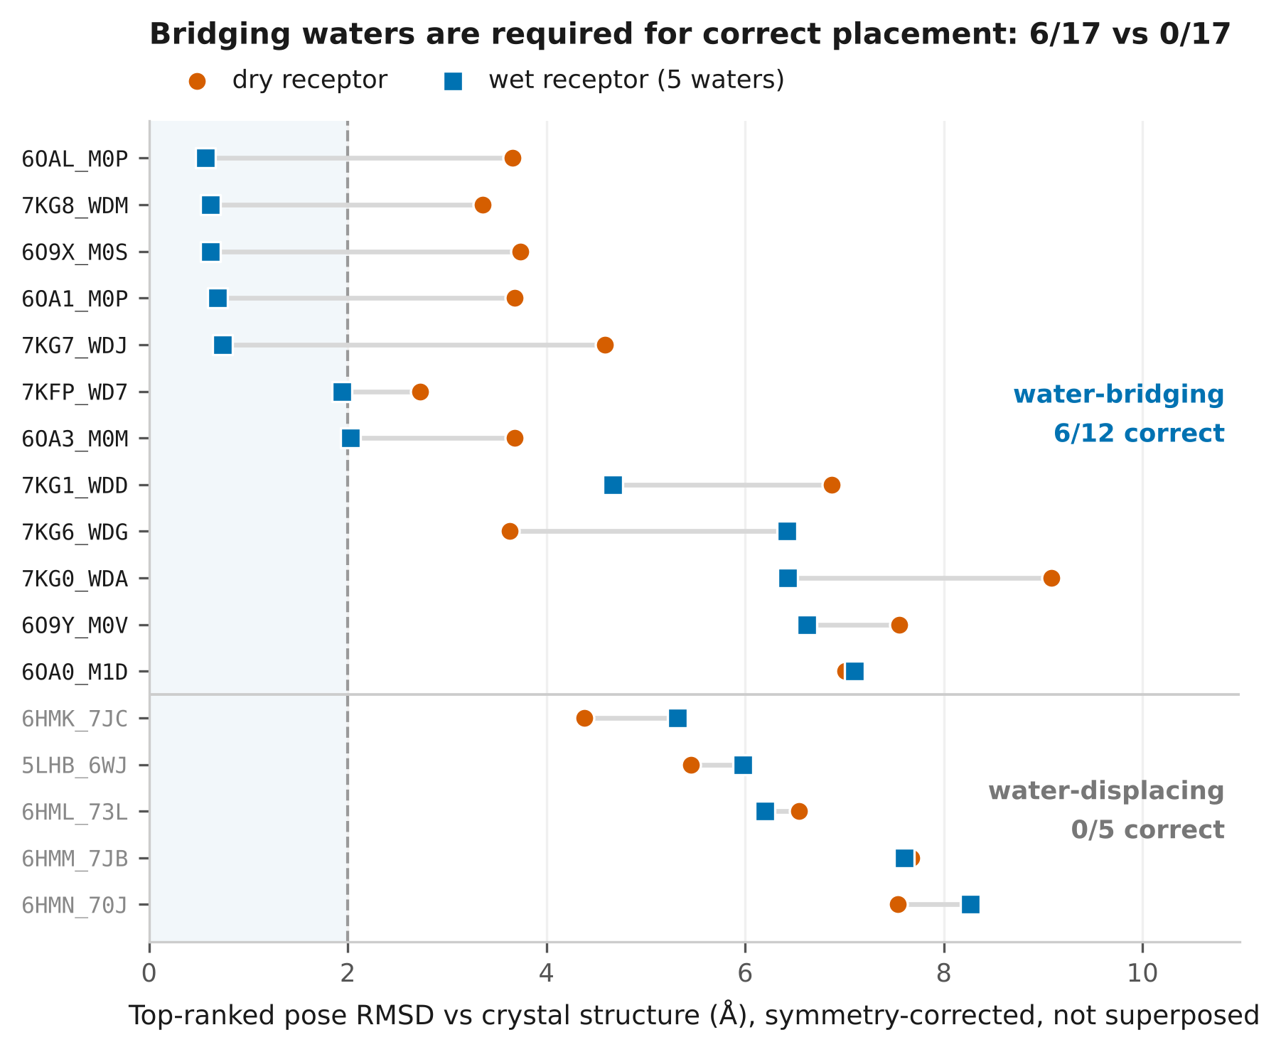
Figure 3. Top-ranked pose RMSD against the crystal structure, dry versus wet receptor, symmetry-corrected and not superposed. Ligands are split by class; the shaded band marks the 2 Å criterion.
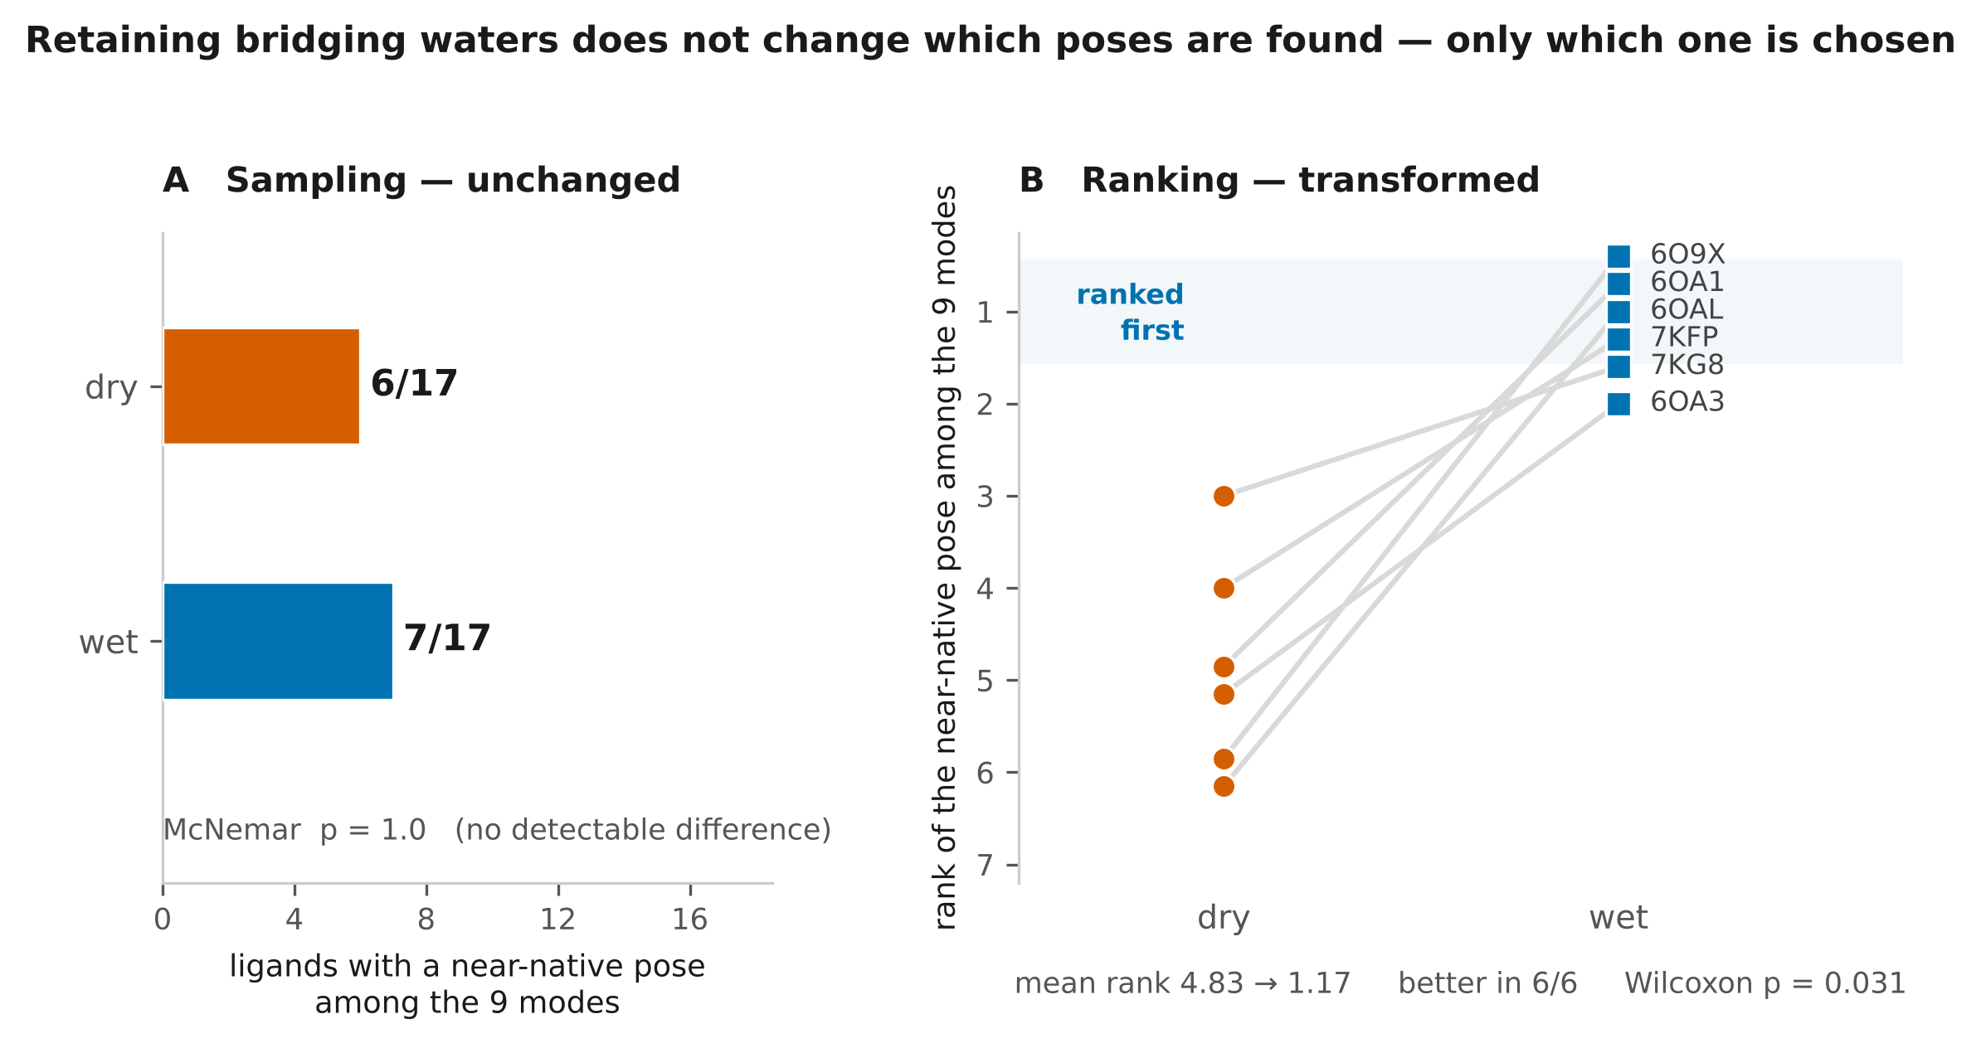
Figure 4. Bridging waters act on ranking, not on sampling. (A) A near-native pose appears among the nine modes in 6 of 17 ligands without waters and 7 of 17 with them; the dry set is a strict subset of the wet set (McNemar p = 1.0). (B) For the six ligands sampled in both receptors, the rank of that pose improves from a mean of 4.83 to 1.17, better in six cases out of six (Wilcoxon p = 0.031).
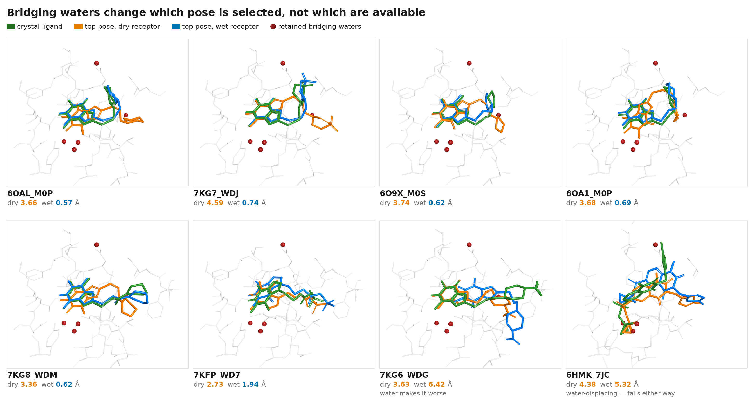
Figure 5. Top-ranked poses against the crystal structure in both receptors. Crystal ligand in green, top-ranked dry pose in orange, top-ranked wet pose in blue; the five retained bridging waters as red spheres. All panels share one view. In the first six ligands the wet pose superposes on the crystal ligand while the dry pose does not. 7KG6_WDG is the single case where water retention worsens the result, and 6HMK_7JC is a water-displacing inhibitor that fails in both receptors.

2.14 Conformational analysis
Binding-site residues were defined as the 23 residues lying within 6 Å of M0M. Side-chain RMSD and maximum displacement were computed per structure, and χ₁ torsions for Tyr795 and Phe902 were measured across all 18 structures and assigned to discrete rotamer states.
Residue | State A | State B | Separation
Tyr795 | +66.3 ± 3.3° (gauche⁺) | −168.5 ± 4.0° (trans) | ~235°
Phe902 | −155.0 ± 4.4° | −53.1 ± 6.7° | ~102°

The two residues switch in concert in all 18 structures; no structure shows one flipped without the other, and nine structures occupy each state. Every successfully docked ligand derives from a state A structure.
On the B-factor objection: Tyr795 in 6OAK refines at 62.4 Å², which alone would be dismissible as disorder. But 6HMK sits at 22.1 Å² in state B and 6OA1 at 27.5 Å² in state A, so well-ordered examples occur in both clusters. The elevated B-factor in 6OAK is a symptom of a residue sampling two positions, not an argument against the finding.
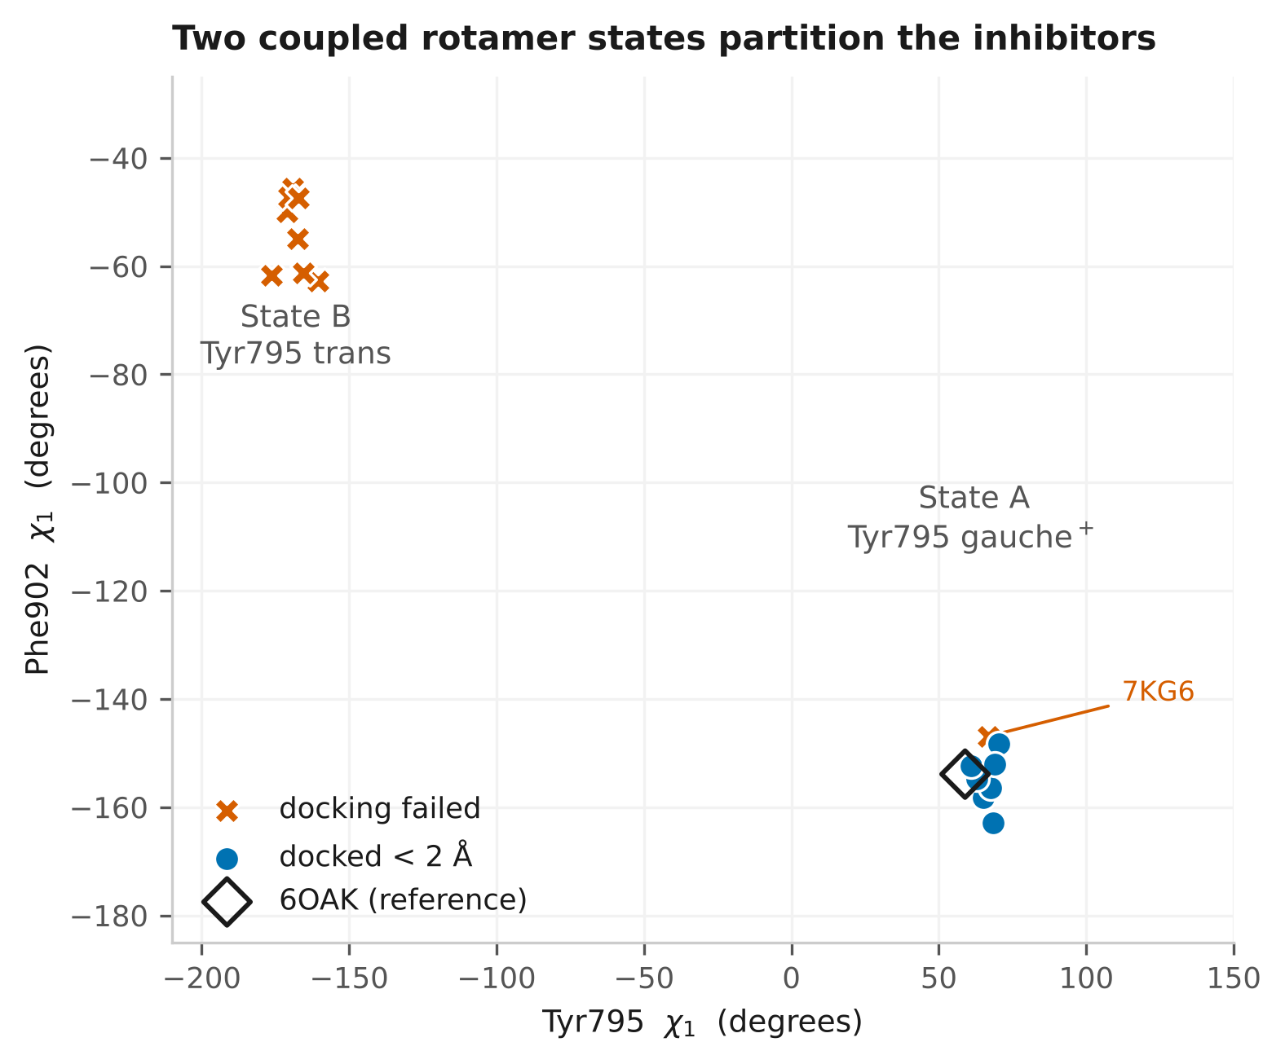
Figure 6. χ₁ torsions of Tyr795 and Phe902 across all 18 PARG structures, showing two discrete rotamer states occupied by nine structures each, switching in concert.
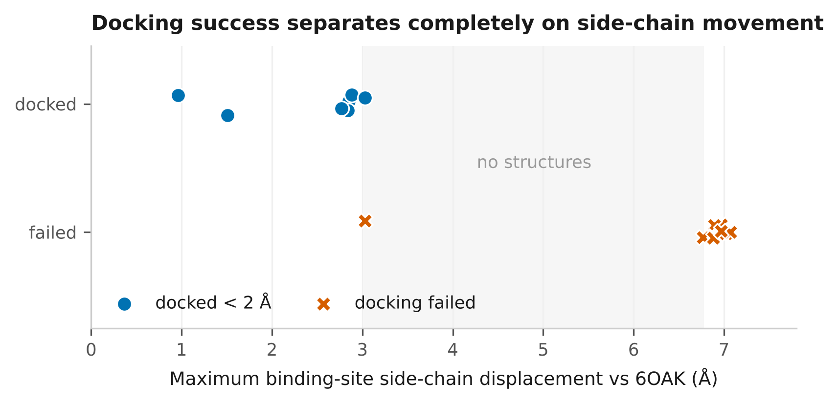
Figure 7. Binding-site side-chain displacement, successfully docked against failed ligands. Note: grouping requires recomputation on the corrected n = 6 / n = 11 split — see §2.16.
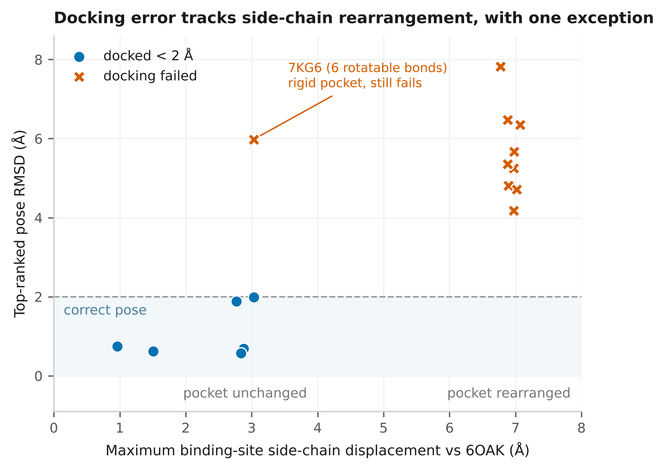
Figure 8. Side-chain displacement against top-1 pose RMSD. Note: as above, pending regrouping.

2.15 Statistical analysis
Paired binary outcomes were tested by exact McNemar, that is, a binomial test on discordant pairs. Paired continuous and ordinal outcomes used the Wilcoxon signed-rank test. Unpaired comparisons used Mann–Whitney U, and count enrichment used Fisher’s exact test. Exact variants were used throughout given the sample sizes. Sidedness differs between analyses and is stated per test: the cross-docking comparisons in §2.13 are two-sided, while the random control in §2.7 was computed one-sided — Mann–Whitney with the alternative that model-ranked affinities are lower, Fisher with the alternative that enrichment is greater. Both one- and two-sided values are reported for the control. Two-sided values are the ones to quote unless the directional hypothesis was fixed before the run.
Comparisons between receptors are paired by ligand, since the same 17 compounds were docked into both. Where sampling differs between receptors, ranking comparisons are restricted to ligands sampled in both, so that denominators match.
No correction for multiple comparisons was applied; nominal p-values are reported and should be read accordingly. Where a test is at its significance floor for the available sample size — as the six-pair Wilcoxon is, returning exactly 2/2⁶ = 0.031 — this is stated.

2.16 Outstanding before submission
The recomputation to true symmetry-corrected RMSD has been applied to the cross-docking top-1 and all-pose analysis only. The following still carry optimal-assignment lower bounds or depend on the superseded grouping:
Item | Status
§2.11 redocking (3.75 / 0.99 Å) | lower bound; direction safe, recompute
Failure analysis groups | now n = 6 / n = 11, not 7 / 10 — recompute means and the bimodal-gap claim
Rotamer exceptions | now two, not one: 7KG6_WDG and 6OA3_M0M (fails by 0.03 Å — describe as borderline)
Ensemble docking figures | 7/17, 6/17, 7/17 all on the old metric
§2.12 class assignment | 7KFP_WD7 computes at 0.96 Å from HOH 1402 — displacing, not bridging; check against 10_waters.py. Conclusion holds either way (p 0.0136 → 0.0145)
Test sidedness | §16 p-values were computed one-sided and the record does not say so; §2.13 is two-sided. Declare both, or re-report the control two-sided
Figures 1, 6, 7, 8 | built from transcribed numbers — regenerate from CSVs
Software versions | RDKit, LightGBM, scikit-learn, SciPy, NumPy still blank
Target selection table | ten-candidate comparison to be recovered and inserted
Gln754 assignment | verify against a primary structural source
Seed counts | LightGBM 5 vs Chemprop 3 — make them match
Zenodo deposition | scripts and data, cite DOI in Methods

