Advancing NASA Sea Level Science and Interdisciplinary Research
Assessment Tools
Visualize and access information and data relevant to understanding and planning for sea level rise in response to ongoing climate change.
- 
Interagency Sea Level Rise Scenario Tool
Visualize and download the sea level scenarios from the U.S. Sea Level Rise Interagency Task Force.
- 
IPCC AR6 Sea Level Projection Tool
Visualize and download global and local sea level projections from the Intergovernmental Panel on Climate Change Sixth Assessment Report.
- 
Sea Level Evaluation & Assessment Tool
View regional relative sea level trends and understand the processes that contribute to the measurements from satellite altimeters and tide gauges.
All assessment tools
Analysis Tools
Analyze and download satellite, in situ, reanalysis and modeled data associated with sea level change and the processes that contribute to it.
- 
Data Analysis Tool
Analyze NASA data with the Data Analysis Tool. Perform regional statistical analysis, time series analysis and comparison.
- 
Virtual Earth System Laboratory
The Virtual Earth System Laboratory includes simulations related to glaciers, ice sheets, sea level and solid earth.
All analysis tools
Understanding Sea Level
NASA keeps track of sea level change and its causes from space. Find out more about how NASA satellite observations help our understanding of this complex topic.
Global Sea Level Regional Sea Level
Explore the main causes: ice melt and heat-driven expansion of ocean water
LEARN MORE ABOUT GLOBAL SEA LEVEL
Sea Level News
› more sea level news

NASA Analysis Shows Unexpected Amount of Sea Level Rise in 2024

NASA Data Helps International Community Prepare for Sea Level Rise
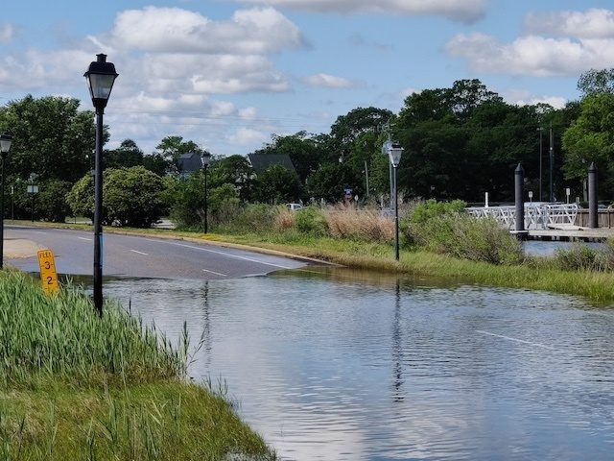
NASA Workshop Helps Coastal Communities Prepare for Sea Level Change
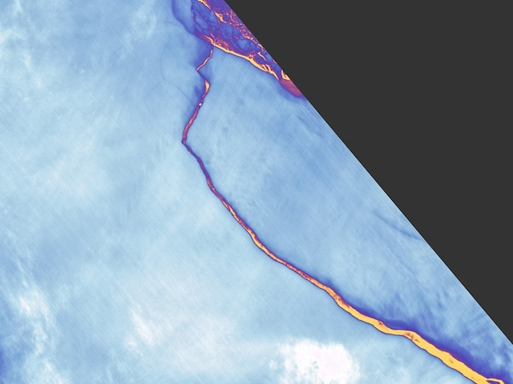
The Secret Life of Melting Ice

Sign up for our Newsletter
Get the latest information on sea level science, news, data, and newest features of the NASA Sea Level Web Portal.

Earth Headlines
- Tonga Eruption Sent Ripples Through Earth's Ionosphere
- NASA Planes Fly into Snowstorms to Study Snowfall
- Small but Mighty NASA Weather Instruments Prepare for Launch
- NASA's Delta-X Helps With Disaster Response in Wake of Hurricane Ida
- Robotic Navigation Tech Will Explore the Deep Ocean

FEATURED MULTIMEDIA
Tracking 30 Years of Sea Level Rise
An animation shows global sea level trends from 1993 to 2022 as observed by several satellite missions.
WATCH
Newsletter
Stay Connected


News & Features
  - Sea Level News
  - Scientist Interviews
  - News Briefs

Understanding Sea Level
  - Overview
  - Global Sea Level
  - Regional Sea Level
  - By the Numbers
  - Vital Signs

Science Team
  - Overview
  - Team Members

Assessment Tools
  - Pacific Islands Flooding Analysis Tool
  - IPCC AR6 Sea Level Projection Tool
  - Flooding Analysis Tool
  - Interagency Sea Level Rise Scenario Tool
  - Sea Level Evaluation & Assessment Tool
  - All Assessment Tools

Analysis Tools
  - Data Analysis Tool
  - Virtual Earth System Laboratory
  - All Analysis Tools

Partners
  - Partners

Resources
  - Multimedia
  - Publications
  - Glossary
  - FAQ
  - Missions

- FEEDBACK PRIVACY POLICY ACCESSIBILITY
Site Manager: Carmen Blackwood
NASA Responsible Official: Doug Newman

