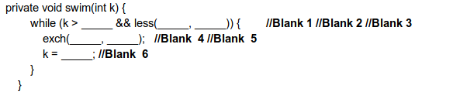

Ans. Blank1: 1

Blank2: k/2

Blank3: k

Blank4: k

Blank5: k/2

Blank6: k/2

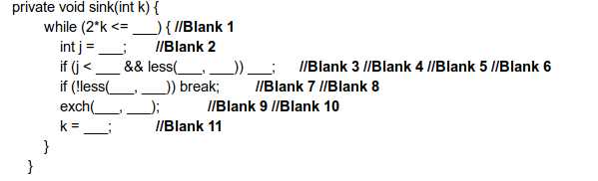

Ans. Blank1: N

Blank2: 2\*k

Blank3: N

Blank4: J

Blank5: J+1

Blank6: J++

Blank7: k

Blank8: J

Blank9: k

Blank10: J

Blank11: J

Fill in the blanks 3:

I A M S T E V E R O G E R S

Ans. Step1: I has the left and right roots as A and M as A is smaller than I it is swapped

Step2: I gets the left and right roots as S and T no swapping

Step3: M gets the left and right roots as E and V, as E is smaller it is Swapped

Step4: S gets the left and right roots as E and R, as E is smaller than I it is replaced with E then I place is given to S and E place is filled with S

Step5: T gets the left and right roots as O and G, as G is smaller then T they get swapped

Step6: so finally the obtained output is:

A E E I G E S S R T O M R V