

**ASSIGNMENT – 4**

COURSE : DEVOPS

Trainer : Mr . MADHUKAR

NAME:N.ALEKHYA

Mail id : alekhyalucky88@gmail.com

* **By Using provisioners copy file from desktop to ec2 instance ?**
* Go to AWS Console Home page then go to EC2 Instance

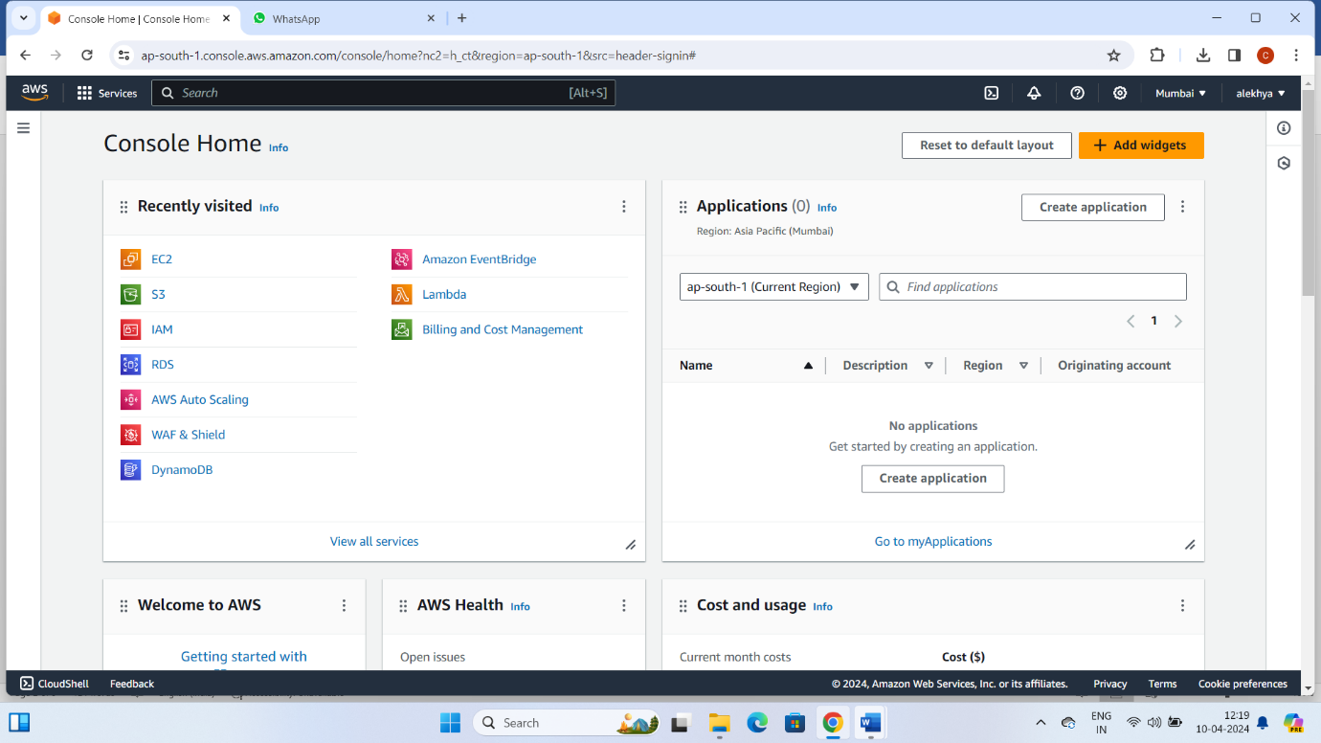

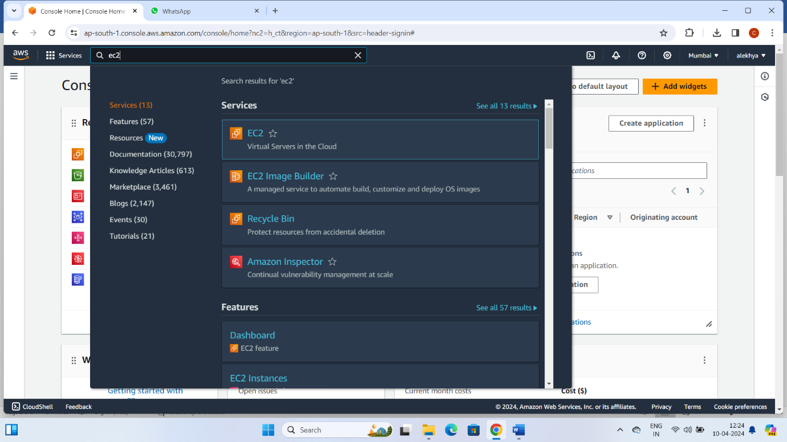

* Click on Launch Instance
* Enter name and select AMI and Instance type
* Create new key pair then click on launch instance

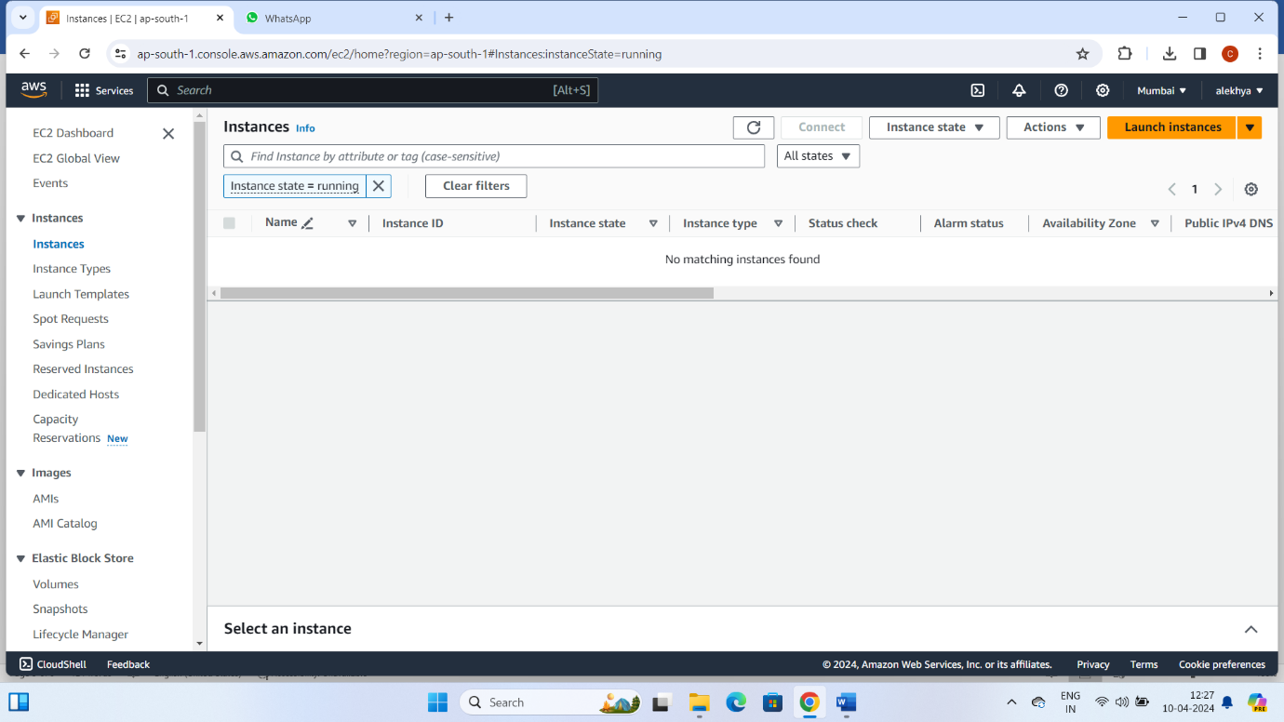

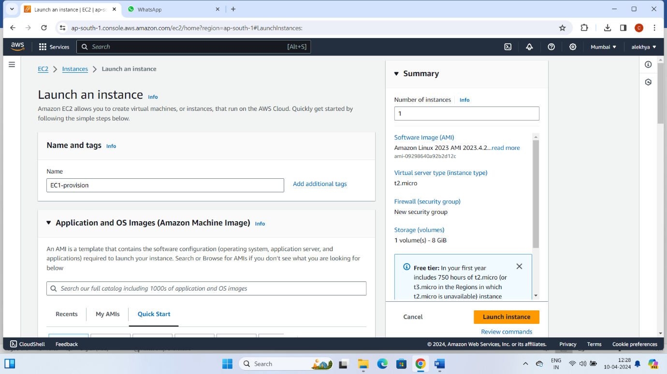

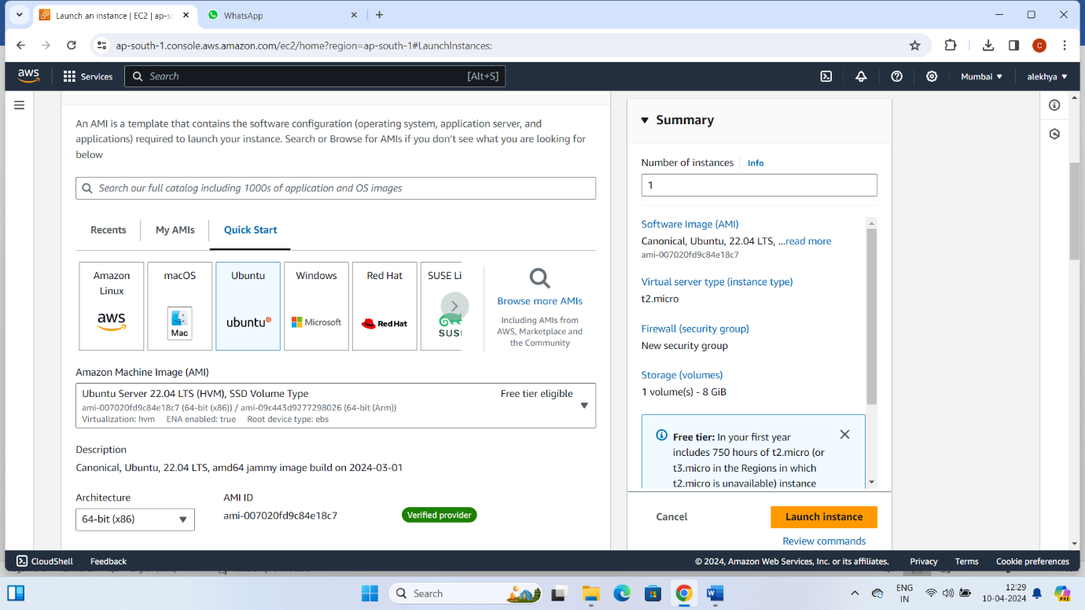

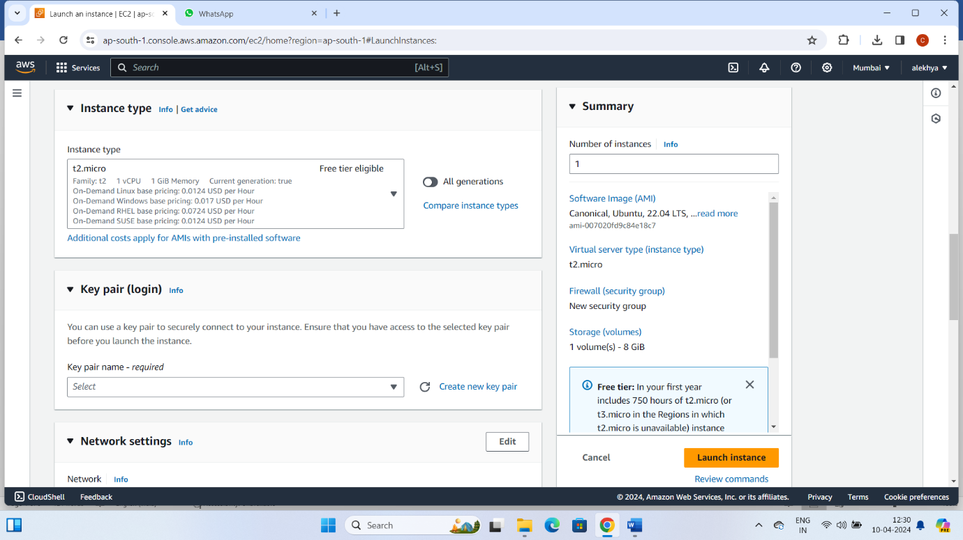

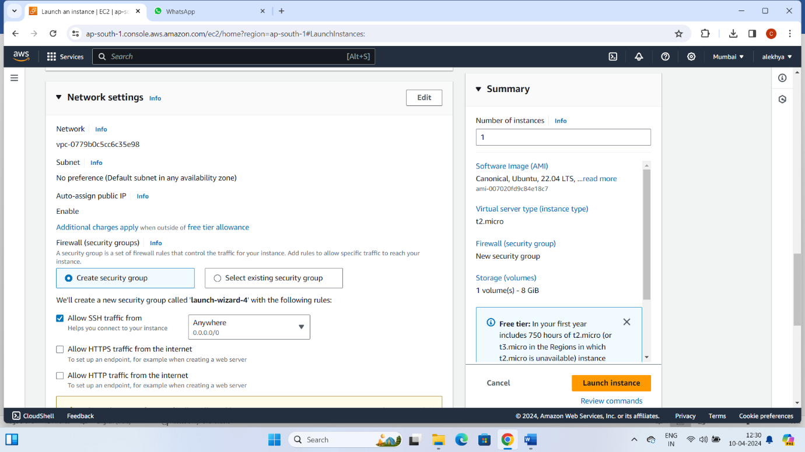

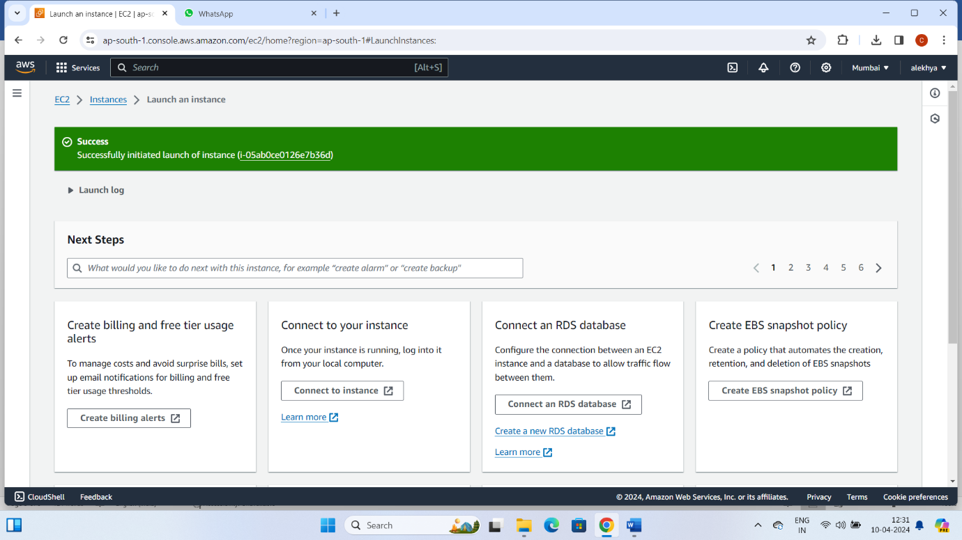

* Go to git bash then create a file in local (or) Desktop
* Enter command for local to remote file
* scp – i <s3-key> <filename> <dns name>:~/<filename>
* **example : scp -i "s3-key" file34 ubuntu@ec2-3-100-207-207.compute-1.amazonaws.com:~/file10**

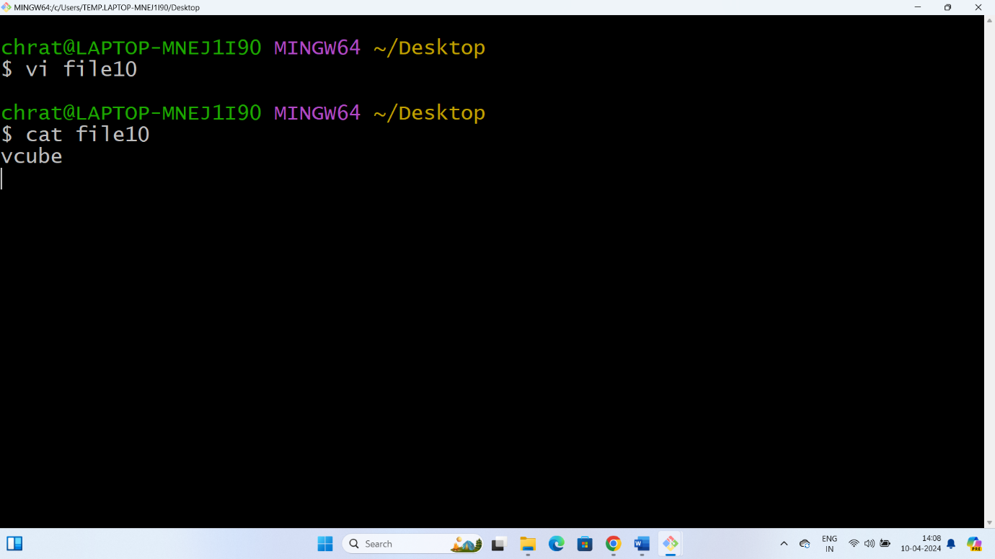

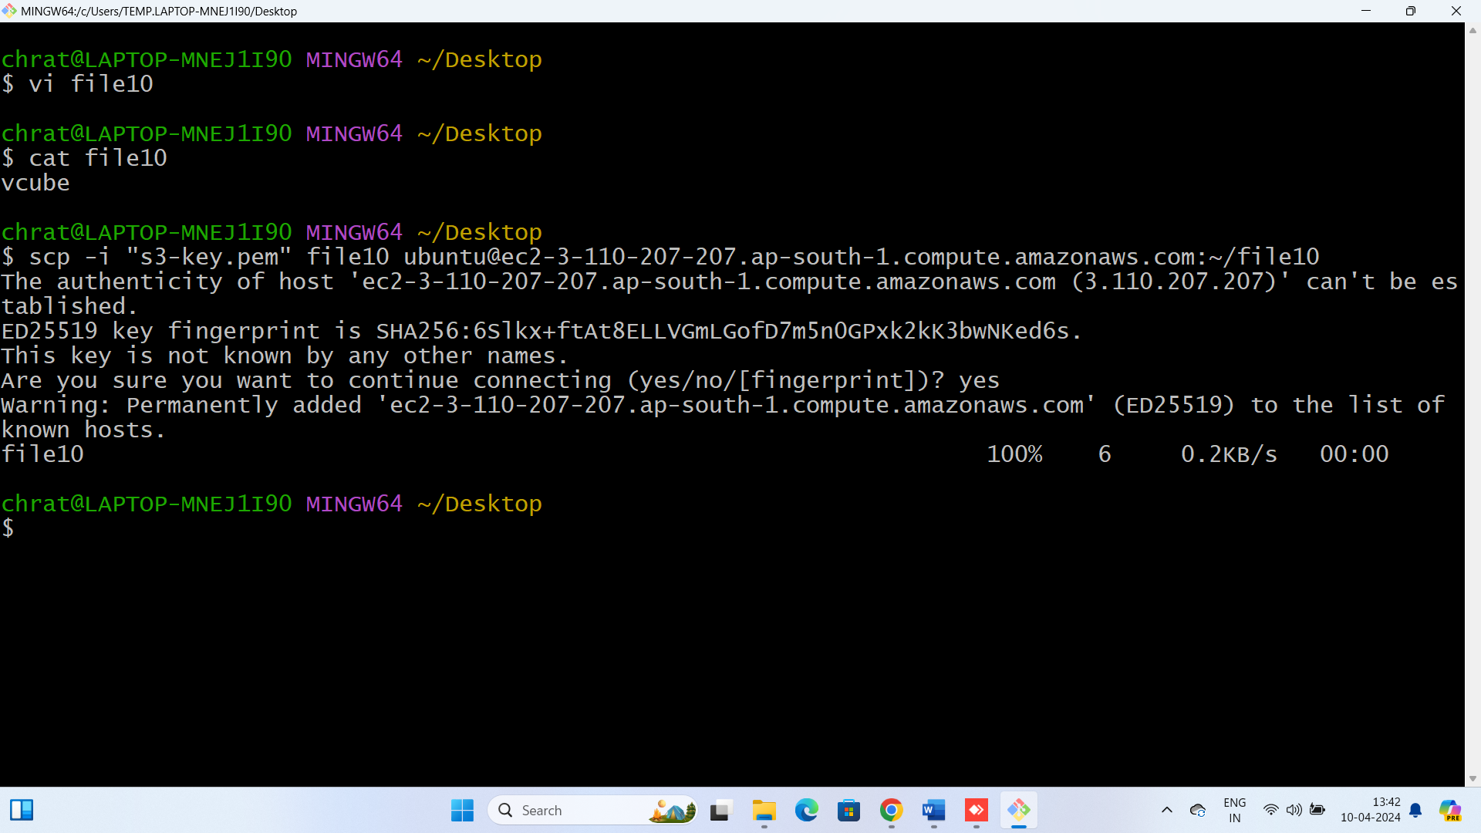



* Now go to ec2 instance and click on instance id
* Select ssh client and copy the ssh command is

**“ssh -i "s3-key.pem" ubuntu@ec2-3-110-207-207.compute-1.amazonaws.com”**

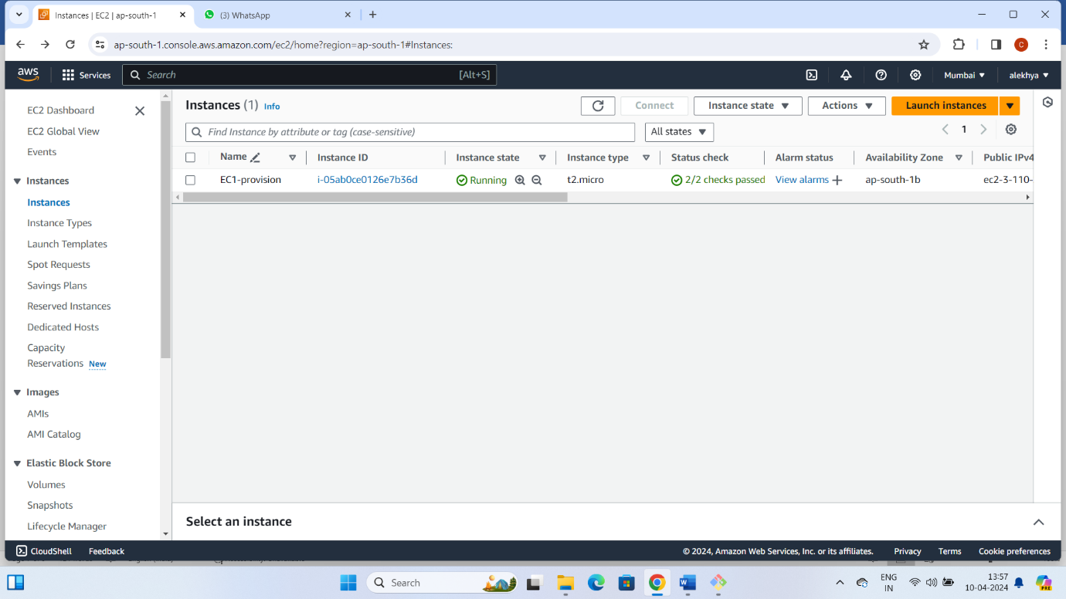

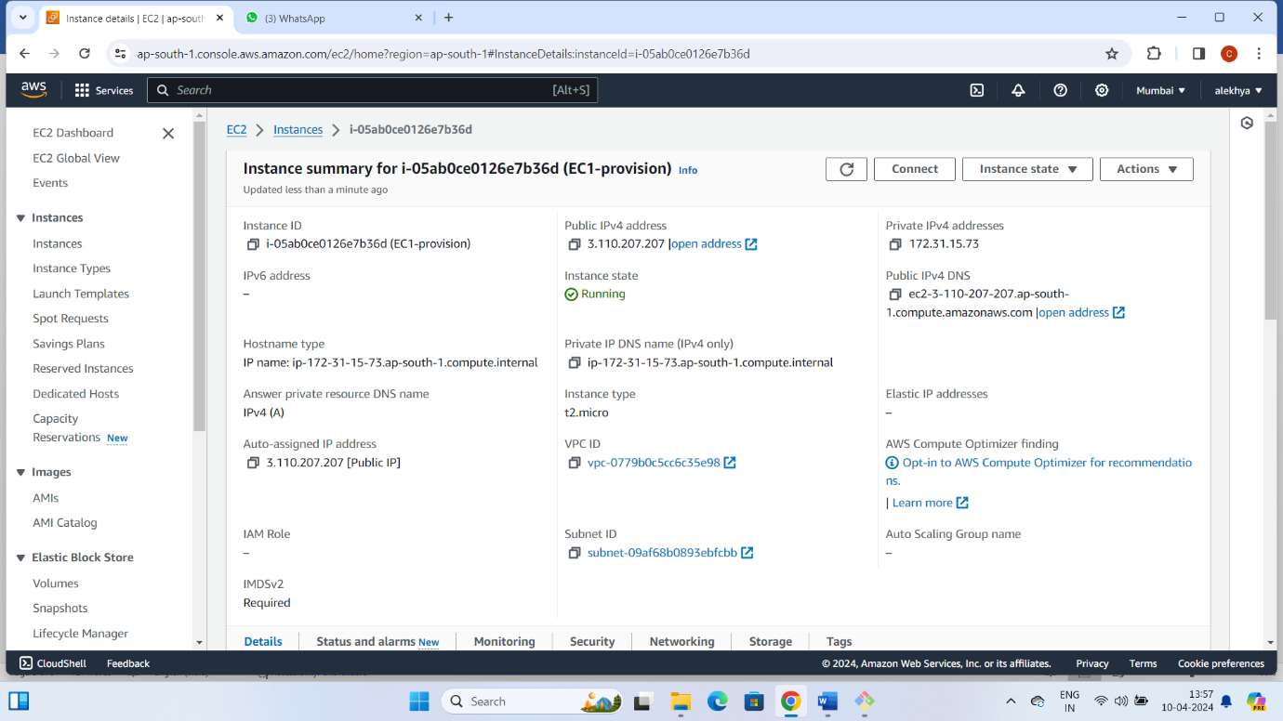

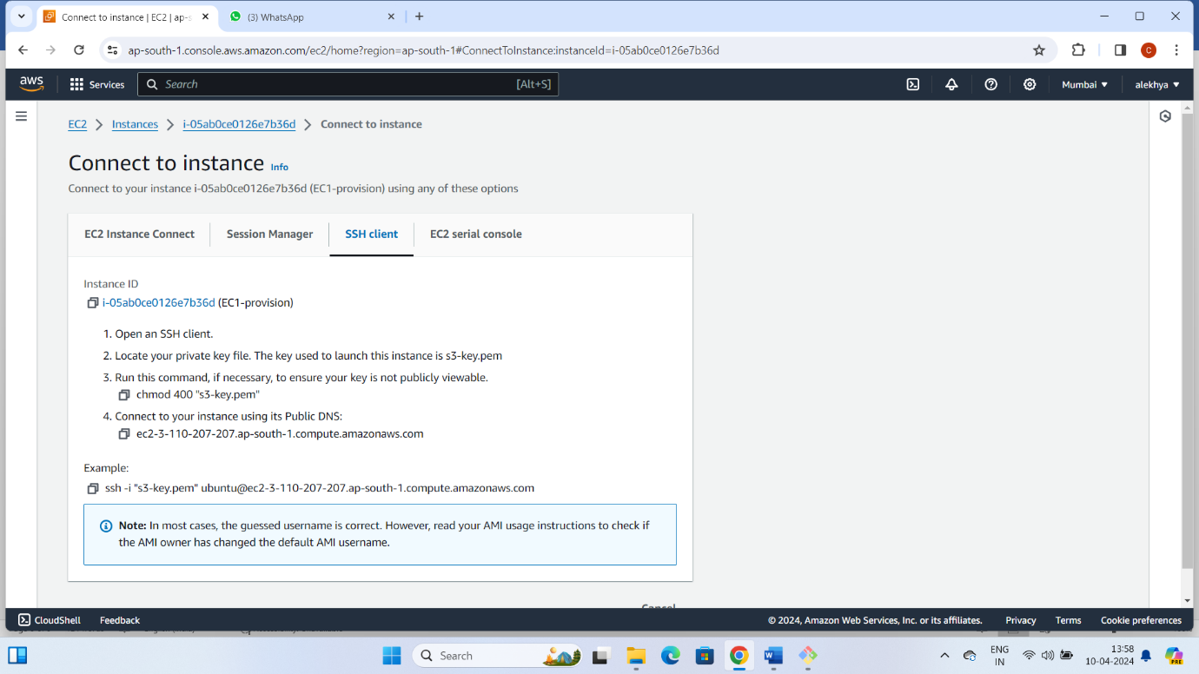

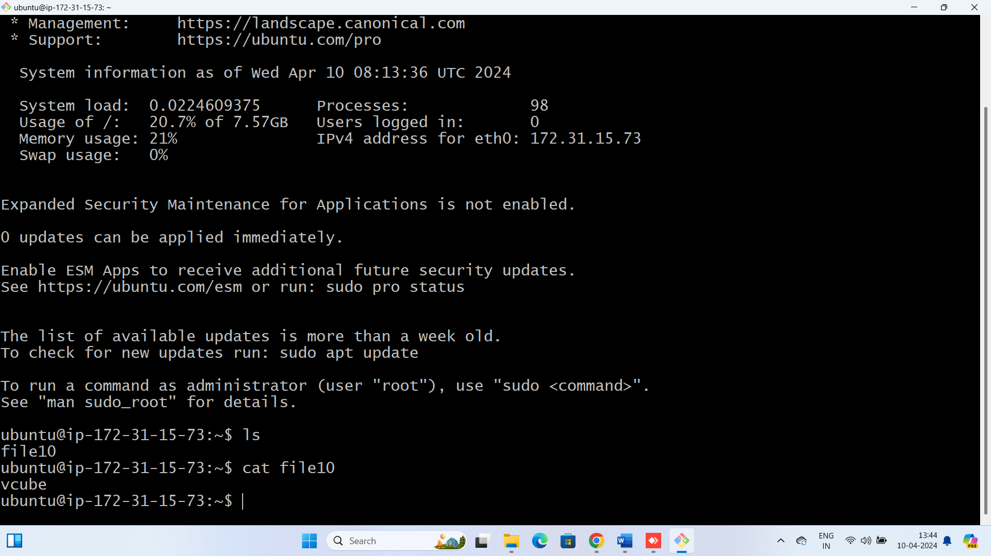

* We see the data file in the remote server.

