**CS551 – MIDTERM EXAM REPORT**

**By:**

**ALEKHYA BOYAPATI**

1. **Design:**

**a. Class Diagram:**

The class diagram for the proposed midterm exam is:

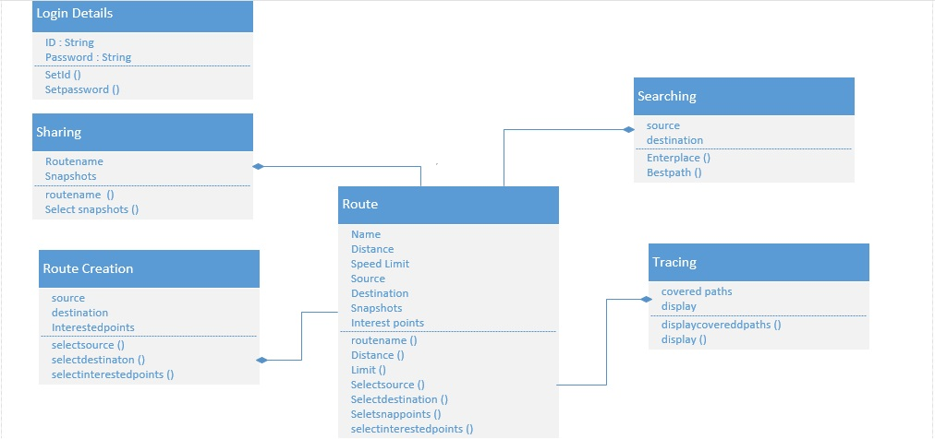

**b. Architectural Diagram:**

The architectural diagram for the proposed midterm exam is:

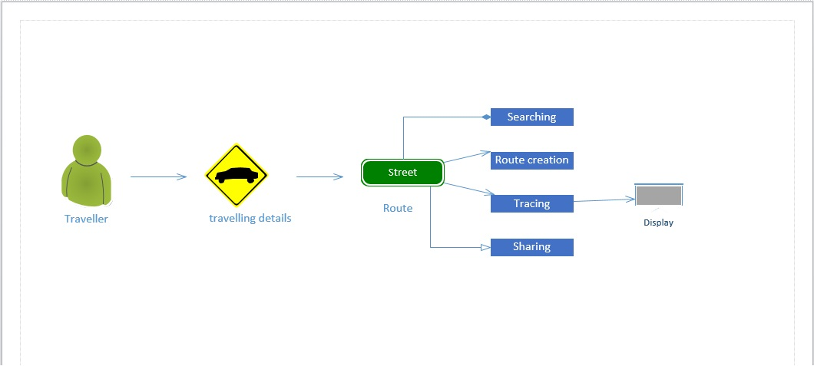

1. **Features Implemented:**
2. **Web Services:** In this project, the UMKC Travel Assist I created a Mobile web application which allows the user tosearch for directions from source to destination and also gives the user an option to save his/her search results and routes to his account by clicking on the “Add to List” button below.

The user can also search some places by using the search option in the left of the web application. He/she can select the location, type of search venue being searched for and also limit his search results by giving an input in the limit text box. When the user selects a particular search result, he/she will be able to see more details on the right hand side of the page.

Also, I have used the Google maps API in this project to show the search results on map for better location based services. Here, the Google maps API is used to display directions for the user and also displaying a particular venue when searched.

1. **Database:** Regarding the data sources, I used the data from foursquare website and also a large part of the reviews come from foursquare.com

The Google maps API has its own dataset of the maps and the locations. Since the data in this project is always changing and dynamic according to the user, it doesn’t have large amount of data to be collected.

In this project, I have tried using the Microsoft Access database for storing the user’s credentials for logging in and also his/her search results and places visited by the user etc.

1. **Mobile User Interface:** I have developed this project as a mobile web application and tried to provide mainly four features in this application.

I primarily created the login option for users and after login the user can simply have an outlook of what the web application does in the About Us tab on the left and the user can create, save and view saved routes in the next tabs.

1. **Screenshots:**

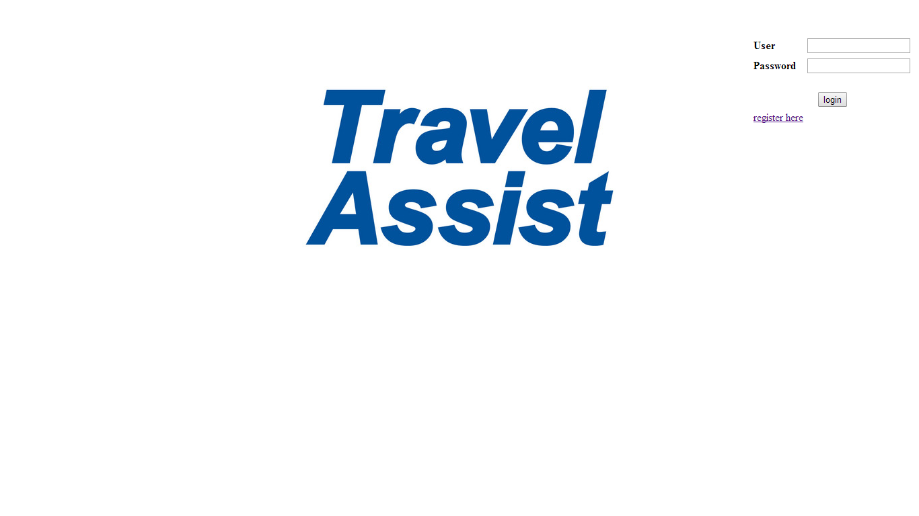

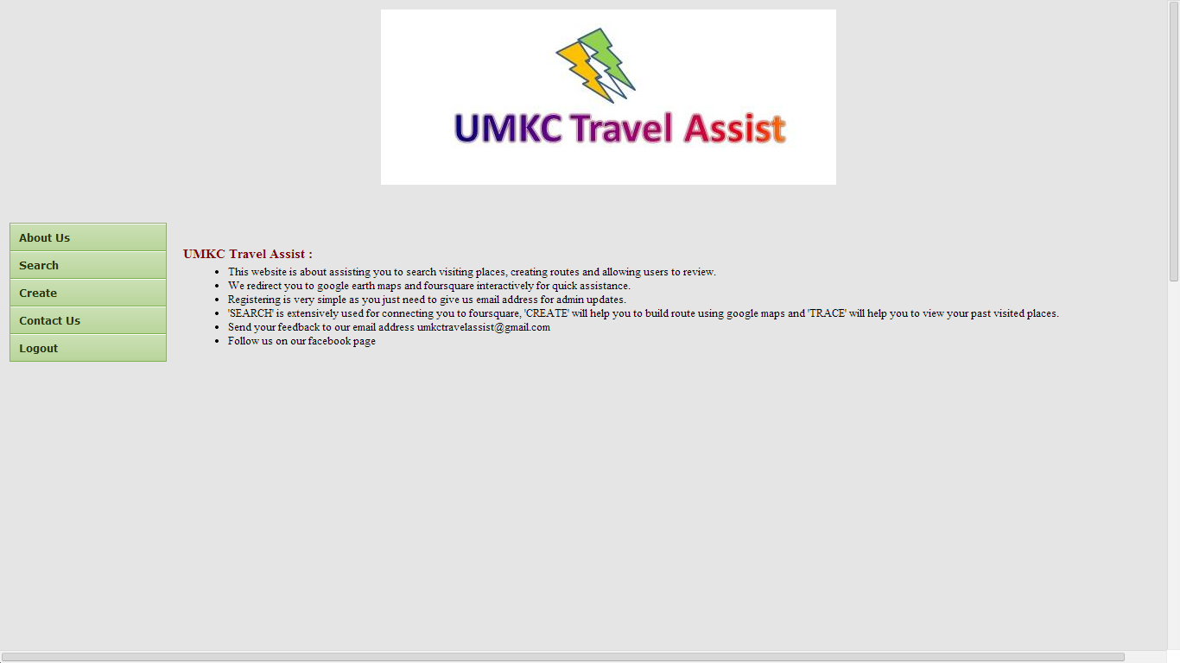

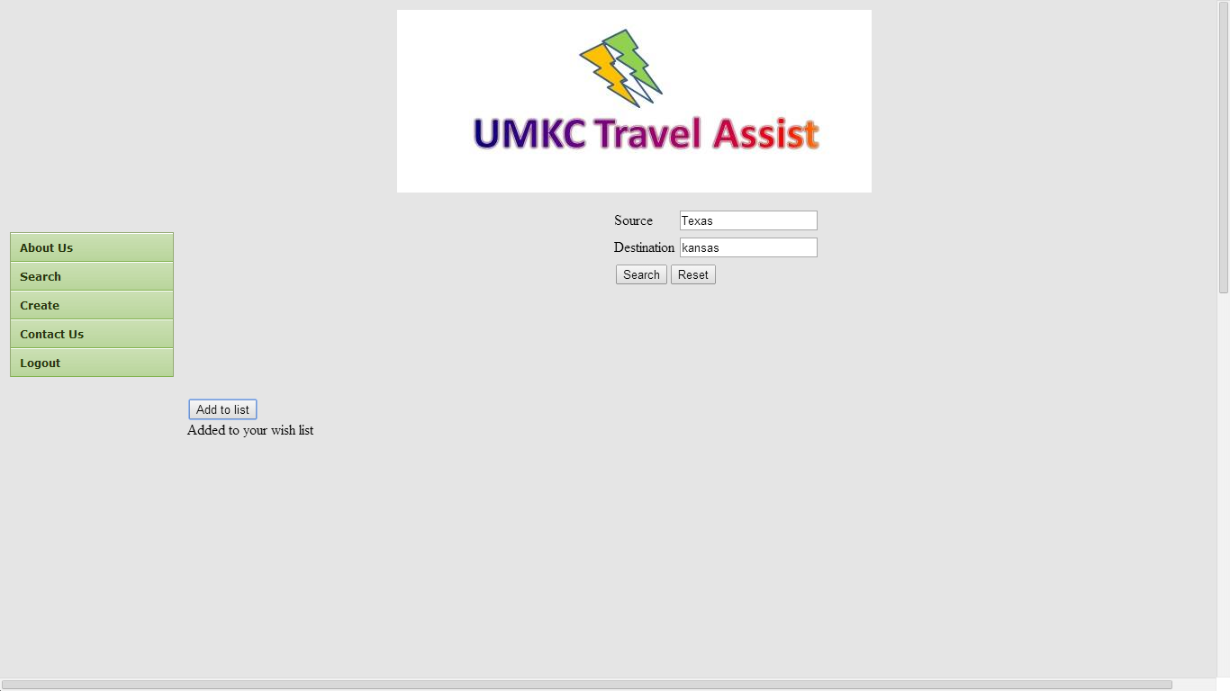

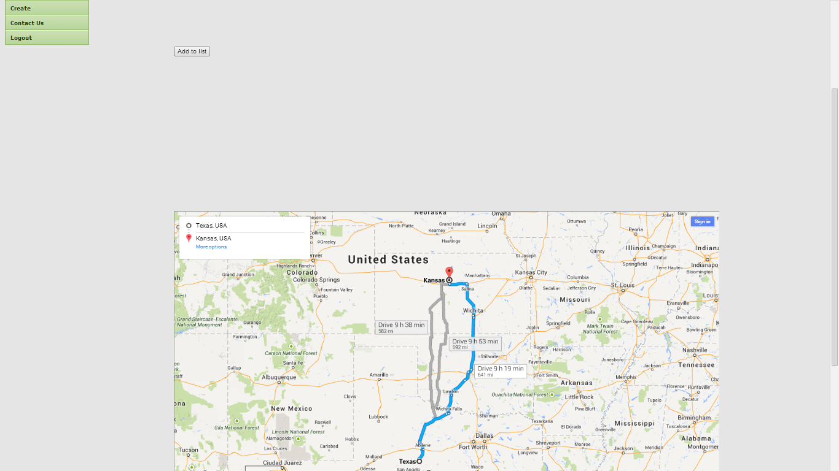

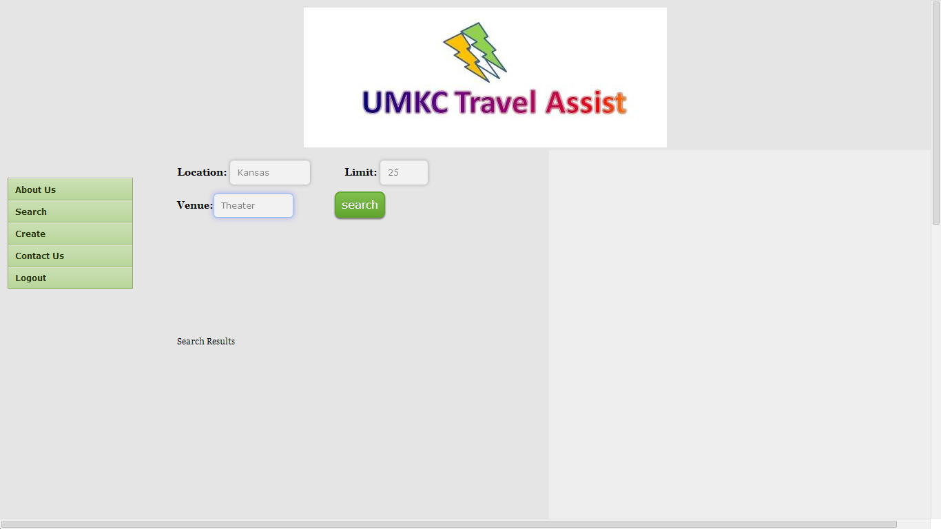

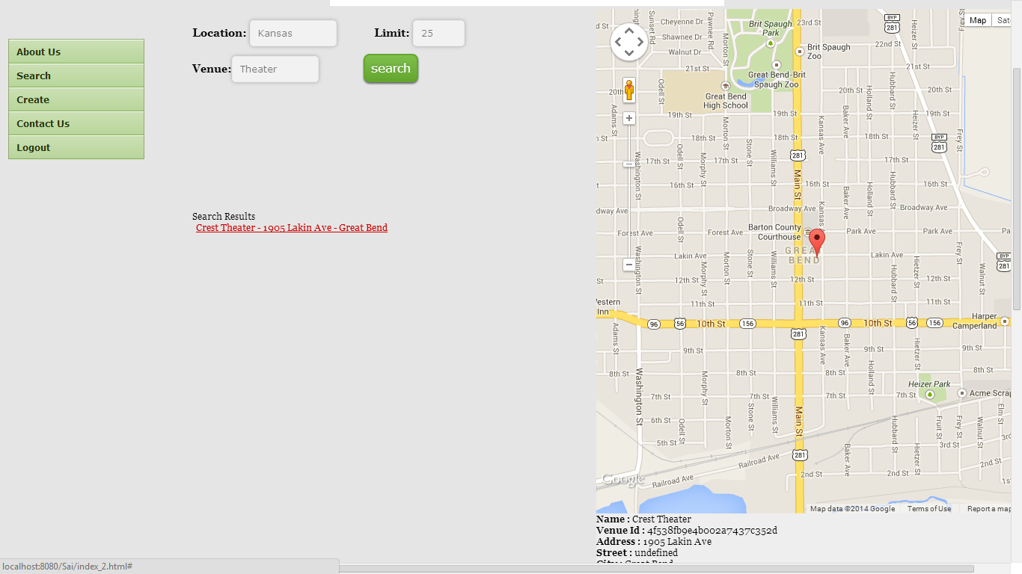

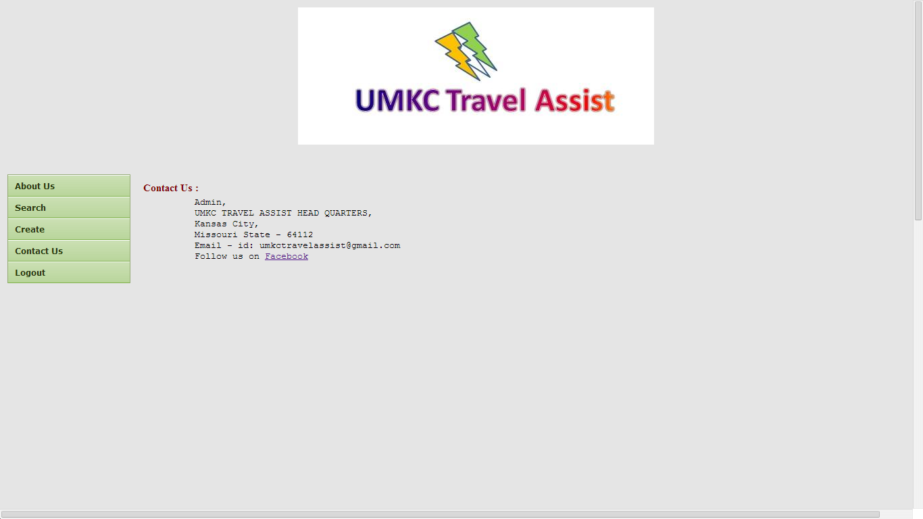

1. **Web Service and Website URL’s:**

**Google Maps API:** https://developers.google.com/

**FourSquare.com:** https://developer.foursquare.com/start

1. **Github URL:**

**https://github.com/alekhya1191/AdvancedSoftwareEngineering/tree/master/Midterm_ASE**

1. **Limitations: We cannot save all paths like flight paths.**

**Limits on number of friends we can share**

**Once saved routes can’t be modified**

1. **References:** [**www.w3schools.com**](http://www.w3schools.com)

[**www.tyretotravel.com**](http://www.tyretotravel.com)

**jquerymobile.com**