

**DEPARTMENT OF**

**COMPUTER SCIENCE AND SOFTWARE ENGINEERING**

***COMP 6231 - DISTRIBUTED SYSTEM DESIGN***

***WINTER 2019***

**WEB SERVICE IMPLEMENTATION OF THE**

**DISTRIBUTED LIBRARY MANAGEMENT SYSTEM**

**Submitted By:**

**Alekya Karicherla (40059347)**

Contents

**Overview** 3

**Terminology & Definitions** 3

**Abbreviations** 3

**Functional Descriptions** 3

**Requirements** 3

**Detailed Architecture** 4

**Detailed System Design** 5

**Class Diagram** 5

**Folder Structure** 6

**Test Scenarios** 7

**Challenges** 9

**References** 9

# **Overview**

The assignment is to develop a Distributed System for a group of libraries: used by library managers to manage the information about the items available in the libraries and library users to borrow or return items across the libraries. All the above said is to be implemented as a web service.

This document presents the designs, methods and architecture used in implementing the project.

## **Terminology & Definitions**

### **Abbreviations**

DLMS: Distributed Library Management System

SOAP: Simple Object Access Protocol

WSDL: Web Service Definition Language

XML: Extensible Markup Language

HTTP: Hyper Text Transfer Protocol

UDP: User Datagram Protocol

# **Functional Descriptions**

## **Requirements**

|  |  |
| --- | --- |
| **Feature** | **Description** |
| Add Item | This allows Manager to add/update details about the books into the respective library. |
| Remove Item | This allows the Manager either to reduce the count or to remove the book from the respective library. |
| List Item Availability | This feature is used by manager to look all the books and their quantity available in the respective library. |
| Borrow Item | This allows the user to borrow a book from the library, else add the user to a waiting list. |
| Find Item | This allows the user to know in which library the book exists along with their available quantity. |
| Return Item | This allows the user to return the book to the library where the book belongs to. |
| Exchange Item | This allows the user to exchange the borrowed item with any other item from same or other libraries. |

# **Web Service**

Web Services are software components described via WSDL which are capable of being accessed via standard network protocols such as SOAP over HTTP.

Web services provide interoperability between various software applications running on various platforms.

# **Detailed Architecture and Implementation**

Create a dynamic web project that consists of client and three servers namely, CON, MCG and MON. All the servers perform same type of operations.

The functionalities mentioned above will be defined in interface file called as Service Endpoint Interface (SEI).

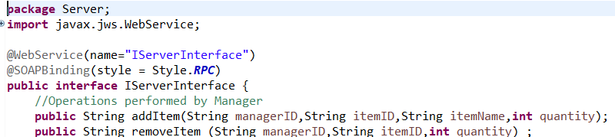

The implementation of the defined functions is added in ServerImpl Class.

This class is annotated as webservice endpoint using @WebService annotation, and the methods with @WebMethod annotation.

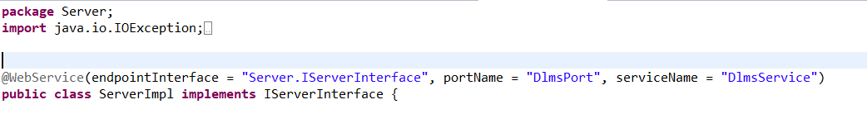

Later we navigate to the path which contains class files e.g., c://path/bin and the following command is executed.

**wsgen -verbose -cp . Server.ServerImpl -wsdl**

This generates .xsd and .wsdl files.

Later navigate to the path where the above files were generated and execute the following command.

**wsimport -keep -d . -p ClientStub DlmsService.wsdl**

This will generate the port,through the call can be made.It acts as a proxy for the remote service.

We can view the wsdl files for each webservice by using the urls,after the server and client are started.

For CON Server: http://localhost:2121/CON?wsdl

For MCG Server: http://localhost:2122/MCG?wsdl

For MON Server: http://localhost:2123/MON?wsdl

We also have ManagerClient and UserClient to perform their respective functionalities.

Data is stored in the form of HashMap & Queues in each server.

Server to Server communication is maintained by UDP.

# **Detailed System Design**

## **Class Diagram**

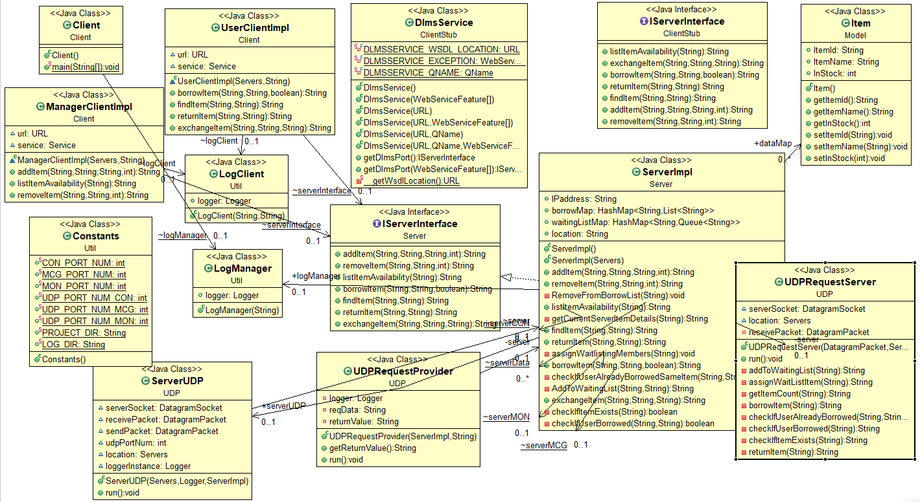

## **Folder Structure**

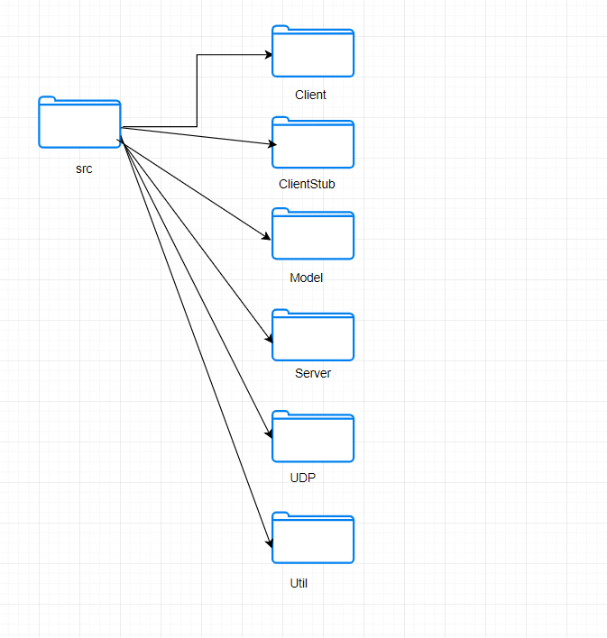

# **Test Scenarios**

|  |  |  |  |
| --- | --- | --- | --- |
| **Test Id** | **Test Description** | **Expected Result** | **Actual Result** |
| **T001** | Manager/User Id is entered. | Menu should be displayed according to the user. | As Expected |
| **T002** | Add Item: Manager adds an item to the library. | Item should be added to the HashMap of the respective server | As Expected |
| **T003** | Add Item: Manager adds existing item to the library | Item quantity should get updated. | As Expected. |
| **T004** | Remove Item: Manager gives the item Id and quantity to the removed for that item | Item quantity will be reduced/the item will be removed from the HashMap. | As Expected |
| **T005** | Remove Item: Manager gives wrong Item details. | Should display a message stating, “Item does not exist”. | As Expected |
| **T006** | List Item Availability: Manager requests to see all the items available in their library | All the items and their available Quantity will be displayed. | As Expected |
| **T007** | Borrow Item: User requests for an item from his/her own library and the book is available. | The book will be assigned to the user. | As Expected |
| **T008** | Borrow Item: User requests for an item from his/her own library and the book is not-available. | User will be prompted whether to be in waiting list for the book or not. | As Expected |
| **T009** | Borrow Item: User wants to be in waiting list | User will be added to a waiting list queue of that item. | As Expected |
| **T010** | Borrow Item: User doesn’t want to be in waiting list. | Main menu for the user will be displayed | As Expected |
| **T011** | Find Item: User searches for a book with its name. | Displays the details about the Item Id and quantity available across all the libraries. | As Expected |
| **T012** | Find Item: User searches for a book with wrong name. | Displays “No records found” message. | As Expected |
| **T013** | Return Item: User returns the borrowed book | The user and book will be removed from the borrowed list, the count of book in the library server will be incremented. | As Expected |
| **T014** | Return Item: User returns a wrong item Id | Error message “No such Item borrowed. Please try again.” will be displayed. | As Expected |
| **T015** | Return Item: Checks the waiting list queue of the book | If there is any user waiting for it, assigns the book to the user and removes him/her from the waiting list. | As Expected |
| **T016** | Borrow Item: User requests to borrow item from another library. | If the item is available, it will be assigned to the user, else adds to the waiting list, as per the user selection. | As Expected |
| **T017** | Borrow Item: User already borrowed one item from other library and requests for another book from the same library | An error message will be displayed as “User can borrow only one book from other libraries”. | As Expected |
| **T018** | User enters id in wrong format. | An error message “Invalid choice! Please try again.” will be displayed | As Expected |
| **T019** | List Item Availability: Manager requests to see all the items available in their library, when no items were added. | A message “No Records found” will be displayed. | As Expected |
| **T020** | Manager/User Id is entered in the form of LIBRXXX | A message “Too many/less characters in the ID. Please enter in (LIBRXXXX) format, where LIB={CON,MCG,MON} and R={M,U}” will be displayed. | As Expected |
| **T021** | User enters an invalid ID (E.g.: CONM7Y*6) | A message “Invalid character in ID. Please enter in (LIBRXXXX) format, where XXXX can only be numbers” will be displayed. | As Expected |
| **T022** | Remove Item: Manager tries to remove an item with quantity greater than available quantity. | A message “Quantity entered is incorrect” will be displayed. | As Expected |
| **T023** | Remove Item: Manager enters the quantity as “-1”. | If the book is borrowed by any user, it will be removed, and the item will be completely removed. | As Expected |
| **T024** | User/ Manager enters invalid item Id. (E.g., XYZ7845) | An error message “Invalid ItemId. Please try again.” will be displayed. | As Expected |
| **T025** | Return Item: User tries to return a book which is not borrowed. | Error message “No such Item borrowed. Please try again.” will be displayed. | As Expected |
| **T026** | Remove Item: Manager tries to remove/reduce another library’s item. | An error message “Item doesn’t exist will be displayed. | As Expected |
| **T027** | Exchange Item: User wants to exchange an item with another item in the same/other library, and the new item to be borrowed doesn’t exist. | An error message “Sorry, cannot process the request currently. Please try again!!” will be displayed | As Expected |
| **T028** | Exchange Item: User wants to exchange an item with another item in the same/other library, and the item already borrowed doesn’t exist. | An error message “Sorry, cannot process the request currently. Please try again!!” will be displayed | As Expected |
| **T029** | Exchange Item: User wants to exchange an item with another item in the same/other library | The new item will be borrowed, and old item will be returned respectively. | As Expected |

# **Challenges**

Understanding and Creation of WSDL files.

Usage of SOAP Binding failed to generate the WSDL files.

Usage of commands was difficult to understand.

# **References**

* Asg3.6231w19.pdf
* WebServices lab tutorial
* https://docs.oracle.com/javase/8/docs/technotes/tools/unix/wsgen.html