

MYOB Coding Exercise

Author: Alekhya Ejjina

Email: [alekhya538@gmail.com](mailto:alekhya538@gmail.com)

Prerequisite

* Eclipse
* Apache Tomcat 7
* Maven
* Copy the given settings.xml to C:/Users/XXX/.m2/
* Working internet connection for the maven to download all dependencies

Usage

* Import the supplied maven project to eclipse (PayGenerator/)
* Create & configure Tomcat server (install directory, ports to use etc.)
* Deploy the web application (Right-Click on project and Run As -> Run on Server)
* Open a browser and navigate to “http://localhost:8080/
* Enter input file in the text box (default path pre-populated)
* Click on button “Generate Pay Details”
* Employee Income details are displayed in a new page in a table
* The same details are also saved as a CSV in below location,

C:/dev/myob/PayGenerator/output/

File name contains timestamp, to avoid unwanted overwrites.

Assumptions

* Solution assumes that the input CSV has correct no. of fields and in pre-defined order (first name,last name,annual salary,super rate,payment start date)
* Output CSV is generated in below location,

C:/dev/myob/PayGenerator/output/empPayDetails_20190604134310.csv

* Output files contain timestamp in name, so as to not overwrite file for every execution.

Application Sequence Diagram

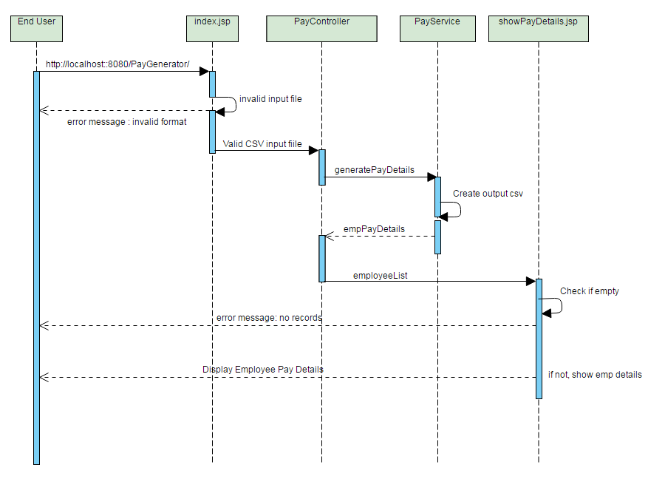

Screenshots

1. Home Page (http://localhost:<port>/PayGenerator/)

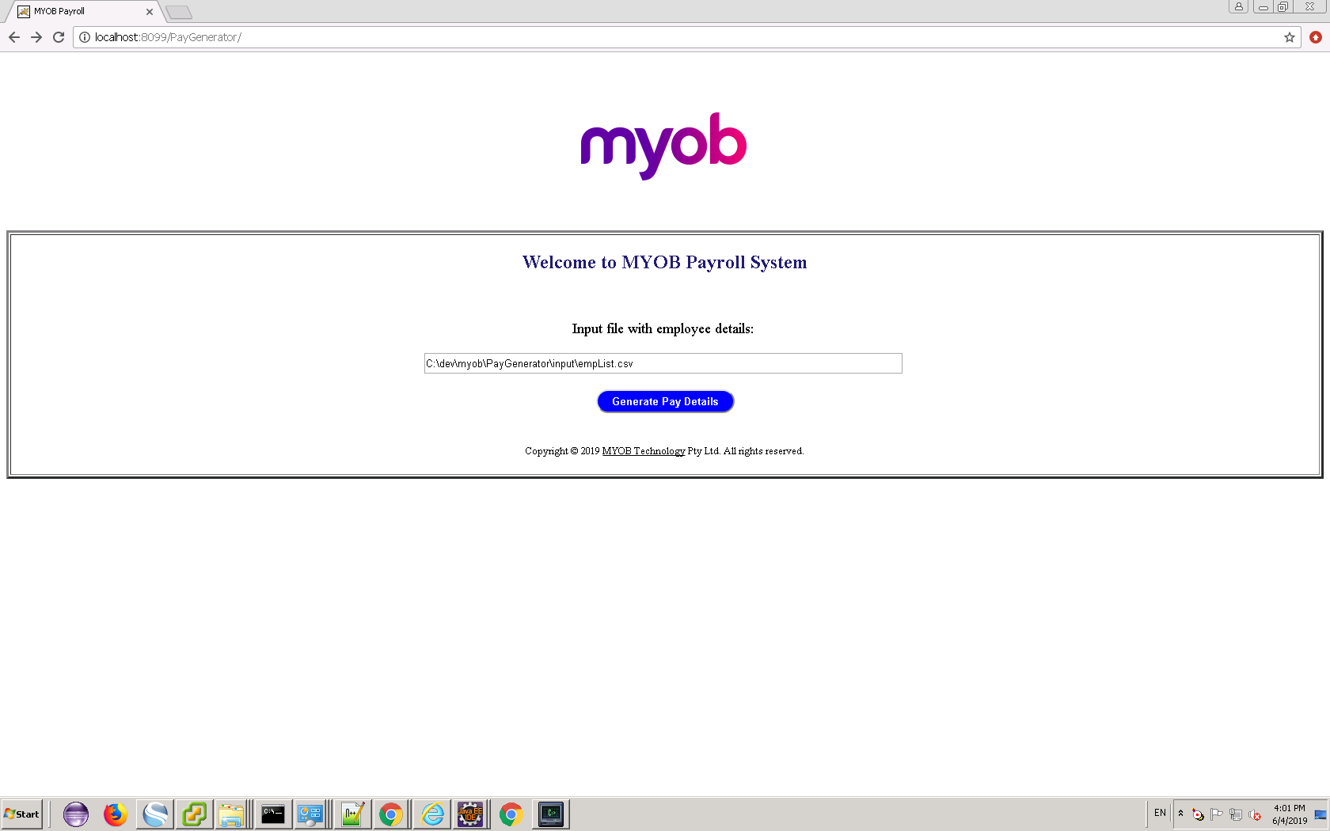

1. Enter Input File with employee details.

The only accepted input file format – CSV. An Error is thrown otherwise.

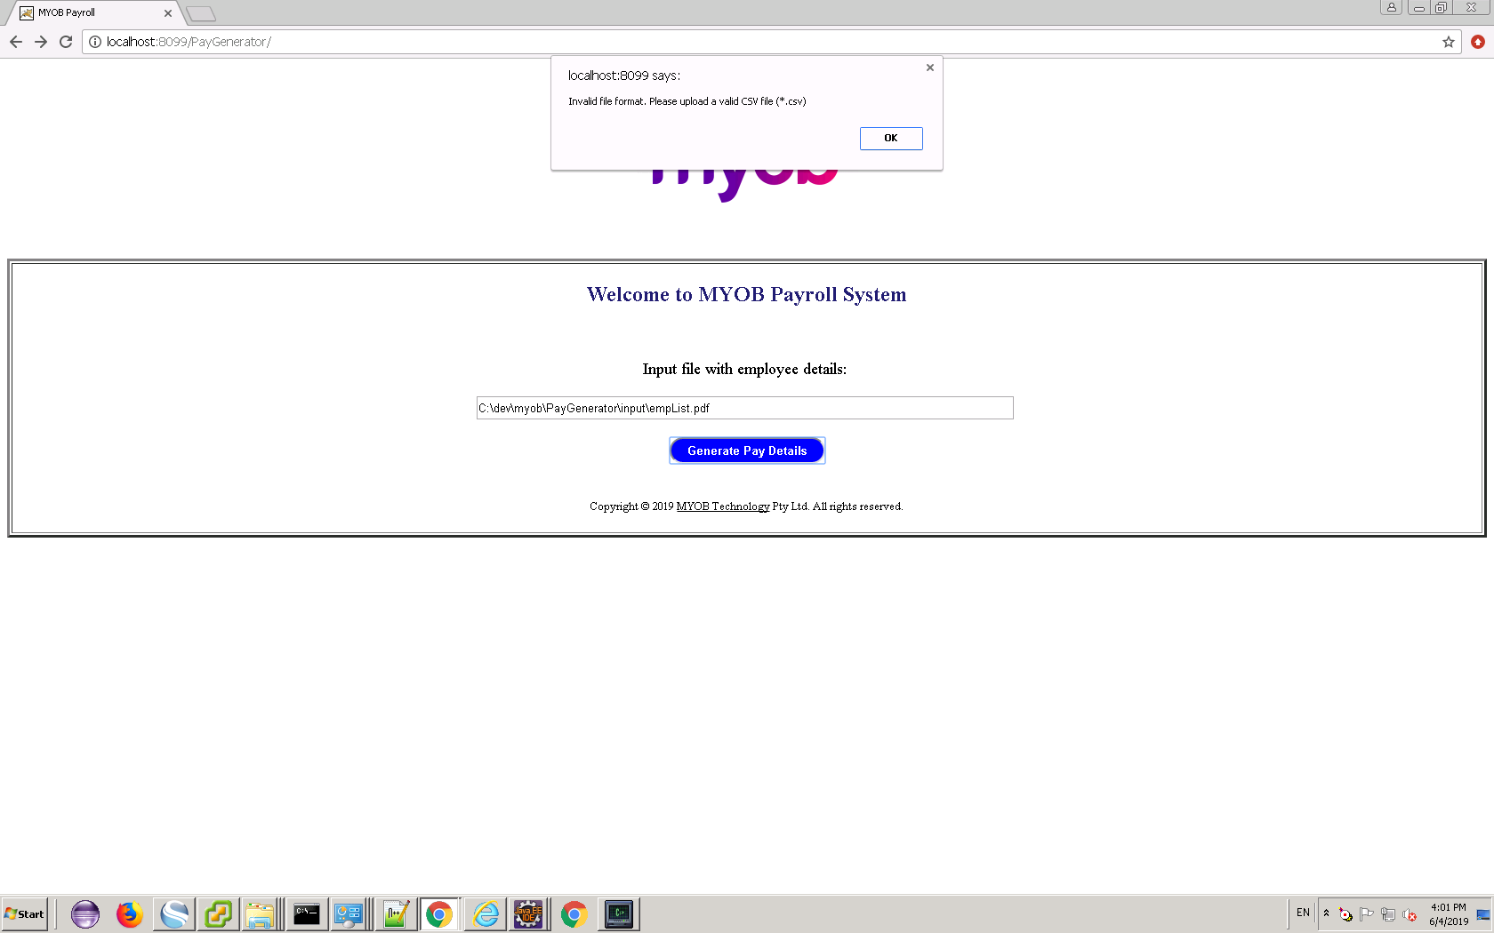

1. Employee Income Details page

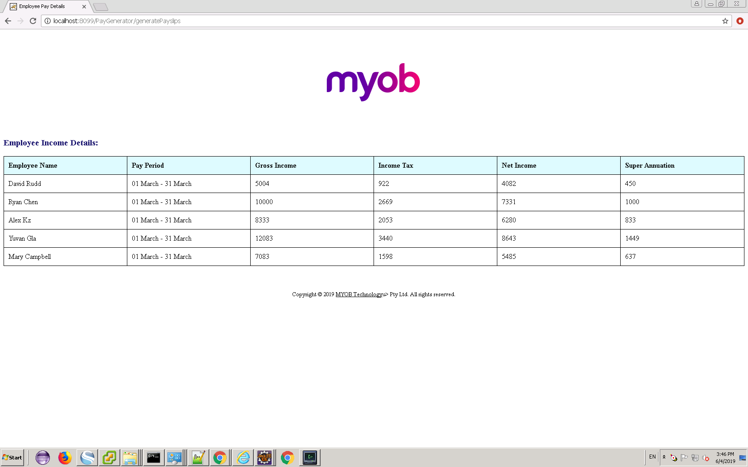

1. CSV is generated in *Output* folder

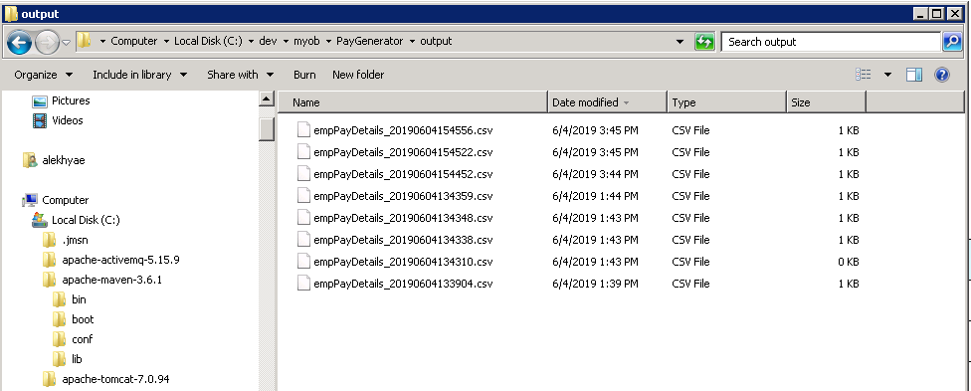

1. If input CSV file is empty, an error message is shown.

