**Each question 5 marks**

1. Create a company on Cloud SaaS platform Hubspot.

2. Create a company website using the SaaS platform.

3. Publish the company URL.

4. Create a Workflow automation.

5. Create a Chatflow automation.

**Section 2 - 25 marks**

Viva on AWS Theory and Simulation. - basic cloud computing questions

1. How many bucket in amazon s3 : 6 buckets

2. What do you understand about the standard bucket in amazon s3?

3. What is private cloud, what is public cloud

4. What is IAAS, PAAS, SAAS difference?

5. Tell me difference between disaster recovery and data centre

6. Advantages of cloud

7. on premises cloud and public cloud and private cloud difference

8. Distributed System

9. What is cloud computing?

**Question 1:**

1. **Create contact**

Not necessary to put linkedin

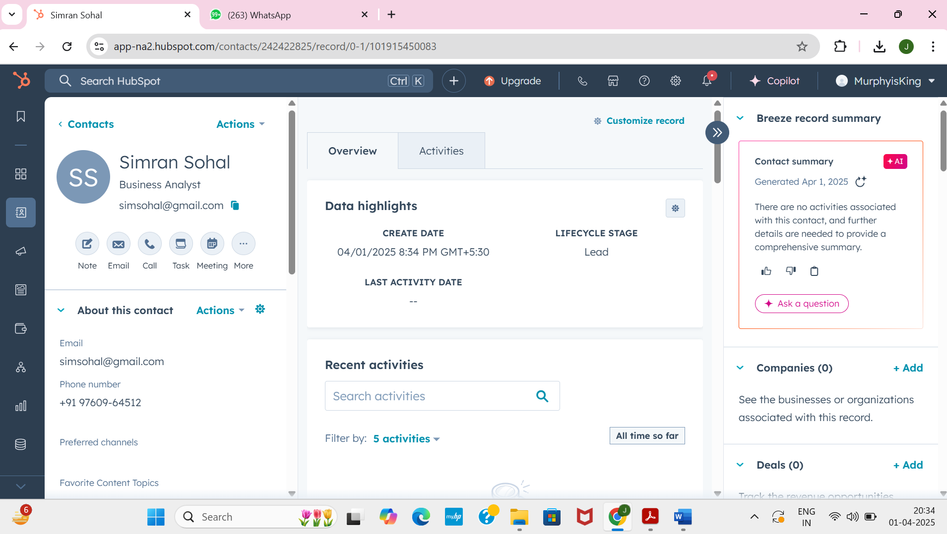

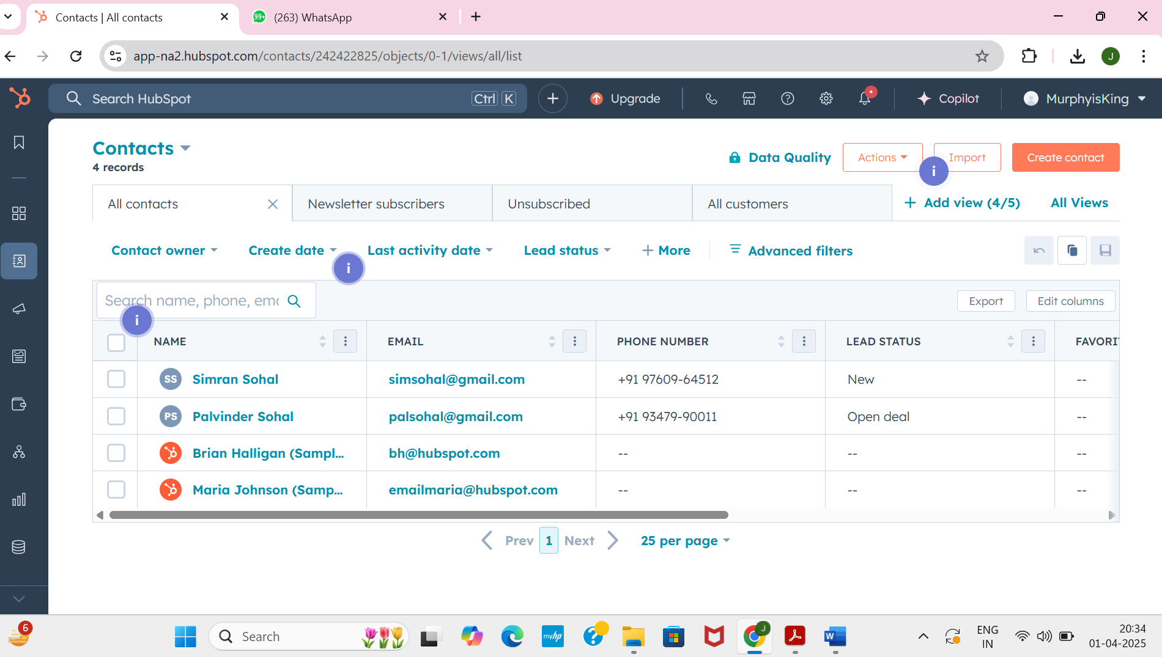

1. **Create company**

Domain name always ends with .com

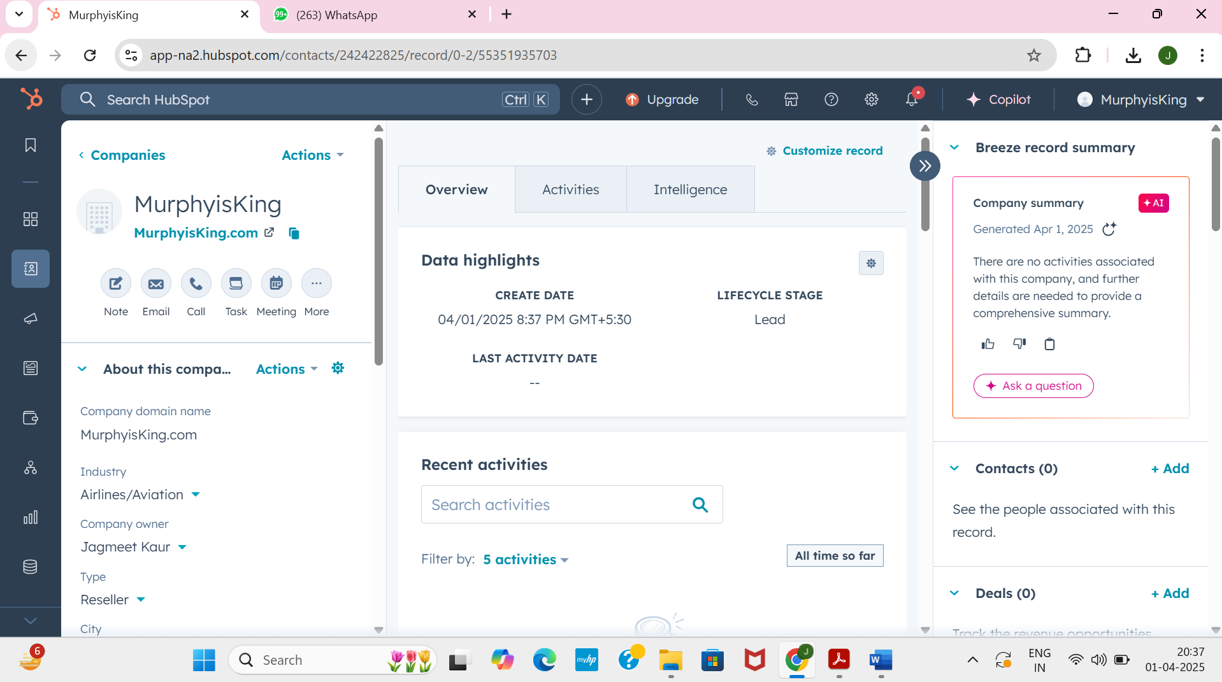

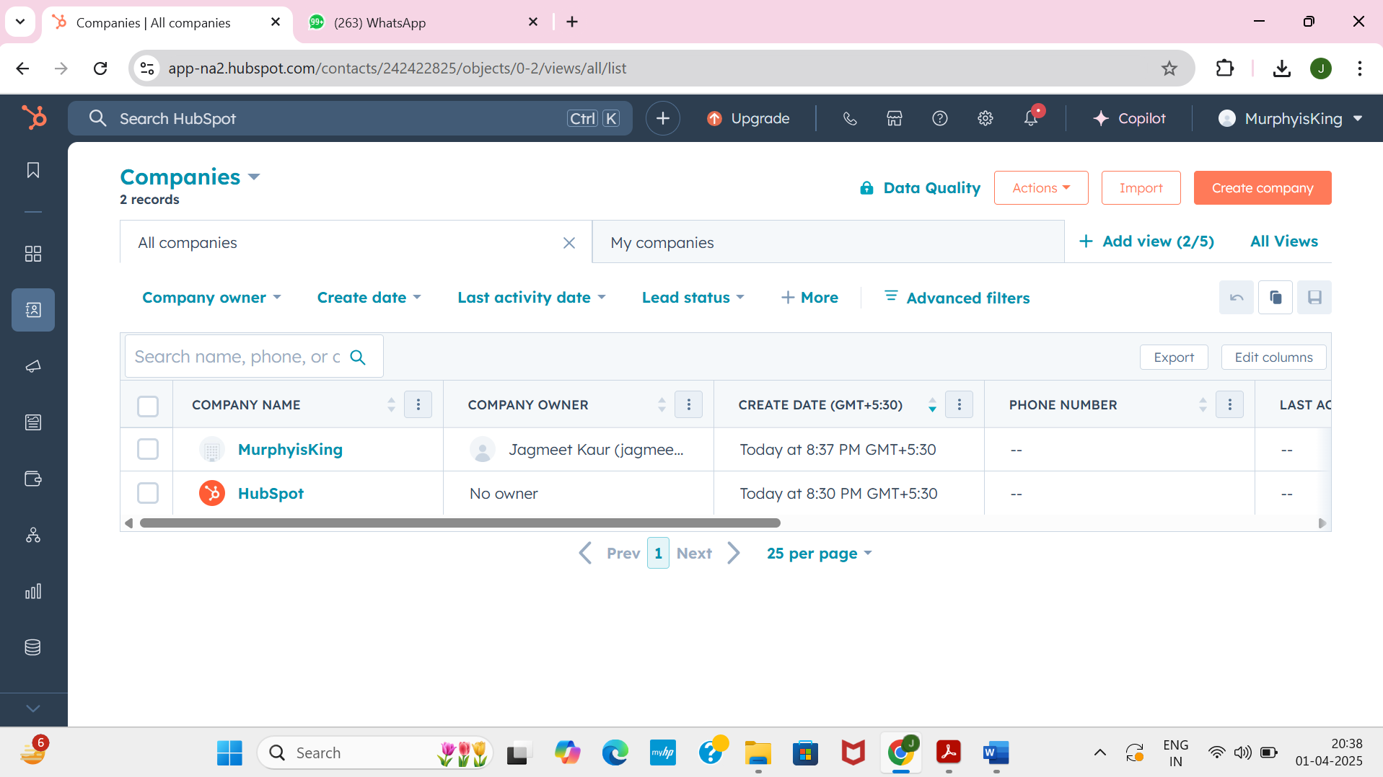

**Question** **2** : **Create Website**

Take Screenshots 🡪 desktop, mobile

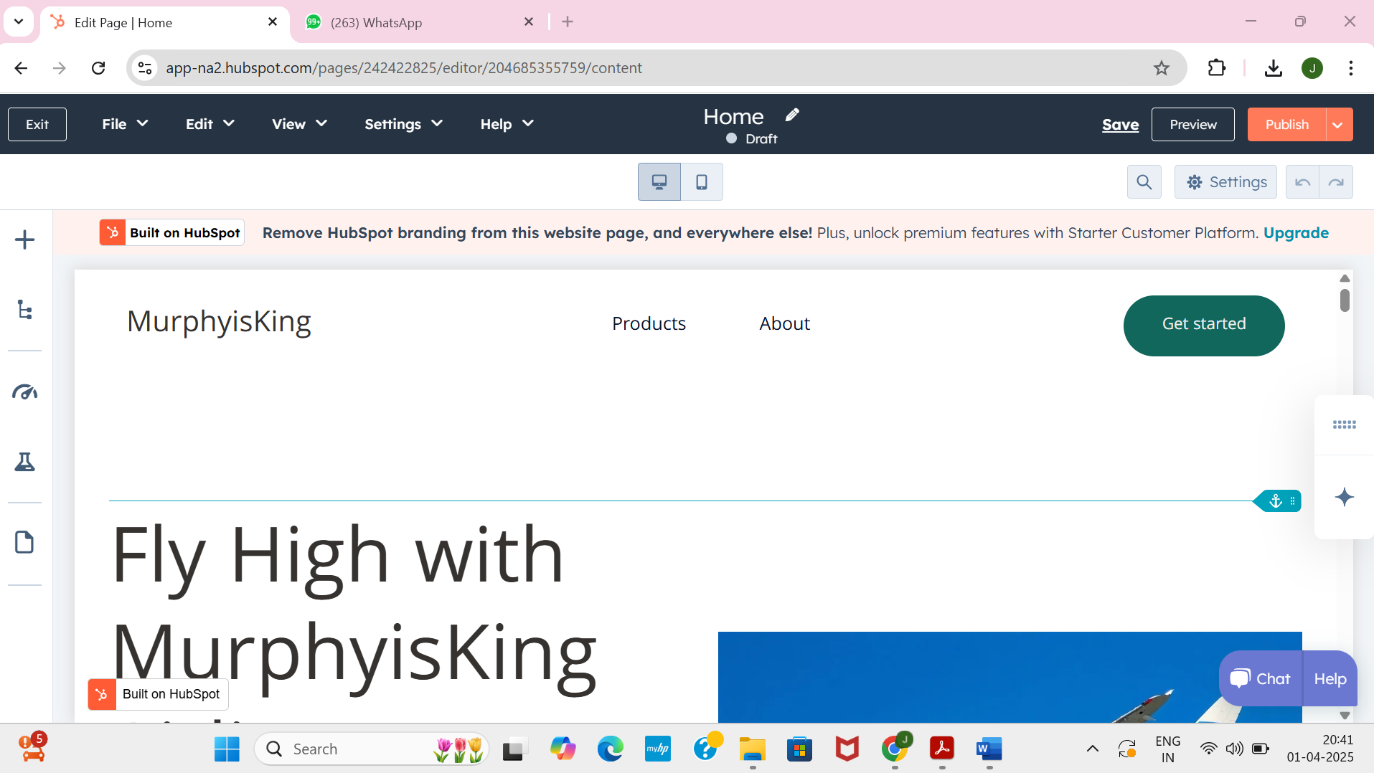

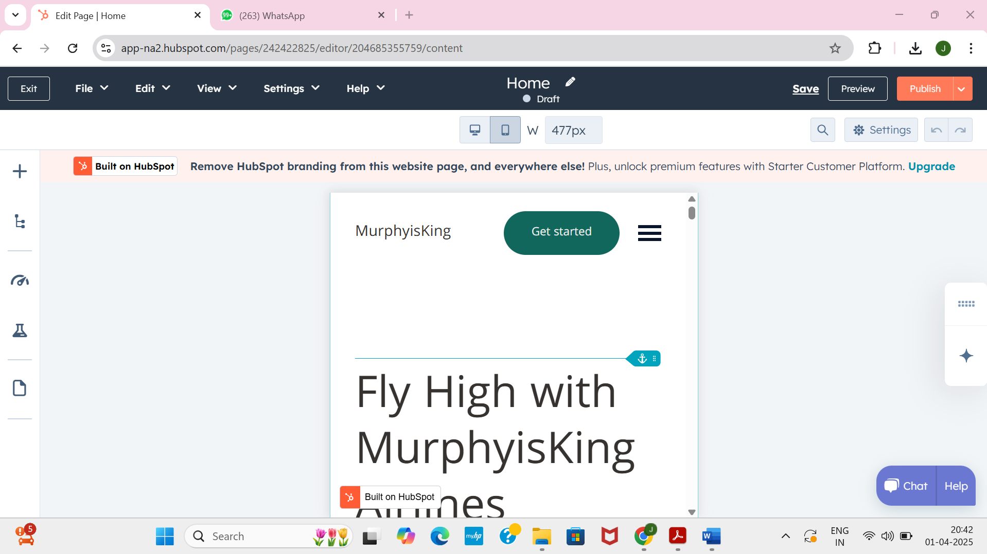

**Question 3:** **Publish Company URL**

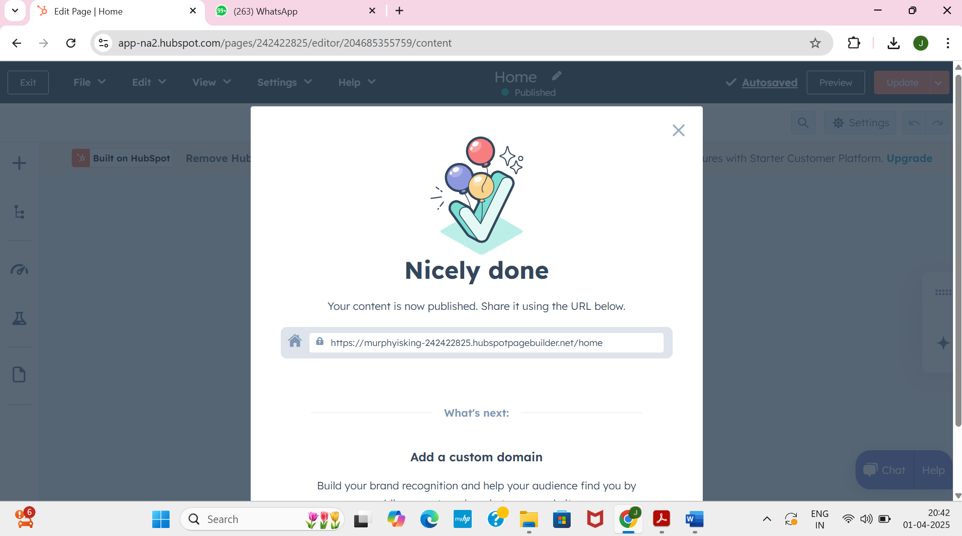

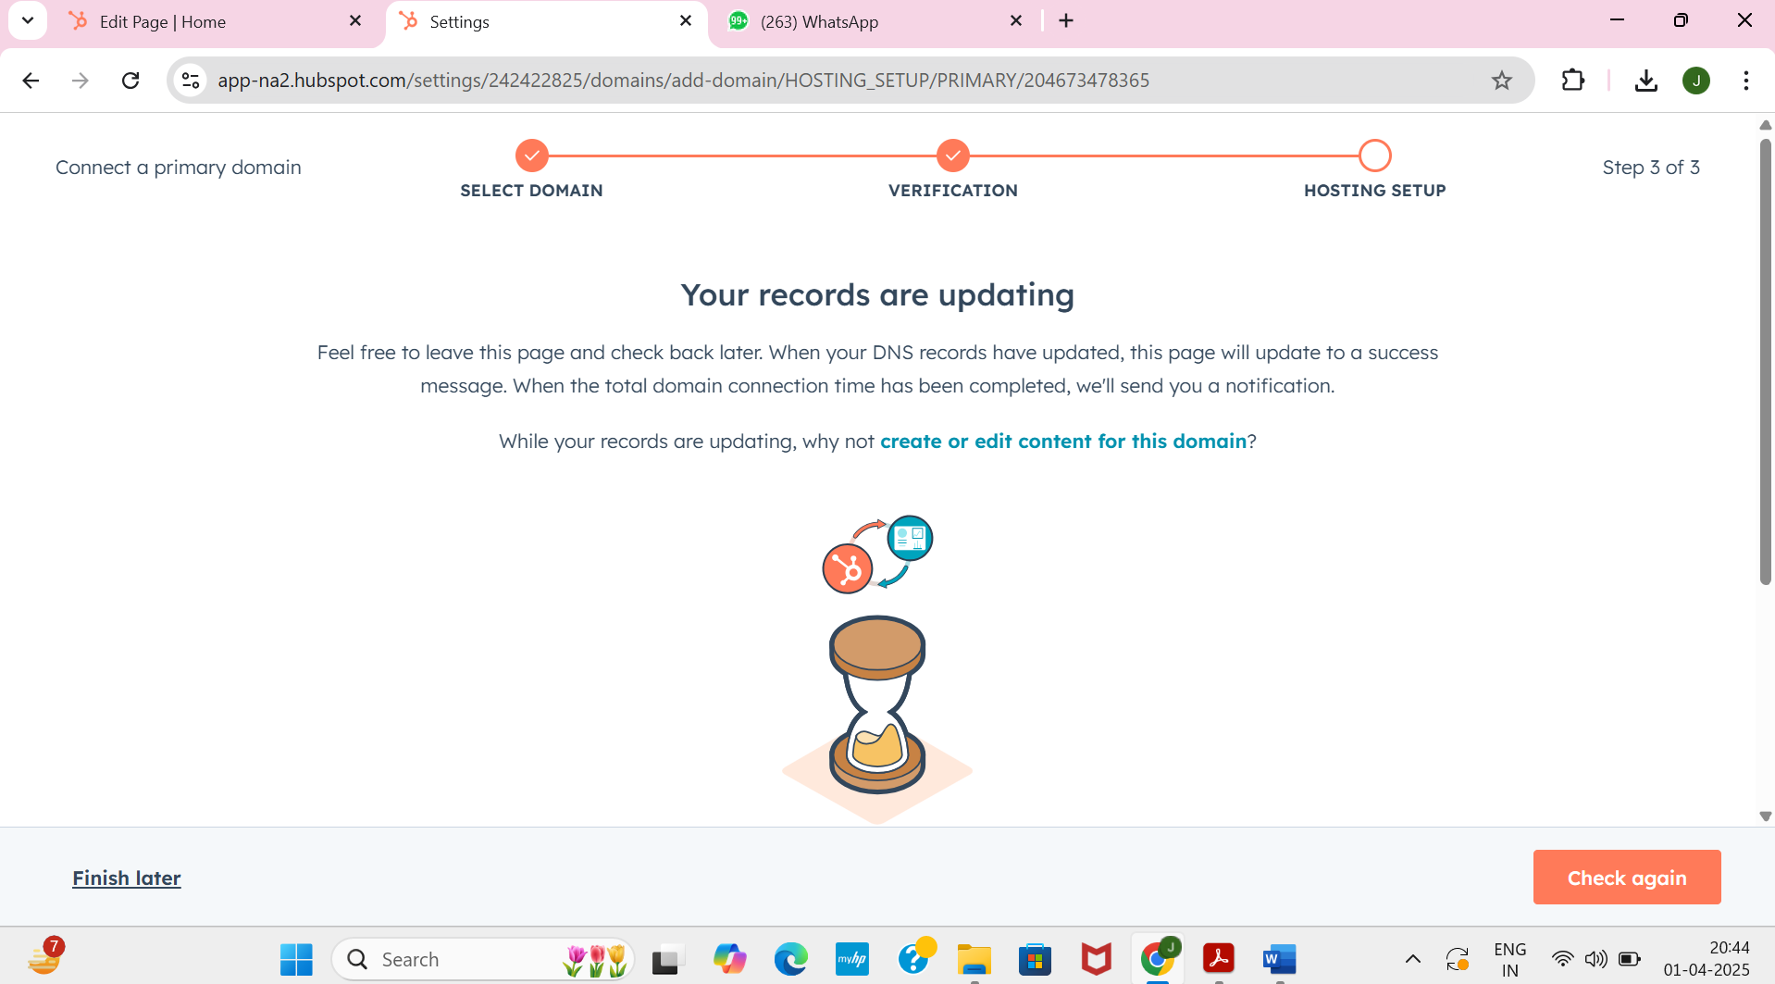

Click Next, next, Verify, on Finish later

**Qusetion 4: Create Workflow Automation**

Click on Start A free 14 day Trail

Tell contact owners when leads interact with your website

Review and pulish

Yes I want to

Next next till “turn on workflow”

Ctrl ---

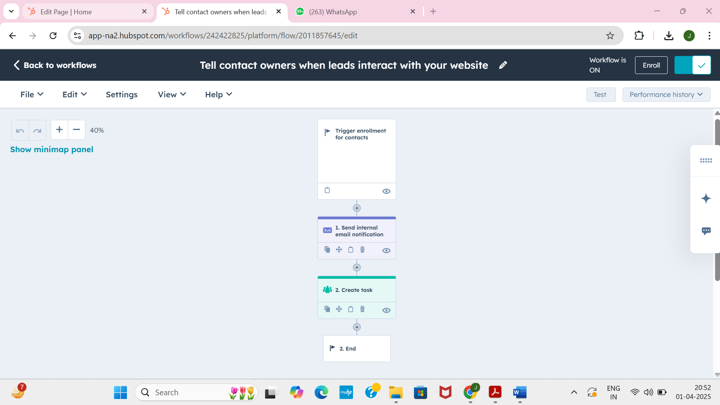

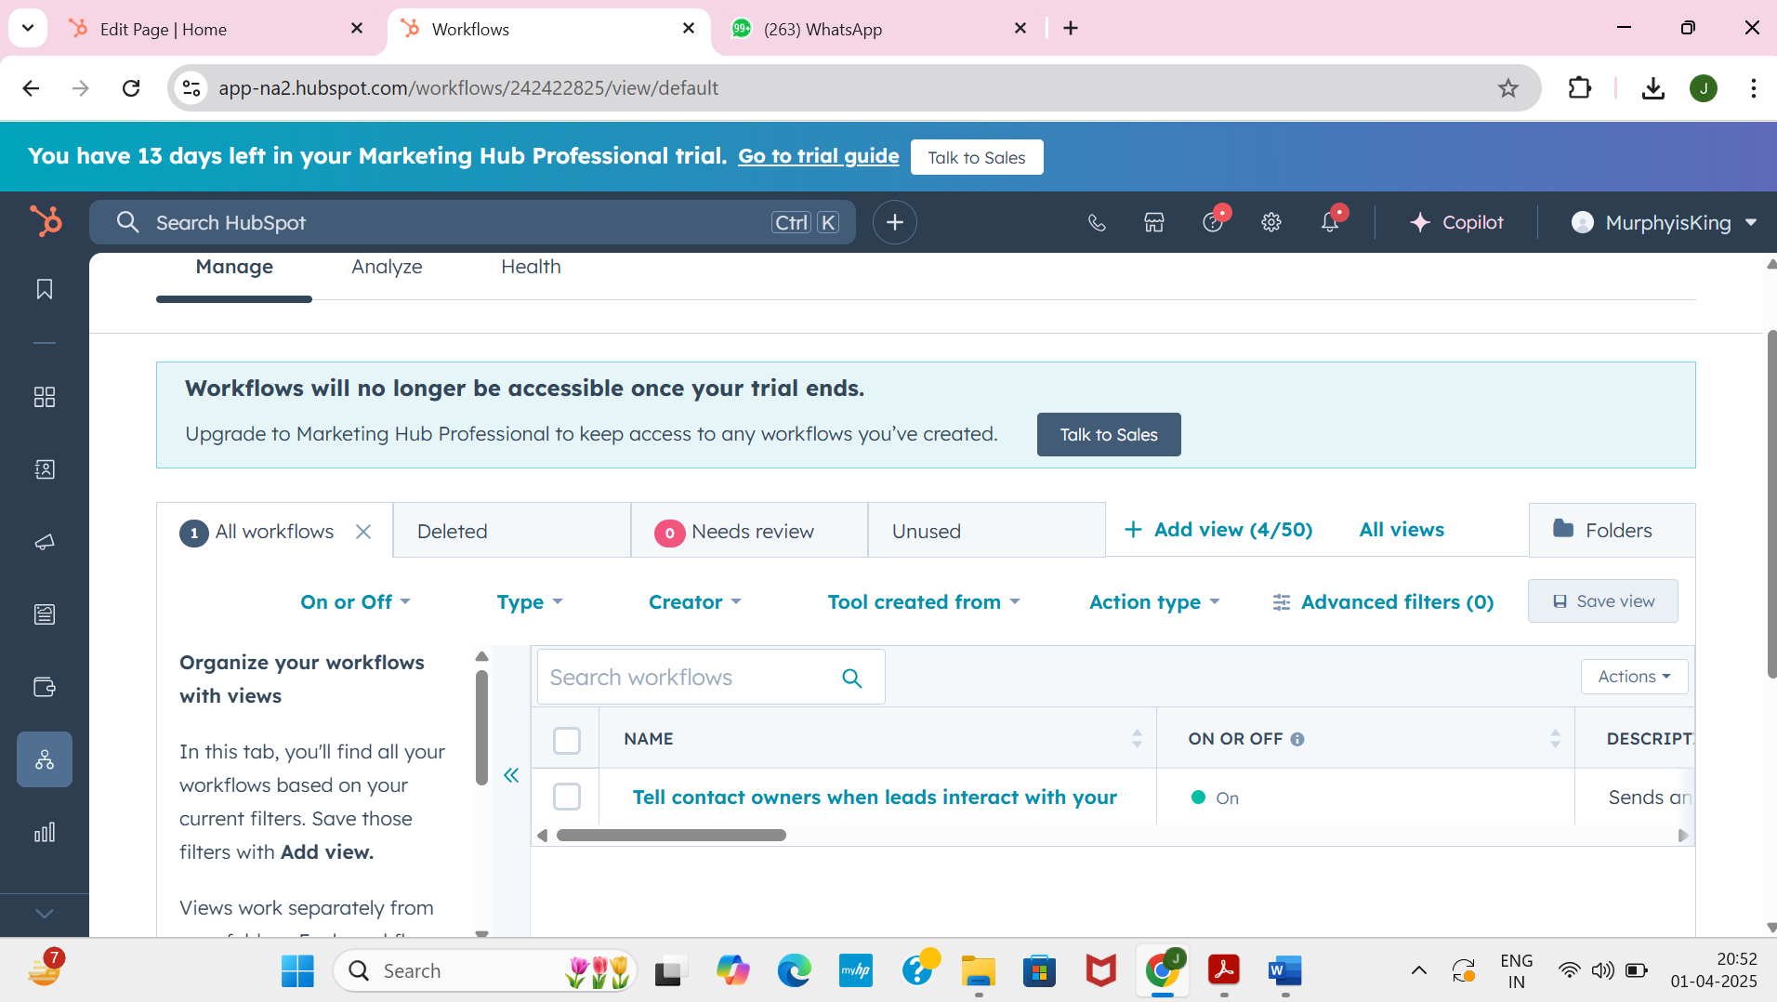

**Question 5: Create a Chatflow Automation**

Choose “website”

Set up chat

Choose “Web”

Change colour/format that you want

Chat is available 24/7

Enter a welcome message

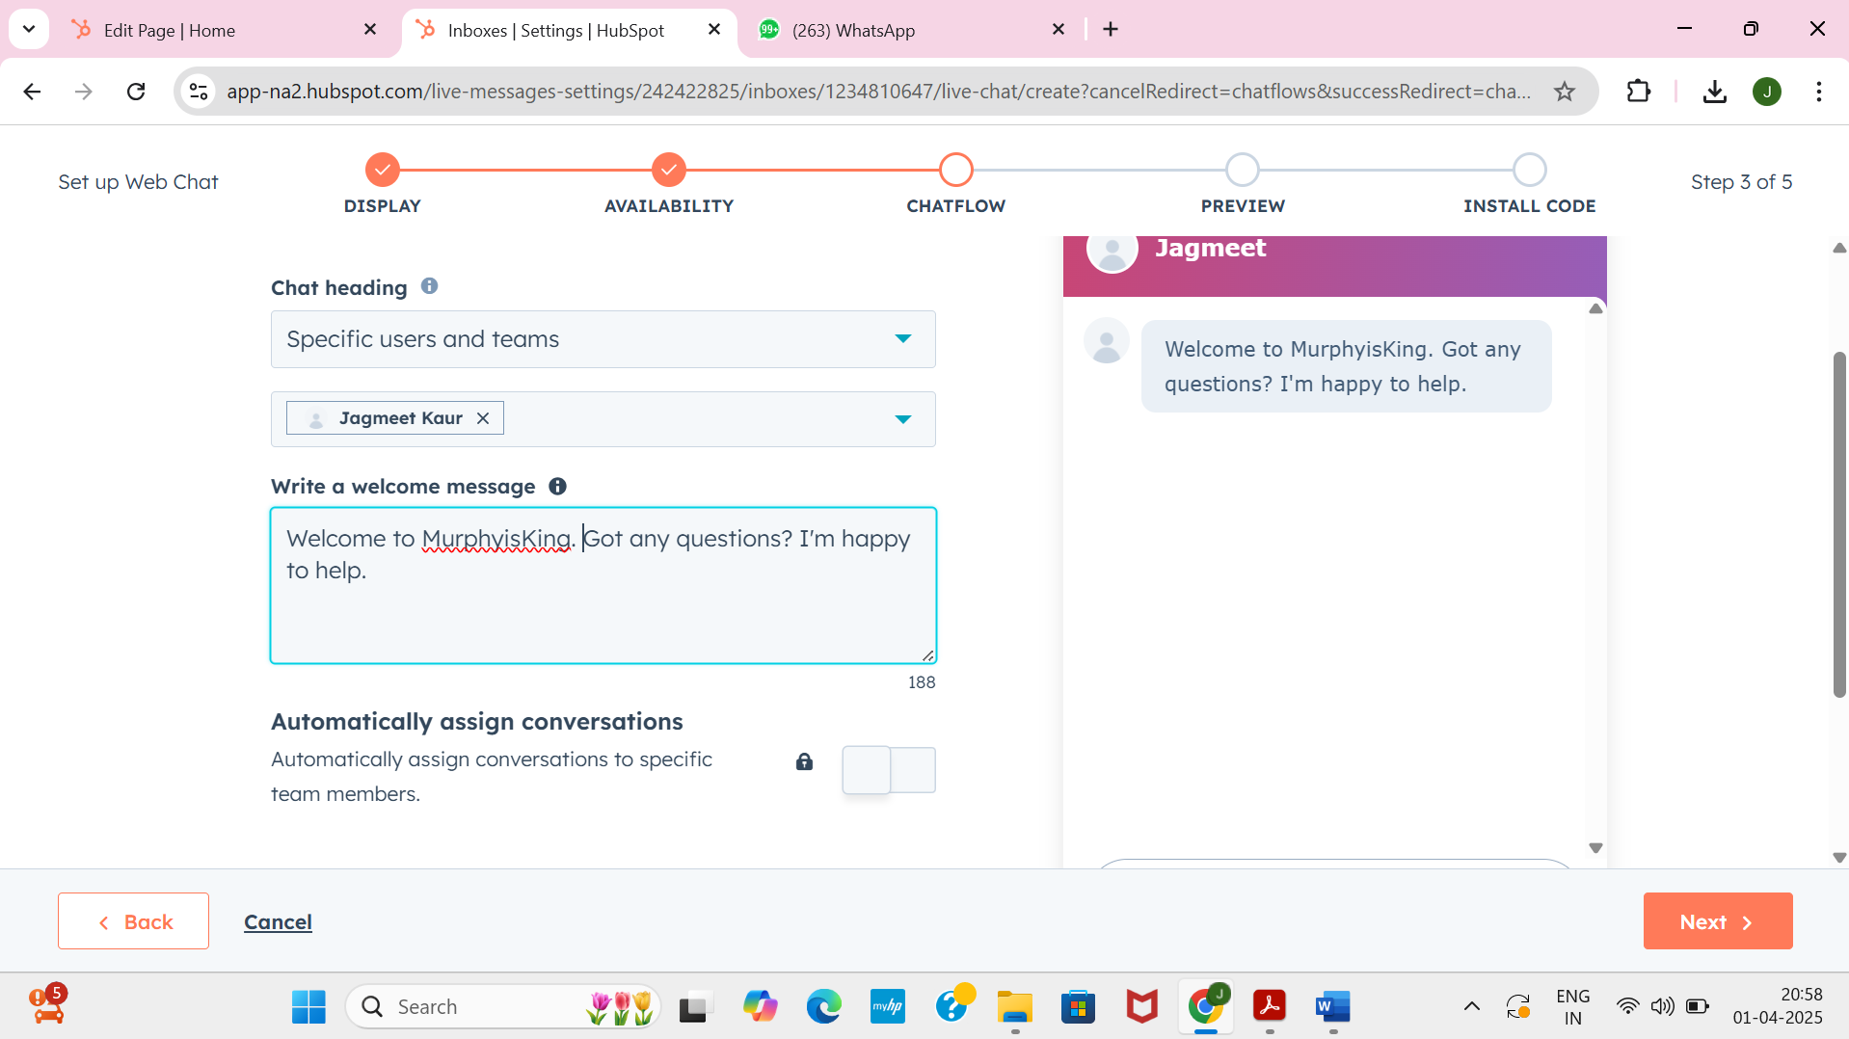

On preview take sreenshots of 🡪 tablet, desktop, mobile

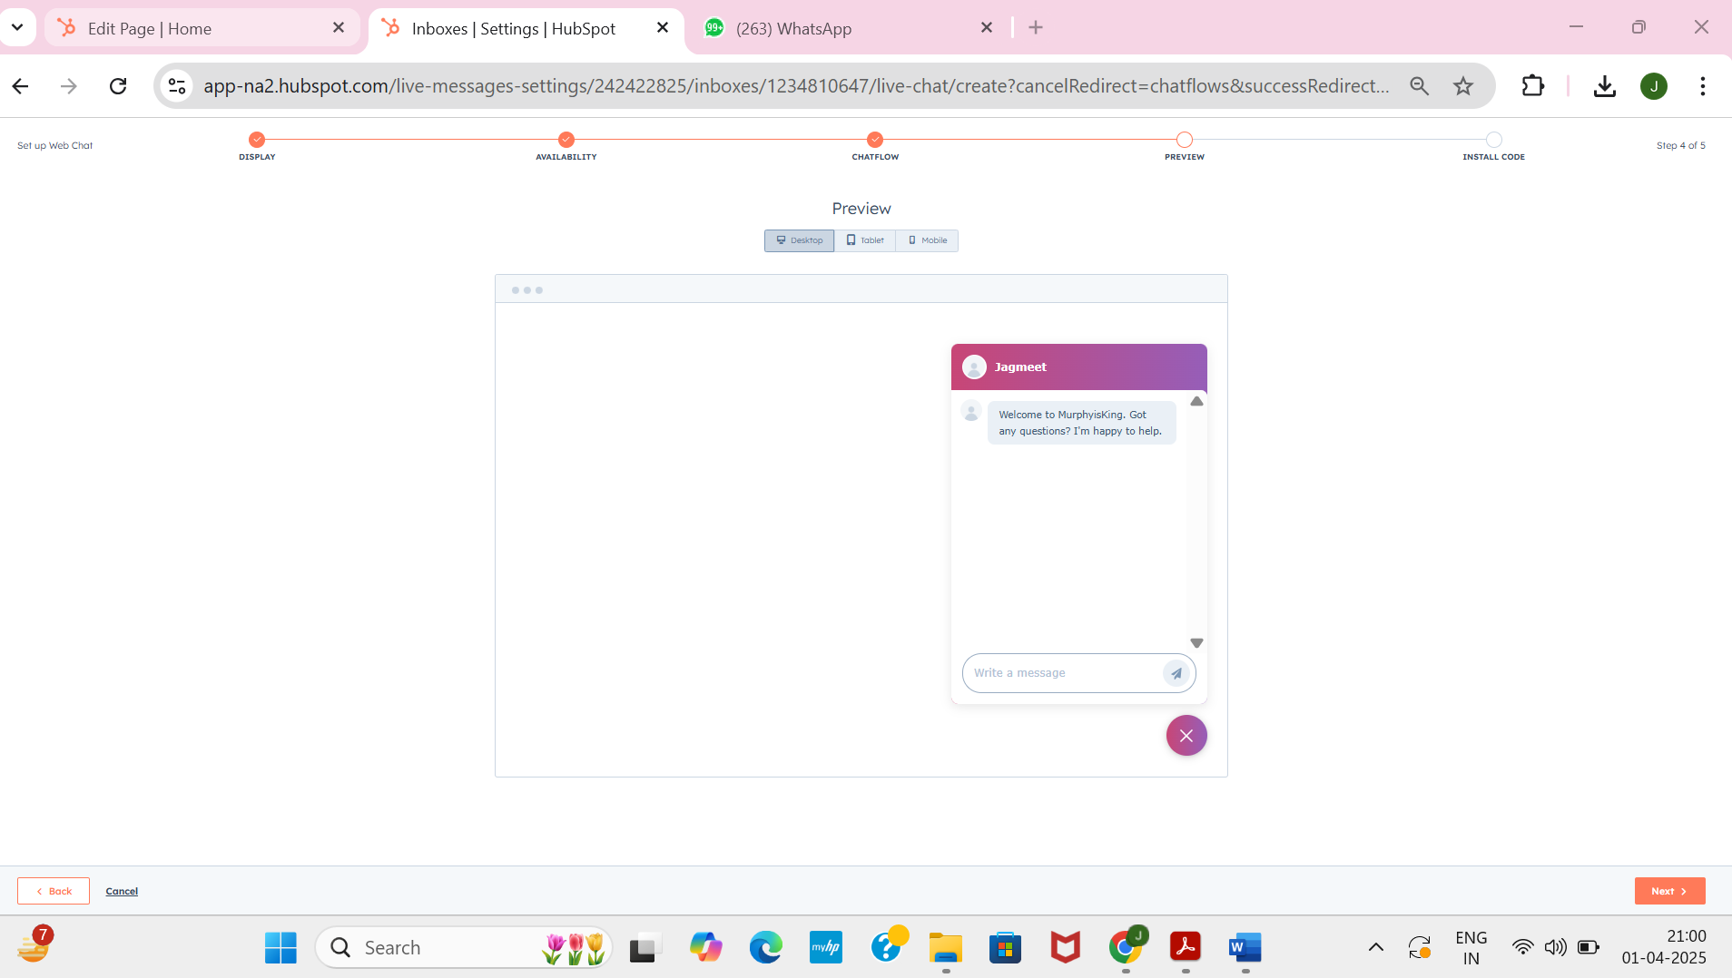

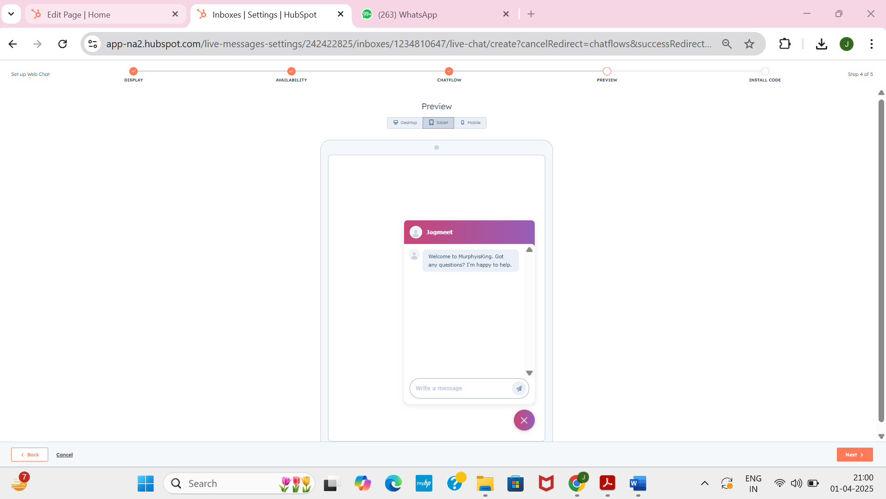

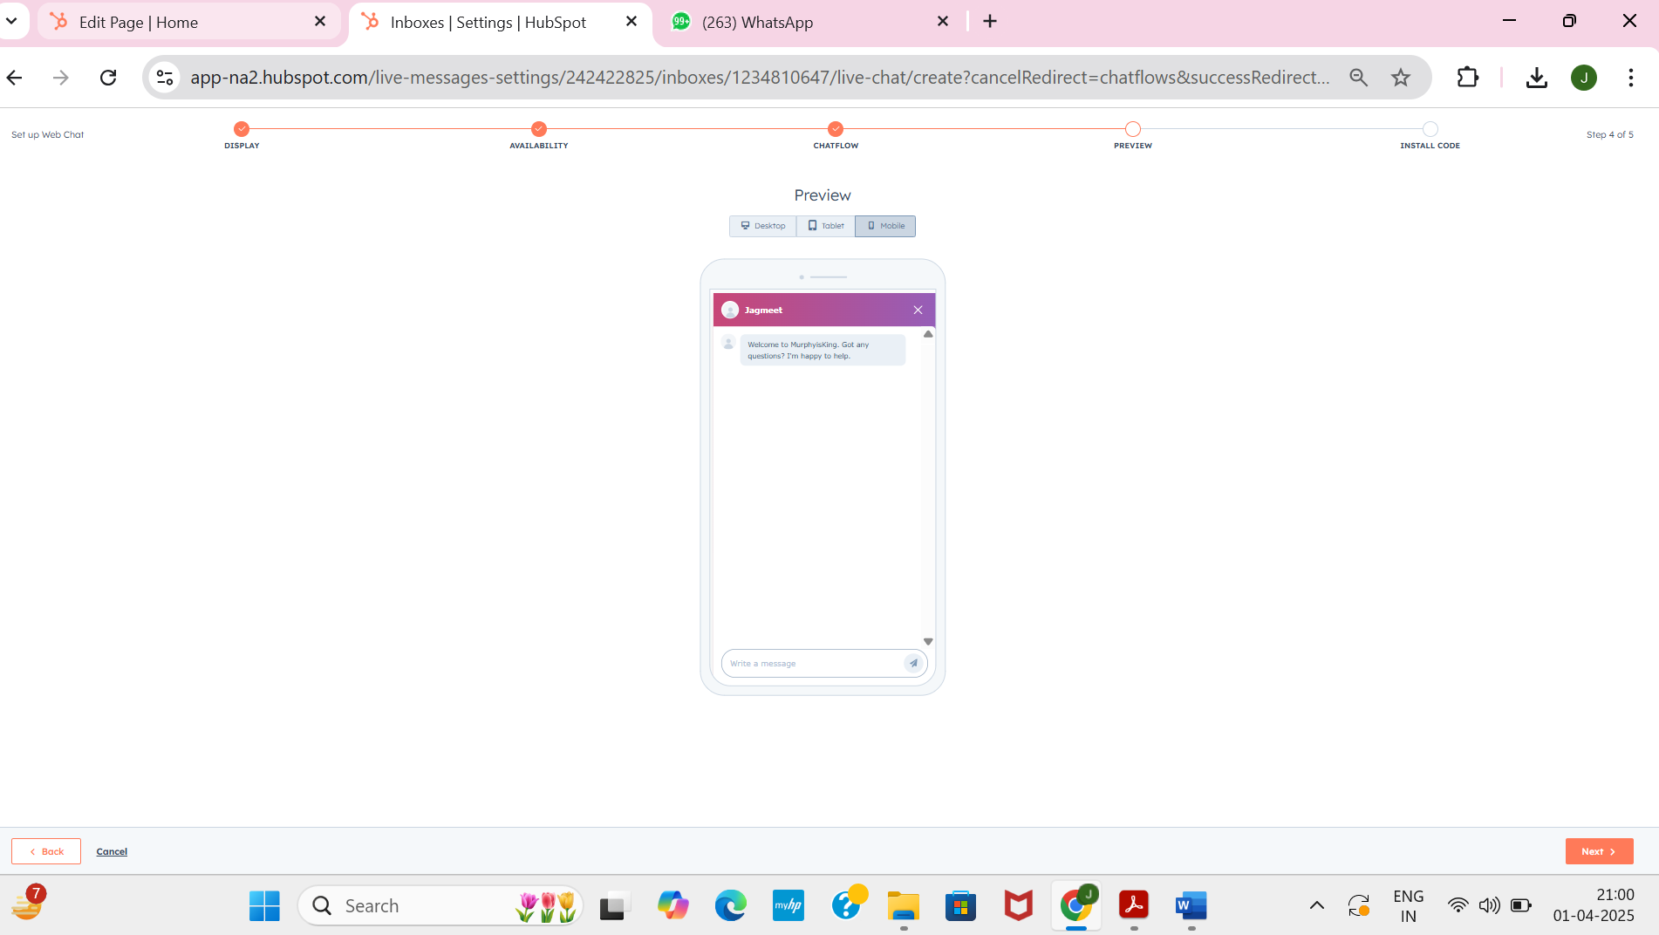

Click next

Click skip for now

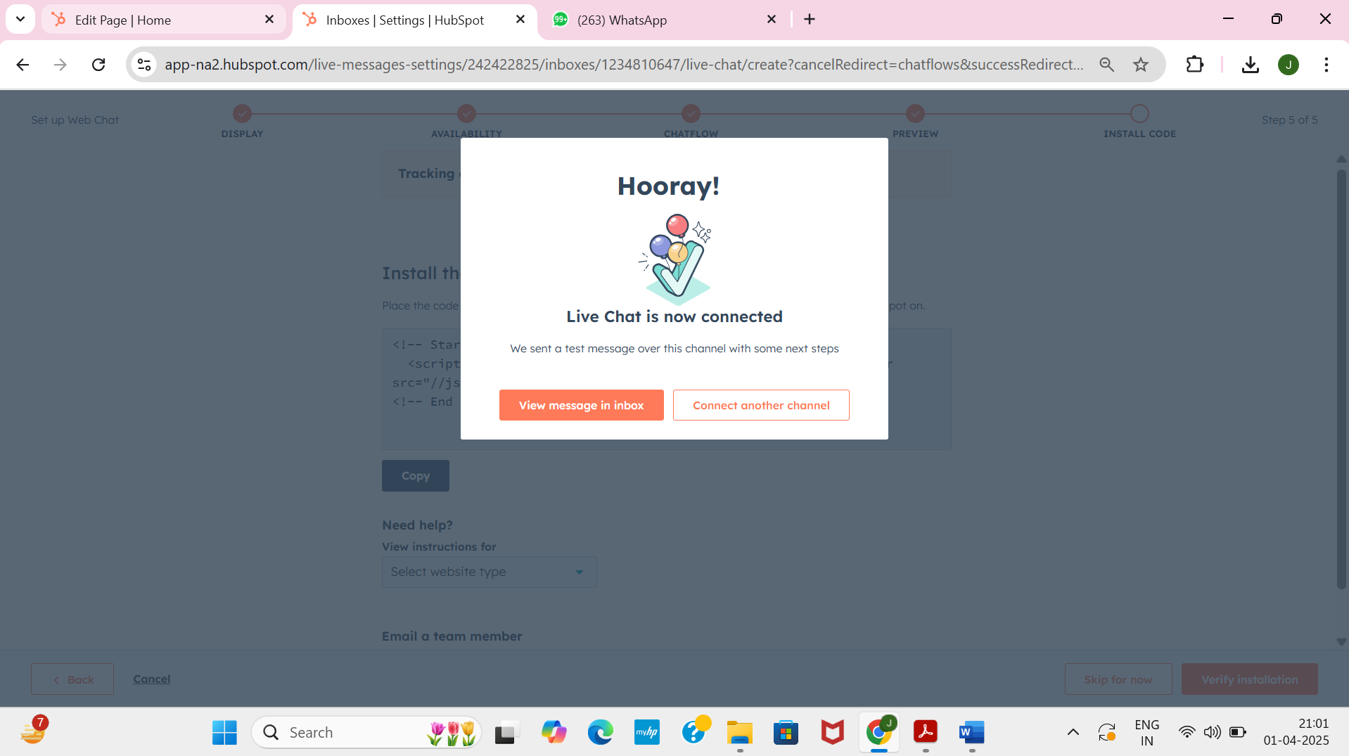

View Messages inBox

