THE BELOW SCREEN SHOWS THE FILE OPERATIONS LIKE DISPLAY ALL OPTIONS AND FILE MENU OPTION.

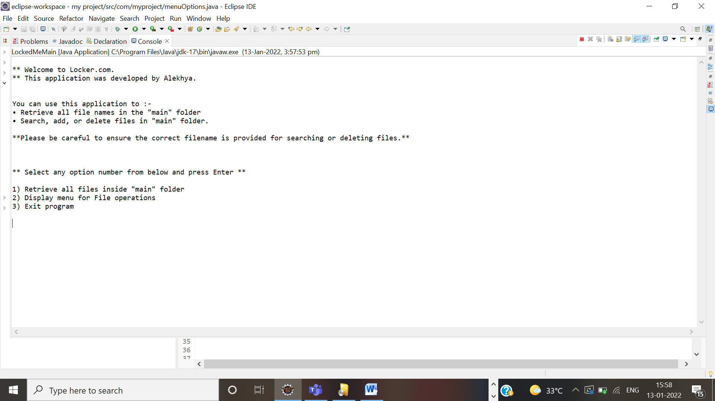

THE BELOW SCREEN SHOWS THE FILE MENU OPTIONS SUCH AS ADD,DELETE,SEARCH.

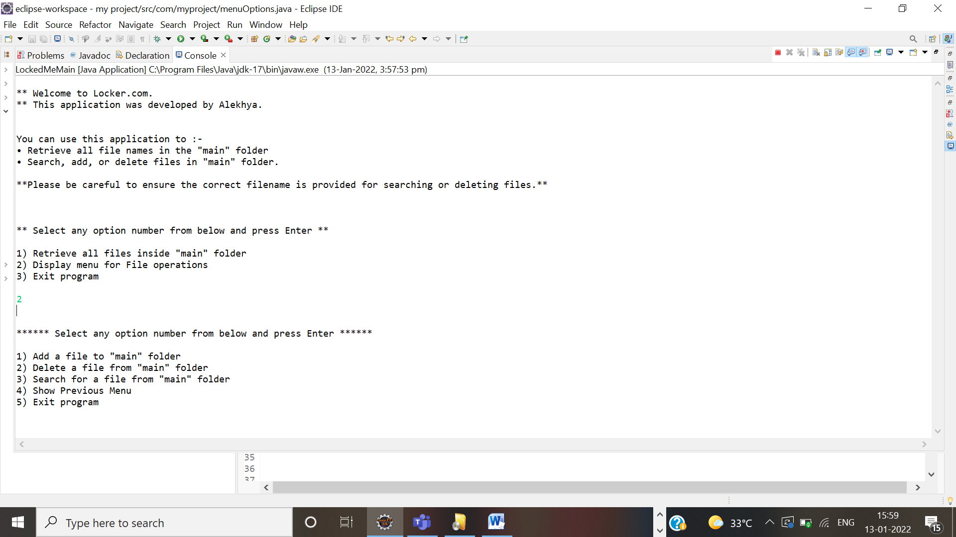

THE BELOW SCREEN SHOWS CREATIN FILE AND ADDING A FILE TO A DIRECTORY .

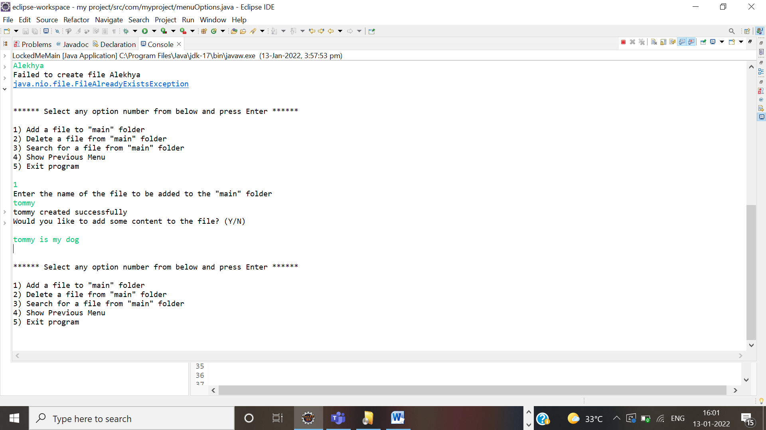

THE BELOW SCREEN SHOWS IS USED TO SEARCH A FILE IN A DIRECTORY.

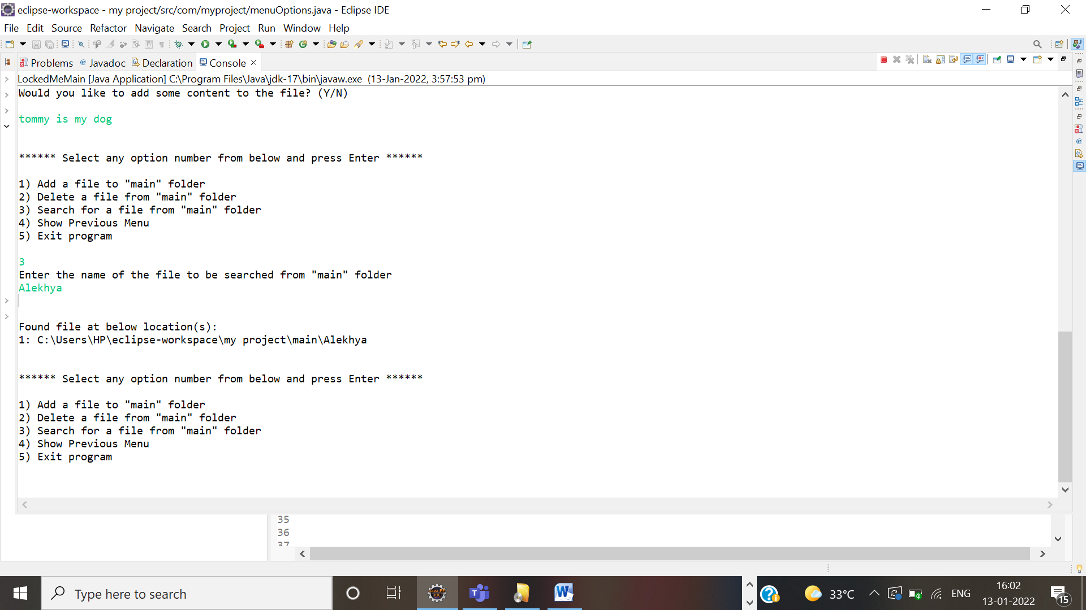

THE BELOW SCREEN SHOWS TO DELETE A FILE IN DIRECTORY.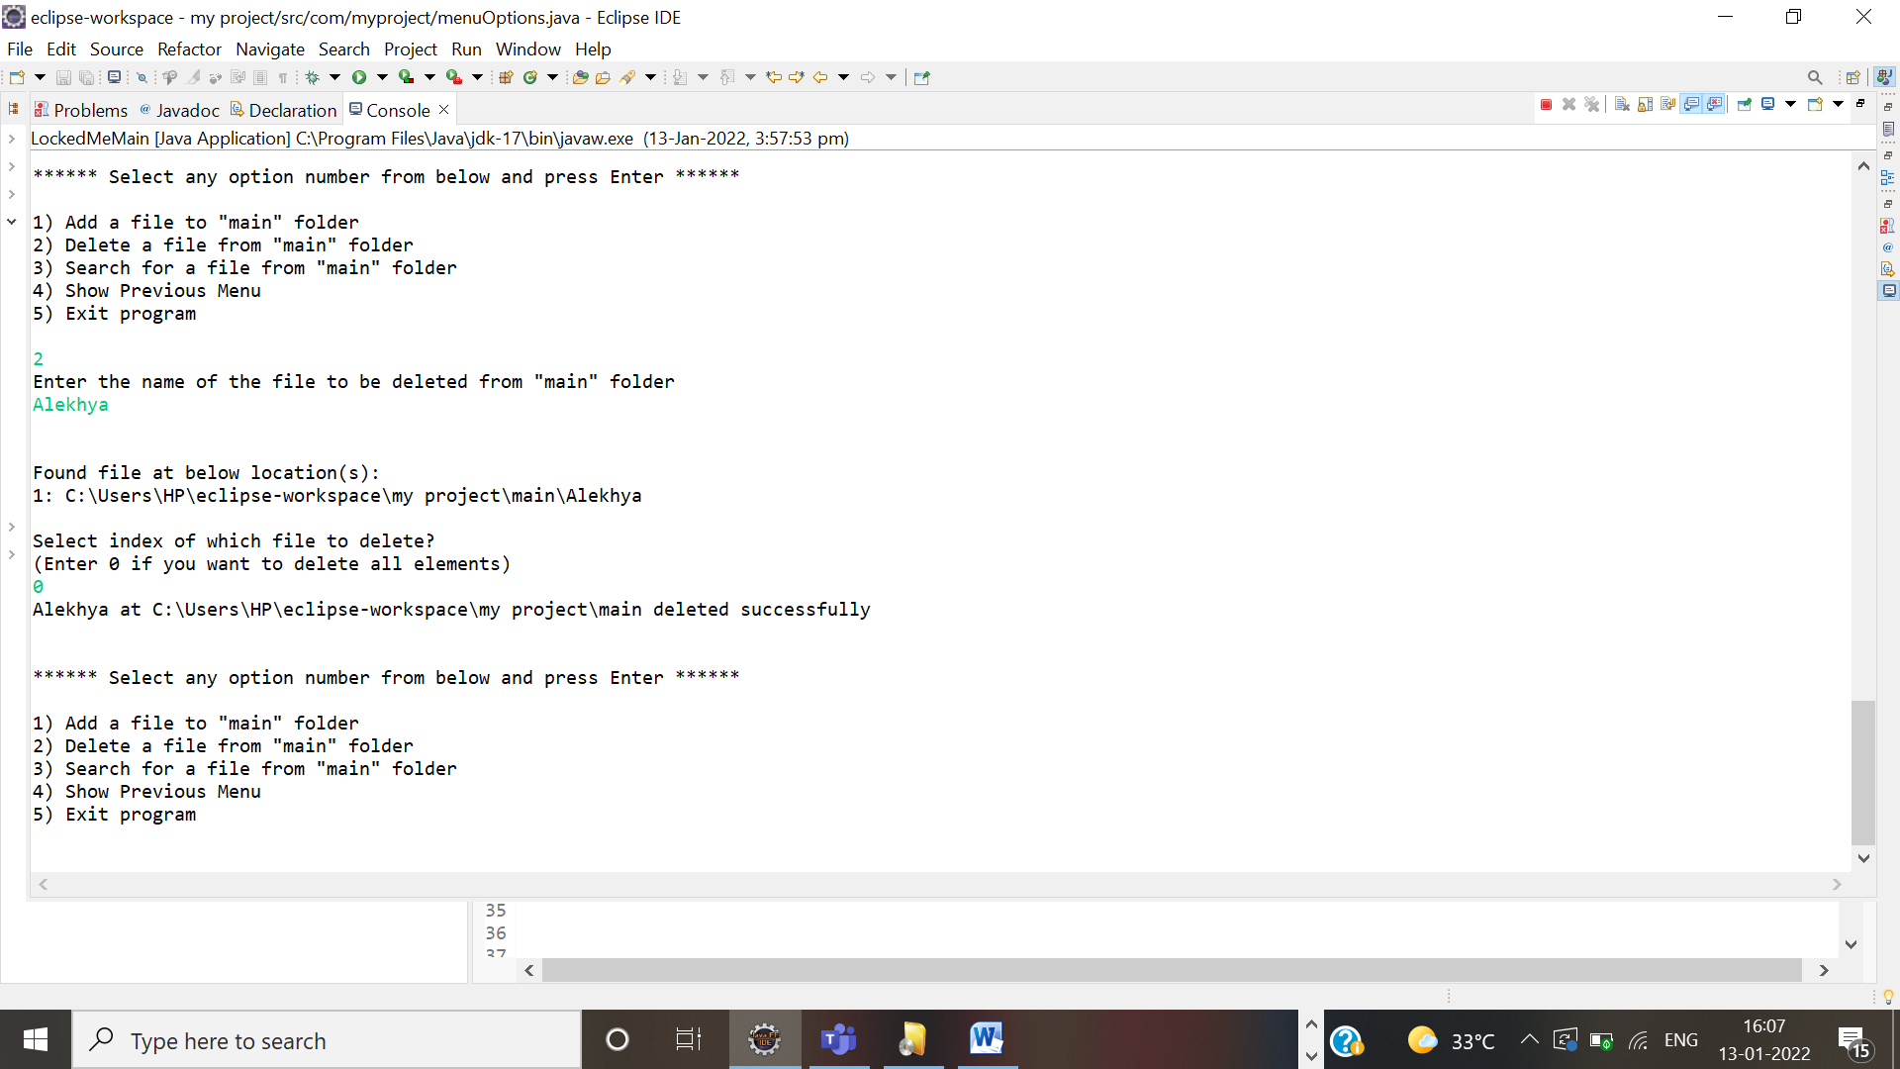

THE BELOW SCREEN SHOWS HOW TO NAVIGATE THE PREVIOUS MENU AND EXCIT.

