**CS 5551 Advance Software Engineering**

**FIRST INCREMENT REPORT**

**Newbie’s Key**

**Team#13**

**Sita Ratna Deepika Lalam**

**Alekhya Polavarapu**

**Avinash Penti**

**Sri Harsha Kumar Raja Golla**

**Project Proposal**

**Project Title: Newbie’s key**

PROJECT GOAL AND OBJECTIVES:

MOVITATION:

Imagine when you first check in a new place and you have no idea of what is going around. One doesn’t know where tom live in and if the selected place is a safety one or not. And so as to overcome these hardships we have an idea of creating an app for renting Apartments. This will be a feasible solution for both the owners and the tenants.

SIGINIFICANCE/UNIQUENESS:

Here both the Owner and Tenant creates their accounts and the owner can add the details of the apartments including the media like photos and videos of the location. Once the user clicks on the search button there will be 2 options available for view i.e. map view as well as a list view. Tenant can get the details of the apartments in a specific radius and if he finds any apartment interesting he/she can contact the owner from there. Tenant can also invite the owner to chat and get further details on the same. Once he/she likes the apartment a deal can be made and the same can be visualized in the app.

OBJECTIVES:

To make it a hassle free experience for every new comer to any new location and helping them to find a perfect place to live, encouraging and letting them to take part in all the activities happening around them.

SYSTEM FEATURES:

* Push Notifications
* Real Time Event Creation
* Maps Direction
* Peer-Peer chat messaging
* Room Availability Info

**PROJECT INCREMENT ONE**

As a part of our project’s 1st increment we have implemented the Login page, a register page and on successful login redirects to the Home page. At first a new user needs to register and be able to login using his name email and the password. Here we will be using the Apartment search API to get the details of the vacant apartments that are ready to be occupied by the tenants in a particular area.

FEATURES:

1. Apartment Availability: Tenant can login the app and then filter his own interests and search for the vacant rooms available in the preferred location. In short to be straight to the point he can do a personalized search.
2. Push Notification**:** Once the user sets his own preferences in case if there is any new apartment details added to the system there will be a push notification sent to all the users falling under that category.
3. Map Locations: We are integrating the maps within the app so that the user can view the exact location on the maps and locate the vacant apartments nearby.
4. Real Time Event Creation: When a user searches a particular query and in parallel if an owner adds a new apartment details it reflects in the search result of the user.
5. Peer-Peer chat messaging: In this application owner and the Tenant can chat with each other in real time and get the things sorted and make a deal.

SERVICE DESCRIPTION:

1. Maps**:** Maps information is displayed using the Google Maps API which gives us the information about the houses in a locality

1. Apartment Search: The information related to the apartments are obtained by using the Apartment search API.
2. Locations: So as to get the auto locations fill we will be using the Auto Location fill API.

GITHUB URL:

<https://github.com/gshkr123/Newbies-Key>

**ARCHITECTURE DIAGRAM:**

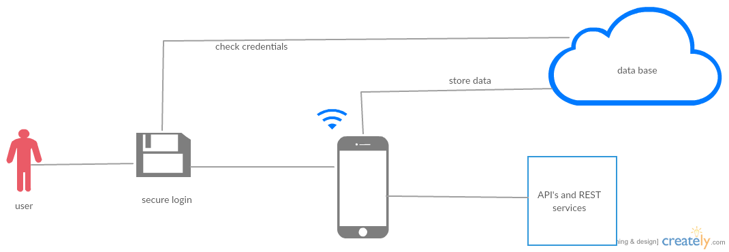

**CLASS DIAGRAM:**

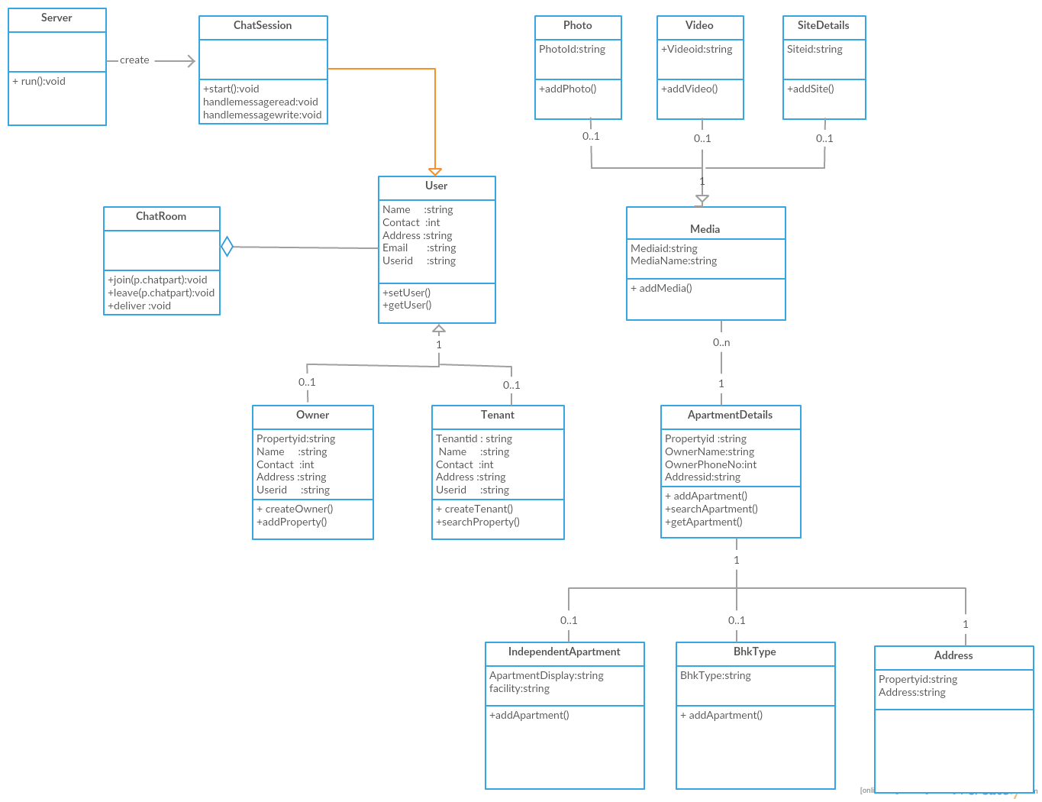

**SEQUENCE DIAGRAM:**

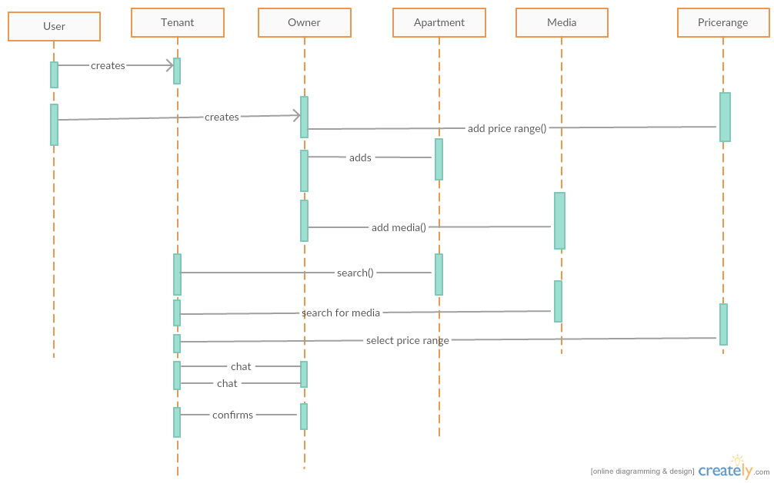

**ISSUES TOOLBAR:**

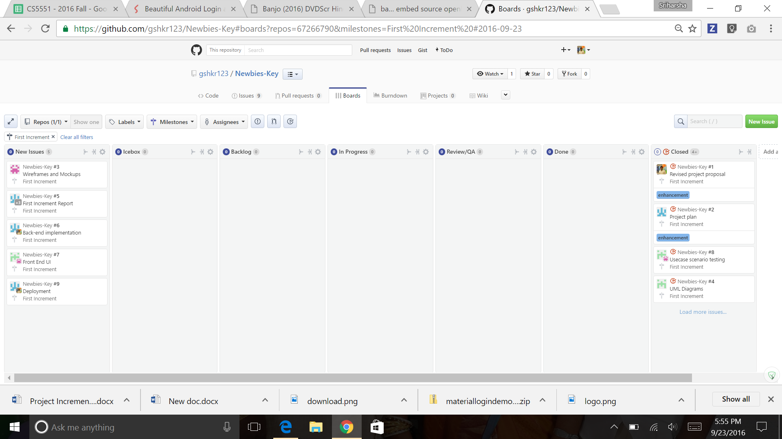

Tasks are assigned to each of us and we made a regular update of the tasks that are assigned to us. Mile stone for the first increment has been created. We completed all the assigned before the milestone

**BURNDOWN GRAPH**:

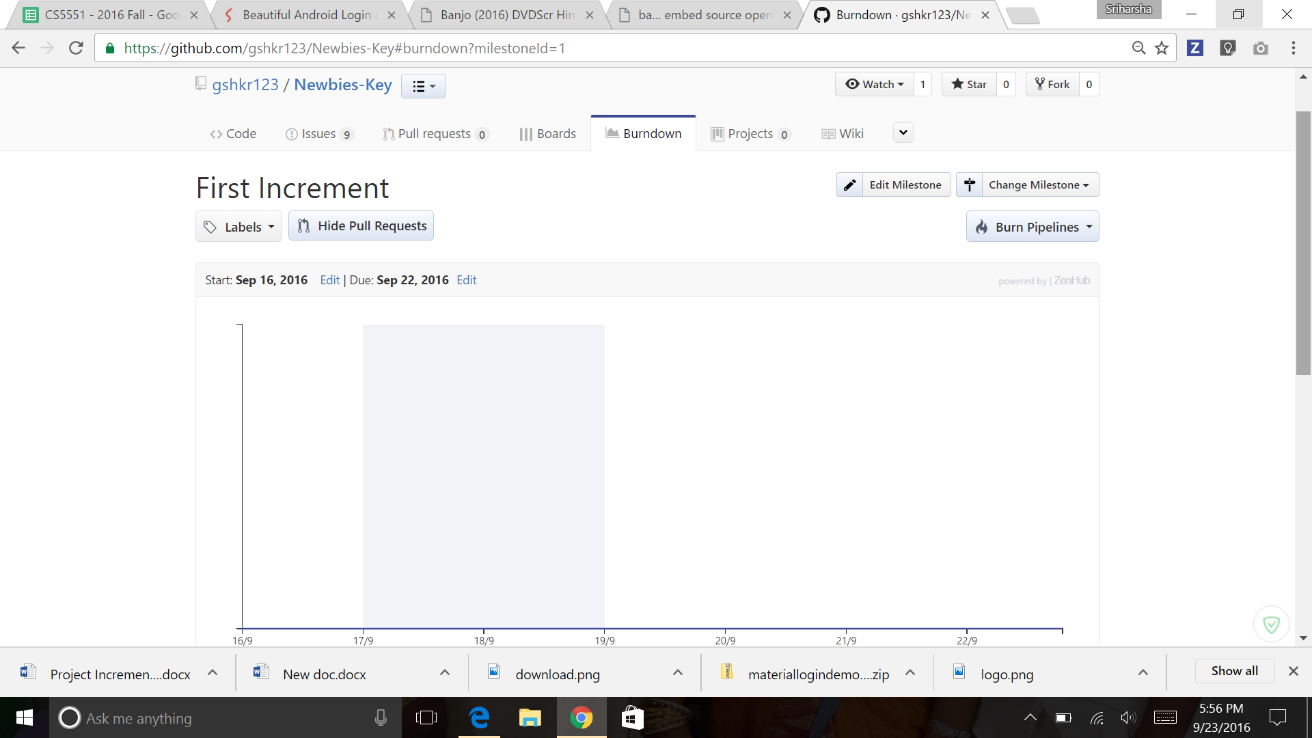

Burn down charts for assigned tasks and completed tasks. Milestone for the first increment has set to 09/23. For the tasks of the first increment, we got above burndown graph

**WIREFRAMES:**

LOGIN PAGE

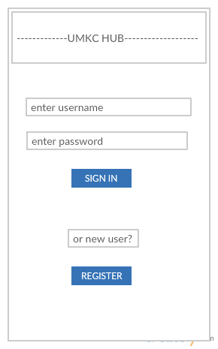

REGISTER PAGE

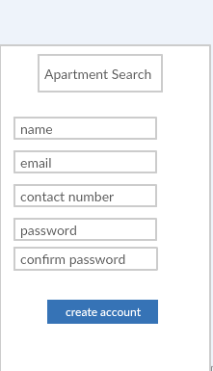

ADD APARTMENT PAGE

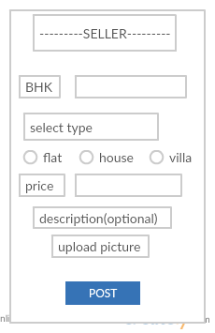

TENANT SERACH PAGE:

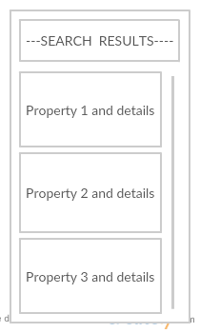

DETAILS OF A PARTICULAR PROPERTY PAGE:

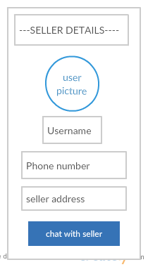

**MOCK-UPS:**

LOGIN PAGE:

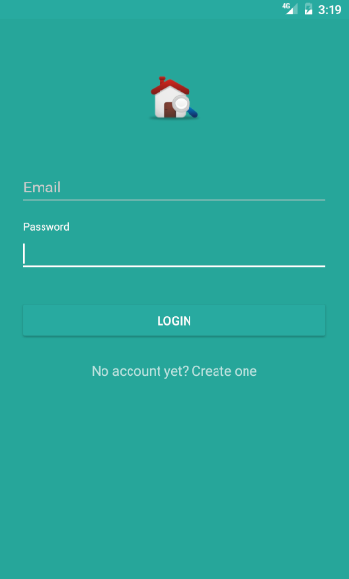

LOGIN PAGE WITH VALIDATIONS:

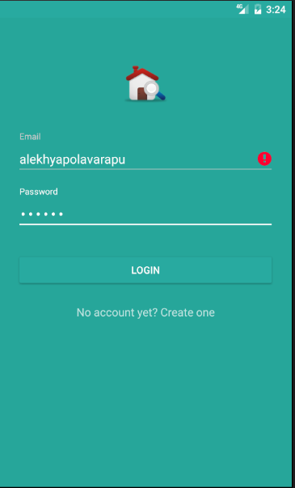

REGISTER PAGE:

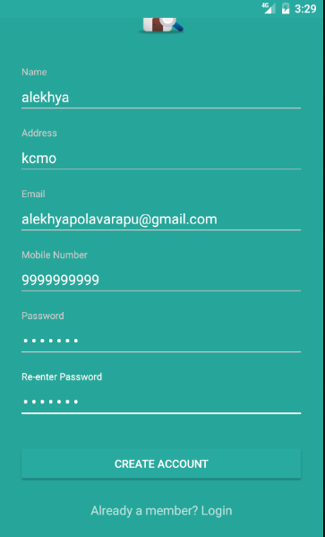

**USER STORIES:**

|  |  |  |
| --- | --- | --- |
| **As A** | **I want to** | **So that** |
| User | Create a login page as owner | I can post my property details |
| Create a login page as Tenant | I can search for the available vacancies in Apartments |
| Check the facilities of the apartment | I can check and get to a confirmation |
| Check for a particular location | I can compare various search results |
| Get the exact location using GPS | I can look for a nearest apartment to my work place |
| Check for the Price Range | I can get the best facilities for that range |

**TEST CASES:**

|  |  |  |  |
| --- | --- | --- | --- |
| **Test Case Name** | **Test Description** | **Expected Results** | **Pass/Fail** |
| Login | Enter Invalid Userid and Invalid Password | Invalid Login Error Message should be displayed | Pass |
|  | Enter Valid Userid and Invalid Password | Invalid Login Error Message should be displayed | Pass |
|  | Enter Valid Userid and Valid Password | Application Should Be Redirected to Home page | Pass |
|  |  |  |  |
| Sign Up | Enter Email Id without @ | Invalid Email id should be displayed | Pass |
|  | Enter Password less than 3 characters | Please check the password instructions an try again | Pass |
|  | Enter the Name field with numbers | Invalid Name should be displayed | Pass |
|  |  |  |  |
| Search Feature | Click on the Search Button | Should display the available apartments | Pass |
|  |  |  |  |
| Add Feature | Click on the add button | Should redirect you to a page to add new details | Pass |

**FINAL SCREEN SHOTS:**

LOGIN PAGE**:**



REGISTER PAGE:

