PATROL COMMANDER for AR.Drone 2.0 Parrot
project idea
by Nadezhda Zlateva, Daniel Tinkov and Alexander Marinov

Table of Contents
Scenario 1
Equipment 1
Hardware 1
Software 1
Specification 1
Launch Pad 2
Cockpit 2
Challenges 4
Creating path trajectories 4
Error correction 5
Authors Experience 5

Scenario
The user initiates a drone flight from a certain starting position by manually controlling it through an app on his phone. The flight is recorded on device memory and displayed with its trajectory to the user. The recorded flight will later be referred to as the flight mission. The user will be able to execute a previously recorded flight missions after positioning the drone at the same starting point as the recorded flight and starting flight in autopilot mode. The drone will execute the recorded commands at the same rate in time as recorded, which will make the drone traverse the same (or almost the same) trajectory. During a flight mission the user can pause/resume the drone movement, call the drone back, manually deviate from the mission and return back to the mission course, as well as take photos.

Equipment

Hardware
AR Drone
Windows Phone 8

Software
MS Windows 8
MS Visual Studio 2012
Windows Phone SDK
ARDrone2 Windows SDK

Specification
The application will be presented by two screens. The first one is the Launch Pad which will play a role of an application main menu. From this screen the user will be navigated to the second one - the Cockpit screen in one of the two piloting modes – auto or manual, depending if the user has selected a recorded mission or he chose to start a new one.

Launch Pad
The Launch Pad screen will display a list of previously recorded flight missions represented by their trajectory contours (Illustration 1). The user can delete any of the missions by dragging it away from the screen or he can start autopilot mode by selecting a mission from the list. At the bottom of the screen a button with label “New Mission” will start a manual flight session. When starting a new mission or sending the drone to a preselected mission, the user is navigated to the cockpit screen.
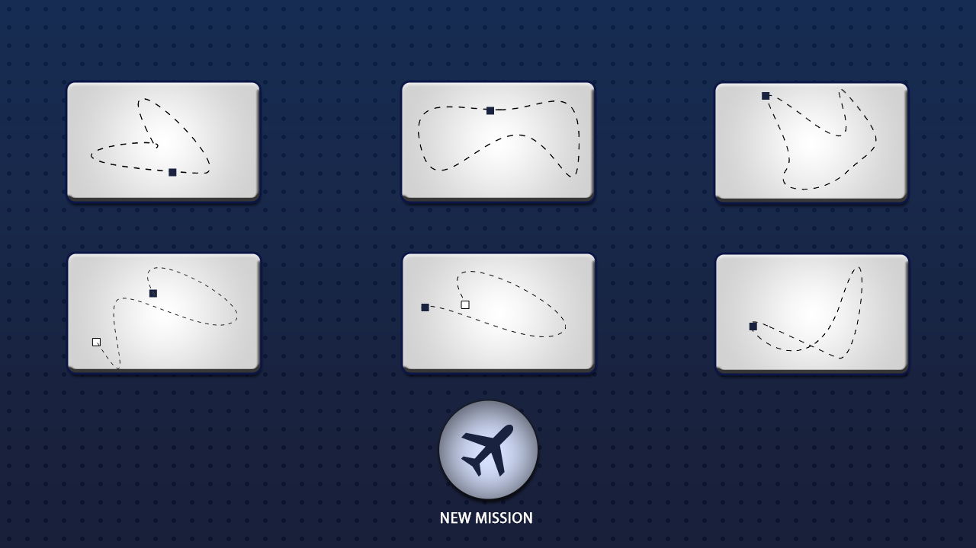Illustration 1: Launch Pad screen design

Cockpit
This screen represents the main cockpit used to navigate the drone manually or to observe its flight in autopilot mode. The user interface elements are composed by Buttons and Handles for commanding the drone, visualization icons for the current state like battery life and Wi-Fi signal strength, and gadgets giving feedback for the current drone position like altitude, tilt and direction. In the middle of the screen will be displayed the current drone trajectory represented as a curve. The position of the drone on the curve will be marked with a special target icon. In manual control mode the target icon will be always at the last edge of the curve. A stopwatch will count the time from drone start to its current position on the curve. All screen elements will be blended on top of the video stream coming from the currently selected drone camera. More details for the user interface elements are provided in tables 1-4.
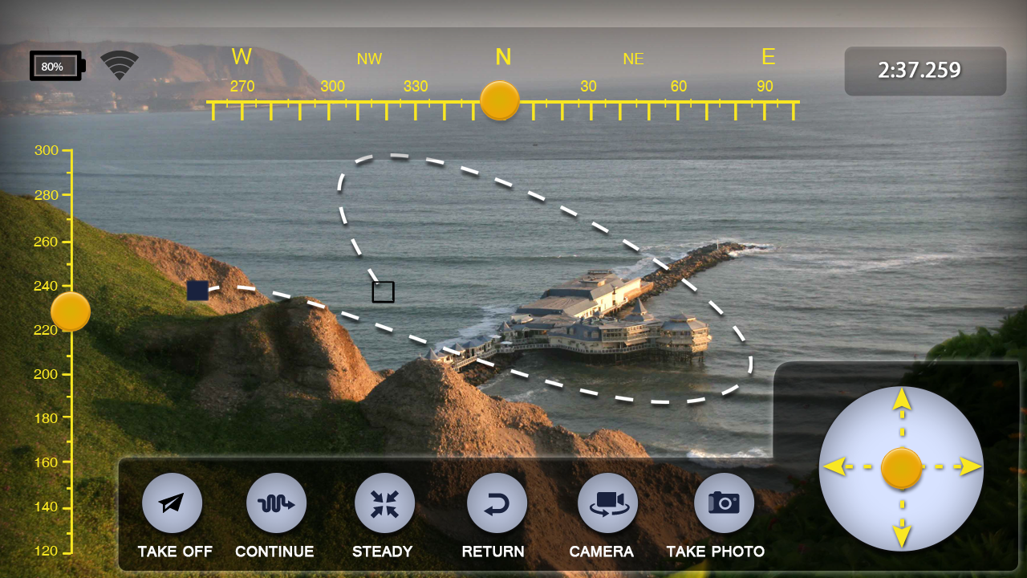Illustration 2: Cockpit screen design
Table 1. Buttons
Name | Description | IsActive condition
Take Off | Launch the drone to start a new mission or use the last loaded mission. | Drone is on the ground
Abort | Land the drone on the ground. Replaces the Take Off button as this is its alternate operation. | Drone is in the air
Return | Return back and land the drone. | Drone is in the air
Switch Camera | Switch vertical and front cameras. | Drone is connected
Pause | Pause the drone movement. | Autopilot mode
Resume | Resume drone movement. Replaces the Pause button as this is its alternate operation. | Autopilot mode
Steady | Pause the stopwatch (see Table 2) and attempt to align the drone with the model path. Resume stopwatch when the drone is stabilized on the model path or the pilot switch Steady mode off | Autopilot mode and if too far from the expected position
Take Photo | Take a photo from the currently selected camera. | Drone is connected
Table 2. Icons
Name | Description | IsActive condition
Battery | Show remaining battery life (0-100%) | Drone is connected
Wi-Fi | Show Wi-Fi signal strength (0-5 bars) or disabled when the device is not connected to the drone. Connection will be attempted periodically every 15 secs. | Drone is connected
Stopwatch | A timer counting the seconds from drone launch. The Pause/Resume button pauses and resume the Stopwatch. | Drone is in the air

Table 3. Handles
Name | Description | IsActive condition
Direction Handle | Move the drone forward/backward/left and right. In autopilot mode the watchdog will be paused while performing the operation. | Drone is in the air
Altitude Handle | Move the drone up and down. In autopilot mode the watchdog will be paused while performing the operation. | Drone is in the air
Rotation Handle | Rotate the drone left and right | Drone is in the air

Table 4. Gadgets
Name | Description | IsActive condition
Drone Compass | Displays drone's current direction (0º, +360º) | Drone is connected
Altitude | Show drone's current altitude (cm) | Drone is connected

Challenges
In this section several technical challenges will be covered and preliminary solutions provided.
The fundamental application idea is creating a flight path and making the drone re-fly the same path with the highest possible accuracy. This leads to two main problems to be resolved. How to represent the path and how to make the drone repeat the same path automatically. Simple solutions to these problems are presented in the next sections.

Creating path trajectories
There are two path trajectories at a time. The model path is the one describing the flight plan which the drone has to follow. And the actual path is the path the drone is actually covering while aiming to match the model path. The two paths cannot be expected to match each other precisely because of different force major circumstances – drone response latency, weather conditions or other obstacles of the surrounding physical environment.
The model path is the actual path which is recorded during a New Mission. This record is tagged with all user control inputs which lead to creating it. While running in auto-pilot mode the drone receives the same navigation commands at the same frequency rate as while creating the model path. The pilot navigates the drone by using the direction and altitude handles. The direction handle also defines the movement speed in the range (0, 100%].
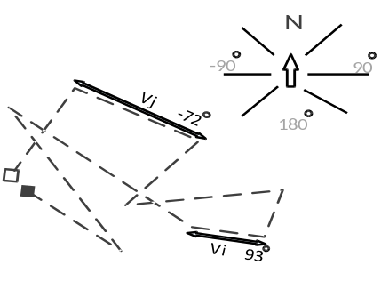Illustration 3: Path example
The path can be represented by a multi-line with segment lengths that depend on the time the drone was moving with a certain speed and direction (3D). At a predefined interval the drone's actual speed and actual direction will be obtained and used to calculate the estimation for the move distance. Assuming the time interval is 1 s and the speed measured in meters per second (m/s), then every second we will add a new segment to the multi-line with length given in meters and direction in degrees. An example path is represented on Illustration 3.

Error correction
The drone is performing the recorded control operations and at each time interval its translation vector is calculated as described in the previous section. We expect that by performing exactly the same sequence of operations every time the drone will walk through close to each other trajectories. Let's assume this is not the case due to the not ideal conditions defined by the physical environment or especially when the pilot decides to manually deviate the drone from the flight plan. At every time interval the position where the drone must be is defined on the model path. The error can be estimated as the distance of the actual point to the expected model point at a certain moment in time. Let's assume the vector to the actual point is V1 and the vector to the expected model point is V2 as shown on Illustration 4. Then the correction vector can easy be calculated by the formula Ve = V2-V1. At that point we have another problem to solve. It is how fast to move toward the estimated direction of Ve, i.e. with what amount to push the direction handler. To solve this problem we will use the past knowledge and apply simple statistics to find the average correspondence between the amount we push the handler and the amount of distance the drone is actually moving. Assuming we define the speed in percentage, we can calculate statistically that throttling the drone engine 1 sec with S% speed will move the drone with M meters in average. From here we derive the following formula for the required correction speed:
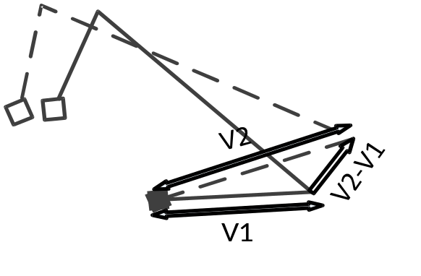Illustration 4: Error correction vector
E% = (S% * |Ve|) / M
The other problem is to decide when to apply the correction vector. The most trivial approach is to apply the correction on every movement. On the other hand, the pilot can press the Steady button at any time, which will start applying and recalculating the error vector until it stabilizes at |Ve| < eps.

Authors Experience
Alexander Marinov has over 20 years of programming experience. He has a Bachelor degree from the Technical University – Sofia, specializing in Applied Mathematics. Together with Nadezhda Zlateva they obtained the Master degree in Computer Sciences from Sofia University, specializing in Artificial Intelligence, and are presently PhD students at the Bulgarian Academy of Sciences [1,2]. Both of them are co-founders of the software company AVIQ Bulgaria Ltd with 6 employees [3] and part of the of AVIQ Systems AG in Switzerland [4]. Alexander Marinov has lead the following completed software products: 4 generations of Set-Top box devices based on Linux, Windows and Android platforms [5], SmartTV apps (Teleboy [6], Zattoo for LG and Samsung [7], port of HollyStar for LG TV [8]), FocusTune [9], Android phone apps (Radio Monte Carlo, Cucina Italia, Omeopatia [10], ClassMeteo [11] and more). Major experience with ASP .NET in [12] and more in already abandoned projects. Author of LuaCURL [13] included in the official Lua distribution. Experience with .NET/XAML apps for Windows Phone 8 based on experimental programming. More details can be found in [14,15,16].

Illustration Index
Illustration 1: Launch Pad screen design 2
Illustration 2: Cockpit screen design 3
Illustration 3: Path example 5
Illustration 4: Error correction vector 5

Bibliography
1: Marinov, A, Scientific CV, 2011, http://iict.bas.bg/SPIR/en/staff_en/a_marinov_en.html
2: Zlateva, N., Scientific CV, 2011, http://iict.bas.bg/SPIR/en/staff_en/n_zlateva_en.html
3: Marinov, A., Zlateva N., Tinkov, D., AVIQ Bulgaria Ltd., 2007, https://www.facebook.com/aviqbg
4: Marinov, A., Zlateva, N., AVIQ Systems AG, 2005, http://aviq.com/web/about-us/management-board
5: Marinov, A., Zlateva, N., Set-Top Box software, 2013, http://aviq.com/web/box-software/tipc4-ott-set-top-box
6: Tinkov, D., Teleboy, 2012, http://www.teleboy.ch/misc/mobile/smarttv
7: Dyankov, N., Marinov, A., Zattoo, 2012, http://corporate.zattoo.com/en/zattoo-launcht-app-fur-samsung-tv/
8: Marinov, A., HollyStar VOD Portal, 2011, http://fr.wikipedia.org/wiki/HollyStar samsung-tv/
9: Zlateva, N., Marinov, A., FocusTune, 2012, http://michaeltapesdesign.com/focustune.html
10: Zlateva, N., Marinov, A., RMC, Cucina Italia, Omeopatia, 2010, http://www.developi.ca/
11: Marinov, A., Zlateva, N., ClassMeteo, 2010, http://www.classmeteo.it/meteo/download/app.html
12: Zlateva, N., Marinov, A., ABMP, 2012, http://aviq.dyndns.org:978/VTX/
13: Marinov, A., LuaCURL, 2007, http://luacurl.luaforge.net/
14: Marinov, A., LinkedIn Profile, 2013, http://www.linkedin.com/in/alekm
15: Zlateva, N., LinkedIn Profile, 2013, http://www.linkedin.com/pub/nadezhda-zlateva/1/637/267
16: Tinkov, D., LinkedIn Profile, 2013, http://www.linkedin.com/pub/daniel-tinkov/35/156/ba2

