Geometric-Morphological Method for Artifact Noise Isolation in the Image Periphery by a Contour Evolution Tree

Dimo Dimov and Alexander Marinov

Abstract: The article offers an original method for noise-filtering of the like of image peripheral artifacts, by defining a Contour evolution tree (CET). CET is defined by classical morphological techniques, but to achieve efficiency, the latter are generally presented by the well known distance transformation for images. The method aims, but is not limited to, improving the noise tolerance of content based image retrieval in a database of trademark images.
Keywords: Image processing, Image morphology, Contour evolution tree (CET), Distance transform, Noise-artifacts, Content based image retrieval (CBIR).

INTRODUCTION
Noise filtering (reduction) in images is a classical and prevailing task in the subject of Image processing and recognition [5, 6, 8]. Particularly, this problem is tackled when dealing with systems, administering Image Databases (IDB), where the so called CBIR (Content Based Image Retrieval) methods for data access have lately been applied. The CBIR access method acts as follows: it extracts the essential content from an initial image, which it then uses to organize the search for similar images in the IDB. Except for speed, the CBIR method needs to provide a certain level of noise resistance, at least as far the standard noise, which is typical for the process of image retrieval. Such a system example is EFIRS (Effective and Fast Image Retrieval System), which is being developed at the Bulgarian Academy of Sciences (BAS) for the needs of the Patent Office of Republic of Bulgaria (PORB), and specifically for their vast IDBs of trademark images [3, 4].
However, except for standard noise, the images at PORB often contain a particular noise of type “artifacts in the image periphery.” The existence of this artifact-noise reduces dramatically the efficiency of the CBIR through the IDB.
This article proposes an original method to isolate/suppress artifact-noise in images. Its main idea is listed below in section 2. Section 3 describes the initial limitations, as well as the applied theoretical base. The crux of the described method, the Contour evolution tree (CET) is illustrated in Section 4. A detailed description of our test experiment as well as guidelines for next research is listed in Sections 5 and 6 respectively.

1. Main concept of the proposed method
Basically, the method operates with black-and-white images, in positive, that is – black objects (and/or artifacts) on a white background. The premise is that the key object (or group of objects) is mainly located around the center of the image, while the non-essential objects (or noise-artifacts) are to be found in its periphery.
The method’s idea is the consecutive and gradual expansion of the separate (disconnected) objects in the image, in observing the process of their grouping and in linking the stopping rule with the status of one grouped object and one grouped noise-artifact on a white background is reached (see Fig.1).
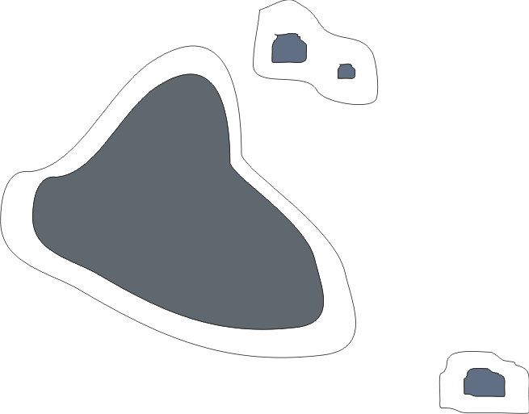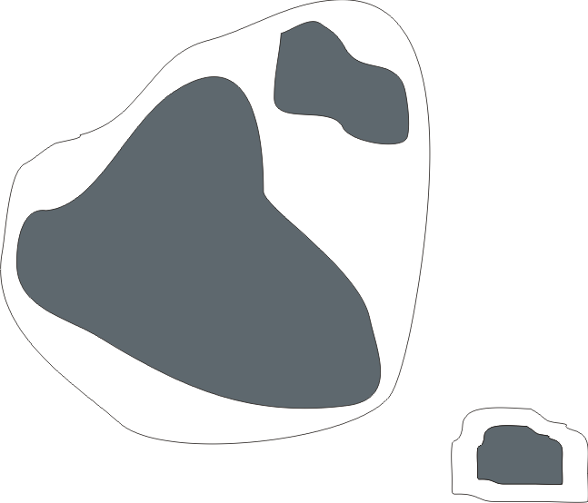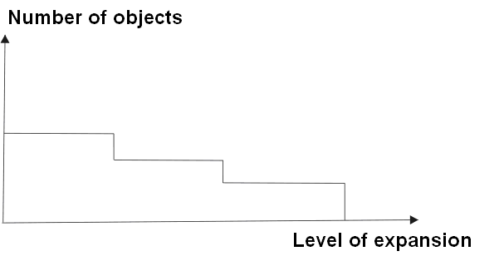

Fig.1. Sequence of grouping of objects in an image.

To formalize the process of expansion and grouping, we are defining the above-mentioned CET. CET describes the process reversibly and uniformly. Every level of the CET reflects one expansion action, e.g. the current image dilation by a radial-isotropic structural element of a “singular” area. The nodes in the CET represent the grouped objects and/or artifacts at a given expansion stage (level). Further weight coefficients are defined in the CET nodes in order to identify more precisely the noise segmentation process. To improve the overall processing speed we exchange the series of morphological expansions with a Distance transform (DT), implemented one time over the entire image [2] (see Fig.2). This change is reasoned on the almost evident fact that as the level of expansion grows, the number of grouped objects decreases monotonically (cf. Fig.1), which allows for a faster, binary search for the stop-estimate primary in the DT-map of the given image.
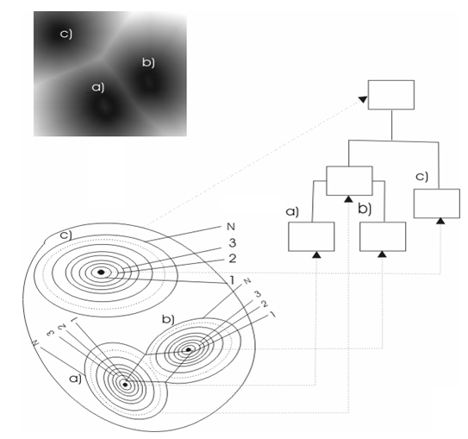

Fig 2. The expansion process, depicted by DT and CDT over an image of 3 elements.

2. Premises of the task
The images under observation abide by the following considerations (also called a priori information [8]):
Consideration 1: The input images are in binary form and contain black objects on white background.
Consideration 2: The key content (the objects) of the image is predominantly located in/around its center.
Consideration 3: The ‘rough’ artifact-noise is located mainly in the image periphery.
Consideration 4: The key object and noise-artifacts are analyzed as groups of geometrically-distinguishable entities, we call them black shapes, or simply shapes.
Thus, we are looking for a geometrically-morphological method for isolating (and/or suppressing) of noise-artifacts in trademark images. Examples of trademark images or trademarks in short, are listed in Table 2.

2.1. Criteria to localize a noise-artifact.
To intuitively segment the noise-artifact in a trademark image, we introduce the following two criteria:
Criterion 1: The bigger the number of shapes which are located close to one another, the higher the certainty that they are objects, as opposed to the rest of artifacts. Reversely, the further away a shape is from the others, the more we consider it as noise-artifact.
Criterion 2: The closer a group of shapes by Criterion 1 is to a major cluster (one which is located near the center of gravity of the image), the bigger the confidence that both the group and the cluster are objects. The basis for this criterion is the possibility that a group of artifacts can form a tightly connected group (by proximity) and in this way to be misrecognized as relevant objects.

2.2. Description of a series of expansions via a DT-map of the image.
Following the main idea, at every expansion stage of the given shapes, we can use the morphological process of dilation ⊕ via a band with single width:
(1)
where per [8] we define: ε² is the original image, analyzed as a set of pixels (black or white); X is any of the shapes which we want to expand (X⊆ε²); and B is the structural element of the given dilation. For an isotropic (equal in all directions) and minimal (but not empty) expansion of X, we pick B as a 3x3 mask filled with black pixels only, and with basis in its center.
For speed of execution by this method (a series of singular expansions), we perform the dilation (1) over the entire image, i.e. we choose X≡ε². However, this does not particularly contribute to the efficiency of the process, since the length of the series of expansions is expected to be commensurable with the dimensions of the image, i.e. it would be fairly inefficient in processing speed.
We therefore propose an alternative calculation of the maximal series, a simultaneous one for all possible series of the given image, via the DT-map of the image. We’ll be using the most efficient implementation of the distance transformation – namely, the DT-5-7-11, which according to Gunilla Borgefors [2] results in a less than 2% maximum difference from the respective Euclidian distance. At that, the execution speed of DT-5-7-11 is comparable to that of a single dilation (1).
An illustration of this DT was given in Fig.1. We’ll describe the method of using DT to execute a random series of singular expansions of shapes in the image later in this paper, as we refer to the CET. Here we’ll only mark that we apply the described congruence: DT ⬄ {series of dilations (1)}, for mostly intuitive reasons. A stricter theoretical analysis would show that the proposed method via DT is rather isomorphic to a series of open/close operations [8] over the given mage. The latter, however, does not significantly change the main idea of using DT.

3. Contour EVOLUTION Tree (CET)
CET is a convenient software structure, whose relevance to the examined problem was already briefed in Section 2. Now we have to illustrate an algorithm for its implementation.
For efficiency, CET stores the shapes (of black pixels) by their contours (in vector format), but not the very shapes (in bitmap format). We utilize classical algorithms for contouring black-and-white shapes [1, 4, 6, 7, 8]. In effect, we employ the apparent isomorphism: {contour & fill-in color} ⬄ {bitmap shape}.

3.1. Building the tree
We construct the CET in the process of the above-described consecutive expansion of the shapes in the image. We create a node for every available shape at every stage of expansion, i.e. CET level. The respective nodes between two successive levels are joined with a rib. When two or more shapes of the preceding level are grouped (merged), the newly created node is referred to as a parent of the particular merged shapes (successors). In other words, the tree looks like inverted (see Fig.3). That is, if by programming traditions the root is located at the top (the root corresponds to the image frame), then the original image is illustrated from the leaves (on the bottom), and the expansion process evolutes ‘bottom-up’ (Fig.3).
Thus constructed, the tree clearly shows that the shapes with minimum branching and located close to the root have a tendency of being artifacts. Similarly, the shapes which are located deeply in the tree and which are begotten by a significantly branching parent will be considered relevant objects, or parts of the object (trademark in our case).

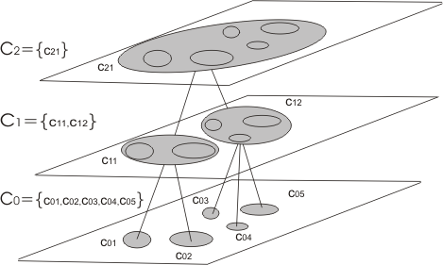

Fig.3. Illustration of the CET for a given image. By tradition the root of the CET is placed on top, but the described expansion and shape-grouping/merging process advances ‘bottom-up’.

3.2. Optimization of CET construction via DT.
Clearly, the DT-map of the given image harbors the same information, which underscores the very evolution tree. We could imagine the result of the DT as relief map, which iso-lines are defined over the pixels of equal distance (to the image object(s)). Thus, the move from the CET leaves to the CET root can be interpreted as moving down a slope (of the relief), in this way creating bigger and bigger degrees of grouping (merging) – see also the illustration in Fig.2.
Thus, the idea of optimizing the computation of a random series of expansions via the DT-map appears (almost) obvious. The fact that the number of merging shapes is monotonically decreasing with every ensuing expansion (evolution) step, is employed considerably – see also the illustration in Fig.1.
Therefore, registering of shape merges can be achieved by applying a fast method for binary search for (all necessary) CET levels of evolution collision. Moreover, if the number of shapes at two different levels of the CET is the same, then this number is the same in the interim levels, i.e. the last can be skipped during the search.

4. Two approaches for analyzing the CET
Having the constructed CET we need to analyze its structure to distinguish the relevant objects from the artifacts. The following two approaches have been experimented.

4.1. A cut CET approach (with a stopping rule)
This approach idea consists in finding the evolution stage where to stop the evolution (expansion) of the image. The pictures (the current image) we expect to see at that stage is the expanded central shape covering the major part of the object (trademark) components, while the other surrounding shapes to be considered noise-artifacts. However, the experiments discredit this primary idea, it works only in simple cases of comparatively small number of shapes, and in very special their disposition. Therefore, this approach has been described only for reasons of initial analysis of our use case.
4.2. A full CET approach (with weight coefficients over the nodes)
CET, and especially the DT processed CET, gives a good visual picture, but not an accurate indication whether and to what degree given shapes are artifacts. We can gain to such a conclusion by introducing weight coefficients in the CET nodes by the following simple algorithm. First, we assign a value of 1 to the root. Next, every interim node gets an equal share of the value of the parent with that of its successors. For example, if a given node is assigned a value of k and branches off to n number of successors, then every successor with get a value of:
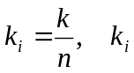 – value of the i-th successor (2)
Noticeably, the sum of the values of the leaves equals 1, which prompts us to interpret the values as probabilities.
Next processing is tightly connected with the final cleaning up of the image, i.e. making it free from the recognized artifacts.

4.3. Generating the “cleaned-up” image
First, a new image shell is created full of a background, which color/intensity is the closest to the original one and upon which the output image will be overlaid. Every (x, y) pixel from a shape, recognized as an object, is superimposed over the respective (x, y) pixel of the new image, but with a “transparency degree” equal to its currently shaped value. This technique is known in computer graphics under the name - Alpha Blending [1] and can be expressed by the following assignment operator:
r := o*(1- k) + r* k , (3)
where o is the value of the original pixel, r is its value at the given level of CET, and k is the weight coefficient of the respective shape, calculated by (2).
The consequentially observed effect is that the output image contains the entire original one, but the intensity of the artifacts is closer to that of the background, which reflects their suppression/reduction. If a complete exclusion of artifacts is requires, binarization can be applied as an ensuing step, for example, one with a global optimal threshold by Otsu [5].
A simple technique to find the closest intensity to the one of the background is to locate the most prevalent intensity in the periphery of the image, where the probability of expecting dominating background to object intensities is the highest.

5. Experimental results
To evaluate the contribution of the proposed (geometrically-morphological) filter to the noise-resistance of the target system EFIRS in its practical application at PORB, we conducted tests over a set of actual images, cordially provided by PORB.
The testing approach we chose allows estimating the improvement of EFIRS recognition rate when applying the proposed filter. To achieve an independency from the current stage of EFIRS development we apply an indirect experimental schema. Thus, we conducted two types of tests: (1) Filter + EFIRS and (2) EFIRS without preliminary filtering.
The specific test image database (IDB) contains 584 (= 4 x 146) images, which are structured in 4 test sets as follows:
- The first two sets are: the set {o} of the original 146 images and the set {c} of the same images, but preliminary manually cleaned up from noise-artifacts.
- The other two sets are {o1} and {c1}, which correspond to {o} and {c}, upon which the proposed filter has been already applied.
We have organized a separate IDB, accordingly entitled, for each of the 4 sets of images (see Fig.4). Thus we can realize test (T1) applying EFIRS on IDB_o1 and/or IDB_c1, and test (T2) applying EFIRS on IDB_o and/or IDB_c.
{o}
{c}
{o}
{c}
(T1)
{o1}
{c1}
{o1}
{c1}
(T2)
Fig.4. A schematic presentation of both test experiments:
T1). Search after preliminary filtering: IDB_c1, containing the set of images {c1}, is being searched for matching images from {o1}, and reversely (for IDB_o1 and {c1}).
T2). Direct search (without any filter): IDB_c, containing the set of images {c}, is being searched for matching images from {o}, and reversely (for IDB_o and {c}). By the way, a same-name search (by the dotted lines) is out of interest, as it theoretically (and in practice) results in 0 retrieval errors.
(T1a)
(T1b)
For instance, for the first case (Filter + EFIRS) we search: (T1a) with the set {o1} in IDB_c1 and (T1b) with the set {c1} in IDB_o1 (cf. Fig.4a), which completely simulates the targeted situation: a CBIR access method, expanded by the proposed filter. The results of these two tests should be quite close, that is, if there are any retrieval errors, they will mostly be the same in both tests. Any potential errors can be ascribed to imperfections of the tested system itself (EFIRS, in our case), but not to its expansion (with the proposed filter).
The other two test combinations, the tested system alone, without any preliminary filtration, i.e. by the set {o} in IDB_c and by {c} in IDB_o, are naturally expected to result in a much higher error of image retrieval.
A same-name search, that is {o1} in IDB_o1 and {c1} in IDB_c1, as well as {o} in IDB_o and {c} in IDB_c, makes sense for the evaluation of only the base access method, but not of its improvement by an auxiliary filter. The same-name search would only demonstrate the accuracy of the chosen CBIR access method the target system EFIRS gives up, i.e. whether it can correctly retrieve images of given IDB searching them in the same IDB. Therefore, the two primary IDB’s (IDB_c and IDB_o) have to be different; the system does not “know” which of them is “clean” and which is “dirty”. The premise is that EFIRS assures some minimal noise-resistance, which will cover any small differences, resulting from filtering of ‘roughly’ noised images, that is, if the respective images in {o} and {c} turn out to be very different.
The evaluation of the improvement resulting from applying the filter is being determined by the ratio between the respective retrieval errors encountered by both type of tests, (T1) and (T2):
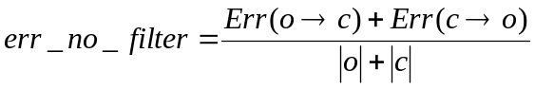, 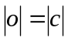
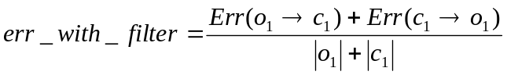 (4)
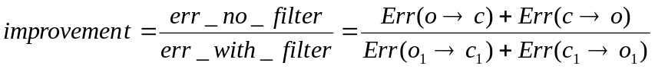

Table 1 contains the results of a few CBIR experiments we undertook. These CBIR access methods, given up by EFIRS, are referred to as “keys.” We considered two types of errors. “Subtle” errors mark the cases of multiple retrieval, i.e. a number (more than 1) of retrieved images that are not distinguish by the system. “Rough” errors are the ones related to a retrieval of nothing.

Table 1. Test results of applying the proposed geometrically-morphological filter.

IDB | Error Types | Key E1 | Key E2 | Key E3
c -> o | Subtle | 16 | 32 | 10
c -> o | Rough | 60 | 56 | 92
c -> o | Total | 76 | 88 | 102
o -> c | Subtle | 20 | 31 | 10
o -> c | Rough | 60 | 53 | 88
o -> c | Total | 80 | 84 | 98
Total for {o}  And {c} | Total  Subtle/Rough | 156  36/120 | 172  63/109 | 200  20/180
Improvement value |  | 2.14 | 1.91 | 1.65
 | With the filter
Total for {o1} and {c1} | Total | 73 | 90 | 121
c₁ -> o₁ | Subtle | 16 | 28 | 10
c₁ -> o₁ | Rough | 19 | 20 | 52
c₁ -> o₁ | Total | 35 | 48 | 62
o₁ -> c₁ | Subtle | 17 | 21 | 10
o₁ -> c₁ | Rough | 21 | 21 | 49
o₁ -> c₁ | Total | 38 | 42 | 59

Analyzing comparatively the number and type of errors resulting from both tests, (T1) and (T2), we find out an improvement of about 2 times, i.e. the percentage of error reduction when applying the proposed fitter is about 50%. We consider this a good proof of the effectiveness of the proposed geometrically-morphological method for eliminating artifact-noise in trademark images.
Examples of the filter application on 4 trademark images of from the practice of PORB are given in Table 2.

Table 2. Input images (top row) and the here filtered ones (bottom row).
 |  |  | 
 |  |  | 

CONCLUSIONS
The proposed method for artifact suppression (elimination) is based on an approach, exploring the contours of shapes in an image from the standpoint of the distances between them. The method underscores groups of contours that are related by their geometric proximity. The same idea is applied recursively over the so-formed groups as new shapes. Thus, the newly defined new structure – Contour Evolution Tree – illustrates the closeness of the contour groups at all levels. The tree allows for interpretations of a variety of heuristic approaches for analysis and evaluation of tasks related to segmenting of rough artifact-noise in images.
Two approaches were investigated in this report: (a) by splitting the tree using a stopping rule, and (2) by a probability evaluation of the entire tree, that is of every contour of the original image, whether and to what degree it is a noise artifact. The above evaluation is then used at the final stage of reconstructing the image, in eliminating the thus-segmented noise. The proposed method is valid for random images, not only black-and-white ones, we examined the later in order only to present the proposed method essence.
Future work will involve perfecting the proposed geometrically-morphological filter by improving the approach for evaluating the nodes of the tree.

AKNOWLEDGEMENTS
This work was supported by following grants of the Institute of Information Technologies at Bulgarian Academy of Sciences: Grant # I-1306/2003 of the National Science Fund at Bulgarian Ministry of Education & Science, Grant # RC6/2004 of the Bulgarian Agency for ITC Development, and Grant #010056/2003 of BAS.

REFERENCES
[1] Ammeral L., Computer Graphics for Personal Computers, 1992, Sol System, Moskow, ISBN: 5-85316-001-X (in Russian).
[2] Borgefors G., Distance Transformations in Digital Images, Comp. Vision, Graphics, and Image Proc., 34 (1986) 344-371.
[3] Dimov D., Experimental Image Retrieval System, Cybernetics and Information Technologies, BAS, Sofia, 2, 2 (2002) 120-122.
[4] Dimov D., Fast Image Retrieval by the Tree of Contours Content, Cybernetics and Information Technologies BAS, Sofia, 4, 2 (2004) 15-29.
[5] Russ J. C., Image processing, CRC Press, ISBN: 084931142X, ….
[6] Leondes, C. T., Image Processing and Pattern Recognition, Academic Press, ISBN: 0-12-443865-2, ….
[7] Singh R., I. Pavlidis, and N. Papanikolopoulos, Recognition of 2D shapes through contour metamorphosis, In Proceedings of the 1997 IEEE International Conference on Robotics and Animation, Albuquerque, New Mexico, April 20-25, 1997. vol. 2, pp. 1651-1656,
[8] Soille P., Morphological Image Analysis, Springer, ISBN: 3-540-42988-3, ….

ABOUT THE AUTHORS
Dimo Dimov, Assoc. Prof., Ph.D., Institute of Information Technologies, Bulgarian Academy of Sciences, Tel: (+359 2) 8706493, E-mail: dtdim@iinf.bas.bg
Alexander Marinov, Ph.D. student, Institute of Information Technologies, Bulgarian Academy of Sciences, Tel: (+359 2) 8706493, E-mail: alek.marinov@aviq.com

