Cu-Li phase diagram
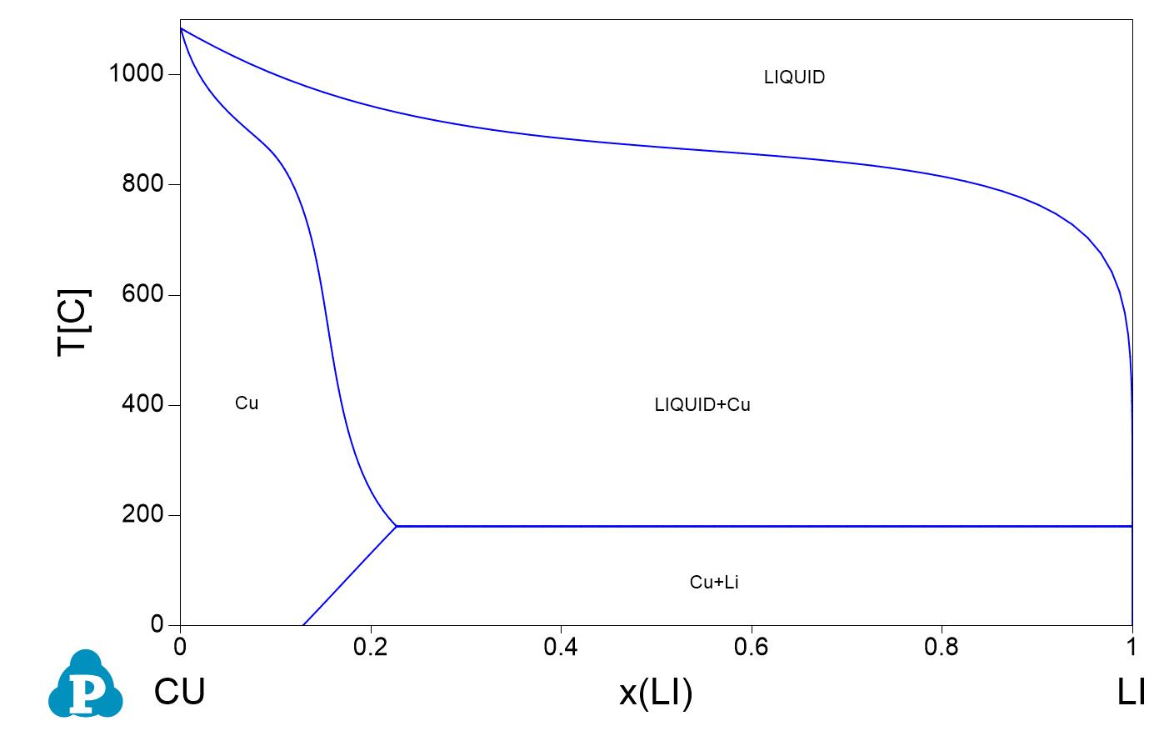
The phases that are present are:
Liquid, Cu, Cu + liquid and Cu + Li.
We have one invariant point that is a eutectic reaction at approximately x(Li) =1 and T=180 °C.
L→Cu+Li
This is a 3-phase equilibrium and so one invariant point.

Cu-Mg phase diagram
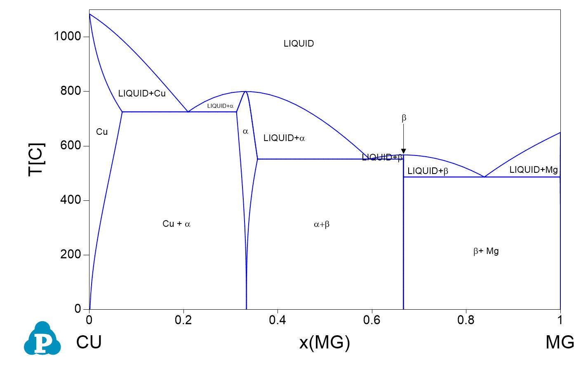
Phase present are:
Liquid, Cu, Mg, α, β
Two-phase fields: L + Cu, Cu + α, L + α, α + β, L + β, β + Mg.
Invariant points:
-Eutectic x(Mg) = 0.2 at T = 725 C
L→Cu+ α
-Eutectic x(Mg) = 0.59 at T = 548 C
L→ α+ β
-Eutectic x(Mg) = 0.83 at T = 484 C
L→ β+Mg

Li-Mg phase diagram
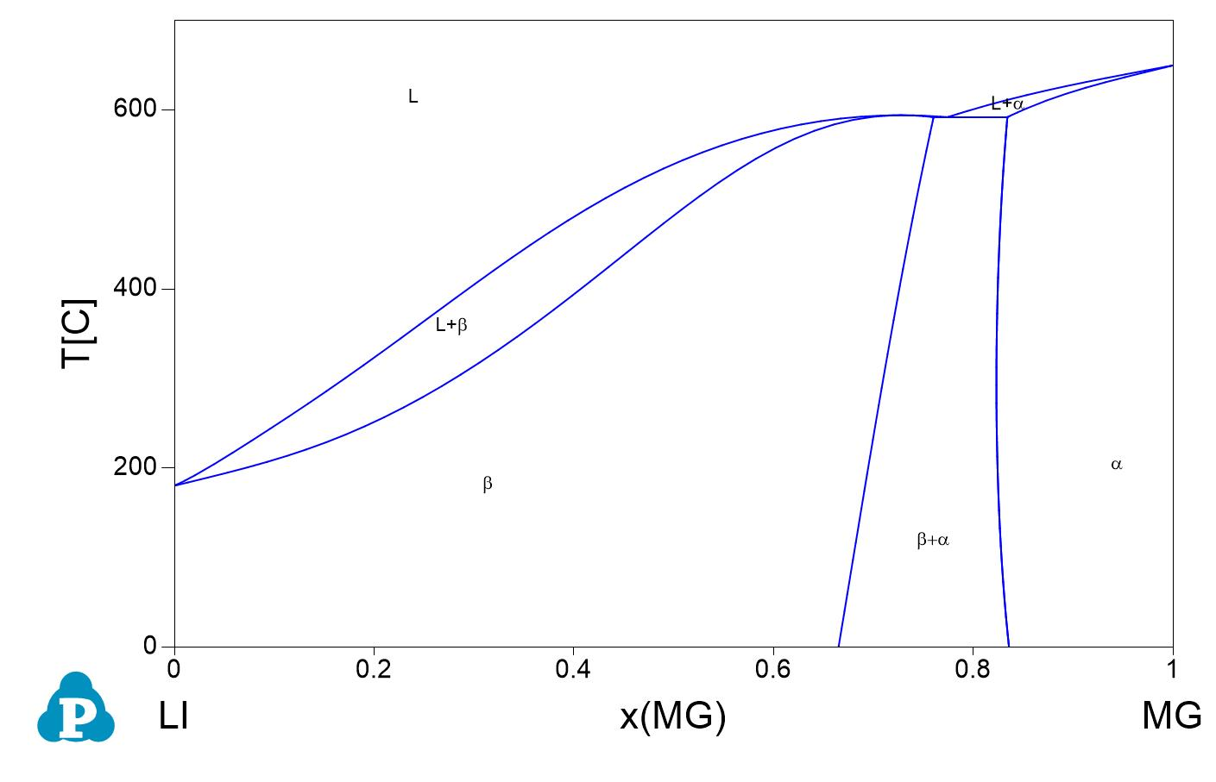
Phase present are:
Liquid, α, β
Two-phase fields: L + α, α + β, L + β.
Invariant points:
-Eutectic x(Mg) = 0.79 at T = 590 C
L→α+β

Phase diagram Li-Mg-Cu
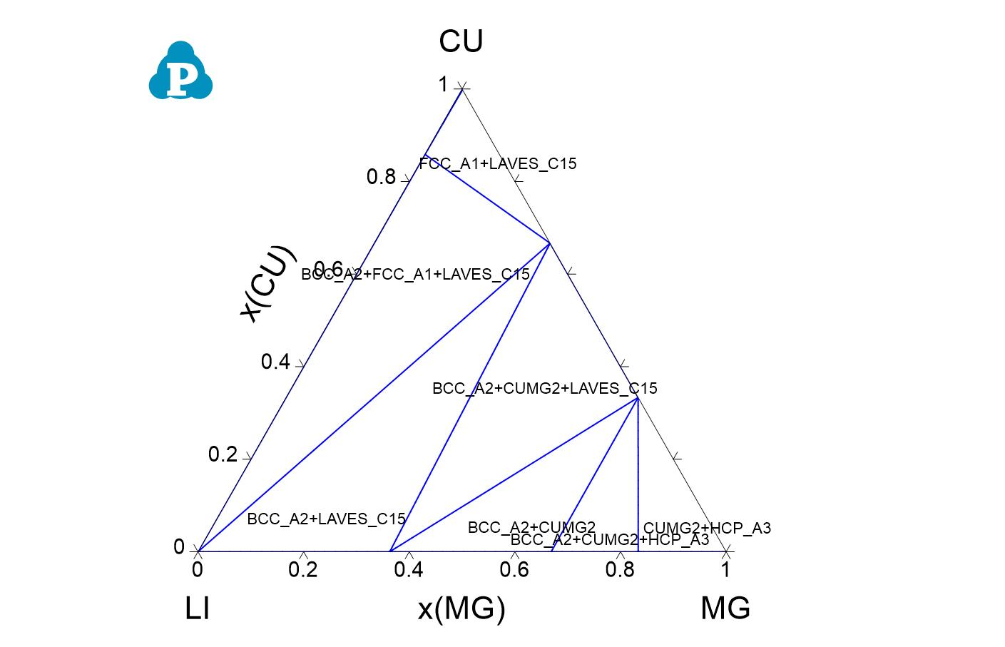
The amount of each phase present at the composition Cu = 0.3, Li = 0.25 Mg = 0.45 is:
-Fraction of BCC_A2 is 0.39.
-Fraction of CUMG2 is 0.31.
-Fraction of LAVES_C15 is 0.29.

