# CREDIT SCORE SYSTEM: Bayesian Ranking System

# Explanation of the credit score system

Let’s take a user ranking website where users vote up/down on users. Simple ranking schemes like percentage of positive votes or up minus down votes perform poorly.

**Percentage**: 60 **up**: 40 **down** — vs — 6 **up**: 4 **down** are both 60%

**up**minus**down**: 100 **up**: 95 **down** vs 5 **up**: 0 **down** are both **+5**

What we would like is for more votes to add more information; 60 votes hold more weight than 6 votes. Let’s use the votes as likelihoods in Bayesian inference. Here’s a set of users A-D with up/down votes and the calculated beta function starting from a uniform beta (1,1) Prior:

|  |  |  |  |
| --- | --- | --- | --- |
| ID | Upvotes | Downvotes |  |
| A | 60 | 40 | Beta(61,41) |
| B | 12 | 3 | Beta(13,4) |
| C | 30 | 12 | Beta(31,13) |
| D | 10 | 20 | Beta(11,21) |

We need to find the minimum value of the beta distribution such that we are 95% confident that the True value is greater. This can be done by subtracting a number of standard deviations from the mean.

*Ranking = Mean + z-score × standard deviation*

Using this formula, we will be able to rank the users and have a score out of /100.

The higher the score the more trusted the user.

When a transaction is complete between the users, the lender has the ability to vote “Thumbs up” or “Thumbs down” for the user that he/she lent money to. The purpose is to build a system that rewards users for paying back on time. The cumulative votes that a user get will make up for his/hers ranking. In order for the system to be as objective as possible the score will be calculated after the first 15 votes, where there are enough data to support a credible score.

Demonstration on how the system works

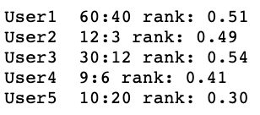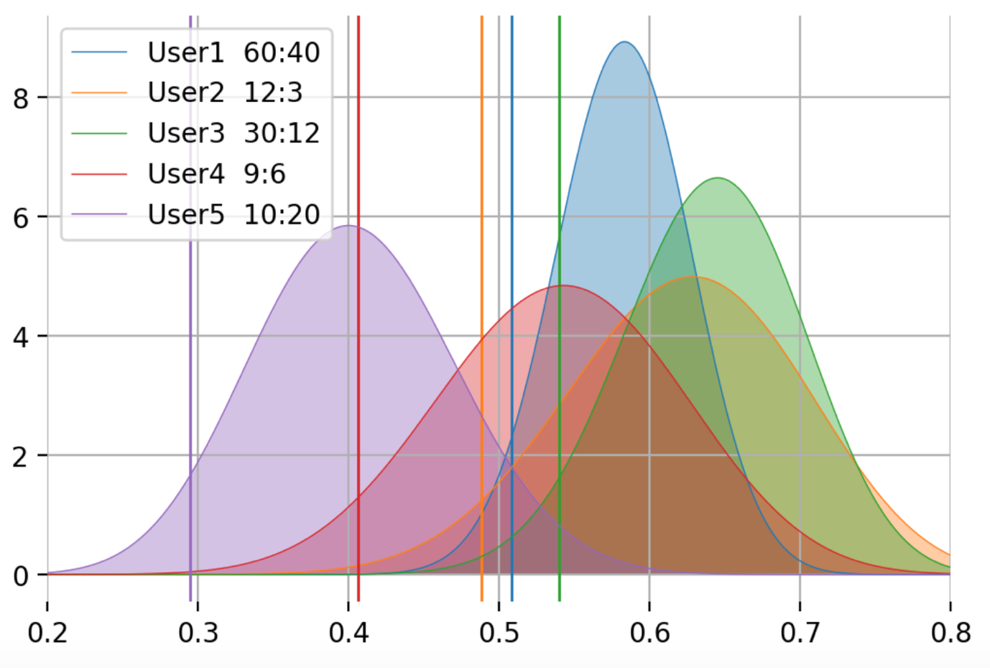

*The code needed to perform the above calculations is included in a separate file.

From the above demonstration we can understand that the user with the highest score is user3. The system is made up in a way that it rewards both the percentage difference and the absolute difference of the votes.