Lab 7 – Bayesian Modelling
Aleksander Rębisz 300177
Maciej Staniszewski 300180

The goal of this lab was to compare different approaches of disease prediction modelling. In our research we implemented the following Bayesian class models:
- Gaussian Naïve Bayes
- Multinomial Naïve Bayes
- Complement Naïve Bayes
- Bernoulli Naïve Bayes
- Categorical Naïve Bayes.

Libraries:
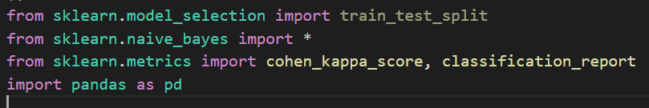

Data Preparation:
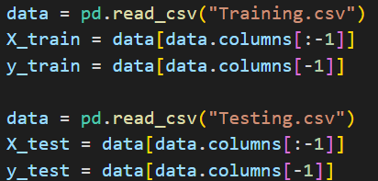

Evaluation:

Results:
The following is a fragment of disease prediction yielded by one of the models:
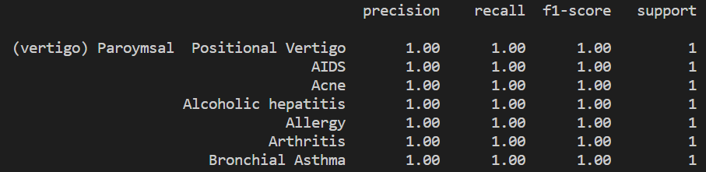
The list is not complete as the number of features is very long and in our case is stable and identical for each of the models. This may be the result of a small data set used in the training process.
The evaluation metrics:
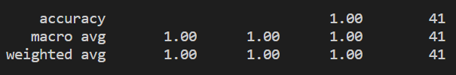
The cohen_kappa_score was 1.0 and identical for each of the models used.

References
Video Tutorial
Towards DS
Documentation

