## Technologies used during the development of the "Robotoni" project

Team members:

* Aleksa Radnojic,
* Marko Perovic,
* Nemanja Petrovic,
* Vukasin Petrovic,
* Nikola Simonovic

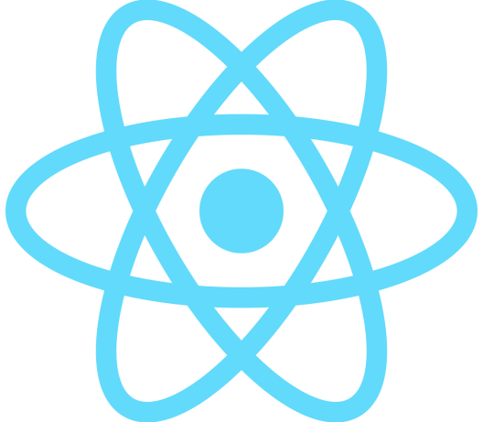**React.js** is an open source JavaScript FrameWork library that provides an overview of data written in HTML. React.js previews are usually provided using components that contain additional components defined as custom HTML tags. React.js provides the developer with a model in which subcomponents cannot directly affect external components, efficiently updating the HTML document when changing data, and clearly separating components in today's single-page applications. React.js is used for backend of application.

**Firebase** is a platform created by Google for creating mobile and web applications. Firebase provides real-time database and backend services. The service provides application developers with an API that enables synchronization of application data via the client and their storage on the cloud. The company provides client libraries that allow integration with Android, JavaScript, Objective-C and Node.js applications. The database can also be accessed via the REST API and links to several JavaScript libraries such as AngularJS, React.js, VueJS, Ember.js and Backbone.js. The REST API uses the server protocol to send events, which is in fact an API for creating HTTP connections to receive notifications from the server. Developers, using a real-time database, can secure their data using the prescribed security rules provided by the company server. Firebase is used for databse.

**npm** is a package manager for the JavaScript programming language. npm is also the default JavaScript package manager for the Node.js desktop environment. It consists of a console also called npm and an online database of public and paid private consoles.

Figma is a graphical editor with the help of which a user interface is created for applications, web applications and websites. It was used for interface design.

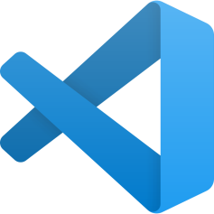

Visual Studio Code is a code editor developed by Microsoft for Windows, macOS and Linux operating systems. Typing and code generation were used.

**Google authentication** login via Google account.



**Facebook authentication** allows developer applications to interact with the Graph API on behalf of Facebook users and provides a one-time login mechanism for web, mobile and desktop applications. In this project he was used to apply.

Progresive web application (PWA) commonly known as progressive web application, is a type of application software delivered via the web, created using common web technologies including HTML, CSS, JavaScript and WebAssembli. It is designed to work on any platform that uses a standard-compliant browser, including desktop and mobile devices.