TREE CREATION GUIDE

Packet description: Our packet is quite easy to use. All you need to do is to start creating different trees by dragging the "Generator" prefab from the "Assets\Pack_Trees\Prefabs" folder into the scene.

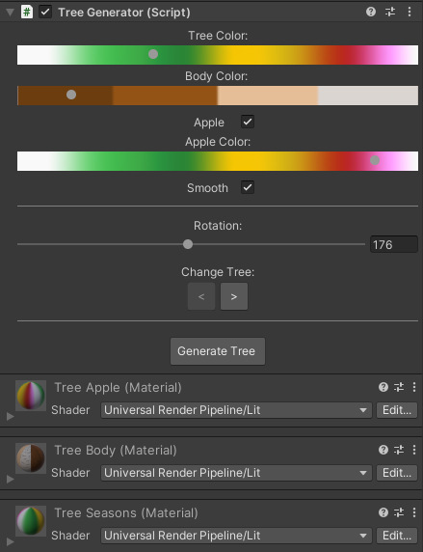Using the Generator:

* Tree Color: Changes the main color of the tree
* Body Color: Changes the body color of the tree.
* Apple: An option that determines whether the tree will have apples.
* Apple Color: If there are apples on the tree, this sets the color of the apples.
* Smooth: The smoothness of the model that will be created, between smooth and flat options.
* Rotation: This option allows the tree to be rotated more comfortably in the scene. (The tree is created already rotated at a certain angle.)
* Change Tree: Provides switching between different types of trees.
* Generate Tree: Press this button before making changes to your design; the final button generates the tree. (After pressing the button, you will see the tree generated in the model in the Assets\Pack_Trees\Prefabs folder)
* Note: Each newly created tree has 3 different materials reconstructed. But these materials can be found in the Assets\Pack_Trees\Materials folder.