**Cards Against Humanity**

There are 7 screens in this app.

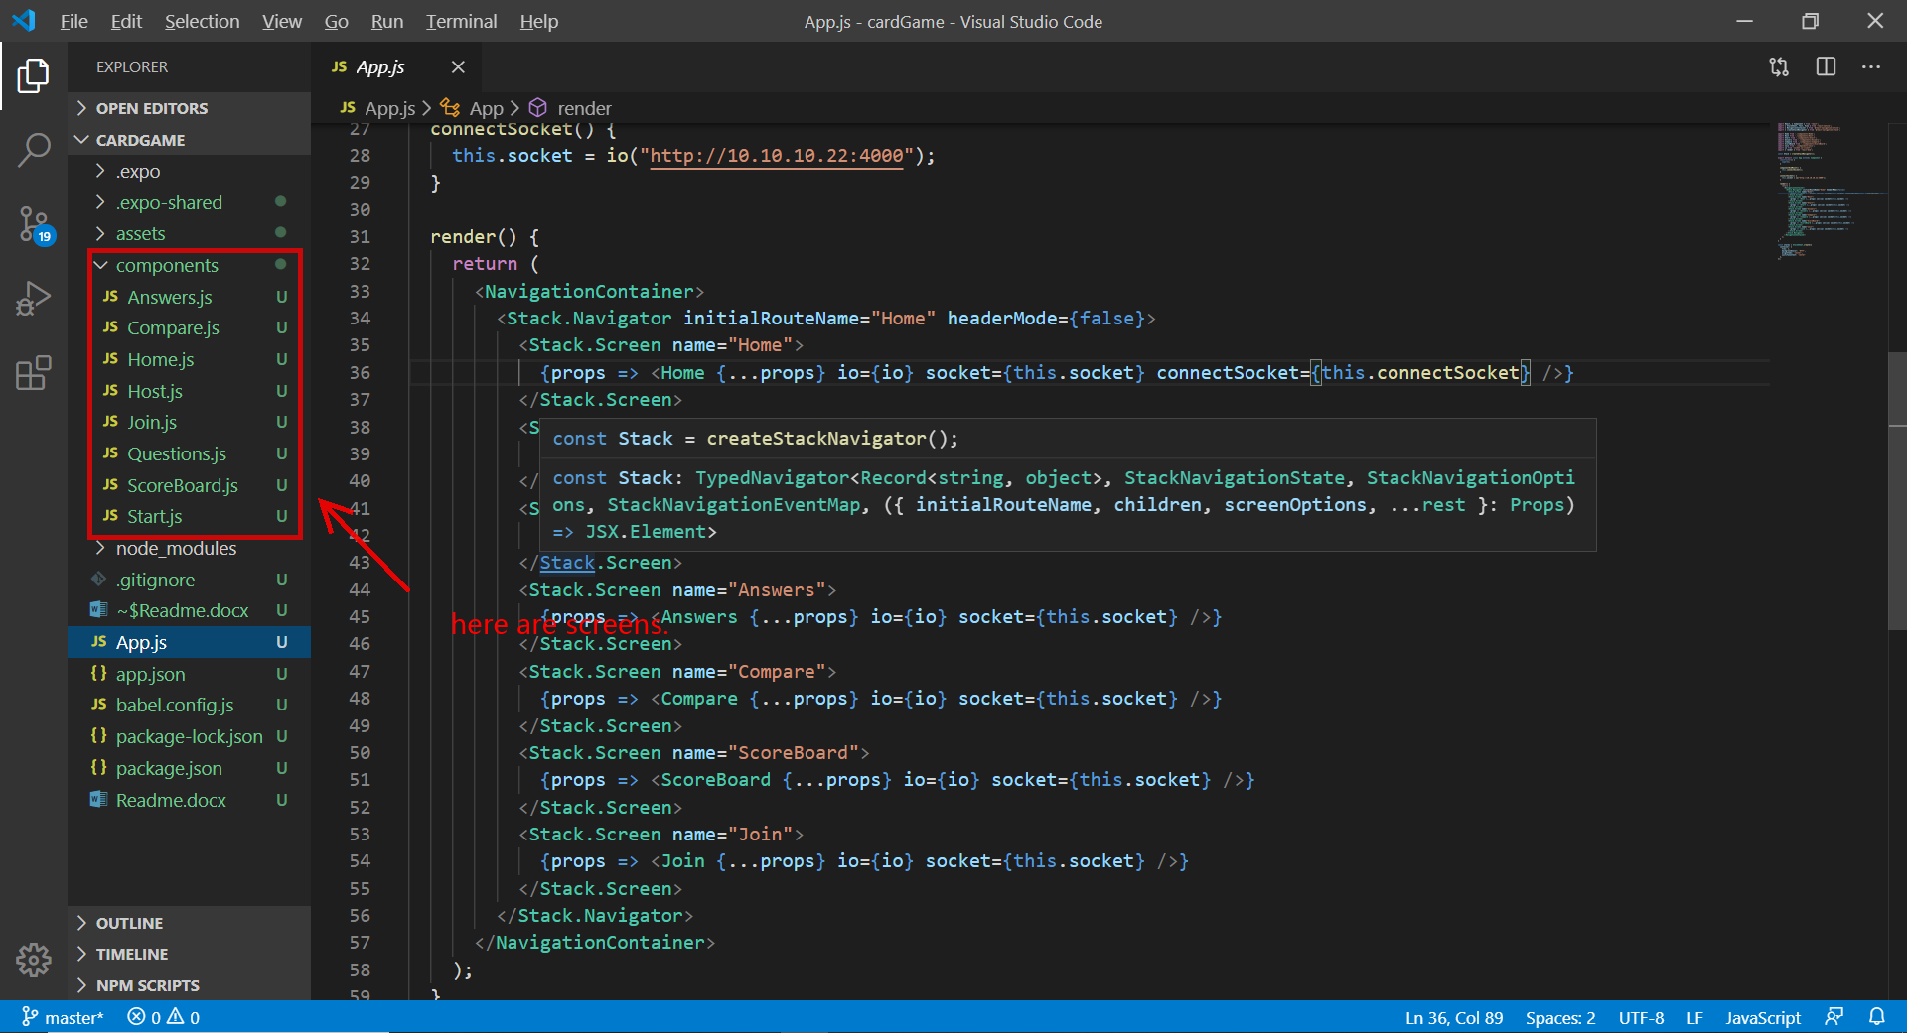

There are also 2 types of users – host and client.

Host create hosting server game and client join with code.

“Home” is the first screen.

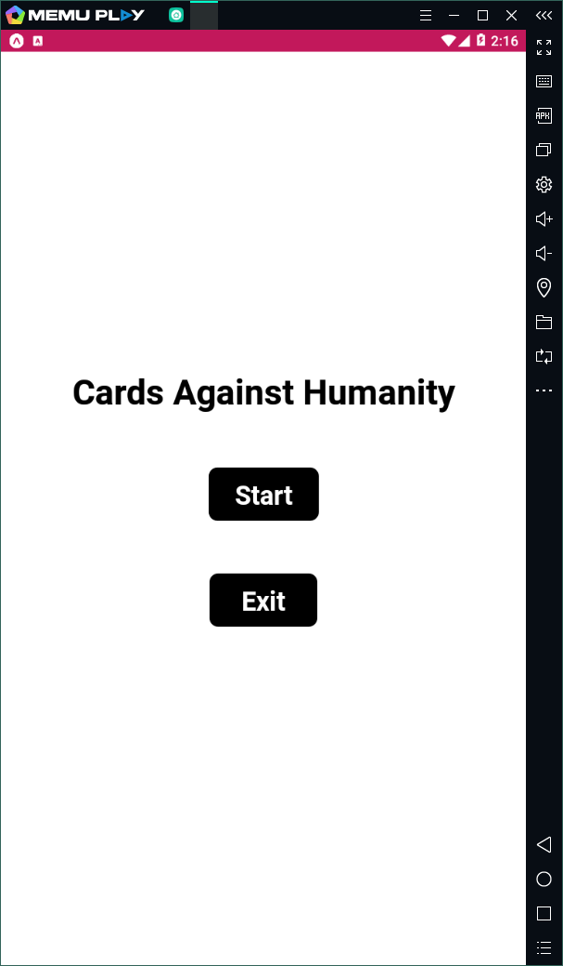

Host and client both click start to button to start gain.

After click start button, you all go to “Host” screen.

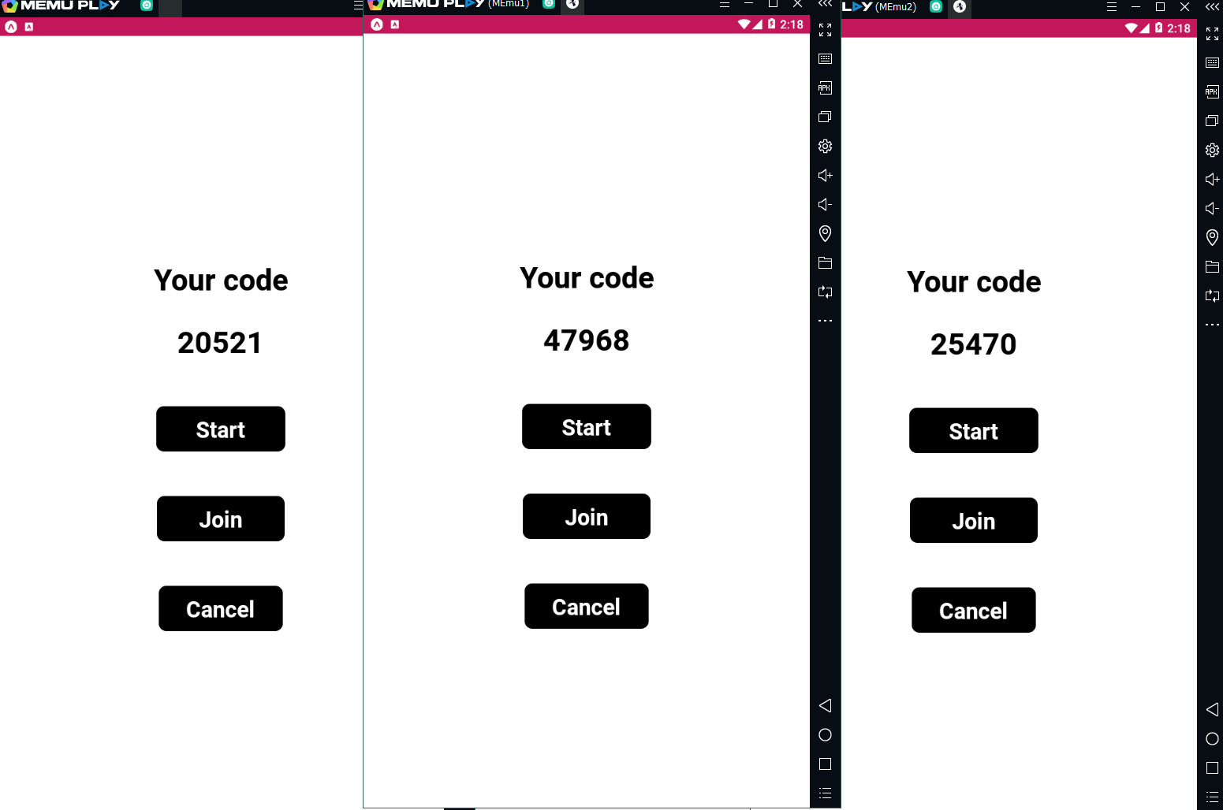

Anyone create server. And others join.

If click start button, then go to here:

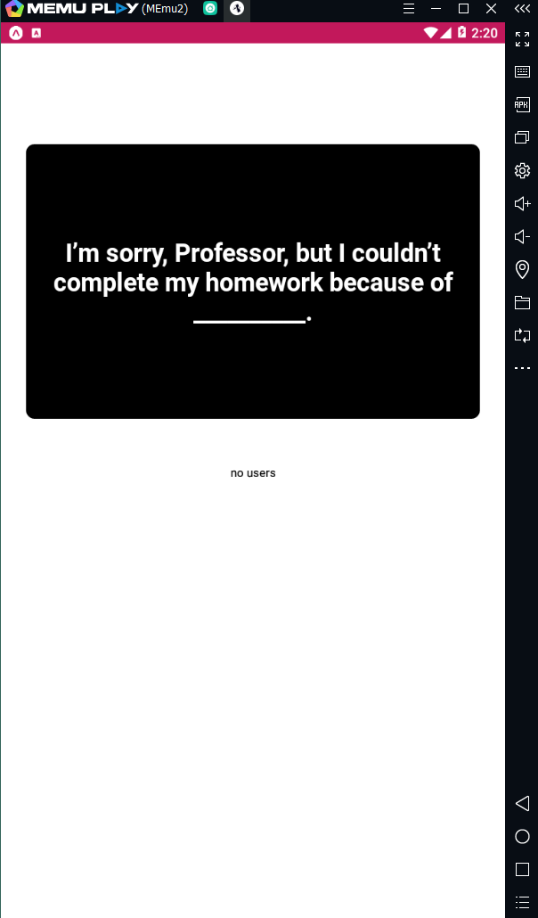

This is “Start” screen. Question is generated in random order according to the “Question” file.  
You can add “Question and Answers” pair.

Client click join button to join game. If click join button, go to here “Join” screen:

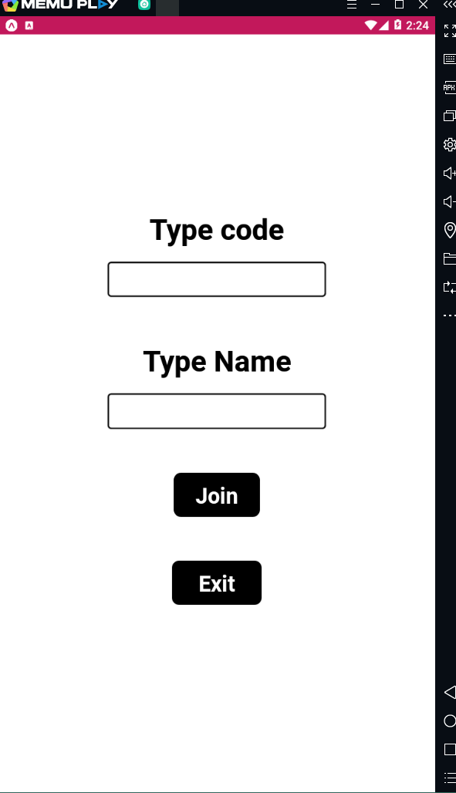

Type code of host and player name like “John” or “Player A” …

After fill in all data, click join button. Then go to “Start” screen.

You can see all clients who joined host.

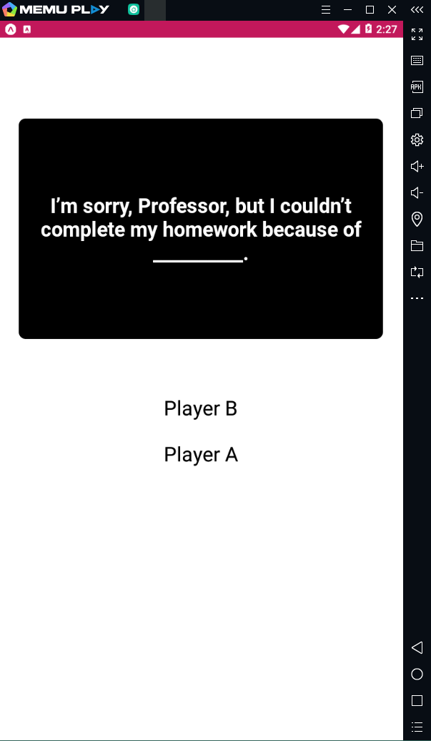

Host click black question tag, and game starts.

Host go to here “Compare” screen and wait for clients’ answers.

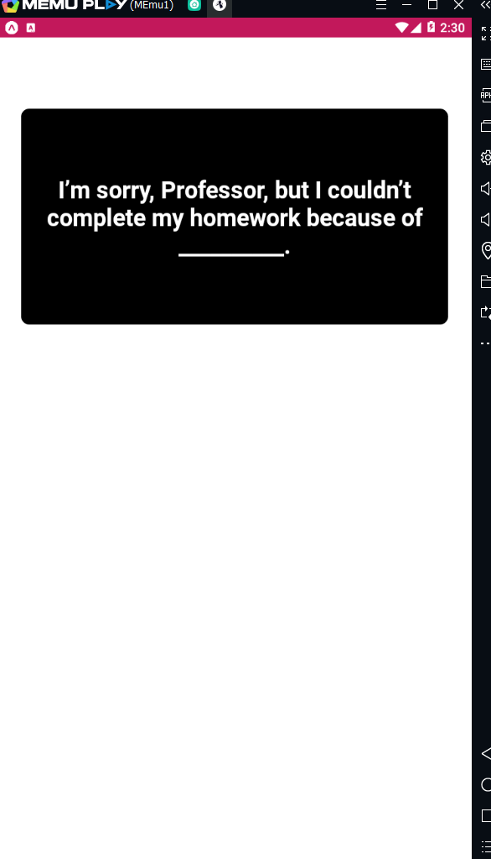

Host starts game and clients go to “Answers” screen and choose one here.

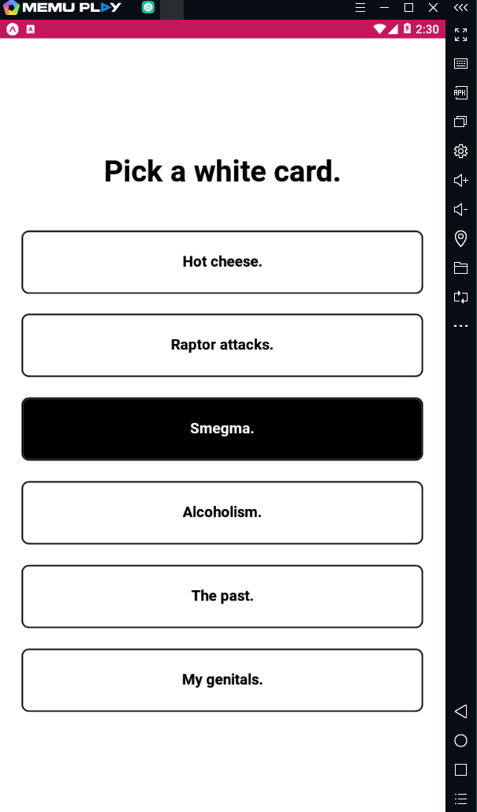

And wait for host judgement.

Host click one in “Compare” screen that he prefer.

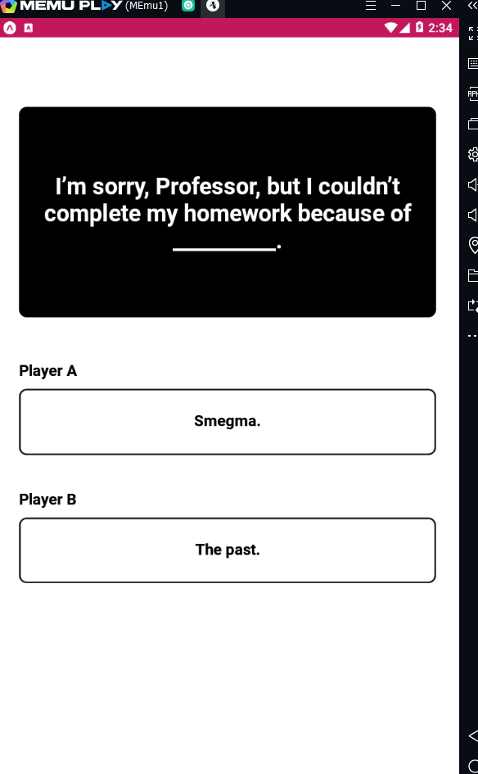

And if there is no client that has 3 marks, then go to “Start” screen again.

And repeat loop of question and answer.

If there is client who has 3 marks, host and client go to “ScoreBoard” screen and see result of game.

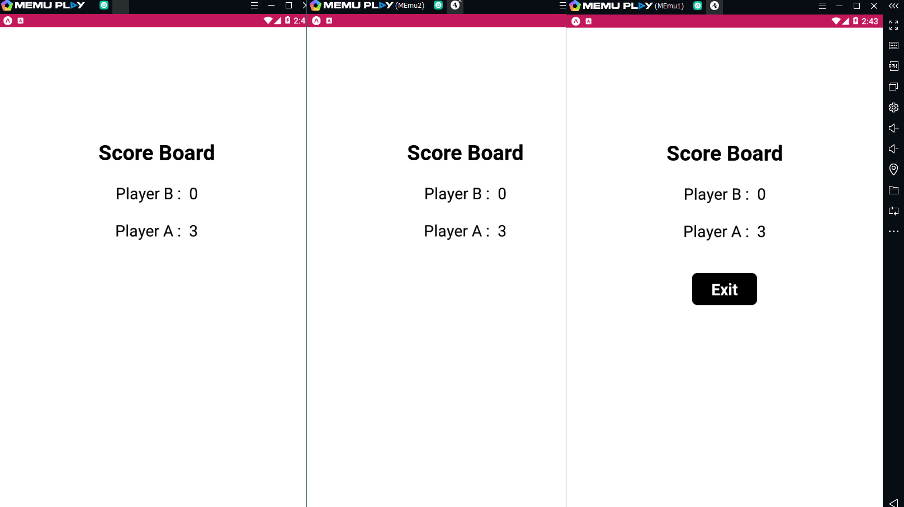

If host click Exit button, all go to “Home” screen again and start game again.

For multi-host and multi-client as you want, I use web socket.

