Dashboard (Oversikt)

**Introduction**

From this point on this document must be read and compered by numbered # sections in the meny structure document.

The Dashboard offers users a holistic view of the fire safety documentation progress, tasks, deviations, notifications, and the latest news articles. Each section is designed to provide a concise overview and facilitate easy navigation.

UI Design: <https://wonderwave.invisionapp.com/console/share/RUEVASK57H3/985076391>

### ****1. Opprett (Create) button****

When this button is clicked a dropdown appears where you can select from:

* Ny oppgave (new task)
* Nytt bygg (new building)

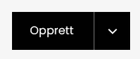

### ****2. Branndokumentasjon (Fire Documentation)****

**Purpose**: To present users with a quick overview of the fire safety documentation progress for each building.

* **Buildings List**:
  + Showcases the 7 latest buildings added to the system.
  + The first building from registration will be here, alongside any subsequent buildings added.
* **Building Progress Bar**:
  + Range: 0% to 100%.
  + Represents the cumulative completion percentage of fire safety documentation for each building.
  + The total percentage for a building is an aggregate of the progress from all its 8 related pages.

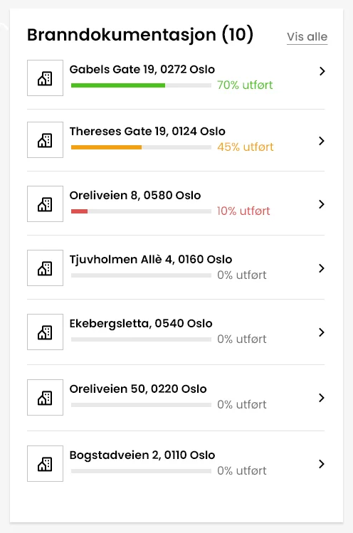

### ****3. Gjøremål (Tasks)****

**Purpose**: Give users an immediate insight into their tasks' status.

* Four tabs detailing task statuses:
  1. **Løst (Resolved)**
  2. **Forfalt (Expired)**
  3. **Pågår (Ongoing)**
  4. **Åpen (Open)**
* Showcases the task name, building address and status and name of assigned vendor, superuser or leader.
* Possibility to click a task to get more details about the task
* Each tab displays the 3 most recent tasks aligned with that specific status.
* **"Vis alle" (View all) Button**: This button redirects users to the "Oppgaver" (Tasks) page, where they can view an exhaustive list of tasks for all buildings.
* Under system settings, the administrator will be able to adjust the frequency of e-mail notifications and notifications based on a matrix and drop-down list for when a task is converted into a deviation and the time it takes before a deviation is notified upwards in the fire protection organisation.

### ****4. Avvik (Deviations)****

**Purpose**: Highlight deviations that demand user's attention.

* Showcases the task name, building address, status and name of assigned vendor, superuser or leader.
* Deviation category, which tells the degree of severity : TG 1, TG 2, TG 3. TG 3 being a serious critical issue/error.
* Possibility to click a task to get more details about the task
* Focuses on the 3 most recent tasks with the "Forfalt" (Expired) status.
* **"Vis alle" (View all) Button**: This button guides users to the "Avvik" (Deviation) page, granting them a complete view of deviation tasks associated with all buildings.
* A user can select to filter based on the different degree of severity.

### ****5. Varslinger (Notifications)****

**Purpose**: Inform users about the latest application activities.

* **"Marker alle som lest" (Mark all as read) Button**: This button marks all new notifications as read.
* Orange notification dot marking a new notification which has not been read.
* **Recent notifications include:**
  + Name of the action executor.
  + Specific activity undertaken.
  + Relevant timestamp.
  + Associated building's name.
  + List of all system notifications will be given soon.

### ****6. Nyheter (News)****

**Purpose**: Update users with the newest articles, updates, or announcements.

* **Article Elements**:
  + Representative article image.
  + Informative article title.
  + Posting date.
  + Author's identification.
* Users can browse through articles using left/right arrows.
* Articles are managed via the admin panel.