# Summary of indoor location technologies made for Zero G Bee challenge

## Types of distance sensors

### Computer vision

* Technology of the future. Efficiency can be easily upgraded through uploading of new algorithms. It can be specifically adapted and calibrated to space station’s environment ( advantage of already known environment).
* Few sensors are needed for mapping the whole area. With fish eye lens and algorithm for processing altered image view angle can be widened.
* QR code localization is very simple and cheap. Finding the robot plane is also very easy. Training of algorithm has to be done, usually with neural networks. In the simplest realization one camera is enough.
* Disadvantage is that line of sight is must. That is why it has to be combined with some other system for localization. But it is very good as backup system because of the precision and robustness.
* Also slightly bigger processing power is required . That is why careful choice of algorithm is needed. This system doesn’t have to work all the time, but it can be switched on from time to time.
* Perception of depth problem. Could be solved with stereovision, but there is simpler solution. For example combination with some of the technologies mentioned later in text.

### Ultrasound

* Ultrasonic sensors use sound instead of light for ranging , so ultrasonic sensors ( some people call it sonar) can be used outside in bright sunlight. These sensors are amazingly accurate ,though they may be thrown off by a sound absorbing obstacle , like a sponge. The only real issue that arises is the "ghost echo" issue. As you can see below , the walls bounce off in a strange pattern causing a ghost effect.
* 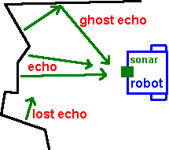
* Waves with very little length. Particle waves so they don’t penetrate walls so easily like RF. This is good for finding position inside rooms.
* Used in these types of sensors:

1. **Time of arrival** (ToA). Simple calculation is made by waiting echo signal to arrive. When the time is measured distance is easily calculated.
2. **Time difference of arrival** ( TDoA ). Two or more stations receive waves which are sent from object in the same time. Instead of measuring ToA, they measure difference in time of wave arrival between them. Minimum 3 stations are used for finding precise location. Measuring is done with ultrasound or ultrasound + RF sensors.
3. **Angle of arrival** ( AoA). Needs rack antennas with 2 or more fingers to measure phase difference between waves which is the used for angle calculation. Sensitive to multi path propagation.

* Calibration has to be made. Especially for time-of-arrival algorithms, there has to be perfect synchronization between transmiter nodes. Also temperature of room has to be accounted because of the speed of sound, which depends on it.
* Disadvantage is that speed of sound is not constant everywhere ( it varies a little bit with temperature so calibration has to be made ). Also, since it is particle wave it cannot be used in vacuum, obviously. In some experiences 40 Khz sound might be a problem if constantly exposed to humans. Maybe higher frequencies are not so big problem, but detailed research was not made.

### RF

* The idea is the same as for ultrasound waves, except these waves have longer wavelength and bigger penetration through the walls and objects. These cause precision to downgrade to aproximattely around 10 cm. Multipath can be big issue because of very good isolation in the space shuttle making it a good Faraday cage.
* Advantage is that similar system, based on RFID is already in use on the ISS, for tagging objects and putting them in the databases for further analysis .
* RFID technology is good because it doesn’t require line of sight. Tags can be active or passive, depending on the range.
* They can work in vacuum, which is obviously big advantage in space.
* Tags can go on drone and beacons can be set all over the station.

### IR

* Good and cheap for detection ( is something nearby ), but not so good for range calculation. One variant is triangulation (Sharp sensor)
* Infrared sensors , emit infrared light ,and therefore the sensors cannot work accurately outside or even inside ( but this is not entirely true for Sharp IR sensors , since they will work pretty accurately in ambient light.)
* Now since light does not reflect the same way off every surface, the infrared sensor reading will be different for different surfaces , different colors, and different shades EVEN if the range is the same.

### LASER

* Very precise, but for longer distances . It is because of very high speed oscillator in electronics has to be very fast.
* Very narrow beam
* Clocking speeds of 15GHz would be needed in a timer capable of 1cm resolution and this is impractical.

### Combinations

* Intel RealSense. Laser scan + regular camera. We can do this with ultrasound + camera
* RF + ultrasound for ToA

## Methods of indoor location

### Trilateration

**Trilateration** is the process of determining absolute or relative locations of points by measurement of distances, using the geometry of [circles](http://en.wikipedia.org/wiki/Circle), [spheres](http://en.wikipedia.org/wiki/Sphere) or [triangles](http://en.wikipedia.org/wiki/Triangle).

Ultrasound sensors can be used here with ToA measuring. It is possible to use also TDoA sensor ( ultrasound or combination of ultrasound and RF ).

Stations are reference points which are sending/receiving beacons to the drone. Position can be calculated on board the drone or somewhere in the station. This is very flexible system.

CDMA, TDMA multiplex can be used for sending beacons from stations. CDMA has bigger refresh rate, but TDMA has bigger precision because there is guard period between sending frames. Using this guard period we reduce the noise caused by Intersymbol Interference ( ISI ) and multipath propagation.

Noise can be reduced using correlation and filters, but it demands bigger processing power.[1]

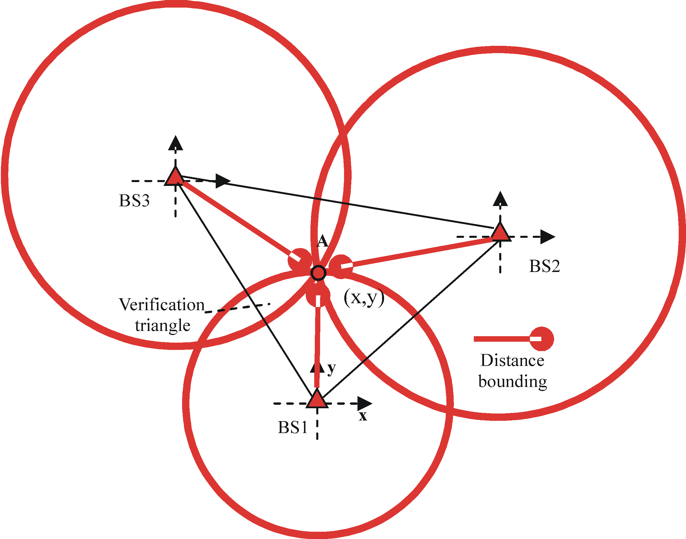

### Triangulation

**Triangulation** is the process of determining the location of a point by measuring [angles](http://en.wikipedia.org/wiki/Angle) to it from known points at either end of a fixed baseline, rather than measuring distances to the point directly ([trilateration](http://en.wikipedia.org/wiki/Trilateration)). The point can then be fixed as the third point of a triangle with one known side and two known angles.

Drone has to send beacons to the stations which then calculate angle using sensors with AoA measuring. Stations also have to precisely know the distance between them.

We have to use sensors which have two or more antennas because we need phase difference between two or more waves to calculate the angle. This is not very precise technic since waves usually bounce off obstacles causing multipath propagation.

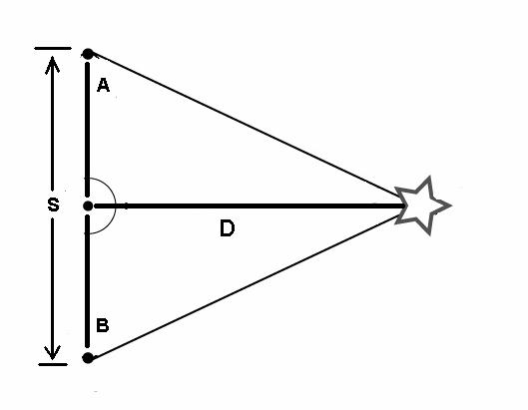

### Multilateration

**Multilateration** is a [navigation](http://en.wikipedia.org/wiki/Navigation) technique based on the measurement of the *difference* in distance to two stations at known locations that broadcast signals at known times. Unlike measurements of absolute distance or angle, measuring the difference in distance between two stations results in an infinite number of locations that satisfy the measurement. When these possible locations are plotted, they form a [hyperbolic curve](http://en.wikipedia.org/wiki/Hyperbola). To locate the exact location along that curve, multilateration relies on multiple measurements: a second measurement taken to a different pair of stations will produce a second curve, which intersects with the first. When the two curves are compared, a small number of possible locations are revealed, producing a "fix".

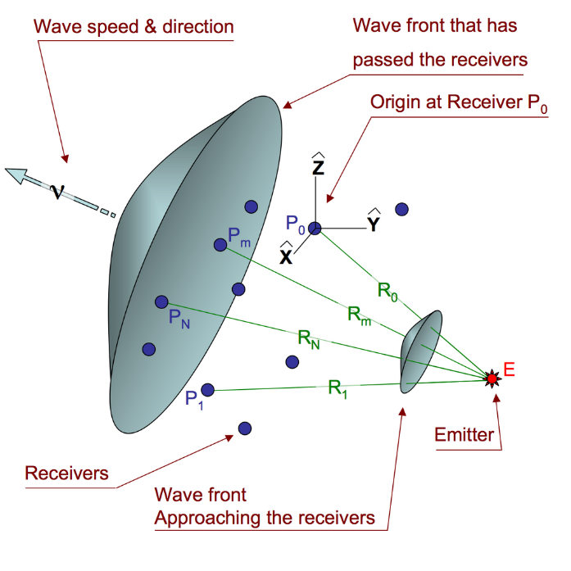

Beacons are emitted from drone to the stations. These measurements can also be done using ultrasound sensors using TDoA.

# Collision avoidance

* Same type of sensors discussed previously for indoor location, just different philosophy. Beacons are not needed, just one or more sensors onboard the drone.
* Here the dominant sensor should be vision and other sensors act as a backup.
* Need for full space mapping ( 4 $π$ steradians ). Vision is the best for this.
* Combination of sensors, like Intel RealSense, 3D cameras…
* We decided that ultrasound + vision is the simplest and best

# Onboard and off board calculation of indoor location and detection of obstacles

* Onboard is good for autonomy, speed, independency
* Off board is good for saving battery in drone. It could also be done on Earth but delay might be problem.

1. Fine-Grained Acoustic Positioning with Compensation of CDMA Interference; Fernando Seco, Antonio R. Jim´enez and Francisco Zampella