Program description

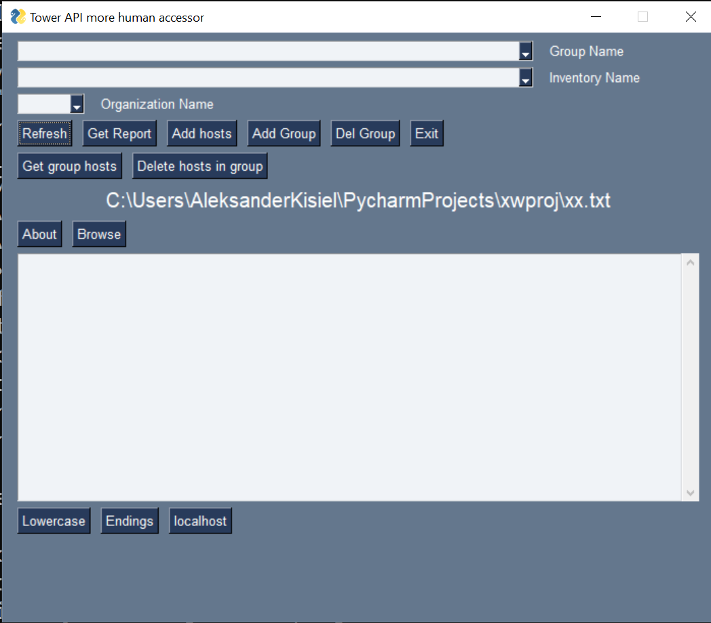

Refresh – refresh the data from the Tower

Get Report – get report about the available asset

Add hosts – add hosts from selected file

Add Group – create a group into selected Tower Organization

Del Group – delete selected Tower Group

Get group hosts – save a file with hosts what belong to the selected group

Delete hosts in group – delete hosts from selected files in selected group

Text Are operations:

Lowercase – convert text in the text area to lowercase

Endings – convert text in the text area to lowercase, and add to the all ends of the lines “ **\* , “**

Localhost – add to text area line with the “localhost”