Aleksander Wojcik
Shopping List Android Application Guide

The application let you:
- Add new shopping lists
- Delete existing shopping lists
- Put new products on the shopping list
- Put existing (previously added) product on the shopping list
- Change products
- Delete existing products in the shopping mode
- Send the shopping list via email and sms
Important screens (activities):
1. Main activity of the application
We can see the button to add new shopping lists (A), the button to default shopping list (B)(that one, we cannot delete and which is always available) and other shopping lists (C). When we click the shopping list’s name button we go to Product List Activity (point 3)

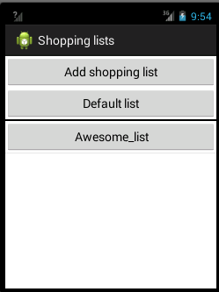
A
B
C
2. Main activity and deleting shopping lists mode
To delete shopping lists, we have to go into menu (MENU) and enable deleting shopping lists mode (D). We can delete all the shopping lists below the line.

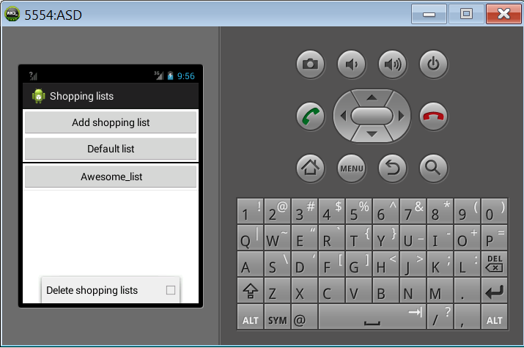
MENU
D
3. Product list activity
We can add new products (E), change products on the list (by pressing the item for a bit longer) and clearing the list (F).

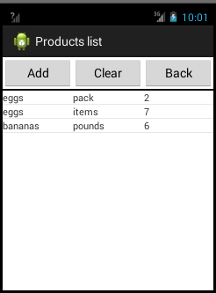
E
F
4. Product list activity and deleting products mode
To delete products on the shopping list, we have to go into menu and enable deleting products option (shopping mode)(G). When the option is enabled we delete products by clicking on their names.

To send the shopping list via email click (H).
To send the shopping list via sms click (I).

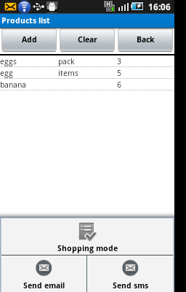
G
H
I

The application was tested on devices:
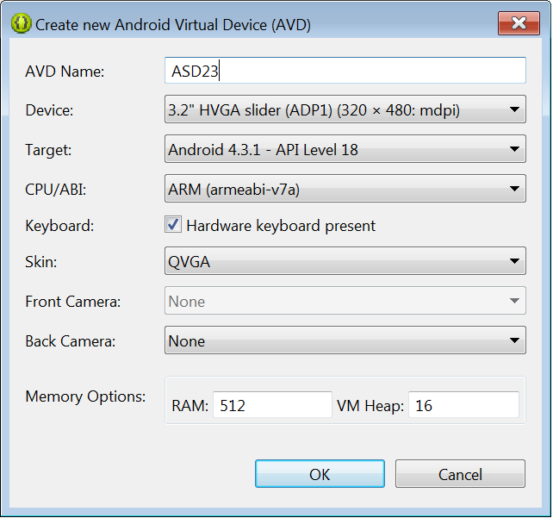
And
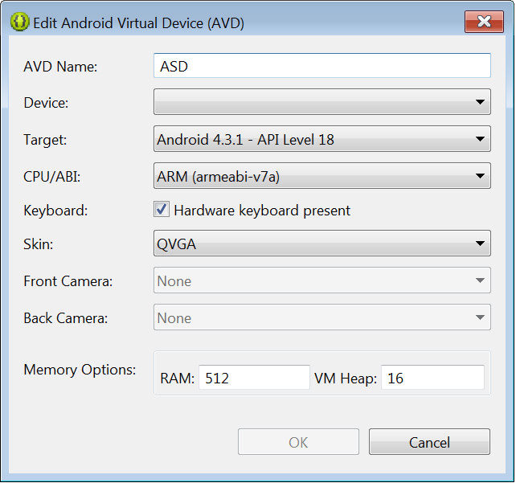
How to run application in Eclipse:
- Unzip the source files to the folder OUTSIDE the workspace
- Go to File/Import/Android/Existing Android Code Into Workspace
- Import source files:
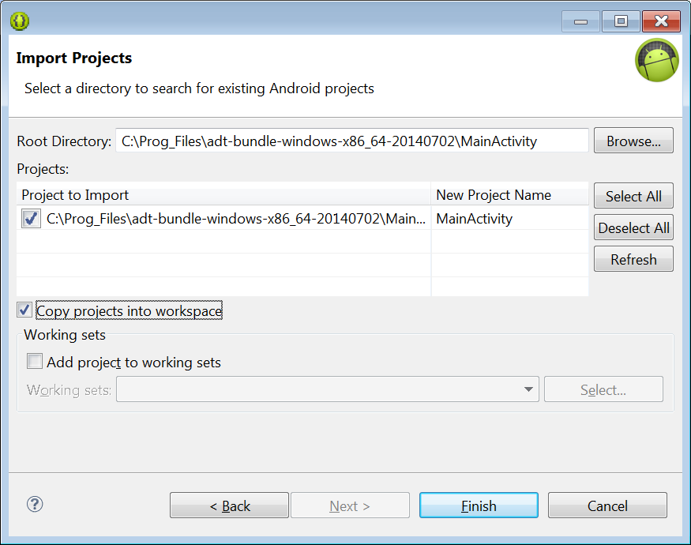
- If you want to import project from Android Studio to Eclipse you should choose the options below:
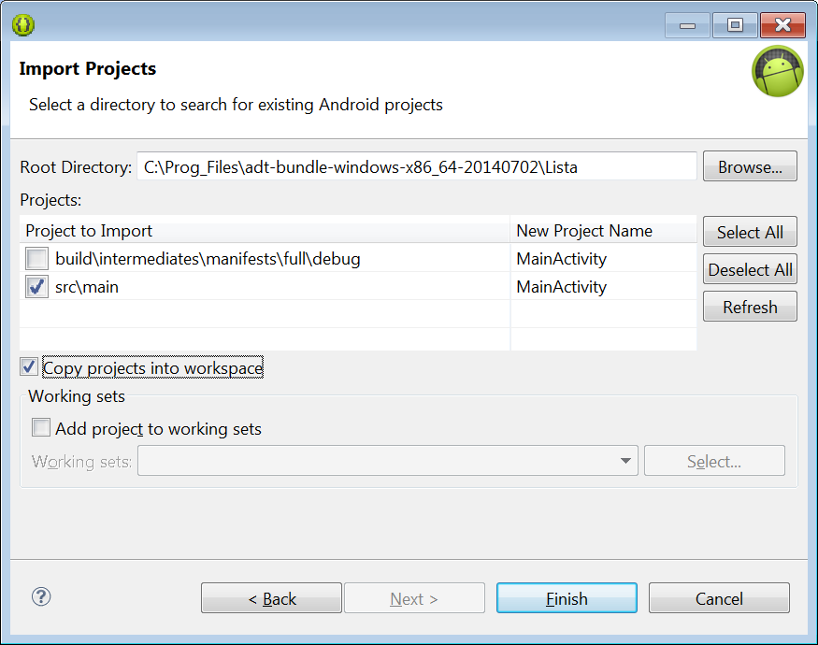
And sometimes you will have to move files and directories from java to src directory:
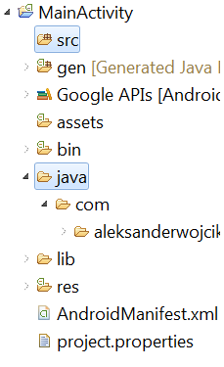
- Run the application:
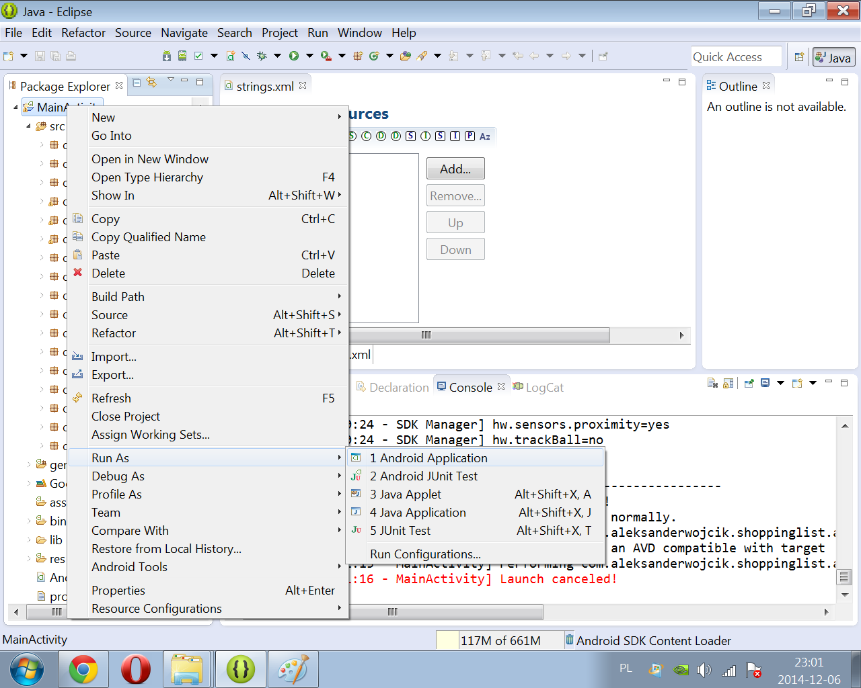
- Choose No in the dialog:
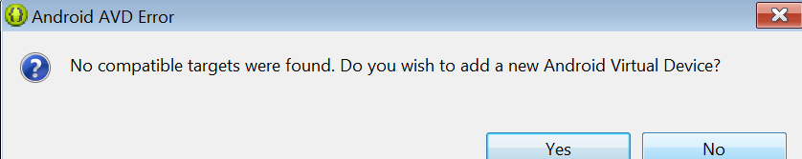
- Choose the device and click OK
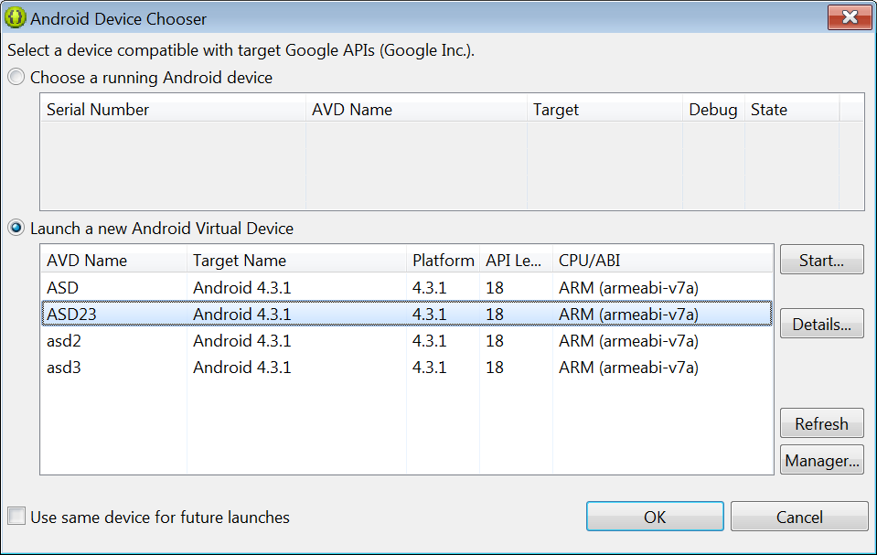
- The application should start.
- Sometimes you need to restart the server:
Go to <adt>\sdk\platform-tools directory, open console (on Windows press shift+right click and select Open command Line##) and type:
adb kill-server
adb start-server

- Connecting to database
If you wish to connect to database, please type commands below, when your device is connected:
adb devices
To see connected devices, then:
adb -s emulator-xxxx shell
sqlite3 data/data/com.aleksanderwojcik.shoppinglist/databases/SHOPPING_LISTS.db
Type .tables to see all tables in database
How to run application in Android Studio:
- You will need to download android sdk and configure IDE.
- To configure project, find file: android-support-v4.jar , right click on it and choose Add As Library…

