|  |
| --- |
| **INTELECS™ COEX - Co-Extrusion Line Control System**  INTELECS™ COEX is a control system designed to fulfill all the requirements of the most sophisticated co-extrusion blown film production. It's built on a solid foundation of the hard-real-time operating system to ensure the highest degree of reliability. On the other hand, the system offers a lot of advanced features such as recipe handling, gauge profile monitoring, pre-defined schedule with temperature profiles for the gradual heating of extruders and die, production reports and statistical process control functions. INTELECS™ COEX features up to 15 inch colour touch screen or a combination of touch screen and push buttons. The INTELECS™ COEX system controls all aspects of multi-layer film production. It handles up to 12-layer film structures, up to 400 temperature control zones and up to 100 continuously blended chemical components. |

|  |  |  |
| --- | --- | --- |
| *INTELECS™ COEX Functional Specifications:*   * Maintains gauge, width and layer composition of the final film product * Controls all line operating parameters including temperatures, co-extrusion layer ratio and haul-off speed (line speed) * Maintains the desired temperature profiles for all extruders and die zones according to the recipe of the product being made * Controls extruder speeds according to the gravimetric monitoring of the material flow and desired gauge of every layer in the multilayer film structure * Controls the blending process either directly or via an interface to a third-party batch blending system * Performs gauge profile monitoring (optional, requires infrared or ultrasonic sensor) * Provides real-time trending for all major line parameters * Performs alarms monitoring * Generates reports (per roll, order, shift, etc.) |  |  |
| *INTELECS™ COEX Hardware Technical Specifications:*   * Intel compatible 266 MHz processor running deterministic hard real-time operating system * Up to 15" VGA color TFT display with touchscreen (resistive) and IP65 protection from the front * Up to 64 MB SDRAM for program/data storage * Built-in Ethernet 10/100 network adapter * Serial RS232 port * 2 USB ports for serial printers, flash memory "sticks", etc. * Compact Flash slot holding up to 2 GB Flash Drive with a file system for recipes and historical data storage * Fanless cooling, metal housing * Power supply 24 V DC, lithium battery * 256 kB SRAM * Real-time clock * Up to 2 slots for digital communication adapters (CAN, Ethernet Powerlink, X2X) |  |  |

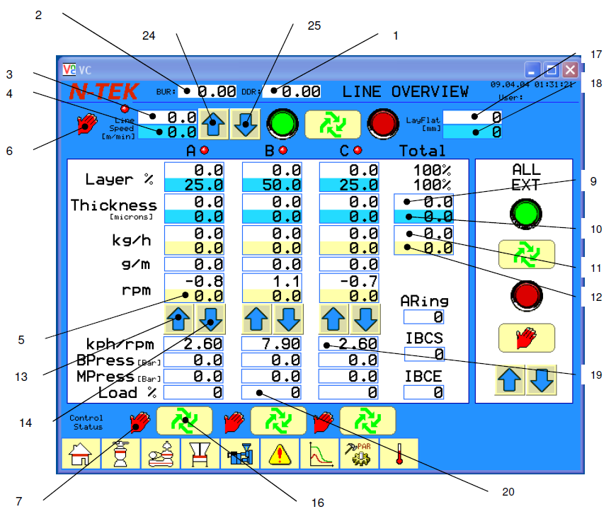

| “LINE OVERVIEW” Page Field Definitions. | | |
| --- | --- | --- |
| Field Name (Number) | Edit­able? | Description |
| Haul off Speed Target (4) | yes | When the Haul off Speed Control Status is in the manual mode the operator may enter the desired haul off speed in this field, and have the Haul off actually go this speed. In the Automatic mode, the Haul off Speed Target is calculated based on the mass continuity equation, Eq. (3), using target film thickness, target layflat width, resin density and die throughput rate.  This value can be entered from the touch screen or adjusted with the manual haul off speed increase/decrease pushbuttons (24, 25). In the Auto mode this number is calculated and set to deliver the correct film thickness given fixed throughput, density, layer distribution and lay flat. When entered from the touch screen, the actual haul off speed ramps to this speed with the 2-stage rates given on the Nip and Lay Flat Parameters Page. |
| LayFlat Target (18) | yes | This is the Target LayFlat Width. The value in this field is used to determine the target haul off speed when the haul off is in the automatic mode. When the layflat control status is in the automatic mode, the bubble width will be controlled to the target by inflation or deflation. |
| LayFlat Actual (17) | no | Layflat width is the actual width of the collapsed bubble, or 0.5π * Bubble Diameter. The value in this field comes from a layflat width sensor and is used for automatic control. The analog sensor input, calibration full scale gain and offset can be accessed from the Haul off and Lay Flat Parameters Page. |
| Haul Off Speed Actual (3) | no | Haul Off Actual Speed is determined by the analog signal, calibration full scale gain and zero offset which can be accessed on the Nip & Lay Flat Parameters Page. This variable reflects the actual speed of the primary nip (haul off). |
| Haul Off Speed Control Status (6) | yes | This status reflects whether the Haul Off Speed is being controlled automatically according to targeted process conditions or whether the speed is manually set by the operator. This status reverts to manual whenever the haul off drive is turned off, or if the operator presses the manual haul off speed increase or decrease pushbuttons (24, 25). The operator must put the status into the automatic mode from the touch screen. In the automatic mode the haul off speed will be calculated using the mass continuity equation, Eq. (2), with the goal of maintaining target film thickness. |
| Blow-Up-Ratio (BUR) (2) | no | Blow-Up-Ratio or BUR is automatically calculated as a ratio of the bubble diameter (2/π * lay flat) to the Die Diameter. Different kinds of product and material have different characteristic BUR ranges where they can be successfully run. Die Diameter must be entered on the Nip & Lay Flat Parameters Page. |
| Draw-Down-Ratio (DDR) (1) | no | Draw-Down-Ratio or (DDR) is automatically calculated as the ratio of the Die Gap to the film thickness. A bigger DDR means a greater degree of drawing the film down from its thickness at the Die Gap. Die Gap must be entered on the Nip & Lay Flat Parameters Page. |
| Total Film Thickness (Gauge) Target (10) | yes | This is overall target thickness (or gauge) for the entire film sheet. |
| Total Film Thickness (Gauge) Actual (9) | no | Overall Film Actual thickness is calculated by the INTELECS™ system according to the Eq. (3). |
| Resin Throughput Target (12) | no | This is the targeted throughput from the extruder based on the continuity equation Eq. (1). In the *Auto* mode each extruder's speed will be adjusted until the *actual* throughput is equal to the *target* throughput. |
| Resin Throughput Actual (11) | no | The actual extrusion rate is computed from the screw speed multiplied by the screw rate. The screw rate is calculated when the extruder is operating at steady state using the weigh hopper loss-in-weight data and the screw speed. |
| Extruder Screw Speed (5) | no | This field indicates the actual speed of the extruder. In the *manual* mode the operator manually adjusts extruder speed with the extruder speed increase/decrease pushbuttons (13, 14). In the *automatic* mode INTELECS™ automatically adjusts the screw speed to achieve the target layer percents, thicknesses and throughputs. Each extruder's Parameters Page contains analog signal data and calibration parameters for extruder screw speed. |
| Screw Rate, (pph/rpm) (19) | no | The screw rate is calculated when the extruder is operating at steady state using the weigh hopper load cell data and the screw speed. Each extruder's Parameters Page contains weigh hopper and screw rate calibration parameters. |
| Drive Current (20) | no | This field indicates the percent of full-scale analog input of the extruder drive current. Warning and limit alarms are used. Each extruder's Parameters Page contains full-scale calibration and limit alarms parameters. |
| Extruder Control Status (7) | yes | In the *Auto* mode extruder screw speed is automatically adjusted to set *actual throughput* equal to *target throughput*. Manual speed adjustment, current or pressure alarm limits or extruder off will set *Auto* mode to *Manual* mode. The operator must set each extruder into the *Auto* mode from the INTELECS™ touch screen using Auto/Man pushbutton (16). |