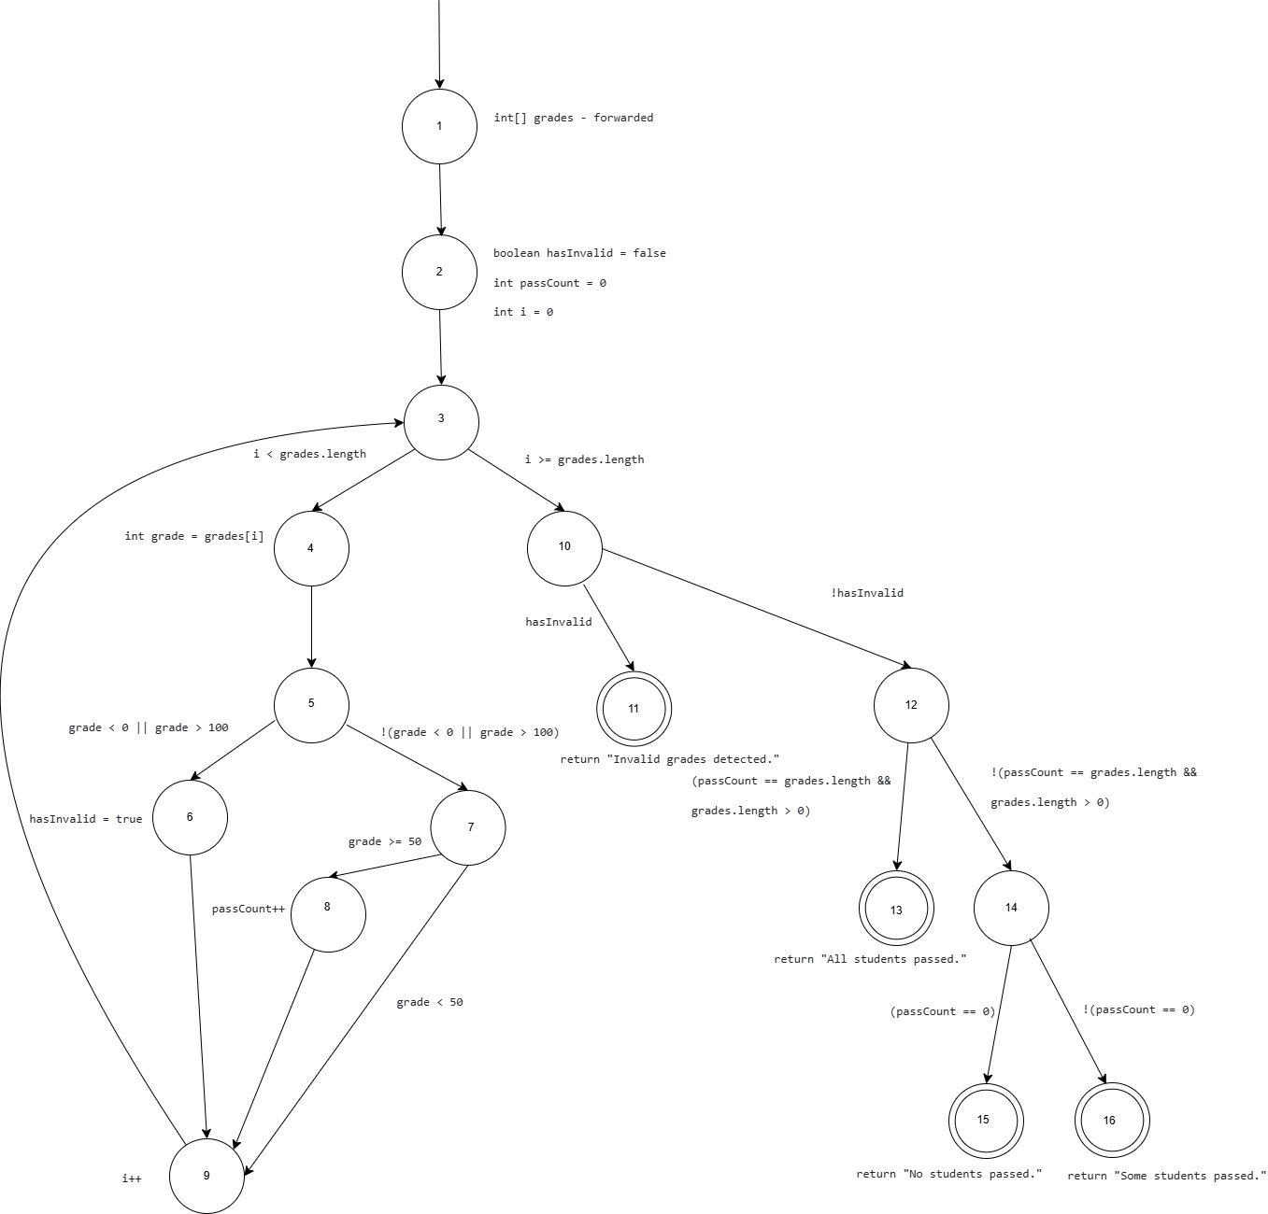

* **find all du-paths that satisfy the criteria for All-Du-Paths Coverage**

|  |  |  |
| --- | --- | --- |
| Node | Def | Use |
| 1 | grades | / |
| 2 | hasInvalid, passCount, i | / |
| 4 | grade | grades, i |
| 6 | hasInvalid | / |
| 8 | passCount | passCount |
| 9 | i | i |

|  |  |
| --- | --- |
| Edge | Use |
| (3,4) | i, grades |
| (3,10) | i, grades |
| (5,6) | grade |
| (5,7) | grade |
| (7,8) | grade |
| (7,9) | grade |
| (10,11) | hasInvalid |
| (10,12) | hasInvalid |
| (12,13) | passCount, grades |
| (12,14) | passCount, grades |
| (14,15) | passCount |
| (14,16) | passCount |

|  |  |  |
| --- | --- | --- |
| Variable | Du-pairs | Du-paths |
| grades | [1,4]  [1,(3,4)]  [1,(3,10)]  [1,(12,13)]  [1,(12,14)] | [1,2,3,4]  [1,2,3,10]  [1,2,3,4,5,6,9,3,10,12,13]  [1,2,3,4,5,7,8,9,3,10,12,13]  [1,2,3,4,5,7,9,3,10,12,13]  [1,2,3,4,5,6,9,3,10,12,14]  [1,2,3,4,5,7,8,9,3,10,12,14]  [1,2,3,4,5,7,9,3,10,12,14] |
| hasInvalid | [2,(10,11)]  [2,(10,12)]  [6,(10,11)]  [6,(10,12)] | [2,3,4,5,6,9,3,10,11]  [2,3,4,5,7,8,9,3,10,11]  [2,3,4,5,7,9,3,10,11]  [2,3,4,5,6,9,3,10,12]  [2,3,4,5,7,8,9,3,10,12]  [2,3,4,5,7,9,3,10,12]  [6,9,3,10,11]  [6,9,3,10,12] |
| passCount | [8,8]  [8,(12,13)]  [8,(12,14)]  [8,(14,15)]  [8,(14,16)] | [8,9,3,4,5,7,8]  [8,9,3,10,12,13]  [8,9,3,10,12,14]  [8,9,3,10,12,14,15]  [8,9,3,10,12,14,16] |
| i | [2,4]  [2,9]  [2,(3,4)]  [2,(3,10)]  [9,4]  [9,9]  [9,(3,4)]  [9,(3,10)] | [2,3,4]  [2,3,4,5,6,9]  [2,3,4,5,7,8,9]  [2,3,4,5,7,9]  [2,3,10]  [9,3,4]  [9,3,4,5,6,9]  [9,3,4,5,7,8,9]  [9,3,4,5,7,9]  [9,3,4]  [9,3,10] |
| grade | [4,(5,6)]  [4,(5,7)]  [4,(7,8)]  [4,(7,9)] | [4,5,6]  [4,5,7]  [4,5,7,8]  [4,5,7,9] |

All-Du-Paths Coverage

1. [1,2,3,4,5,6,9,3,10,12,13]
2. [1,2,3,4,5,7,8,9,3,10,12,13]
3. [1,2,3,4,5,7,9,3,10,12,13]
4. [1,2,3,4,5,6,9,3,10,12,14]
5. [1,2,3,4,5,7,8,9,3,10,12,14]
6. [1,2,3,4,5,7,9,3,10,12,14]
7. [2,3,4,5,6,9,3,10,11]
8. [2,3,4,5,7,8,9,3,10,11]
9. [2,3,4,5,7,9,3,10,11]
10. [8,9,3,4,5,7,8]
11. [8,9,3,10,12,14,15]
12. [8,9,3,10,12,14,16]
13. [1,2,3,10]
14. [9,3,4,5,6,9]
15. [9,3,4,5,7,8,9]
16. [9,3,4,5,7,9]

* **find the minimal test set that achieves Prime Path Coverage and create real Junit tests**

Simple Paths

[1,2]  
[2,3]  
[3,4]  
[4,5]  
[5,6]  
[5,7]  
[7,8]  
[6,9]  
[8,9]  
[7,9]  
[9,3]  
[3,10]  
[10,11]  
[10,12]  
[12,13]  
[12,14]  
[14,15]  
[14,16]  
[1,2,3]  
[2,3,4]  
[2,3,10]  
[3,4,5]  
[4,5,6]  
[4,5,7]  
[5,6,9]  
[5,7,8]  
[5,7,9]  
[7,8,9]  
[6,9,3]  
[8,9,3]  
[7,9,3]  
[9,3,4]  
[9,3,10]  
[3,10,11]  
[3,10,12]  
[10,12,13]  
[10,12,14]  
[12,14,15]  
[12,14,16]  
[1,2,3,4]  
[1,2,3,10]  
[2,3,4,5]  
[2,3,10,11]  
[2,3,10,12]  
[3,4,5,6]  
[3,4,5,7]  
[4,5,6,9]  
[4,5,7,8]  
[4,5,7,9]  
[5,6,9,3]  
[5,7,8,9]  
[5,7,9,3]  
[7,8,9,3]  
[6,9,3,4]  
[6,9,3,10]  
[8,9,3,4]  
[8,9,3,10]  
[7,9,3,4]  
[7,9,3,10]  
[9,3,4,5]  
[9,3,10,11]  
[9,3,10,12]  
[3,10,12,13]  
[3,10,12,14]  
[10,12,14,15]  
[10,12,14,16]  
[1,2,3,4,5]  
[1,2,3,10,11]  
[1,2,3,10,12]  
[2,3,4,5,6]  
[2,3,4,5,7]  
[2,3,10,12,13]  
[2,3,10,12,14]  
[3,4,5,6,9]  
[3,4,5,7,8]  
[3,4,5,7,9]  
[4,5,6,9,3]  
[4,5,7,8,9]  
[4,5,7,9,3]  
[5,6,9,3,4]  
[5,6,9,3,10]  
[5,7,8,9,3]  
[5,7,9,3,4]  
[5,7,9,3,10]  
[7,8,9,3,4]  
[7,8,9,3,10]  
[6,9,3,4,5]  
[6,9,3,10,11]  
[6,9,3,10,12]  
[8,9,3,4,5]  
[8,9,3,10,11]  
[8,9,3,10,12]  
[7,9,3,4,5]  
[7,9,3,10,11]  
[7,9,3,10,12]  
[9,3,4,5,6]  
[9,3,4,5,7]  
[9,3,10,12,13]  
[9,3,10,12,14]  
[3,10,12,14,15]  
[3,10,12,14,16]  
[1,2,3,4,5,6]  
[1,2,3,4,5,7]  
[1,2,3,10,12,13]  
[1,2,3,10,12,14]  
[2,3,4,5,6,9]  
[2,3,4,5,7,8]  
[2,3,4,5,7,9]  
[2,3,10,12,14,15]  
[2,3,10,12,14,16]  
[3,4,5,6,9,3]  
[3,4,5,7,8,9]  
[3,4,5,7,9,3]  
[4,5,6,9,3,4]  
[4,5,6,9,3,10]  
[4,5,7,8,9,3]  
[4,5,7,9,3,4]  
[4,5,7,9,3,10]  
[5,6,9,3,4,5]  
[5,6,9,3,10,11]  
[5,6,9,3,10,12]  
[5,7,8,9,3,4]  
[5,7,8,9,3,10]  
[5,7,9,3,4,5]  
[5,7,9,3,10,11]  
[5,7,9,3,10,12]  
[7,8,9,3,4,5]  
[7,8,9,3,10,11]  
[7,8,9,3,10,12]  
[6,9,3,4,5,6]  
[6,9,3,4,5,7]  
[6,9,3,10,12,13]  
[6,9,3,10,12,14]  
[8,9,3,4,5,6]  
[8,9,3,4,5,7]  
[8,9,3,10,12,13]  
[8,9,3,10,12,14]  
[7,9,3,4,5,6]  
[7,9,3,4,5,7]  
[7,9,3,10,12,13]  
[7,9,3,10,12,14]  
[9,3,4,5,6,9]  
[9,3,4,5,7,8]  
[9,3,4,5,7,9]  
[9,3,10,12,14,15]  
[9,3,10,12,14,16]  
[1,2,3,4,5,6,9]  
[1,2,3,4,5,7,8]  
[1,2,3,4,5,7,9]  
[1,2,3,10,12,14,15]  
[1,2,3,10,12,14,16]  
[2,3,4,5,7,8,9]  
[3,4,5,7,8,9,3]  
[4,5,6,9,3,10,11]  
[4,5,6,9,3,10,12]  
[4,5,7,8,9,3,4]  
[4,5,7,8,9,3,10]  
[4,5,7,9,3,10,11]  
[4,5,7,9,3,10,12]  
[5,6,9,3,10,12,13]  
[5,6,9,3,10,12,14]  
[5,7,8,9,3,4,5]  
[5,7,8,9,3,10,11]  
[5,7,8,9,3,10,12]  
[5,7,9,3,10,12,13]  
[5,7,9,3,10,12,14]  
[7,8,9,3,4,5,6]  
[7,8,9,3,4,5,7]  
[7,8,9,3,10,12,13]  
[7,8,9,3,10,12,14]  
[6,9,3,4,5,7,8]  
[6,9,3,10,12,14,15]  
[6,9,3,10,12,14,16]  
[8,9,3,4,5,7,8]  
[8,9,3,10,12,14,15]  
[8,9,3,10,12,14,16]  
[7,9,3,10,12,14,15]  
[7,9,3,10,12,14,16]  
[9,3,4,5,7,8,9]  
[1,2,3,4,5,7,8,9]  
[4,5,6,9,3,10,12,13]  
[4,5,6,9,3,10,12,14]  
[4,5,7,8,9,3,10,11]  
[4,5,7,8,9,3,10,12]  
[4,5,7,9,3,10,12,13]  
[4,5,7,9,3,10,12,14]  
[5,6,9,3,10,12,14,15]  
[5,6,9,3,10,12,14,16]  
[5,7,8,9,3,10,12,13]  
[5,7,8,9,3,10,12,14]  
[5,7,9,3,10,12,14,15]  
[5,7,9,3,10,12,14,16]  
[7,8,9,3,10,12,14,15]  
[7,8,9,3,10,12,14,16]  
[4,5,6,9,3,10,12,14,15]  
[4,5,6,9,3,10,12,14,16]  
[4,5,7,8,9,3,10,12,13]  
[4,5,7,8,9,3,10,12,14]  
[4,5,7,9,3,10,12,14,15]  
[4,5,7,9,3,10,12,14,16]  
[5,7,8,9,3,10,12,14,15]  
[5,7,8,9,3,10,12,14,16]  
[4,5,7,8,9,3,10,12,14,15]  
[4,5,7,8,9,3,10,12,14,16]

Prime Paths

[4,5,7,8,9,3,10,12,14,15]  
[4,5,7,8,9,3,10,12,14,16]  
[4,5,7,8,9,3,10,12,13]  
[4,5,6,9,3,10,12,14,16]  
[4,5,6,9,3,10,12,14,15]  
[4,5,7,9,3,10,12,14,15]  
[4,5,7,9,3,10,12,14,16]  
[4,5,7,9,3,10,12,13]  
[4,5,7,8,9,3,10,11]  
[1,2,3,4,5,7,8,9]  
[4,5,6,9,3,10,12,13]  
[4,5,7,9,3,10,11]  
[4,5,7,8,9,3,4]  
[5,7,8,9,3,4,5]  
[4,5,6,9,3,10,11]  
[1,2,3,4,5,7,9]  
[1,2,3,4,5,6,9]  
[1,2,3,10,12,14,15]  
[3,4,5,7,8,9,3]  
[1,2,3,10,12,14,16]  
[8,9,3,4,5,7,8]  
[9,3,4,5,7,8,9]  
[6,9,3,4,5,7,8]  
[7,8,9,3,4,5,6]  
[7,8,9,3,4,5,7]  
[4,5,7,9,3,4]  
[3,4,5,7,9,3]  
[4,5,6,9,3,4]  
[5,6,9,3,4,5]  
[1,2,3,10,12,13]  
[3,4,5,6,9,3]  
[5,7,9,3,4,5]  
[7,9,3,4,5,7]  
[7,9,3,4,5,6]  
[9,3,4,5,7,9]  
[9,3,4,5,6,9]  
[6,9,3,4,5,6]  
[1,2,3,10,11]

Test Paths

1. [1,2,3,4,5,7,9,3,4,5,6,9,3,4,5,7,8,9,3,10,11]
2. [1,2,3,4,5,7,9,3,4,5,7,9,3,4,5,7,9,3,10,12,13]
3. [1,2,3,4,5,7,8,9,3,4,5,7,8,9,3,4,5,7,8,9,3,10,12,14,16]
4. [1,2,3,10,11]
5. [1,2,3,4,5,7,9,3,10,12,14,15]
6. [1,2,3,4,5,6,9,3,10,12,14,16]
7. [1,2,3,10,12,13]
8. [1,2,3,4,5,6,9,3,4,5,6,9,3,10,11]
9. [1,2,3,4,5,7,8,9,3,10,12,14,15]
10. [1,2,3,4,5,7,9,3,10,11]
11. [1,2,3,4,5,6,9,3,10,11]
12. [1,2,3,10,12,14,15]
13. [1,2,3,10,12,14,16]
14. [1,2,3,4,5,7,8,9,3,4,5,6,9,3,10,11]
15. [1,2,3,4,5,6,9,3,10,12,13]
16. [1,2,3,4,5,7,8,9,3,10,12,13]
17. [1,2,3,4,5,6,9,3,10,12,14,15]
18. [1,2,3,4,5,7,9,3,10,12,14,16]