|  |  |
| --- | --- |
| Project name | Concert Hall Booking System |

|  |
| --- |
| 1. Short project description |
| This systemprovides ability for Event Creators to book concert hall for their upcoming concerts and for people to buy tickets for the events they want. In addition to that it allows users to register, and administrators to manage them.  The main user roles:  • *Anonymous User* – can only register.  • *Registered User* – can buy tickets. After buying, he has access to information about the event for which he bought tickets (date, time, place).  • *Concert Creator* – can create concerts, book a concert hall, update concert details and see who bought tickets.  • *Administrator*– can manage (create, edit concert data and delete) all registered concerts. |

|  |  |  |
| --- | --- | --- |
| 1. Main Use Cases / Scenarios | | |
| **Use case name** | **Brief Descriptions** | **Actors Involved** |
| * 1. **Register** | Anonymous User can register in the system by providing a valid e-mail address, first and last name, and choosing password. He also must be at least 18 years old. | Anonymous User |
| * 1. **View program and program info** | The User can view the program with upcoming concerts and see information such as the date and time of a concert. | Registered User,  Concert Creator,  Administrator |
| * 1. **Buy tickets** | Registered User can buy tickets for a concert. | Registered User |
| * 1. **Create event** | Concert Creator and Administrator can create concert event. | Concert Creator,  Administrator |
| * 1. **Book Concert Hall** | Concert Creator book a concert hall if it’s free. | Concert Creator |
| * 1. **Edit concert info** | Concert Creator or Administrator can edit concert info. Concert Creator or Administrator saves the edited concert. | Concert Creator, Administrator |
| * 1. **View buyers** | Concert Creator and Administrator can see list of registered users who bought tickets for a specific concert. | Concert Creator, Administrator |
| * 1. **Browse Concert** | Registered User can browse through his visited concerts.  Concert Creator can browse through his created concerts.  Administrator has access to all of all data. | Registered User,  Concert Creator |

|  |  |
| --- | --- |
| 1. Main Views | |
| **View name** | **Brief Descriptions** |
| * 1. **Home** | Presents the introductory information for the purpose of the system as well as detailed instructions how to start using it. |
| * 1. **Register** | Provides ability to register. |
| * 1. **Buy tickets** | Provides ability to buy tickets for selected concert. |
| * 1. **View my purchases** | Shows all concerts for which a user has bought tickets. |
| * 1. **Create Concert** | Provides ability to create concert. |
| * 1. **Book Concert Hall** | Provides ability to book concert hall for a concert. |
| * 1. **View my events** | Shows all events which Concert Creator has created. |
| * 1. **Users** | Presents ability to manage (CRUD) Users and their User Data (available for Administrators only). |

Domain Entities

1. Ticket

Attributes:

* Id: int
* Buyer: User
* Concert: Concert

1. Concert

Attributes:

* Id: str
* Singer: str
* Date: datetime
* Number of tickets: int
* place: Concert_hall

1. Concert Hall

Attributes:

* Address: str
* Capacity: int
* Reserved_dates: [datetime]

1. User

Attributes:

* Username: str
* Password: str
* Email: str
* Age: int

1. Registered User (User)

Attributes:

* Tickets: List[Ticket]

1. Event Creator (User)

Attributes:

* Concerts: List[Concert]

1. Administrator

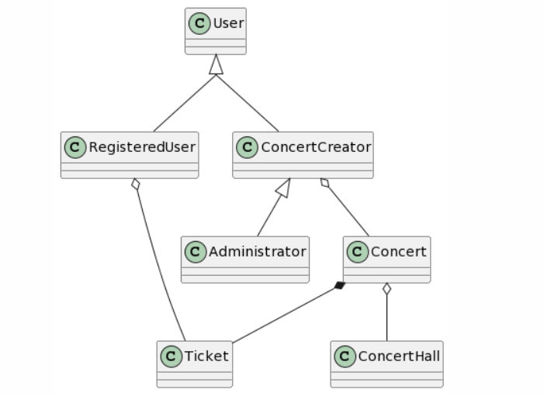

@startuml

skinparam groupInheritance 2

User <|-- RegisteredUser

User <|-- ConcertCreator

ConcertCreator <|-- Administrator

ConcertCreator o-- Concert

RegisteredUser o-- Ticket

Concert o-- ConcertHall

Concert *-- Ticket

@enduml