**Burndown Charts**

The burndown charts were created using a custom built Python application. Each week, after the sprint, a new burndown chart was created and saved.

**Sprint ending on 14.02.2020**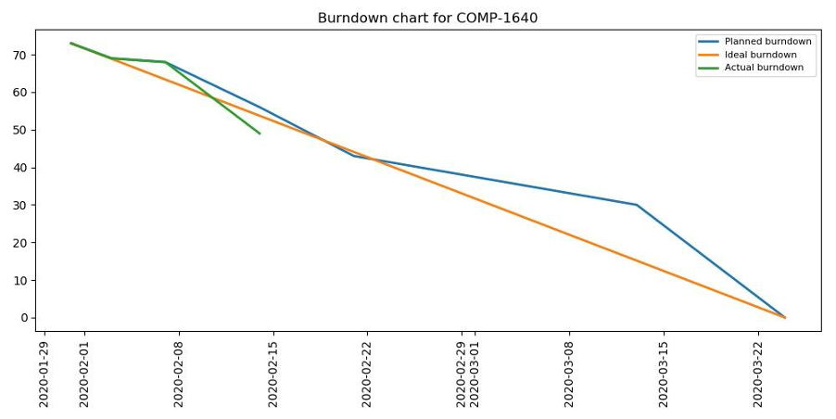

**Sprint ending on 21.02.2020**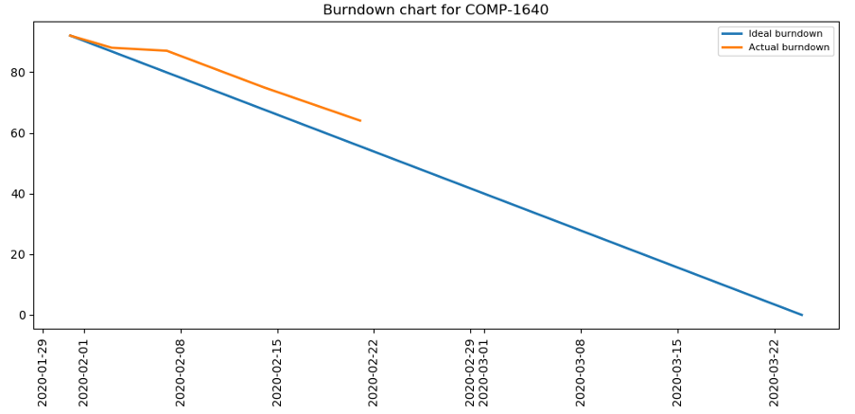

**Sprint ending on 28.02.2020**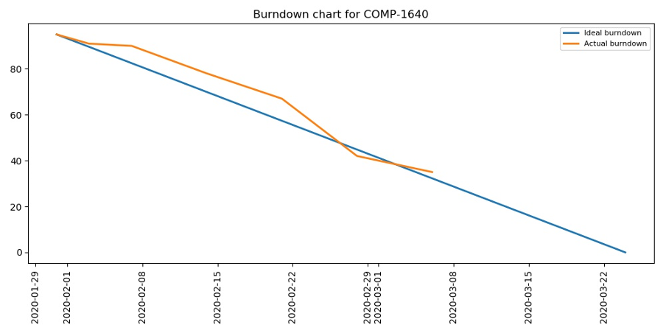

**Sprint ending on 06.03.2020**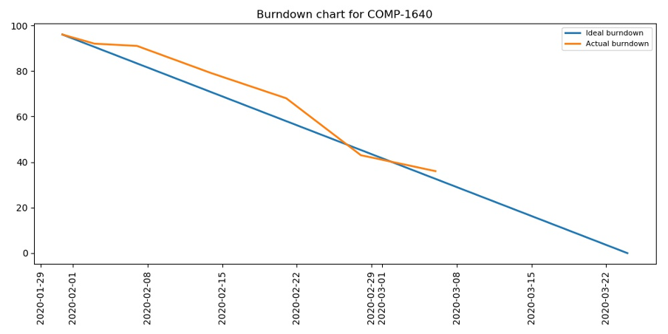

**Final sprint - 20.03.2020**