1) For the first assignment I implement java application which able to read only csv file types and I only tested the nl_postal_codes.csv file

2) For the second assignment to design service I was confused what type of UML diagram you are asking for this reason it is not implement.

3) For the simple CRM API I would make create login end point which would accept POST messages, I would apply SSL (private key exchange) After this the user would receive tokens or any other id. This id helps validate user without login procedure. The next endpoint would keep HTTP GET to get needed information by id, employee name, company name etc. I would use JSON format for data exchange. After certain time the engine would clean recently logged user.

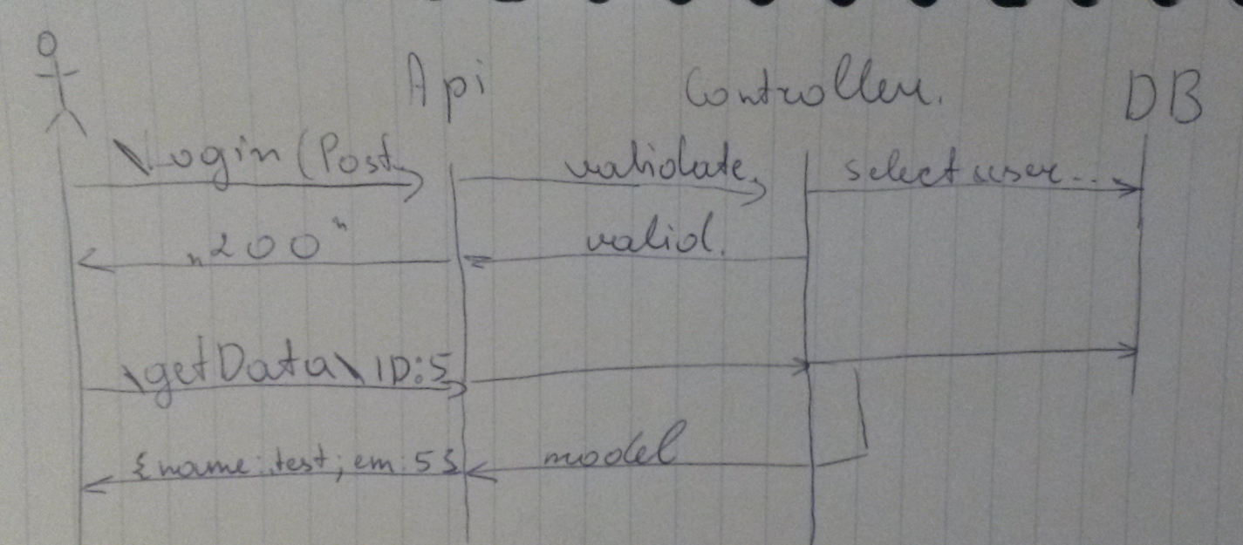

4) **The production** branch I will use only for stable versions. Using tags help in fast way to do roll back. Possible create new branches instead of using tags. Then each of these branches might translated as release version. (Because of hot fixes there always a risk that production branch might be different to master branch)

**The staging** branch is a “fairly” stable version and it is used for testing purposes. This branch can be merged into master.

**The development branch** is used for developing new features. These branches can be removed and again created without any significant affect to the working process. The developers should use them for developing new features and after it merge into staging branch for testing purposes.

**The hot fixes** are emergency fixes for production branches. These branches are created from production branch and merged “immediately” (depends on working process, the also should be tested) to the production branch.

Every company might have own way to manage Git repositories.